**PROBLEM STATEMENT:**

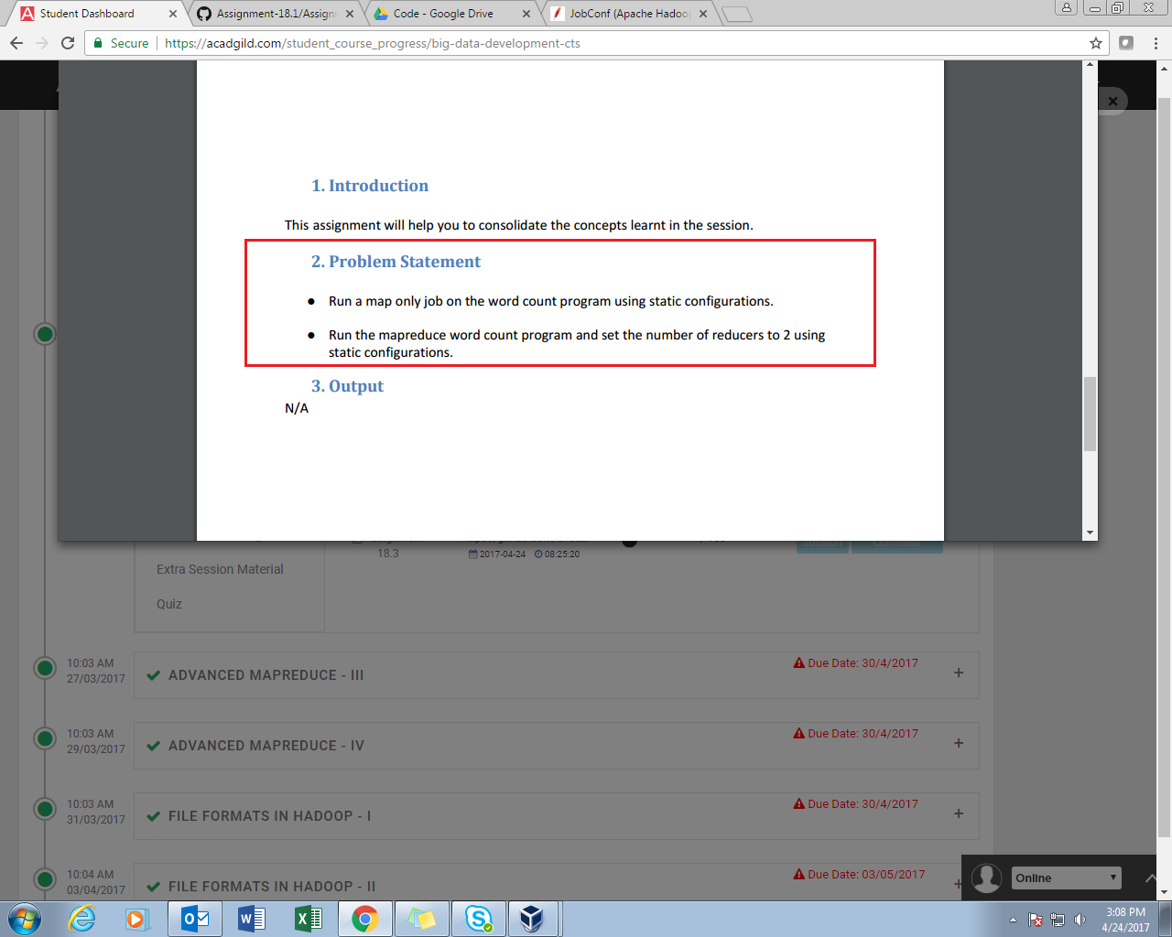

**Q1- Run a map only job on the word count program using static configurations.**

**SOLUTION:**

**PROGRAM:**

//DRIVER CLASS

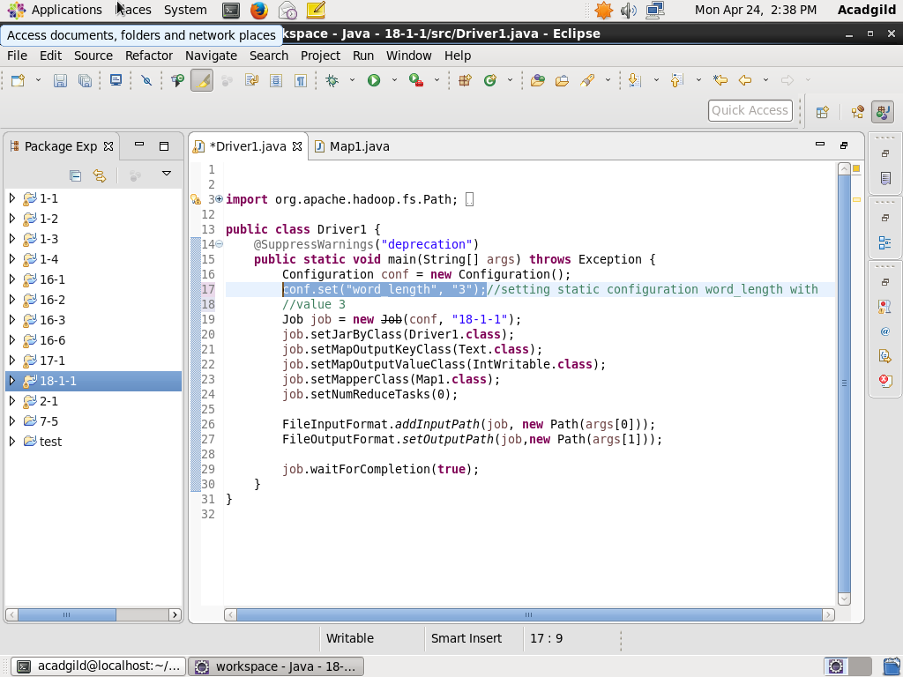

In this code, conf.set() is used to define a variable word_length with value 3.

//MAPPER CLASS

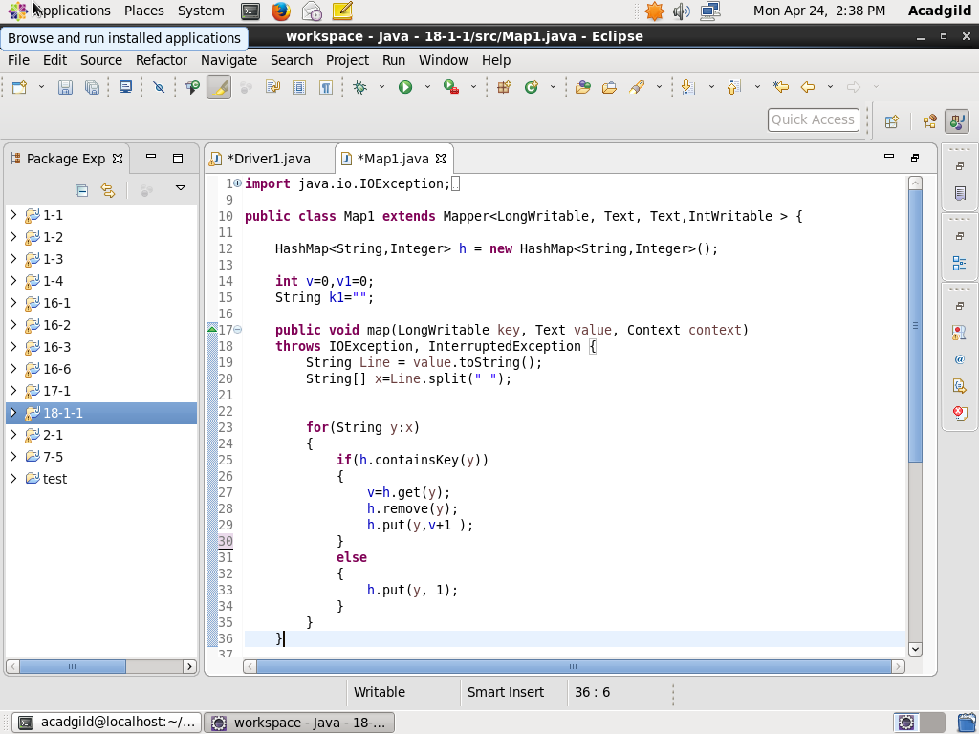

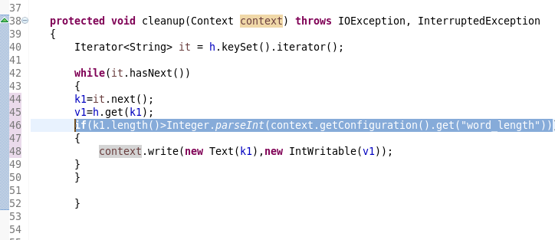

//The words with length greater than word_length (ie. 3) are considered.

**EXECUTION COMMAND:**

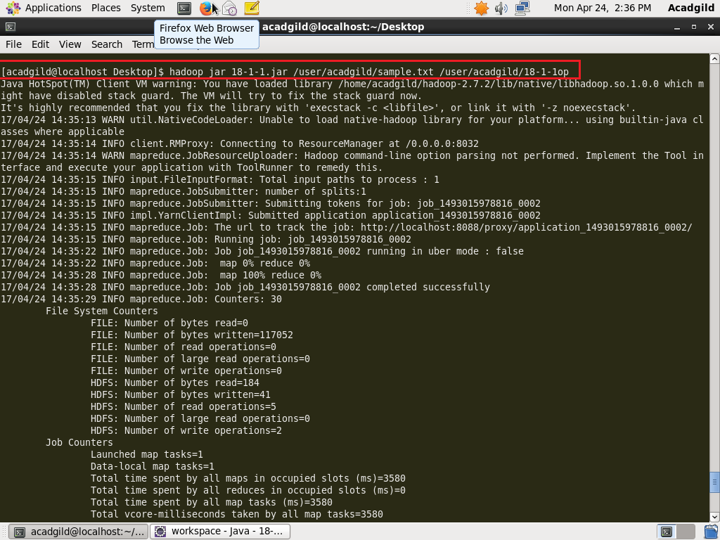

**OUTPUT:**

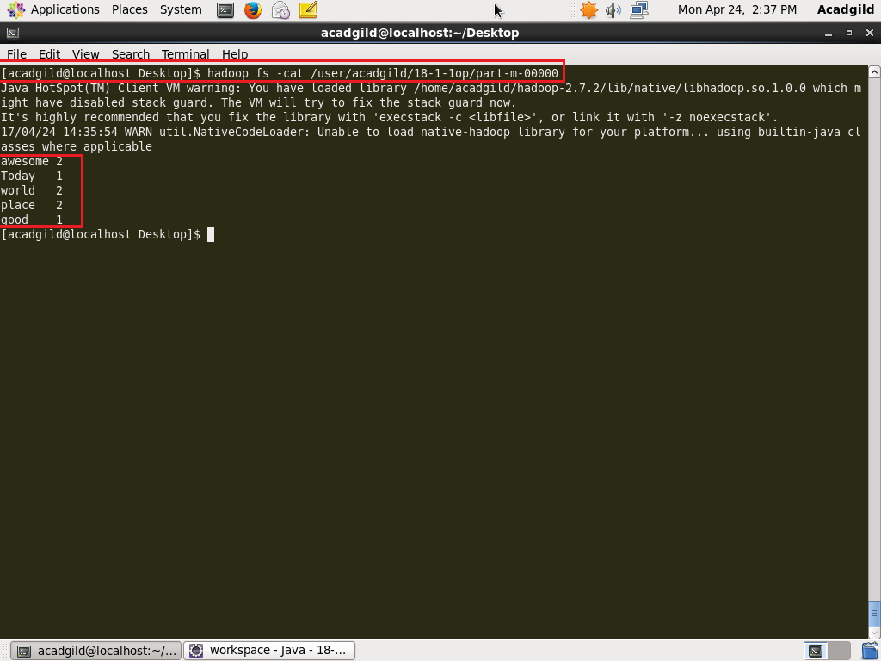

**Q2-Run the mapreduce word count program and set the number of reducers to 2 using static configurations.**

**SOLUTION:**

**PROGRAM:**

//DRIVER CLASS

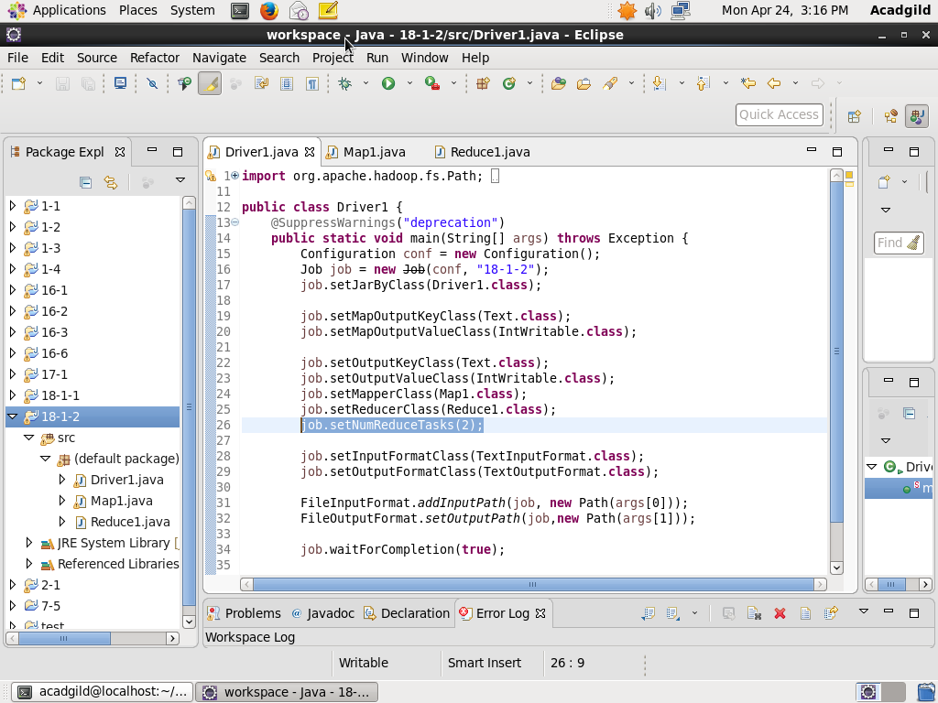

//MAPPER CLASS

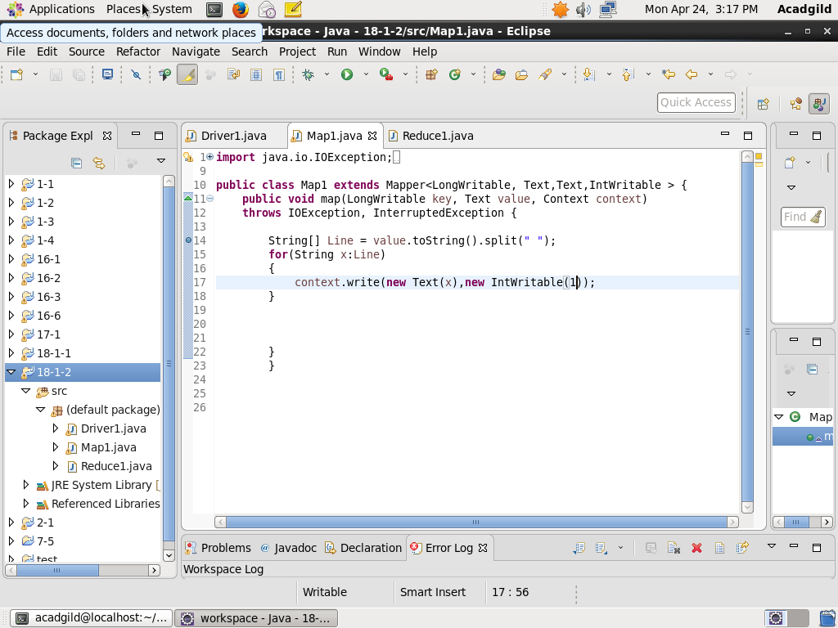

//REDUCER CLASS

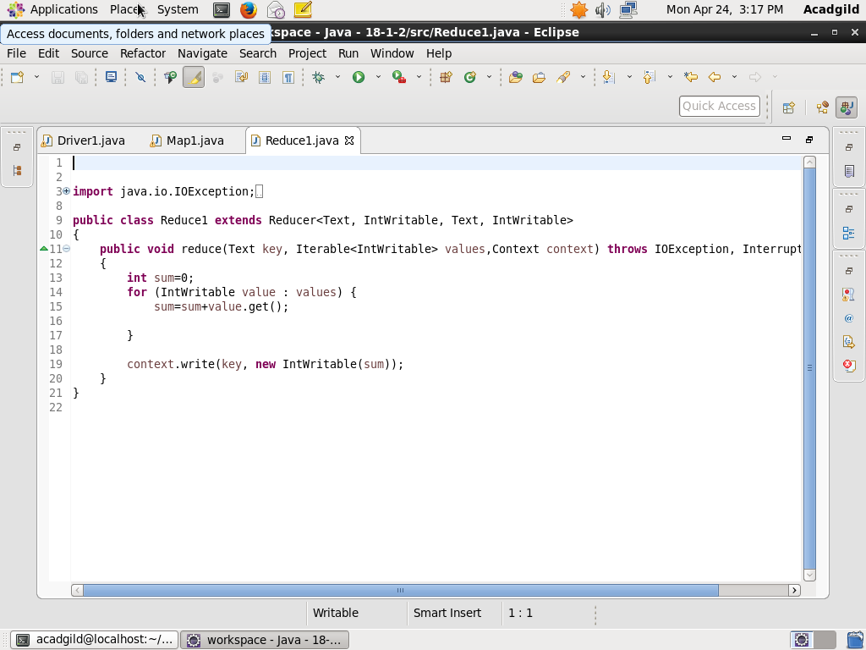

**EXECUTION COMMAND:**

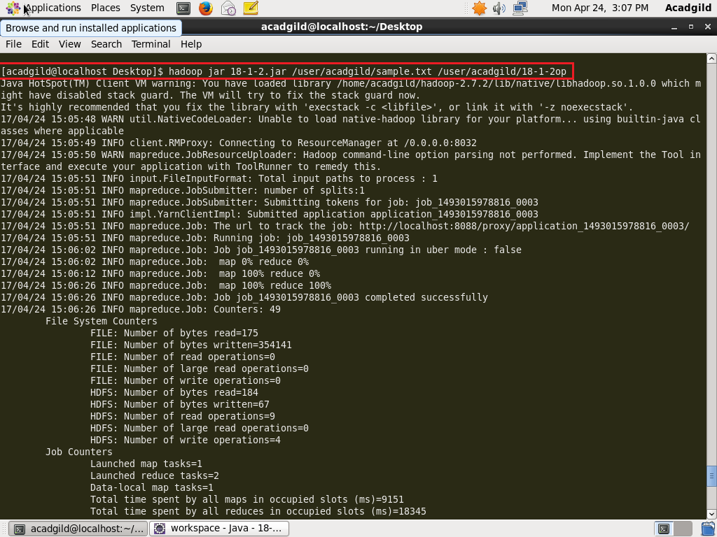

**OUTPUT:**

