**PROBLEM STATEMENT:**

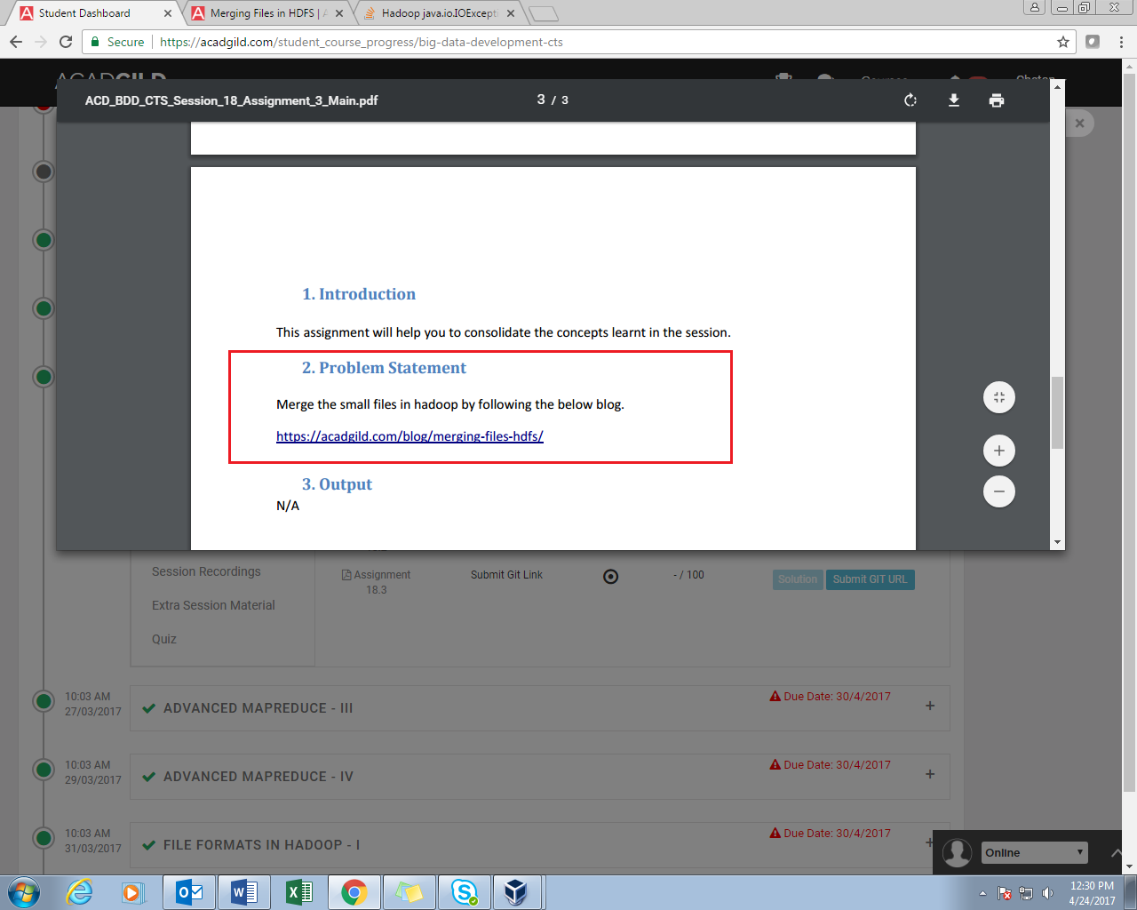

**SOLUTION:**

The HDFS **getmerge** command can copy the files present in a given path in HDFS to a single concatenated file in the local filesystem.

The **getmerge** command has the following syntax:

**Hadoop fs -getmerge -nl <source file path> <local system destination path>**

The **getmerge**command has three parameters:

* <src files> is the HDFS path to the directory that contains the files to be concatenated
* <dist file> is the local filename of the merged file
* [-nl] is an optional parameter that adds a new line in the result file.

//displaying the names of the files in the directory /user/acadgild/merge on HDFS.

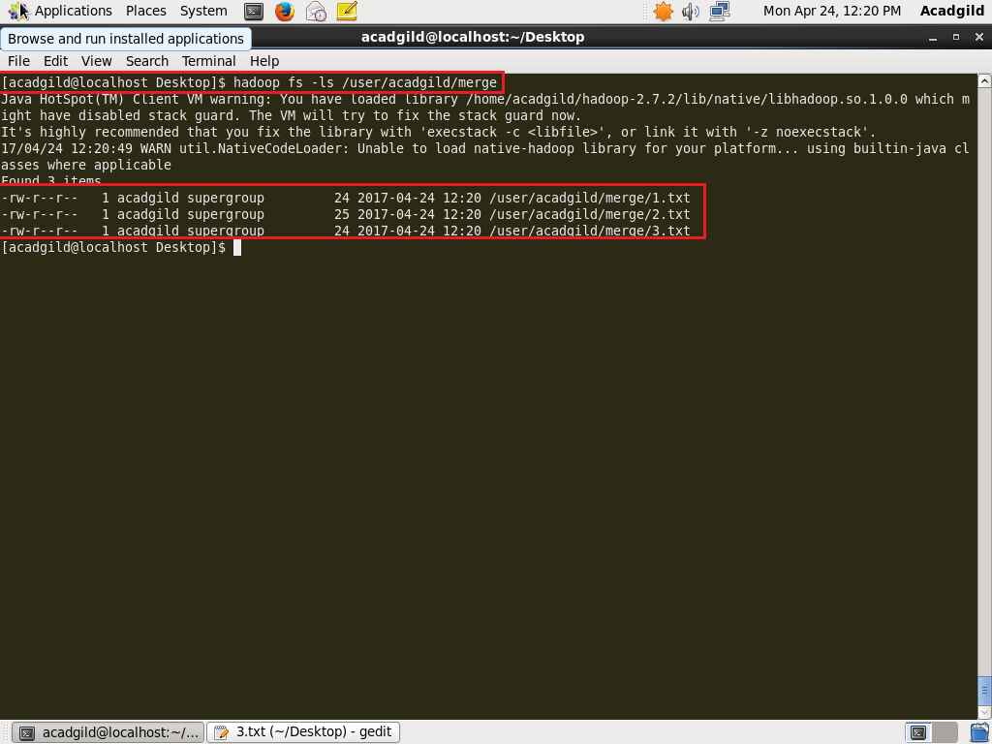

//displaying the contents of each in individual file

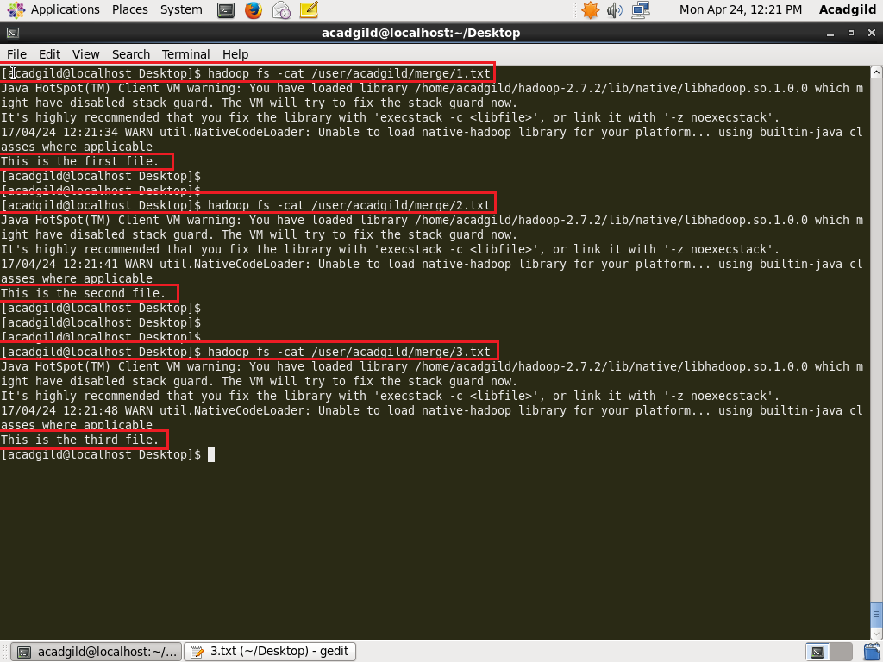

// executing the command and displaying the contents of merged file.

