**PROBLEM STATEMENT:**

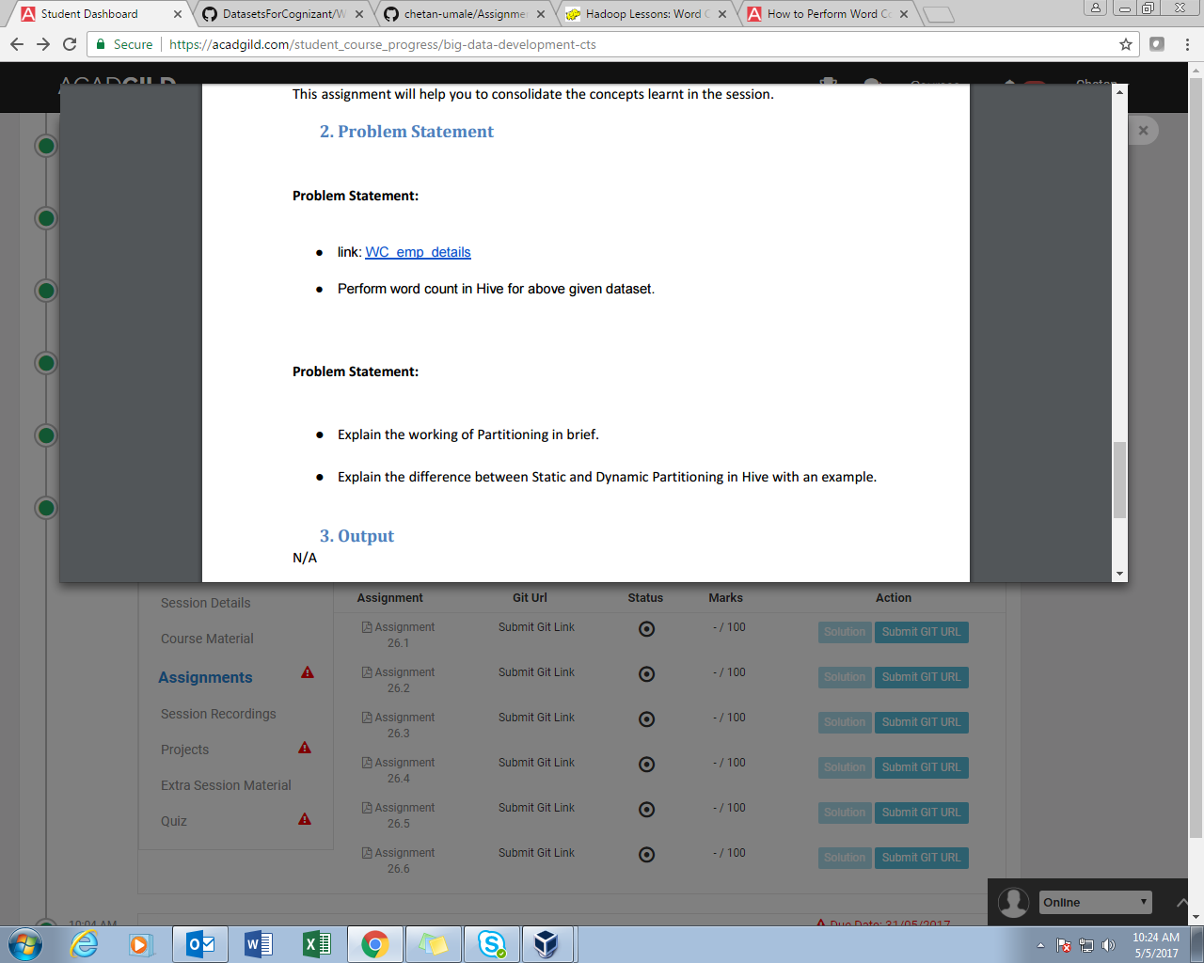

**Q1- WORD COUNT IN HIVE**

**SOLUTION:**

//CREATING TABLE AND LOADING DATA

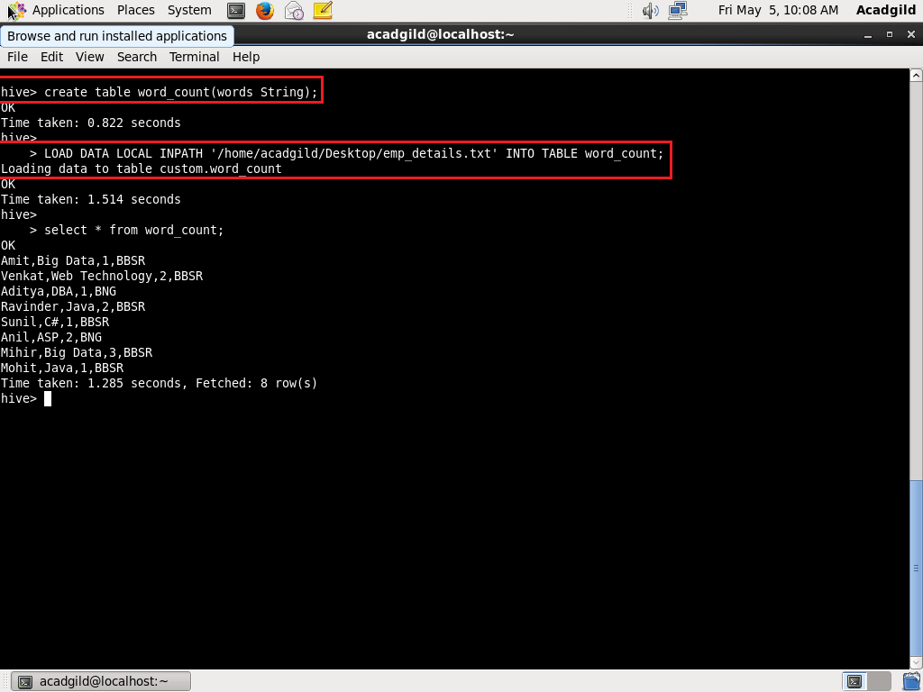

//SPLIT FUNCTION

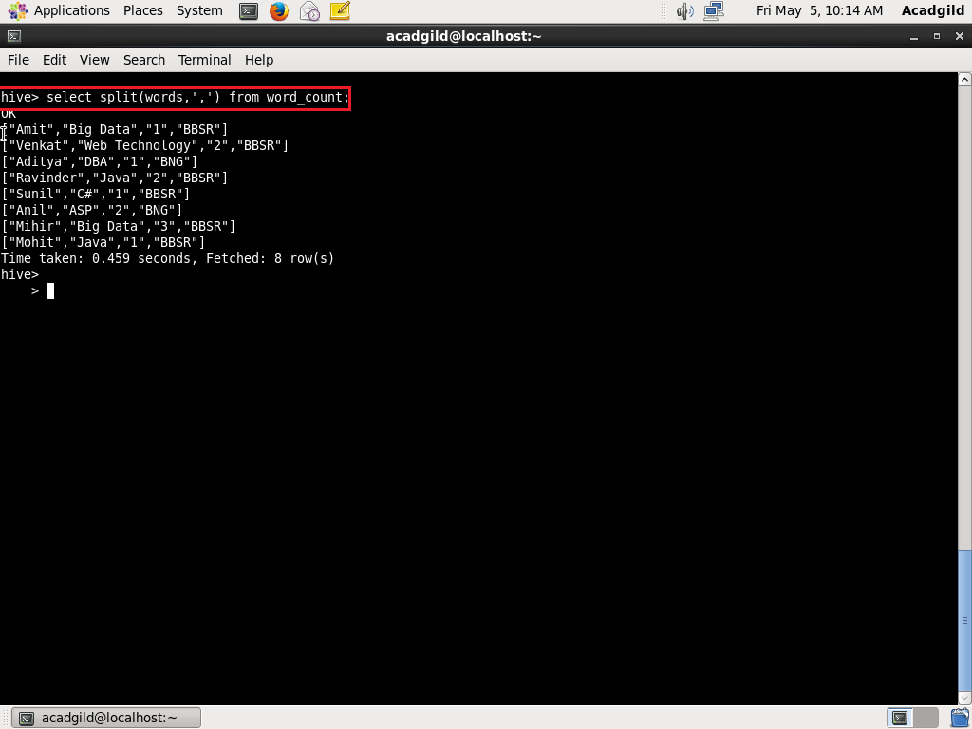

//EXPLODE FUNCTION

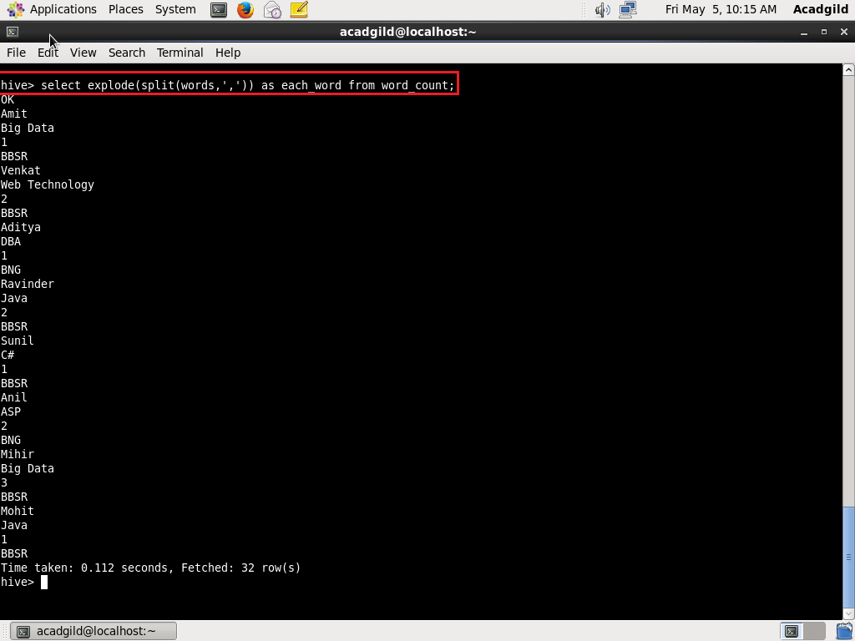

//GROUP BY AND COUNT

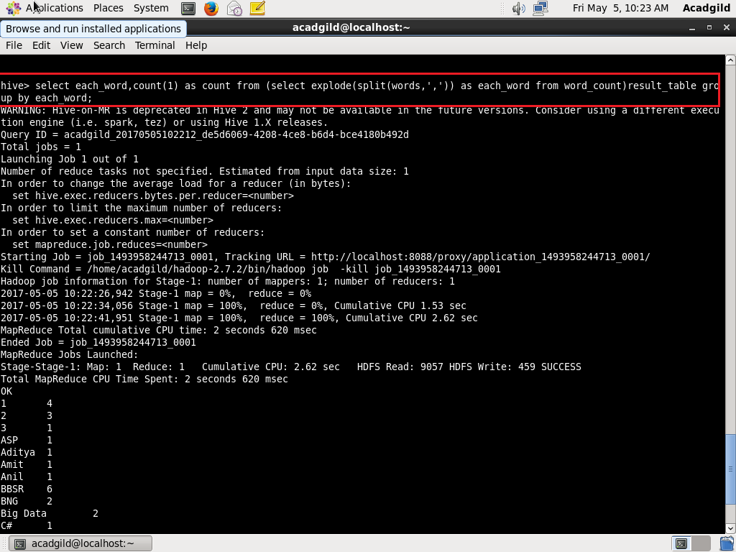

OUTPUT:

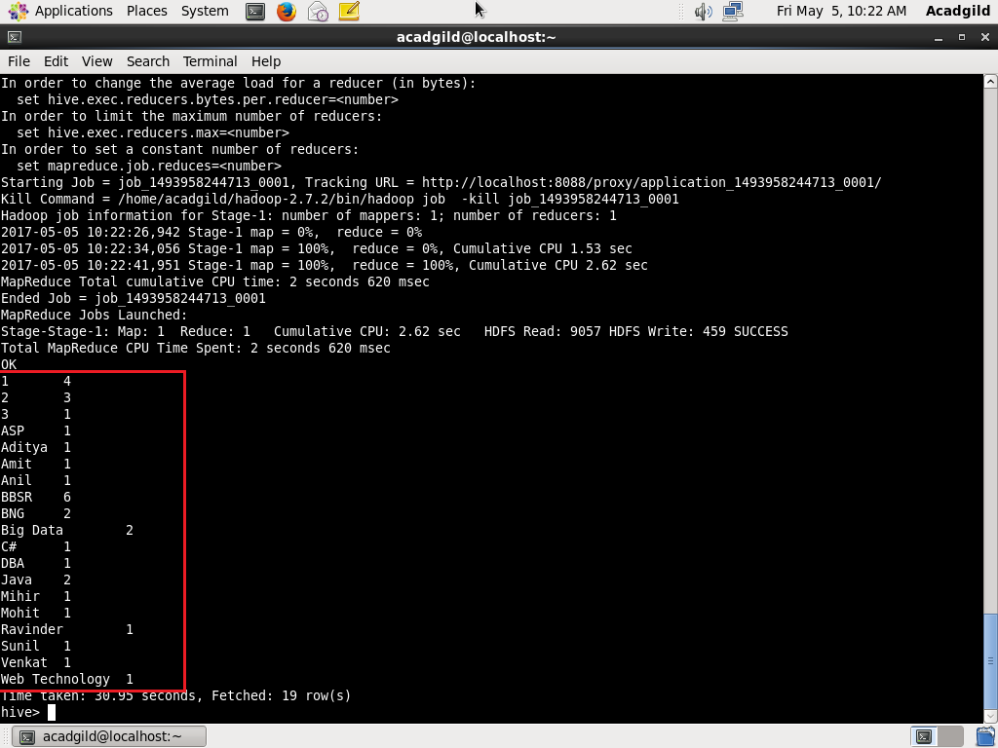

**Q2-Explain the working of Partitioning in brief.**

**SOLUTION:**

1. Hive organizes tables into partitions. It is a way of dividing a table into related parts based on the values of partitioned columns such as date, city, and department.

2. Using partition, it is easy to query a portion of the data.

3. Tables or partitions are sub-divided into **buckets,** to provide extra structure to the data that may be used for more efficient querying.

4. Bucketing works based on the value of hash function of some column of a table.

5. For example, a table named **Tab1** contains employee data such as id, name, dept, and yoj (i.e., year of joining). Suppose you need to retrieve the details of all employees who joined in 2012. A query searches the whole table for the required information. However, if you partition the employee data with the year and store it in a separate file, it reduces the query processing time.

**Q3-Explain the difference between Static and Dynamic Partitioning in Hive with an example.**

**SOLUTION:**

|  |  |
| --- | --- |
| **STATIC PARTITIONING** | **DYNAMIC PARTITIONING** |
| Insert input data files individually into a partition table is Static Partition. | Single insert to partition table is known as dynamic partition. |
| Static Partition saves your time in loading data compared to dynamic partition | Dynamic Partition takes more time in loading data compared to static partition. |
| We can alter the partition in static partition. | We can’t perform alter on Dynamic partition. |
| Static partition is in Strict Mode. | If you want to use Dynamic partition in hive then mode is in non strict mode. |