**PROBLEM STATEMENT:**

**Run parallel jobs in hive by following the steps in the below blog link**

[**https://acadgild.com/blog/hive-parallel-jobs/**](https://acadgild.com/blog/hive-parallel-jobs/)

**SOLUTION:**

//dataset

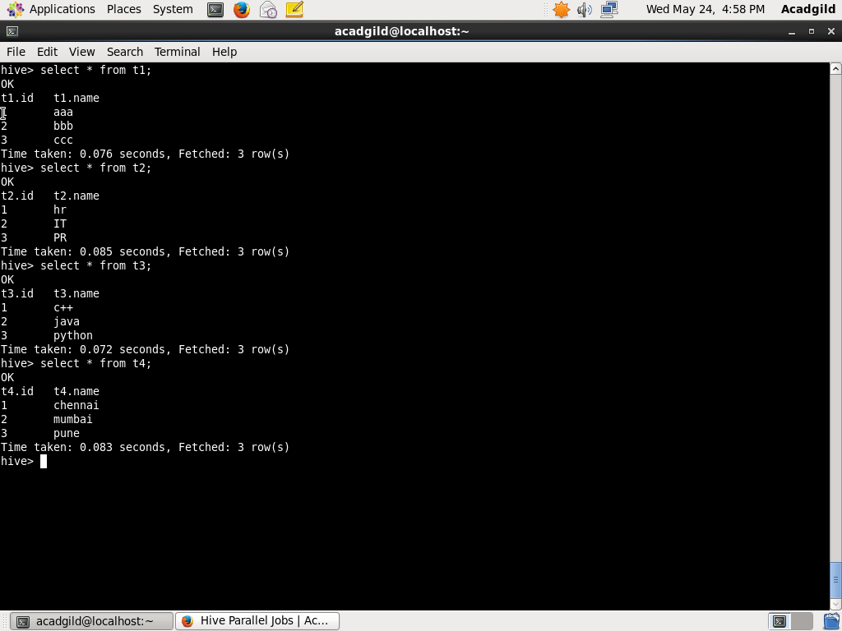

//normal query execution

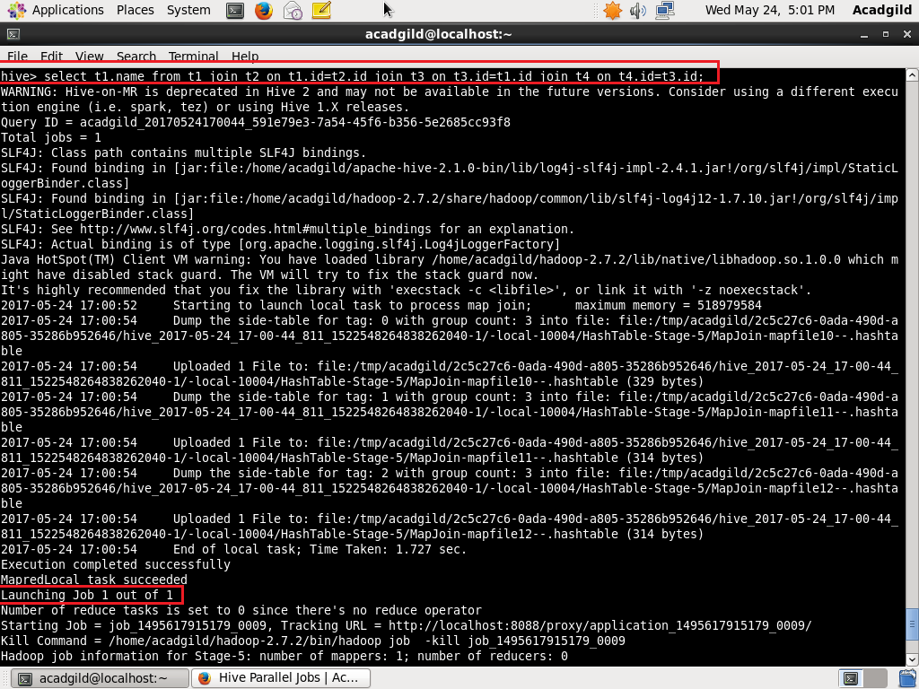

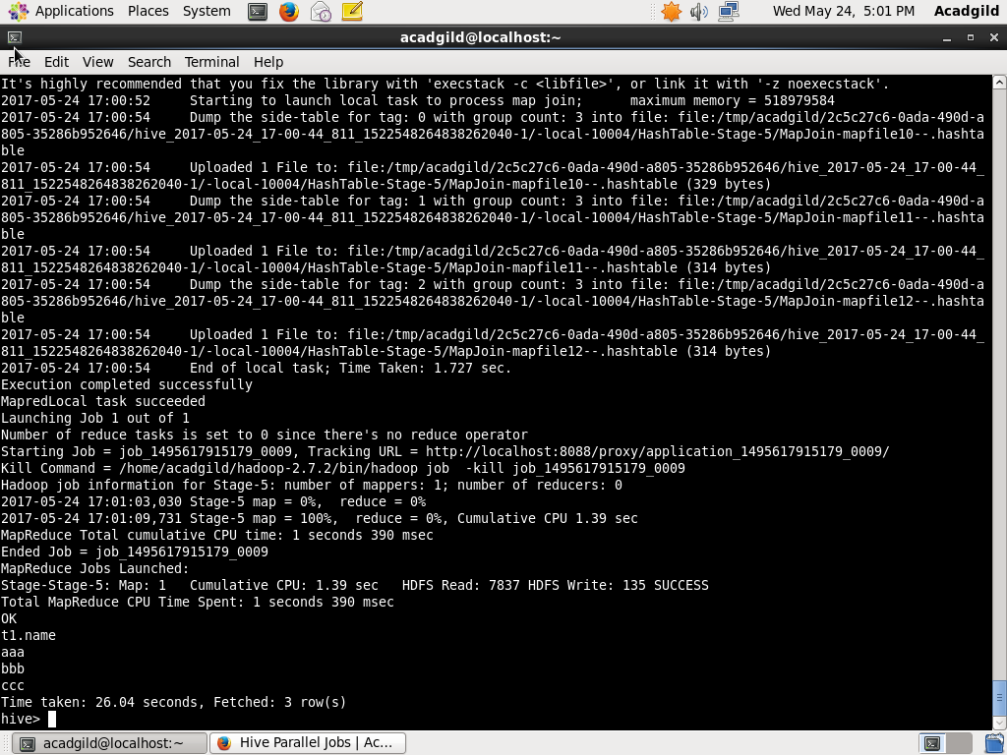

As seen in the screenshots above, only one job is executed.

//enabling parallel jobs

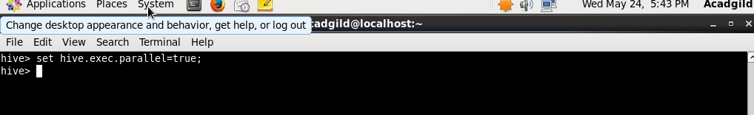

//parallel jobs execution using optimized query

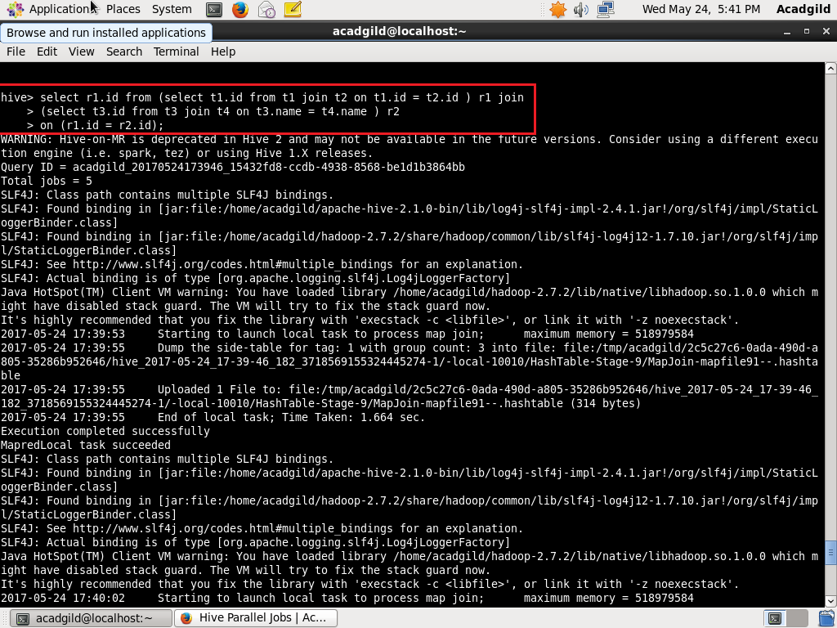

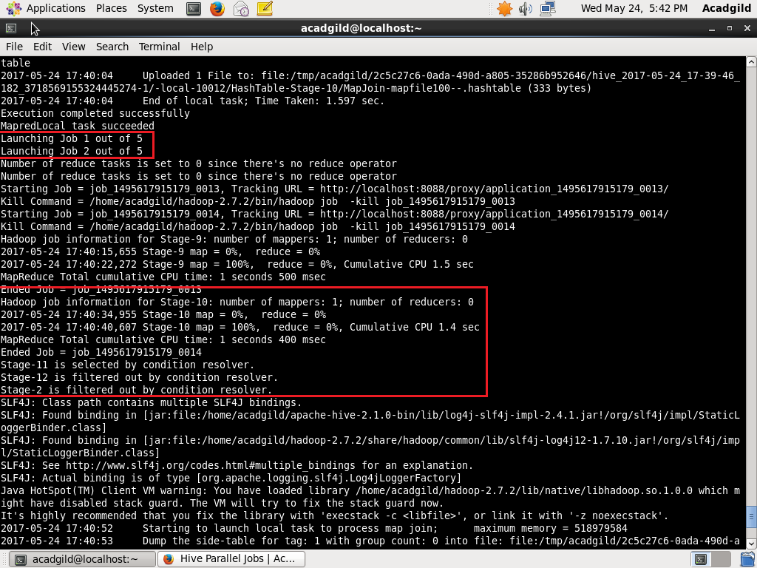

As seen in the screenshots above, multiple jobs and multiple stages in a single job are executed concurrently.