**Q1-Differences between HBASE and HDFS.**

**ANSWER:**

|  |  |
| --- | --- |
| **HBASE** | **HDFS** |
| HBase is an open source, distributed, versioned, column-oriented, No-SQL / Non-relational database management system that runs on the top of Hadoop. | HDFS - a distributed file system that distributes data across a cluster of machines taking care of redundancy. |
| HBase stores data as key/value pairs as in a column database. | HDFS stores data as flat files. |
| It gives you the ability to do random read/writes on your data. | HDFS doesn’t do random reads very well. |
| HBase provides a flexible data model**.** | HDFS does not provide a flexible data model. |

**Q2-** **List and explain the main components of HBASE.**

**ANSWER:**

**Components of Apache HBase Architecture**

HBase architecture has 3 important components- HMaster, Region Server and ZooKeeper.

**HMaster:**

HBase HMaster is a lightweight process that assigns regions to region servers in the Hadoop cluster for load balancing. Responsibilities of HMaster –

Manages and Monitors the Hadoop Cluster

Performs Administration (Interface for creating, updating and deleting tables.)

Controlling the failover

DDL operations are handled by the HMaster

Whenever a client wants to change the schema and change any of the metadata operations, HMaster is responsible for all these operations.

**Region Server:**

These are the worker nodes which handle read, write, update, and delete requests from clients. Region Server process, runs on every node in the hadoop cluster. Region Server runs on HDFS DataNode and consists of the following components –

Block Cache – This is the read cache. Most frequently read data is stored in the read cache and whenever the block cache is full, recently used data is evicted.

MemStore- This is the write cache and stores new data that is not yet written to the disk. Every column family in a region has a MemStore.

Write Ahead Log (WAL) is a file that stores new data that is not persisted to permanent storage.

HFile is the actual storage file that stores the rows as sorted key values on a disk.

**Zookeeper:**

HBase uses ZooKeeper as a distributed coordination service for region assignments and to recover any region server crashes by loading them onto other region servers that are functioning. ZooKeeper is a centralized monitoring server that maintains configuration information and provides distributed synchronization. Whenever a client wants to communicate with regions, they have to approach Zookeeper first. HMaster and Region servers are registered with ZooKeeper service, client needs to access ZooKeeper quorum in order to connect with region servers and HMaster. In case of node failure within an HBase cluster, ZKquoram will trigger error messages and start repairing failed nodes.

ZooKeeper service keeps track of all the region servers that are there in an HBase cluster- tracking information about how many region servers are there and which region servers are holding which DataNode. HMaster contacts ZooKeeper to get the details of region servers. Various services that Zookeeper provides include –

-Establishing client communication with region servers.

-Tracking server failure and network partitions.

-Maintain Configuration Information

-Provides ephemeral nodes, which represent different region servers.

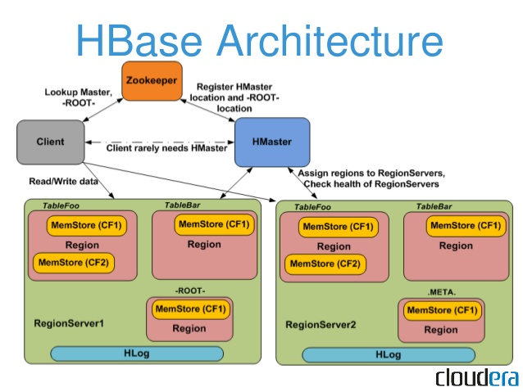

**Q3- Does Hbase support sql?**

**ANSWER:**

1. No Native Hbase Does not support Sql like advance queries.

2. To have Sql like queries you need phoenix on top of hbase.