**PROBLEM STATEMENT:**

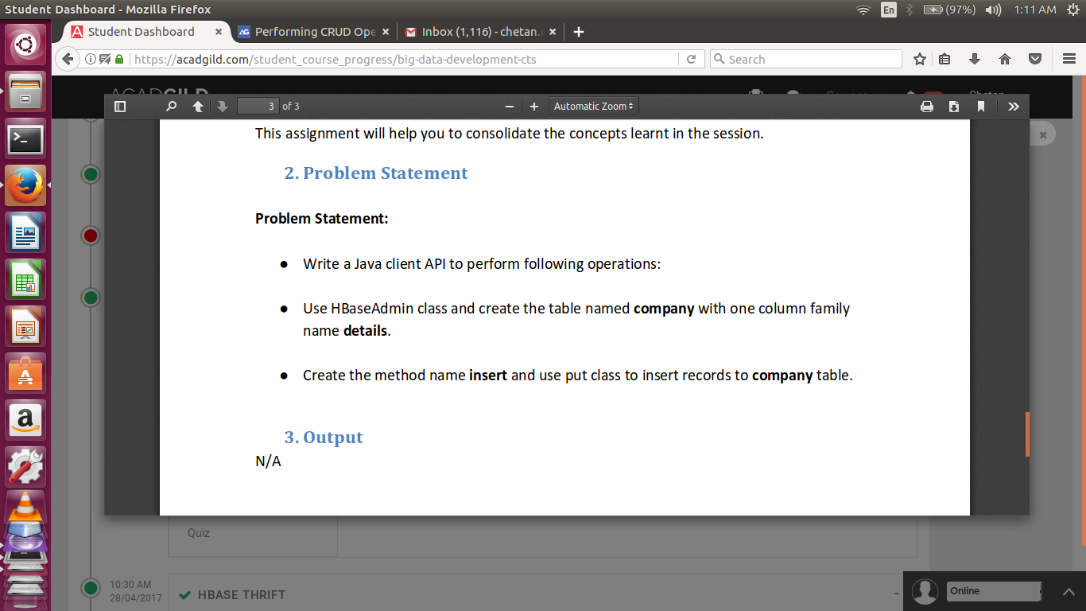

**SOLUTION:**

//CREATE TABLE FUNCTION

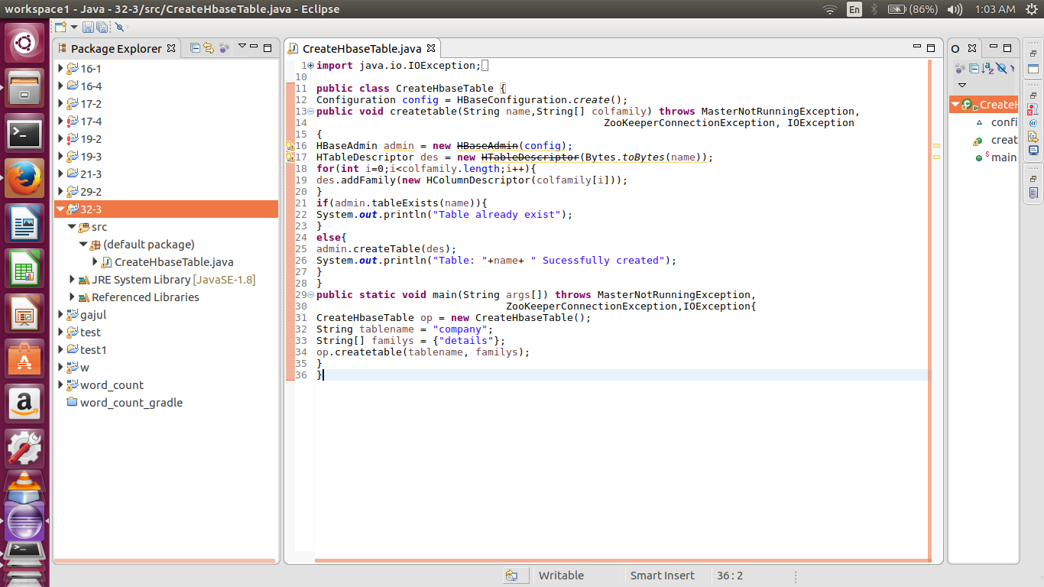

//CONSOLE OUTPUT

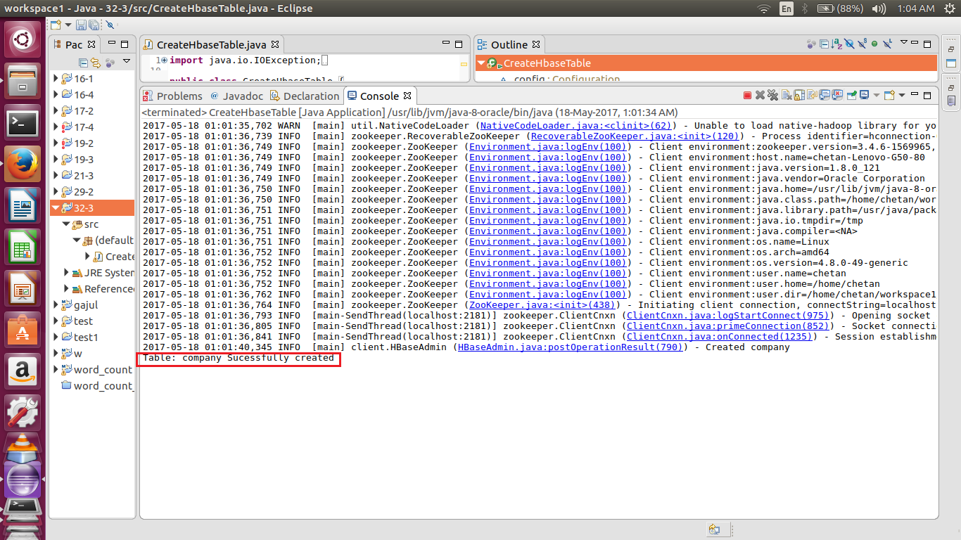

//HBASE SHELL OUTPUT

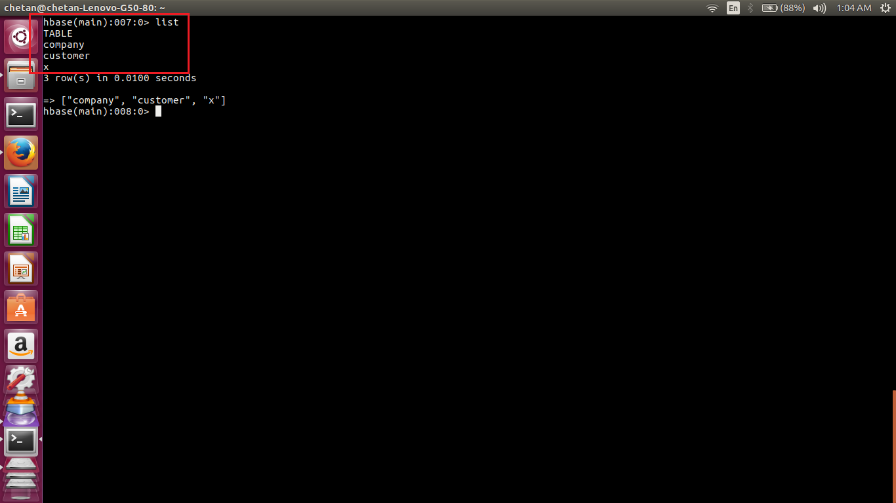

//PUT FUNCTION IN JAVA

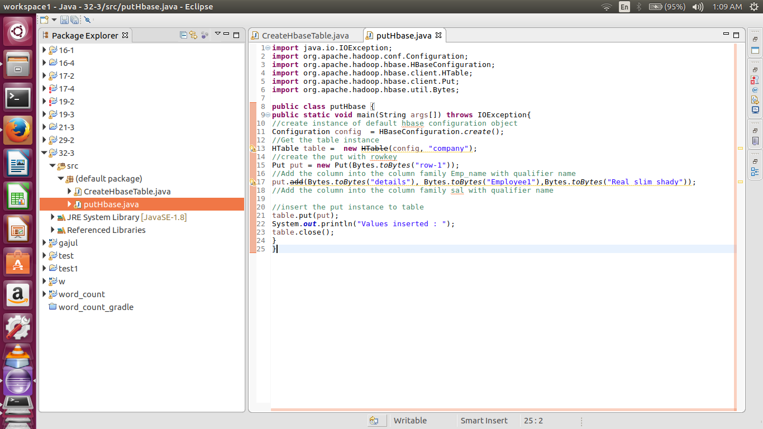

//CONSOLE OUTPUT

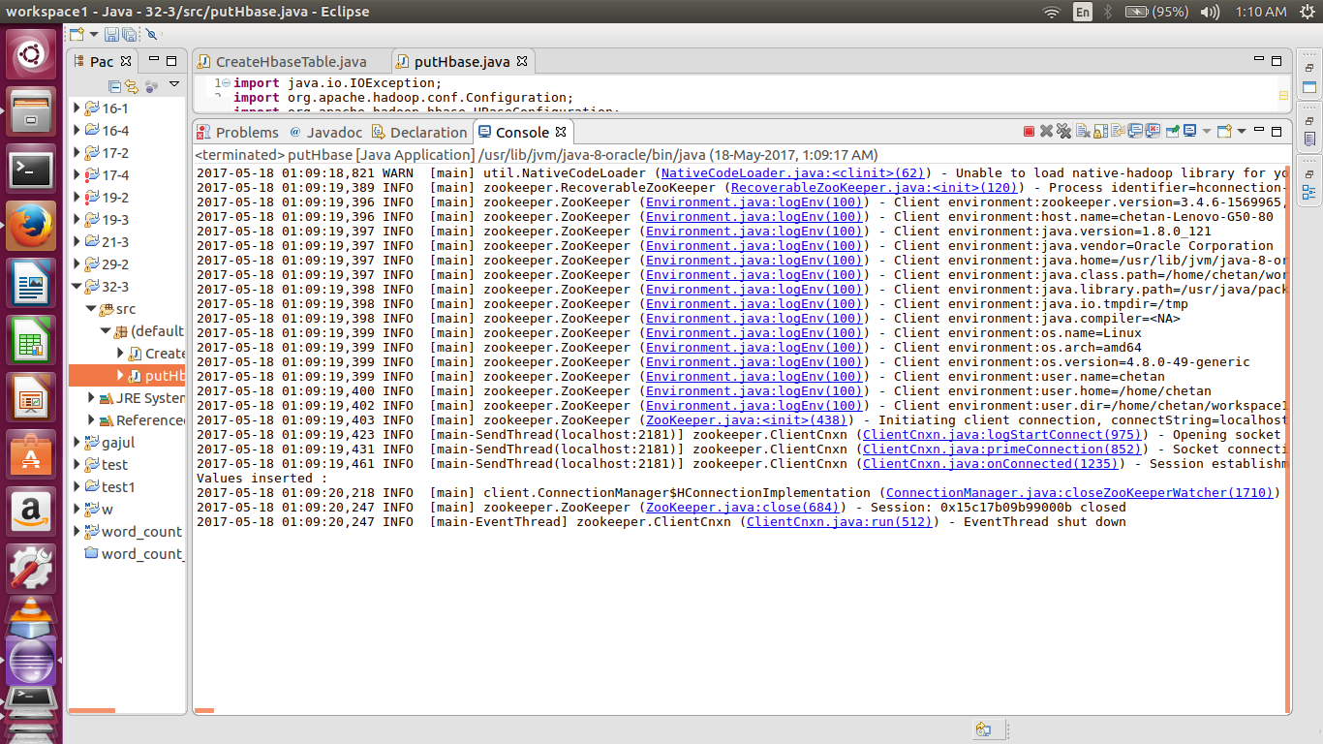

//HBASE SHELL OUTPUT

