**Problem statement:**

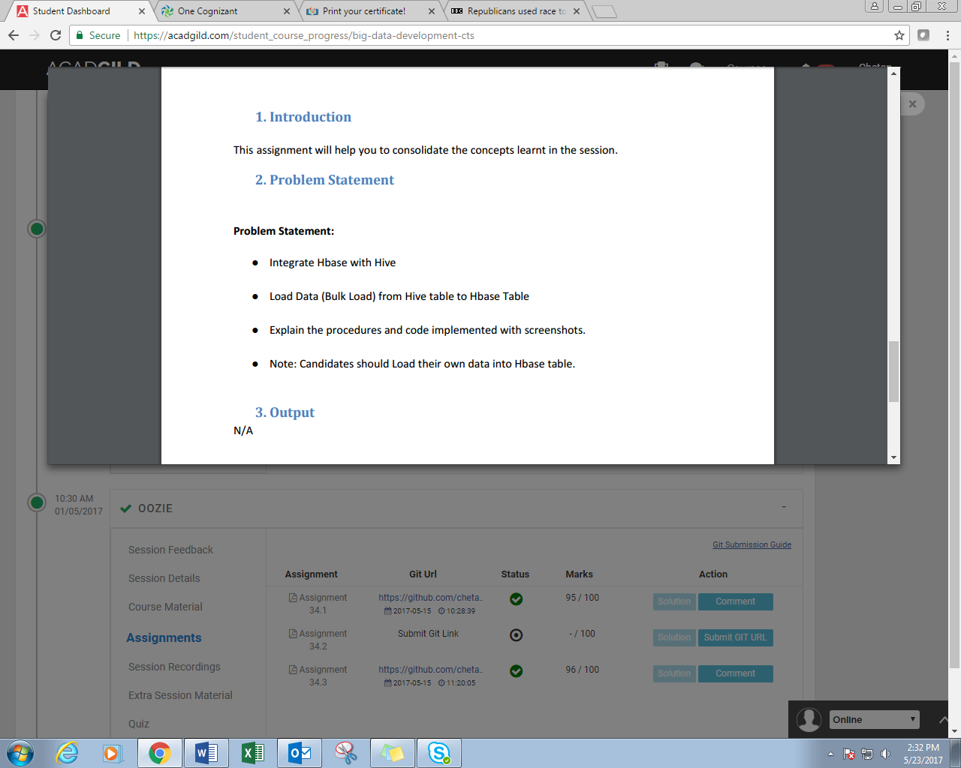

**Solution:**

**FROM HBASE TO HIVE:**

//creating table in hbase and inserting records

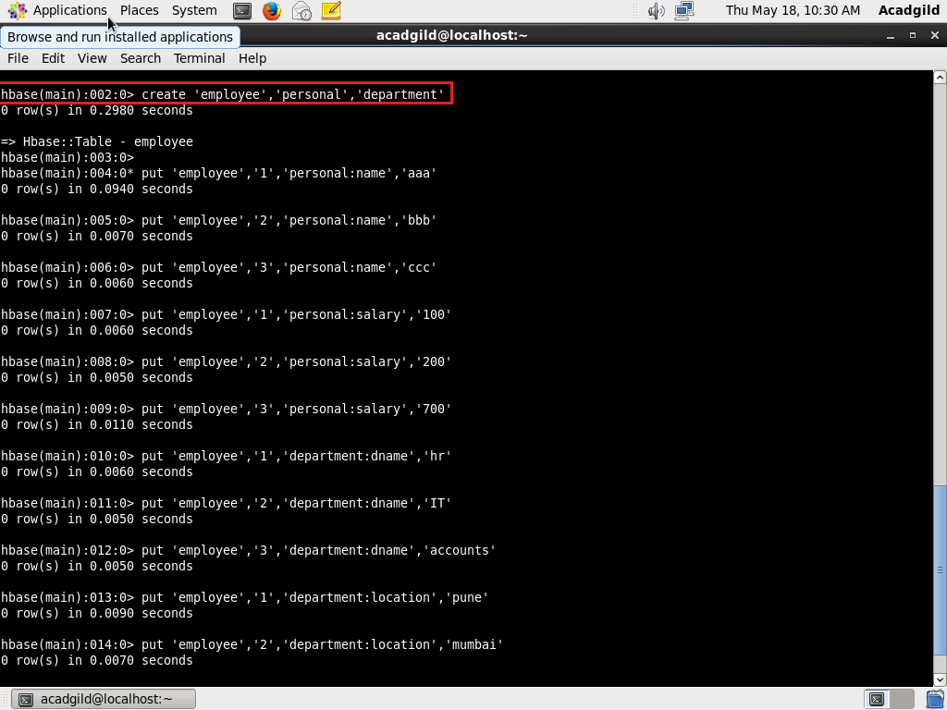

//displaying records in hbase table

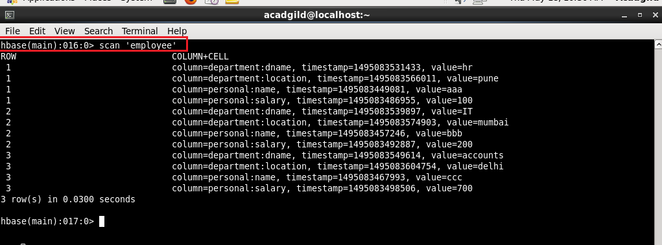

//integrating hbase and hive. Creating an external table in hive which will import data from hbase table

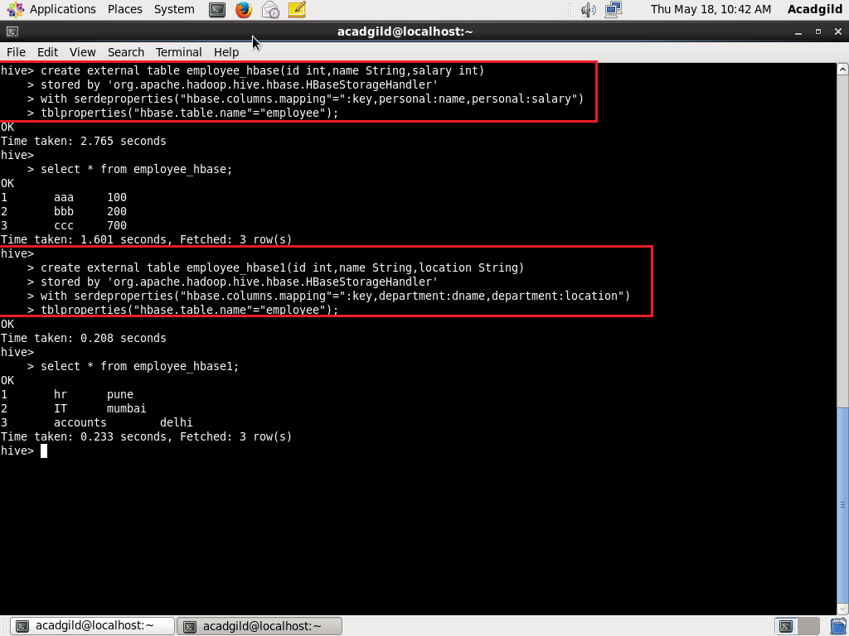

**FROM HIVE TO HBASE:**

//creating table in hbase

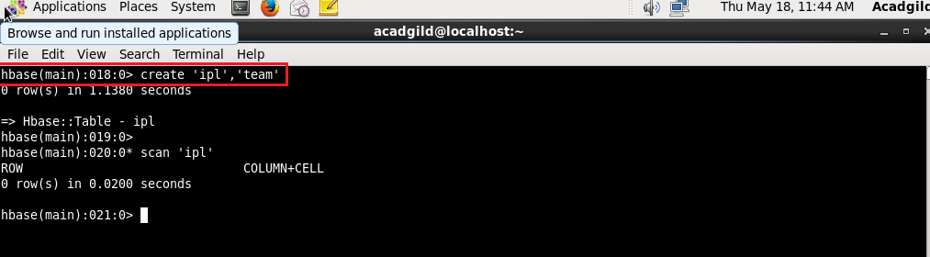

//creating table in hive so that it is integrated with hbase

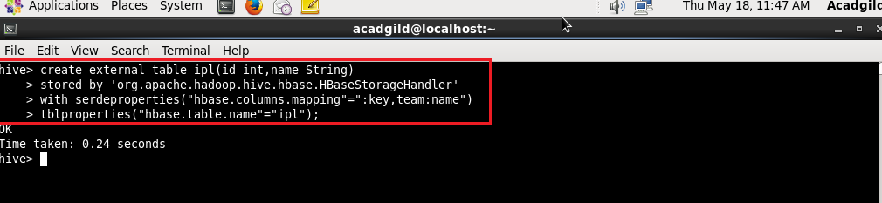

//disp[laying the contents of table in hive

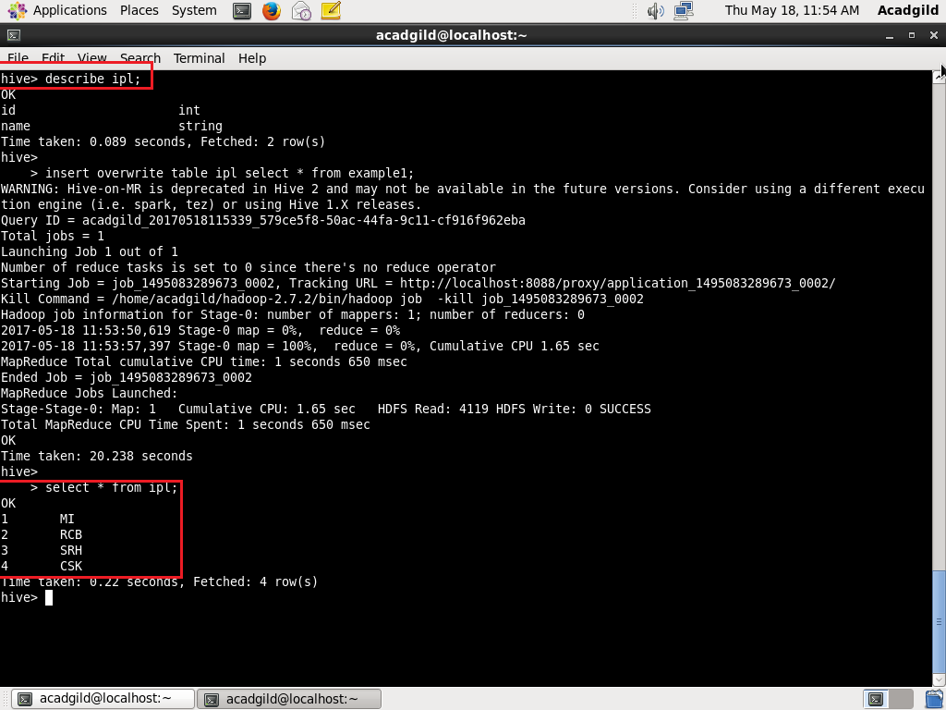

//As can be seen, the contents of the table in hive are loaded into the table in hbase

