**NOTE:**

**THE CODES ARE EXECUTED ON VIRTUAL MACHINE.AS THERE IS NO INTERNET CONNECTIVITY ON VIRTUAL MACHINE AND THE COPY PASTE OPTION FROM GUEST MACHINE TO HOST MACHINE IS DISABLED,I AM ATTACHING SCREENSHOTS OF PROGRAMS.**

Q1-Write a Java program to list down all the files inside a directory and its sub-directories who have last modified timestamp between the start_ts and end_ts passed as an argument. The default value of start_ts is 0 and for end_ts is infinite.

Program:

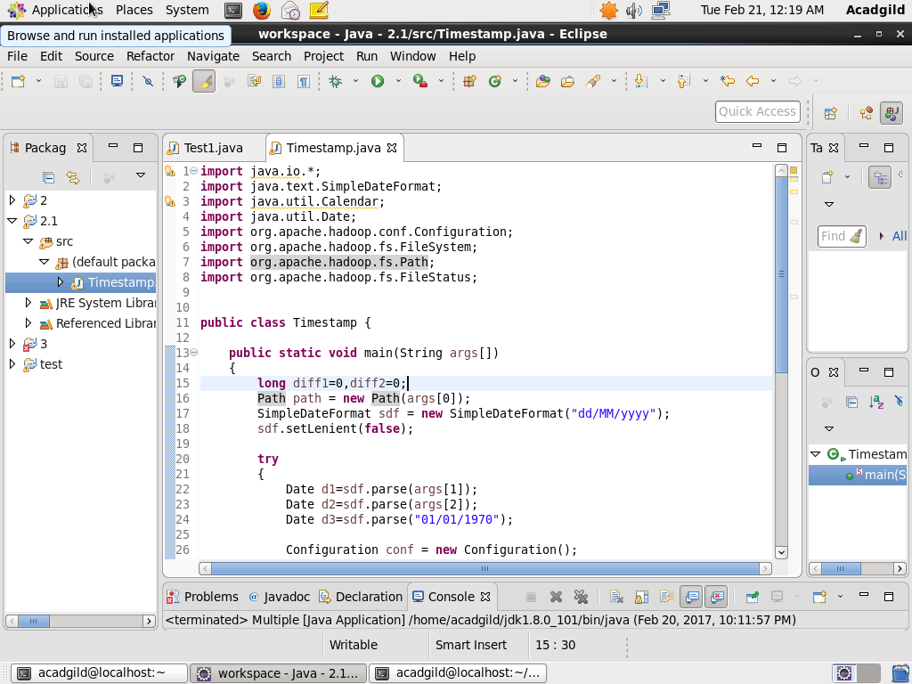

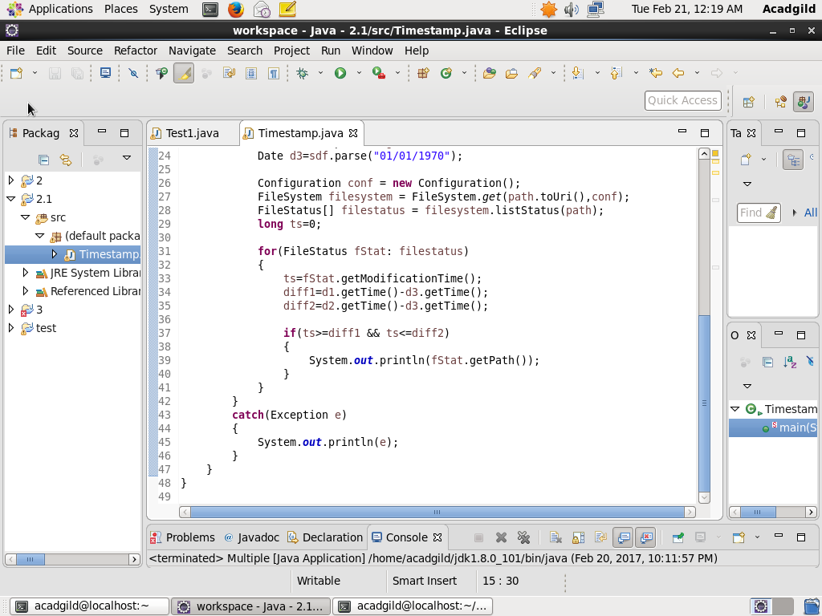

Output:

