Q1-Write a Java program to display the content of a file in HDFS on screen.

PROGRAM:

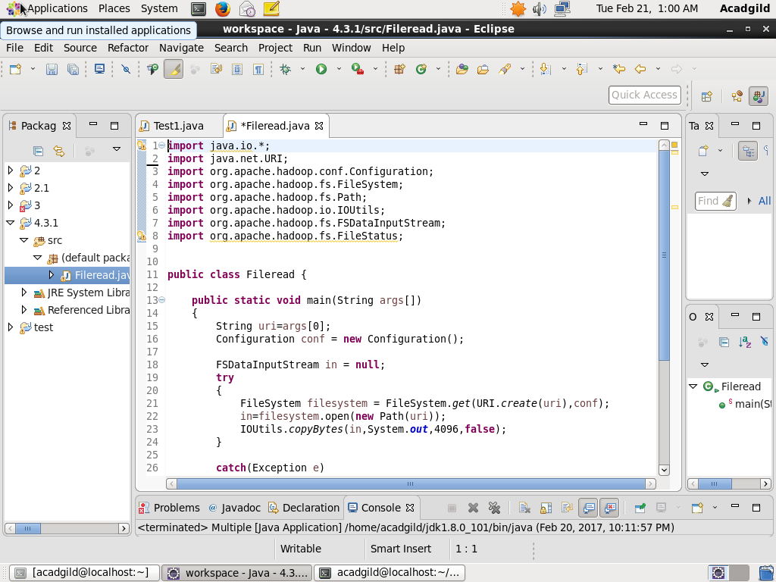

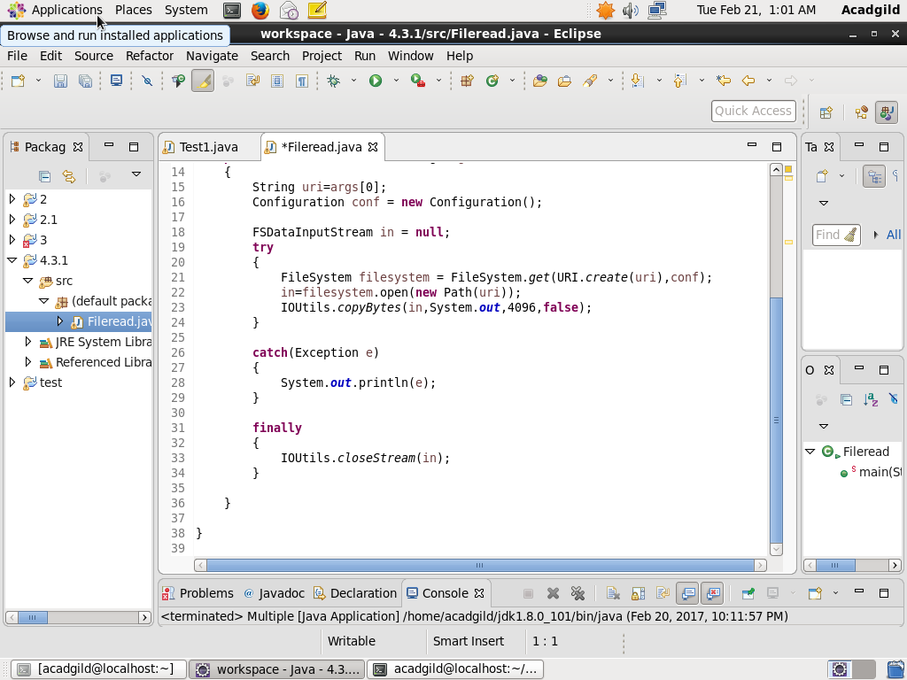

OUTPUT:

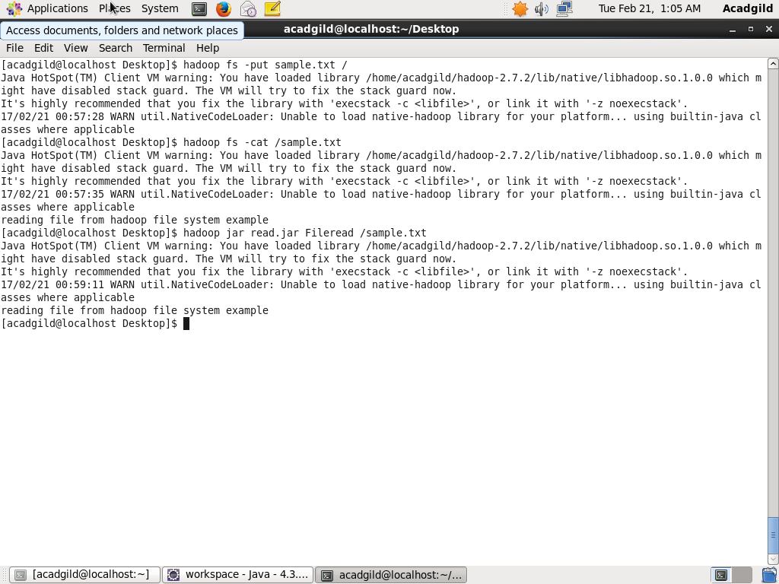

Q2-Write a Java program to copy a file from local filesystem to HDFS.

PROGRAM:

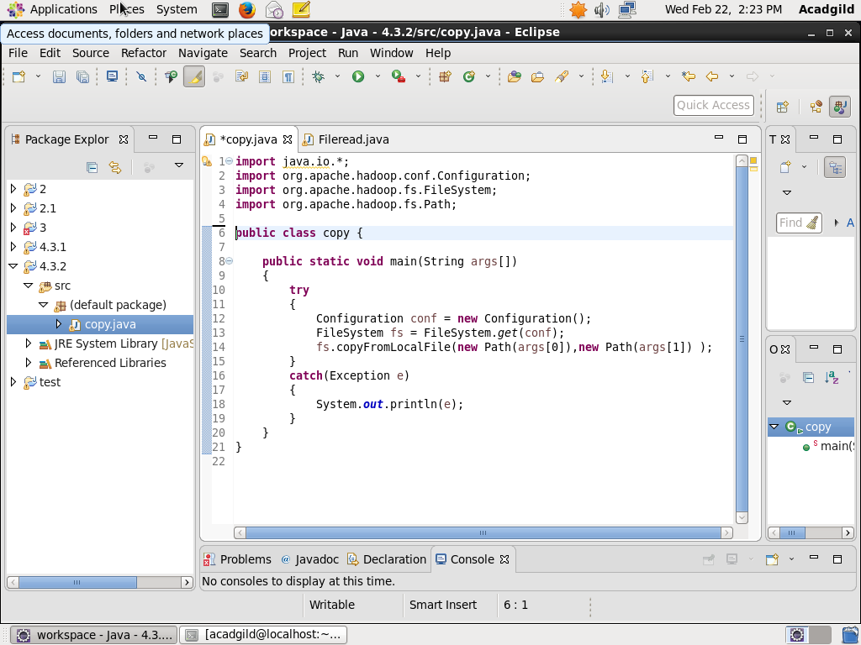

OUTPUT:

