PROBLEM STATEMENT:

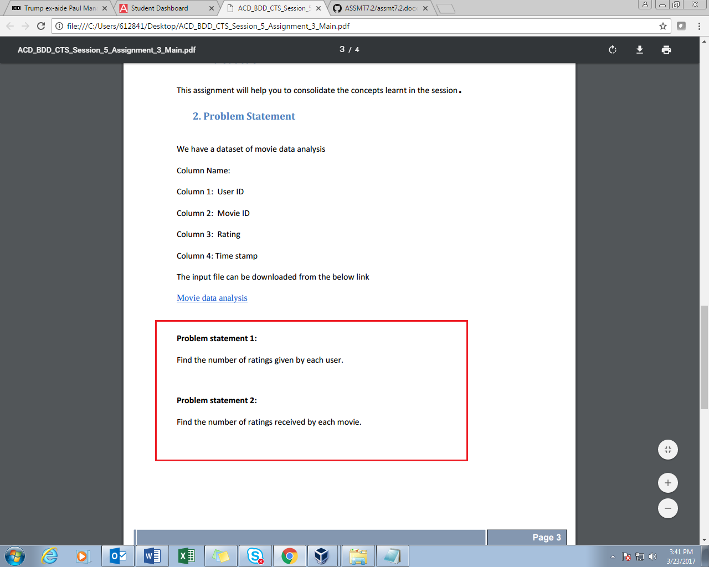

**NOTE:**

**SINCE THE OUTPUT FOR THIS CODE IS HUGE, FINAL OUTPUT IS ATTACHED AS 2 TEXT FILES**

**1. 5-3-1OP.TXT**

**2. 5-3-2OP.TXT**

SOLUTION-1:

PROGRAM:

DRIVER

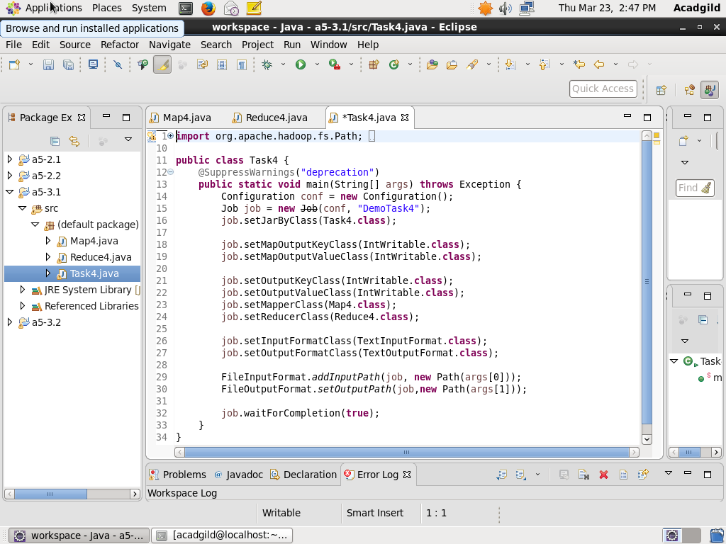

MAPPER

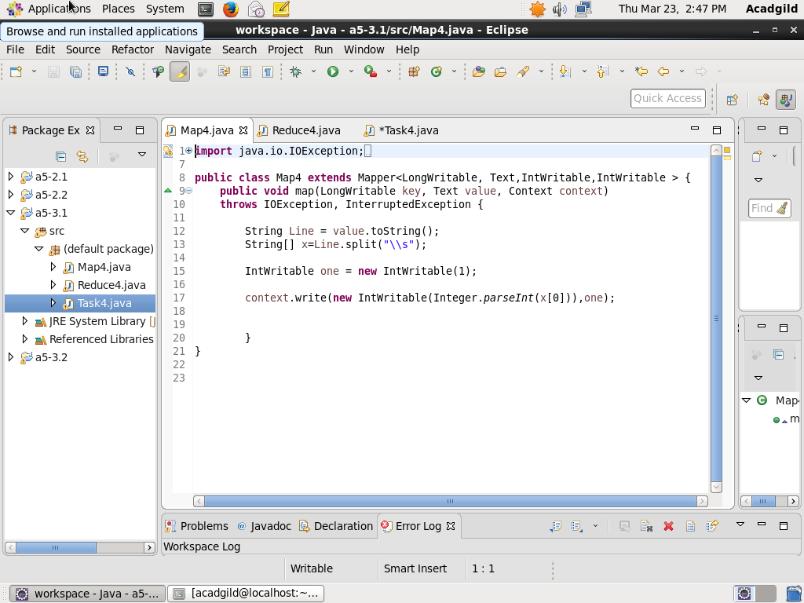

REDUCER:

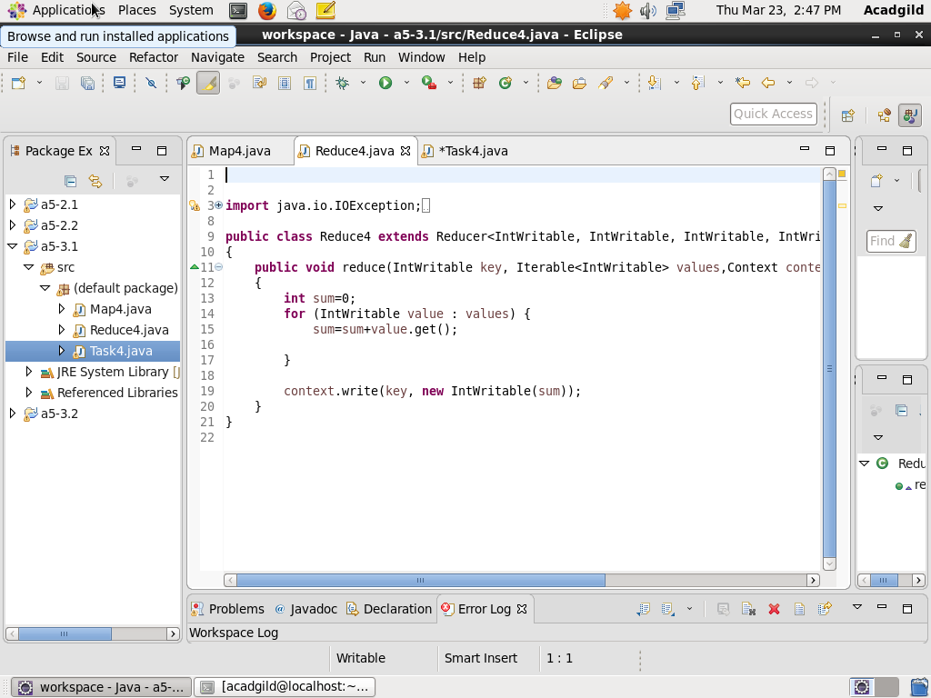

OUTPUT:

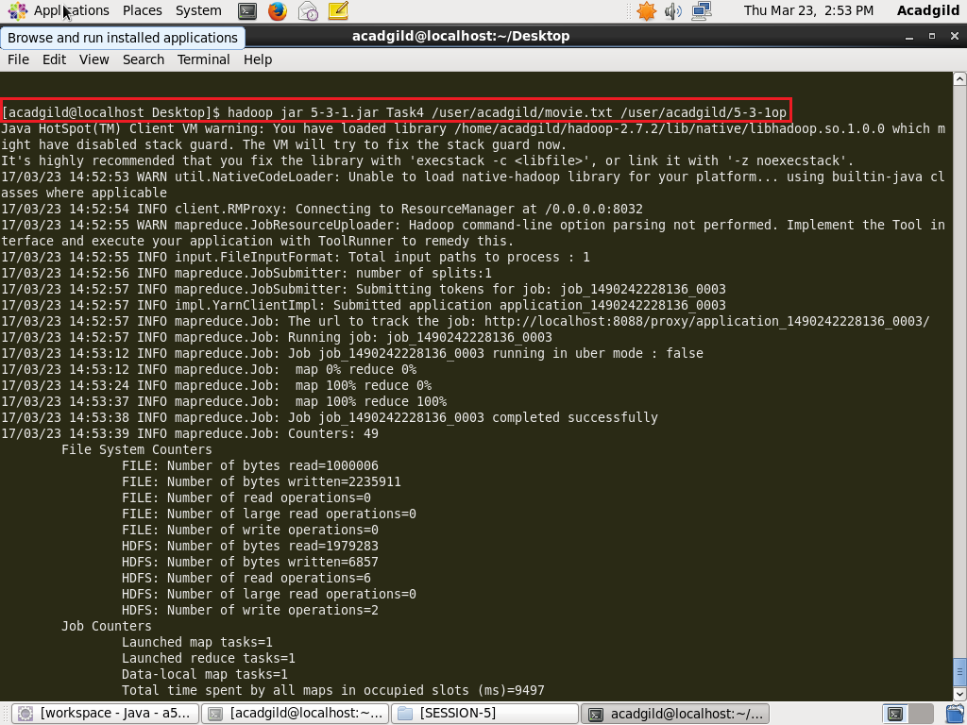

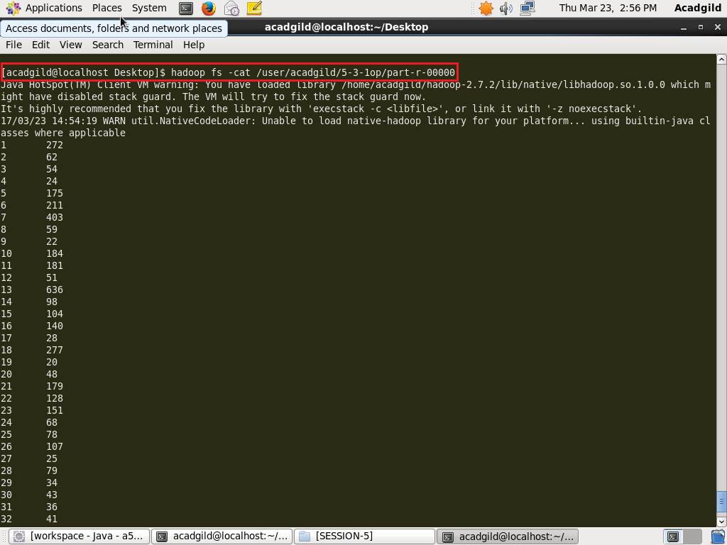

SOLUTION-2:

PROGRAM:

DRIVER

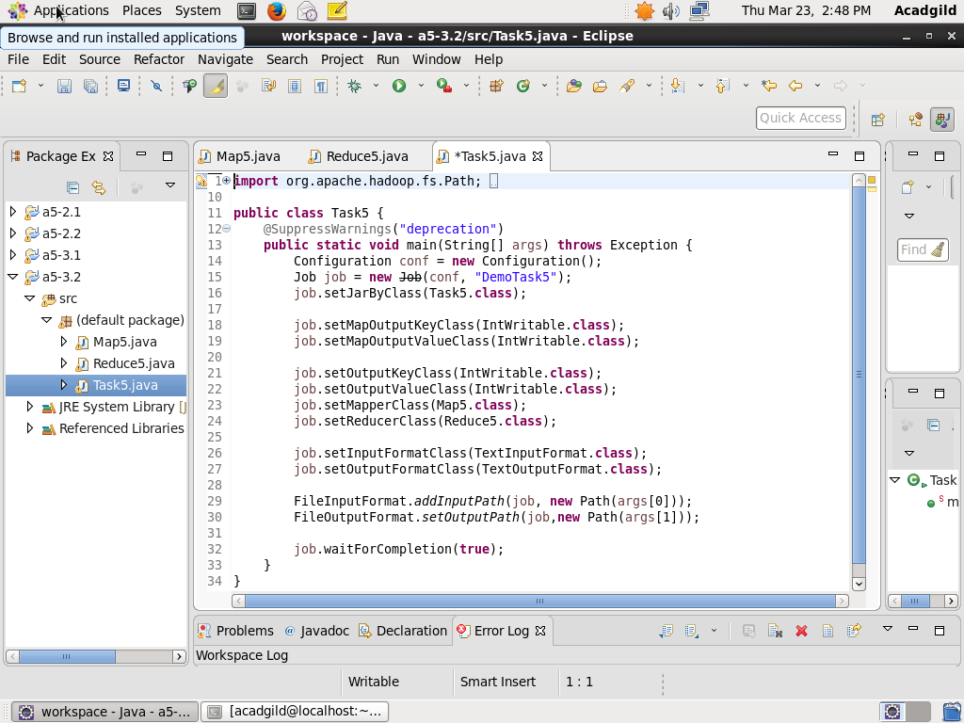

MAPPER

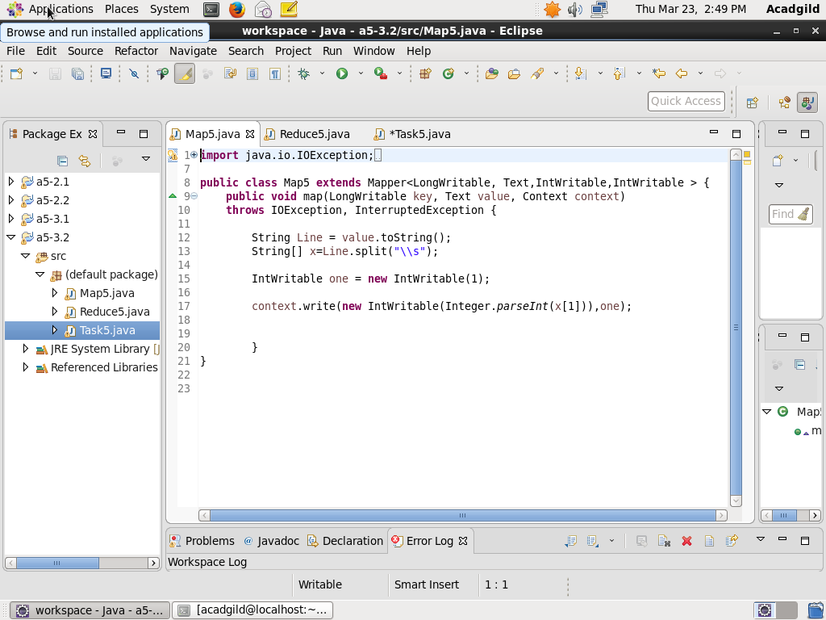

REDUCER:

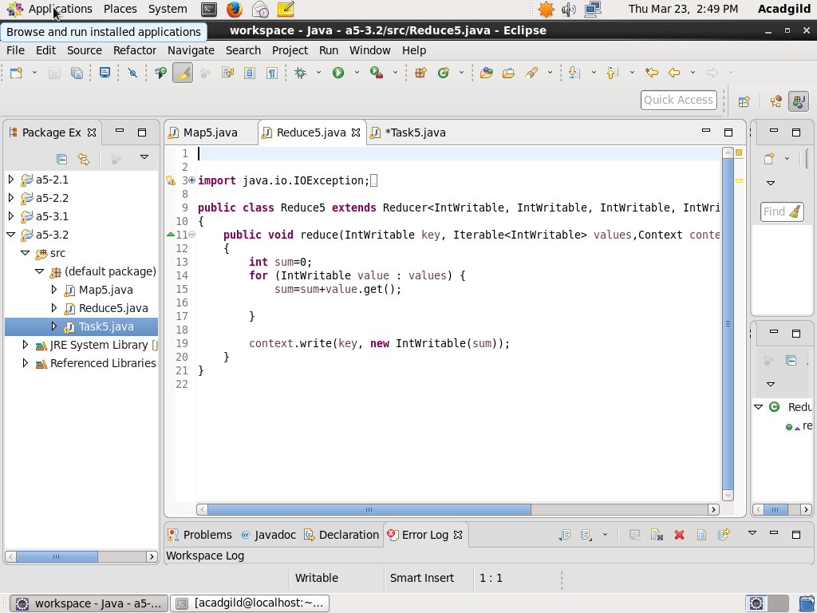

OUTPUT:

