**Titanic Data Analysis**

**Write a mapreduce program to find out number of males and females survived in the titanic tragedy. Download the Titanic data set from the below link Titanic_Dataset**

**DATA SET DESCRIPTION**

**Column 1 : PassengerId**

**Column 2 : Survived (survived=0 & died=1)**

**Column 3 : Pclass**

**Column 4 : Name**

**Column 5 : Sex**

**Column 6 : Age**

**Column 7 : SibSp**

**Column 8 : Parch**

**Column 9 : Ticket**

**Column 10 : Fare**

**Column 11 : Cabin**

**Column 12 : Embarked**

**Program:**

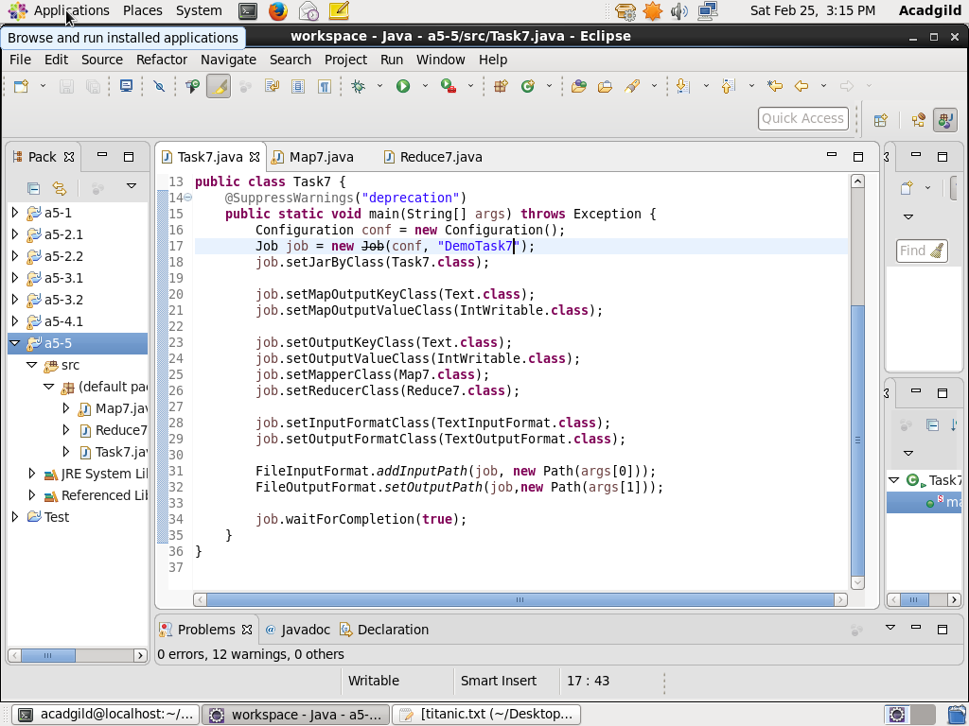

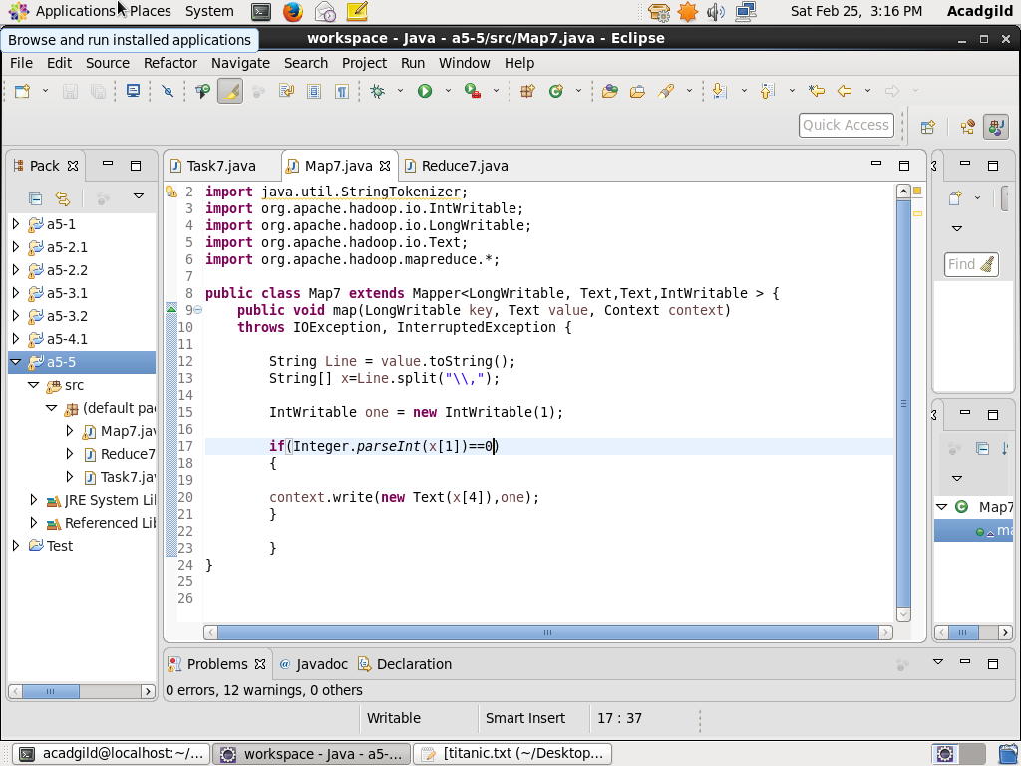

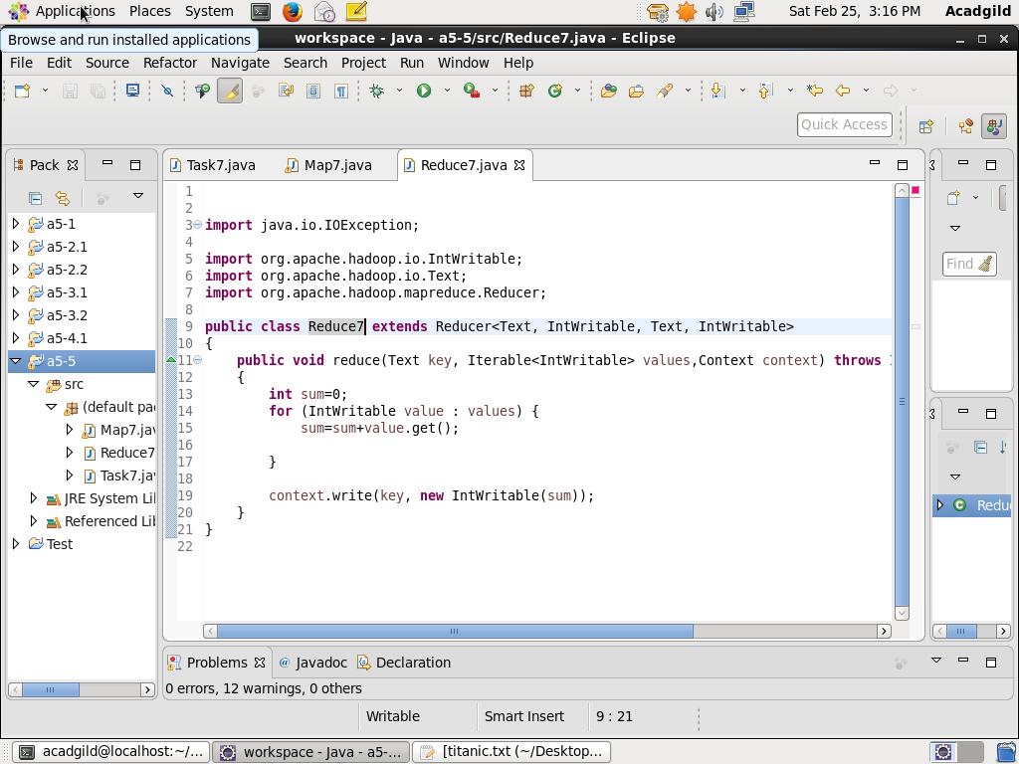

**Output:**

