**We have a dataset of sales of different TV sets across different locations. Records look like: Samsung|Optima|14|Madhya Pradesh|132401|14200**

**The fields are arranged like:**

**Company Name|Product Name|Size in inches|State|Pin Code|Price sales_differentTV : https://github.com/prateekATacadgild/DatasetsForCognizant/blob/master/sales_differentTV.txt**

**There are some invalid records which contain 'NA' in either Company Name or Product Name.**

**Dataset:**

Samsung|Optima|14|Madhya Pradesh|132401|14200

Onida|Lucid|18|Uttar Pradesh|232401|16200

Akai|Decent|16|Kerala|922401|12200

Lava|Attention|20|Assam|454601|24200

Zen|Super|14|Maharashtra|619082|9200

Samsung|Optima|14|Madhya Pradesh|132401|14200

Onida|Lucid|18|Uttar Pradesh|232401|16200

Onida|Decent|14|Uttar Pradesh|232401|16200

Onida|NA|16|Kerala|922401|12200

Lava|Attention|20|Assam|454601|24200

Zen|Super|14|Maharashtra|619082|9200

Samsung|Optima|14|Madhya Pradesh|132401|14200

NA|Lucid|18|Uttar Pradesh|232401|16200

Samsung|Decent|16|Kerala|922401|12200

Lava|Attention|20|Assam|454601|24200

Samsung|Super|14|Maharashtra|619082|9200

Samsung|Super|14|Maharashtra|619082|9200

Samsung|Super|14|Maharashtra|619082|9200

The output of 5.1 will be input dataset for this question ( i.e. all records containing NA have been eliminated) . A screenshot is attached below:

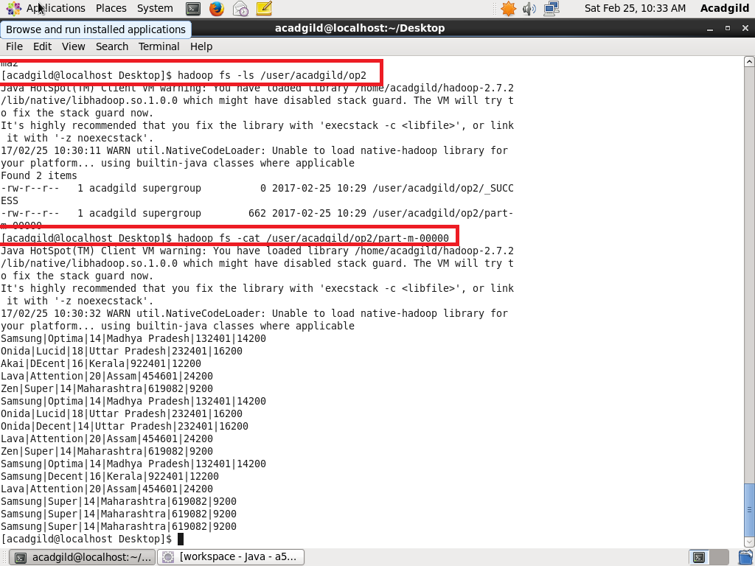

**Sales of different TV Task 2:**

**Write a MapReduce program to calculate the total units sold for each Company.**

**PROGRAM:**

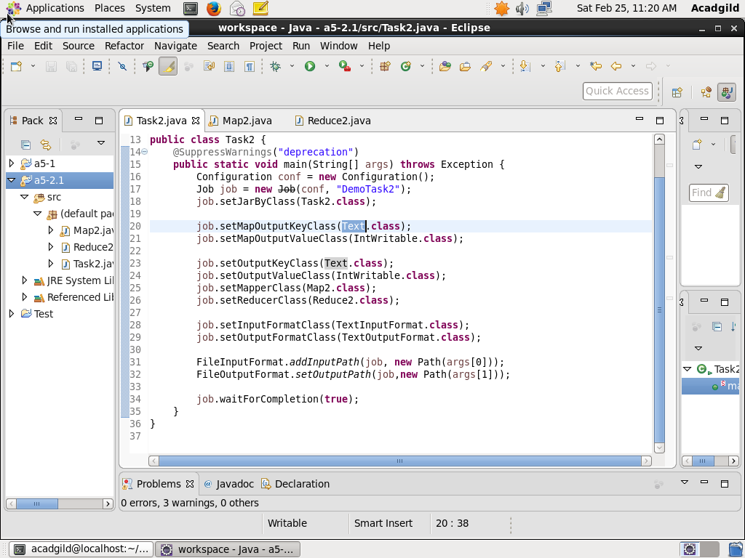

This is the driver class where all the configurations like setting the Mapper Class, Reducer Class, input format, output format etc. are set

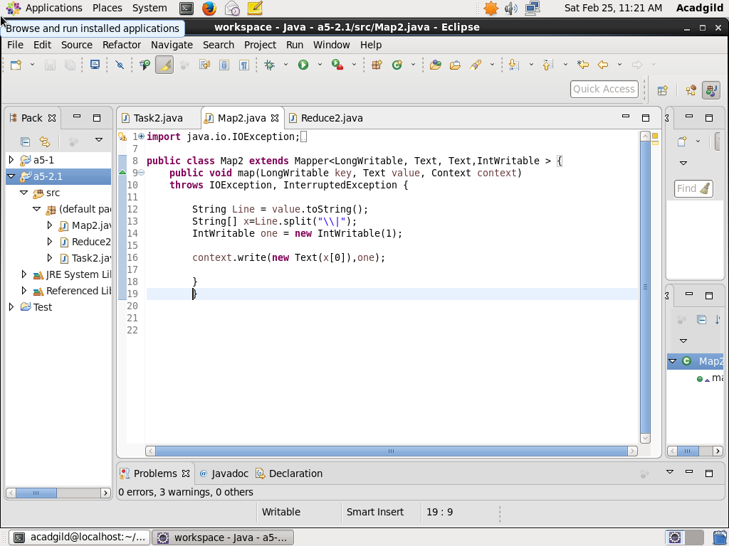

This is the map2 class which segregates the data. It extends the Mapper class and overrides the Map method

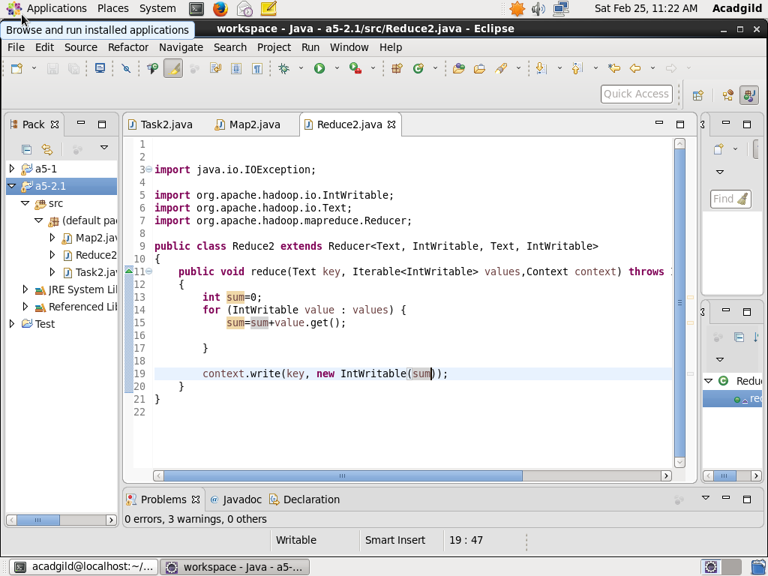

This is the Reduce2 class which aggregates the data. It extends the Reducer class and overrides the Reduce method.

**OUTPUT:**

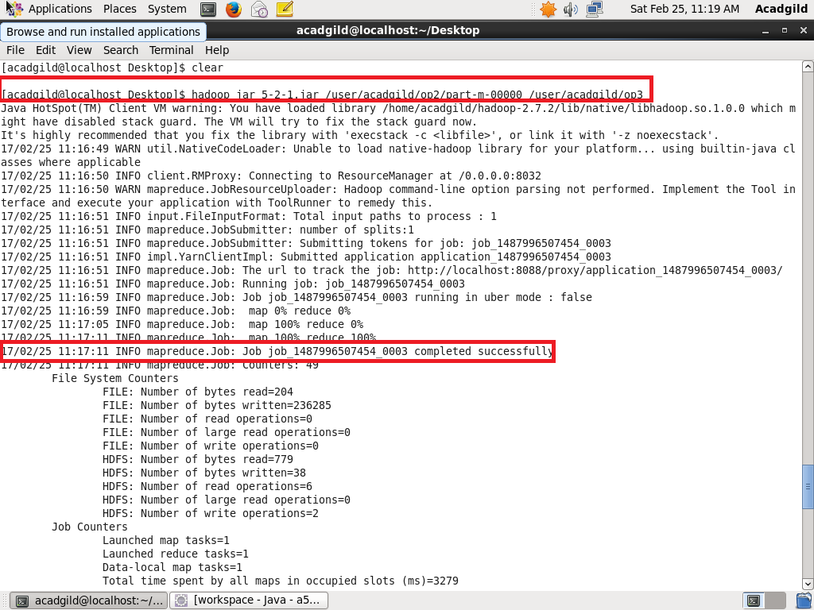

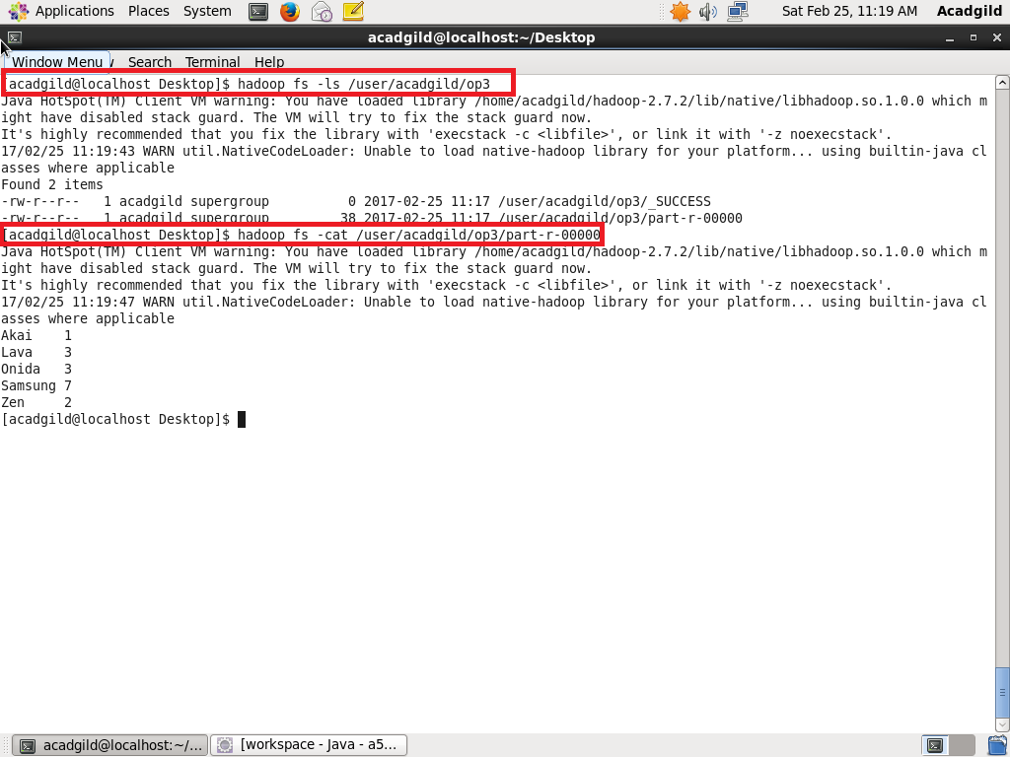

**Sales of different TV Task 3:**

**Write a MapReduce program to calculate the total units sold in each state for Onida company.**

**PROGRAM:**

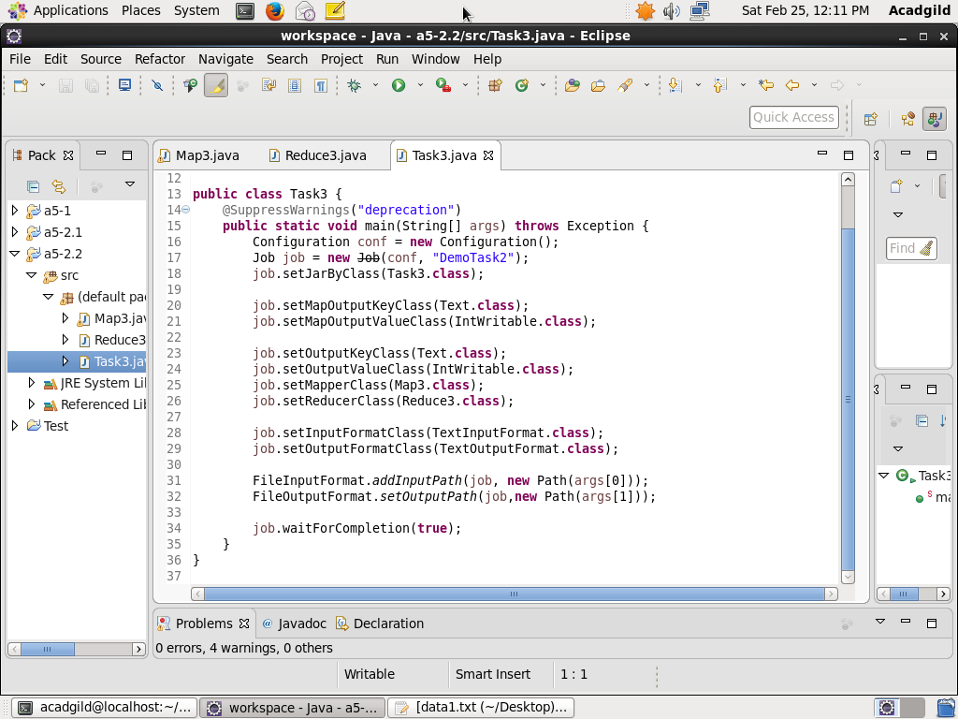

This is the driver class where all the configurations like setting the Mapper Class, Reducer Class, input format, output format etc. are set

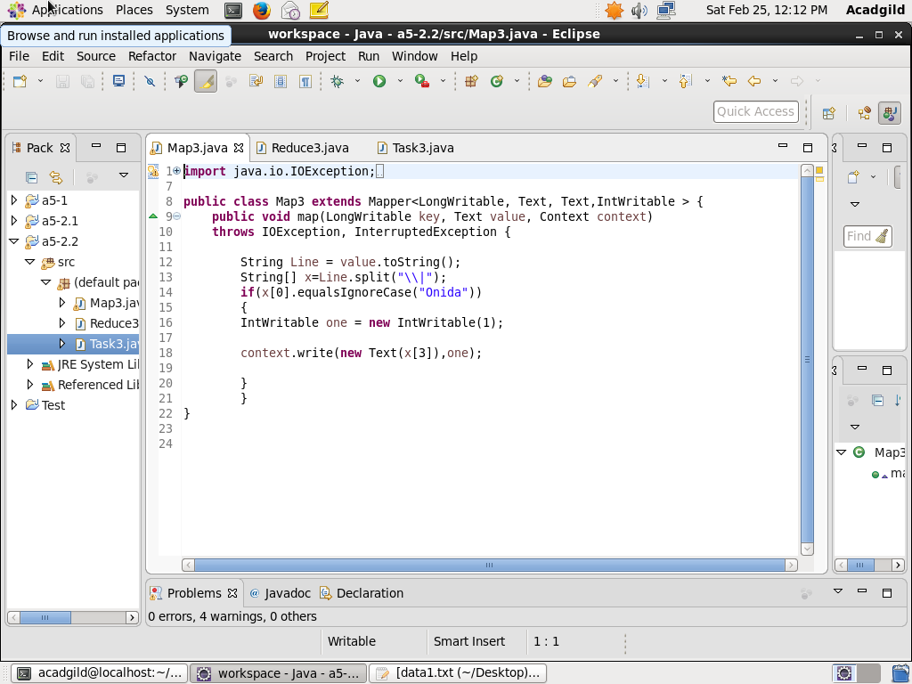

This is the map3 class which segregates the data. It extends the Mapper class and overrides the Map method

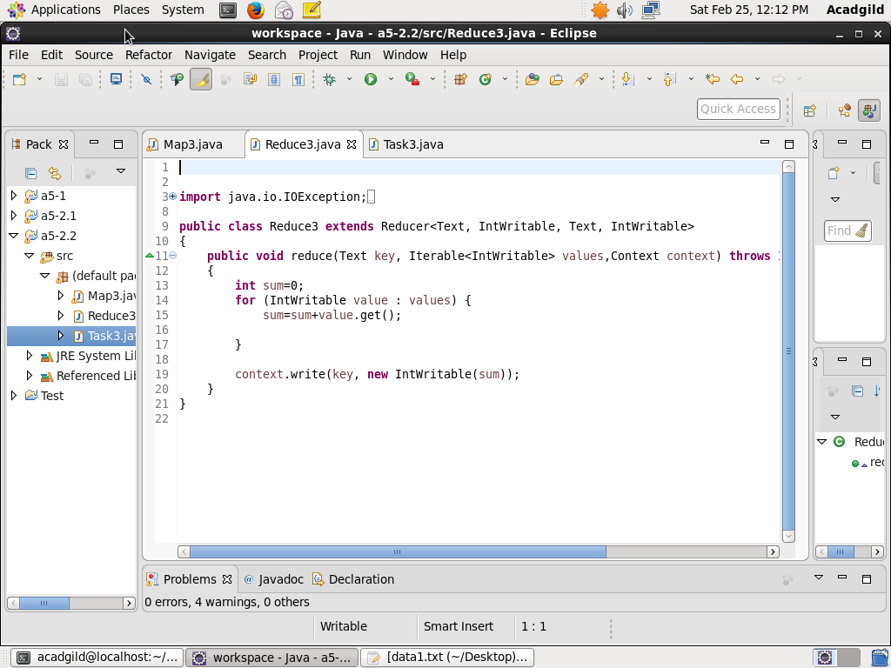

This is the Reduce2 class which aggregates the data. It extends the Reducer class and overrides the Reduce method.

**OUTPUT:**

