**Problem Statement**

We have a dataset of travel data analysis

Column Name:

Column 1: City pair (Combination of from and to): String

Column 2: From location: String

Column 3: To Location: String

Column 4: Product type: Integer (1=Air, 2=Car, 3 =Air+Car, 4 =Hotel, 5=Air+Hotel, 6=Hotel +Car,

7 =Air+Hotel+Car)

Column 5: Adults traveling: Integer

Column 6: Seniors traveling: Integer

Column 7: Children traveling: Integer

Column 8: Youth traveling: Integer

Column 9: Infant traveling: Integer

Column 10: Date of travel: String

Column 11: Time of travel: String

Column 12: Date of Return: String

Column 13: Time of Return: String

Column 14: Price of booking: Float

Column 15: Hotel name: String

Problem statement 1:

Find out how many people has chosen their destination as MIA and MCO

Problem statement 2:

Find out the number of people undertaken the trips from the places MIA and HOU

Problem statement 3:

Find out how many people has chosen airline mode of travel for the places LAS and LAX

**SOLUTION:**

For this problem, instead of creating separate project for every task, all 3 tasks are implemented in a single project. So this project has 3 Mapper classes and 1 Reducer class as the functionality of reducer is the same for every task. Also, the driver class has 3 Job objects corresponding to 3 MapReduce jobs which are being executed.

**PROGRAM:**

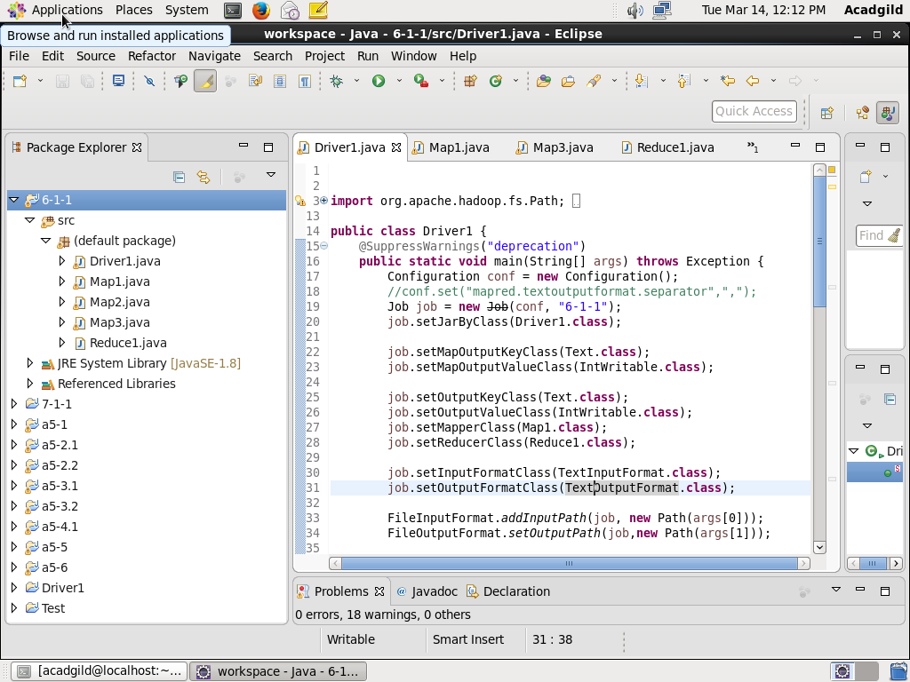

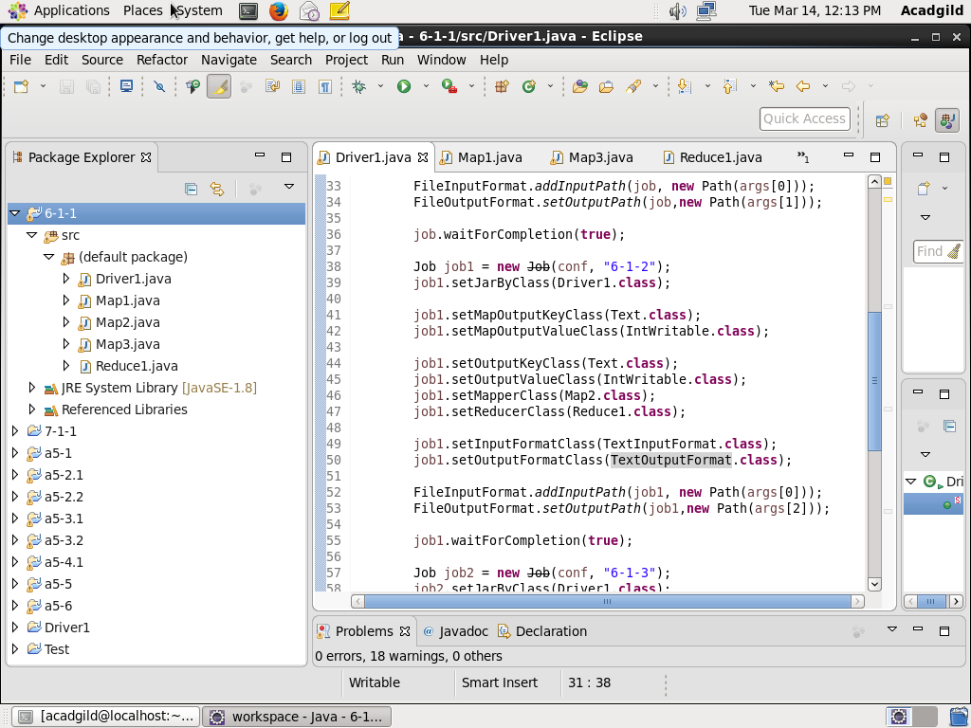

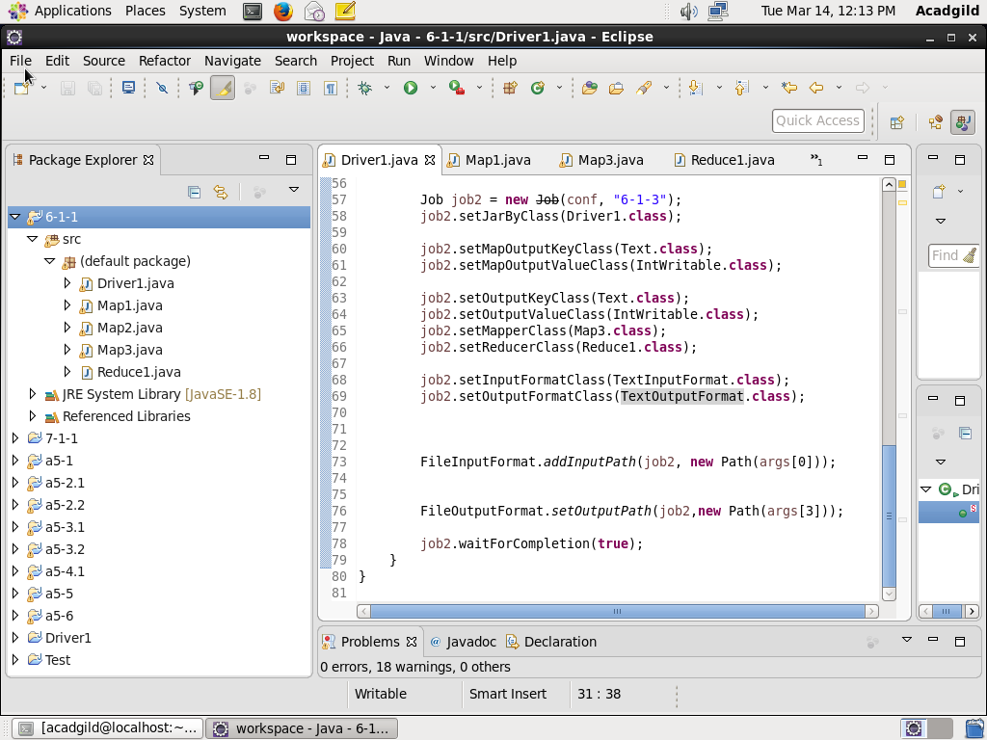

This is the driver class where all configurations are set. There are 3 Job objects namely job, job1, job2 corresponding to 3 tasks in this problem statement.

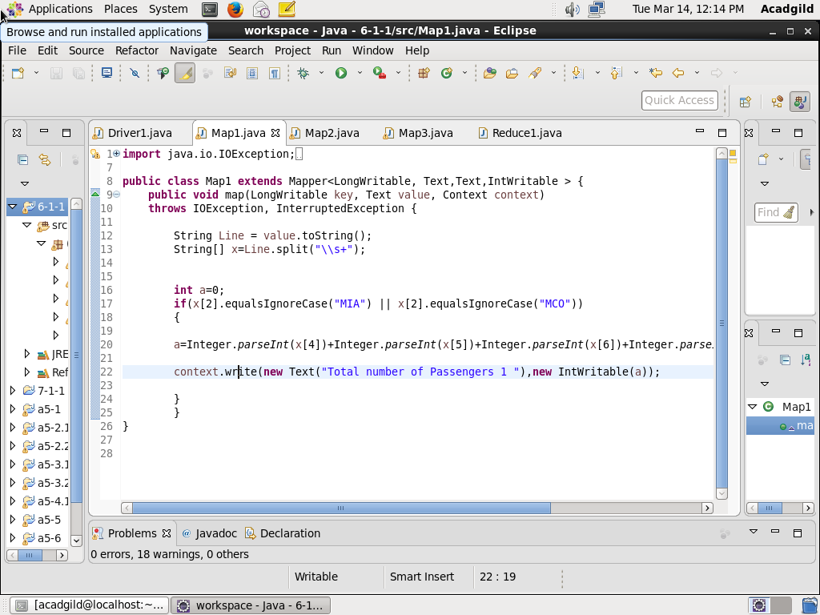

First Mapper class.

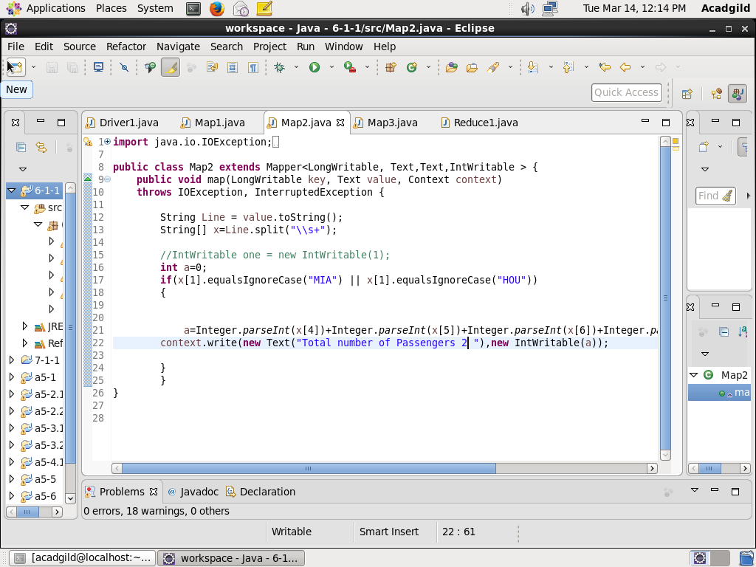

Second Mapper Class.

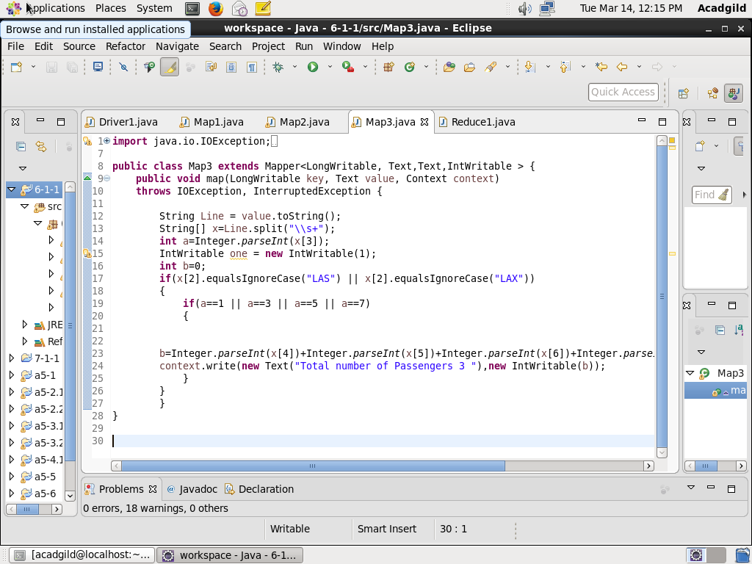

Third Mapper class.

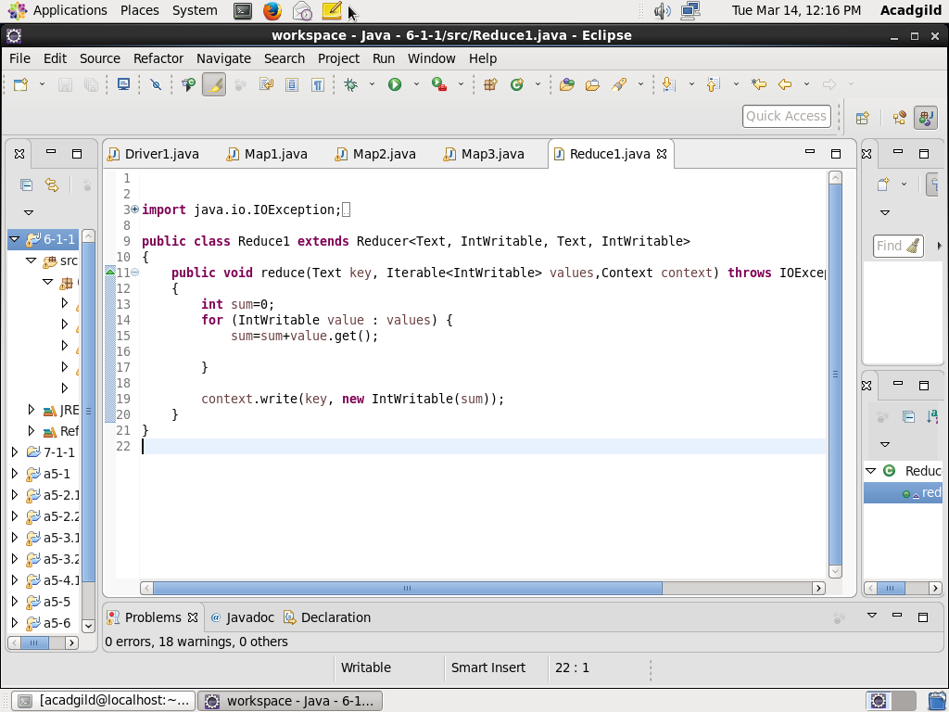

Reducer class

**Output:**

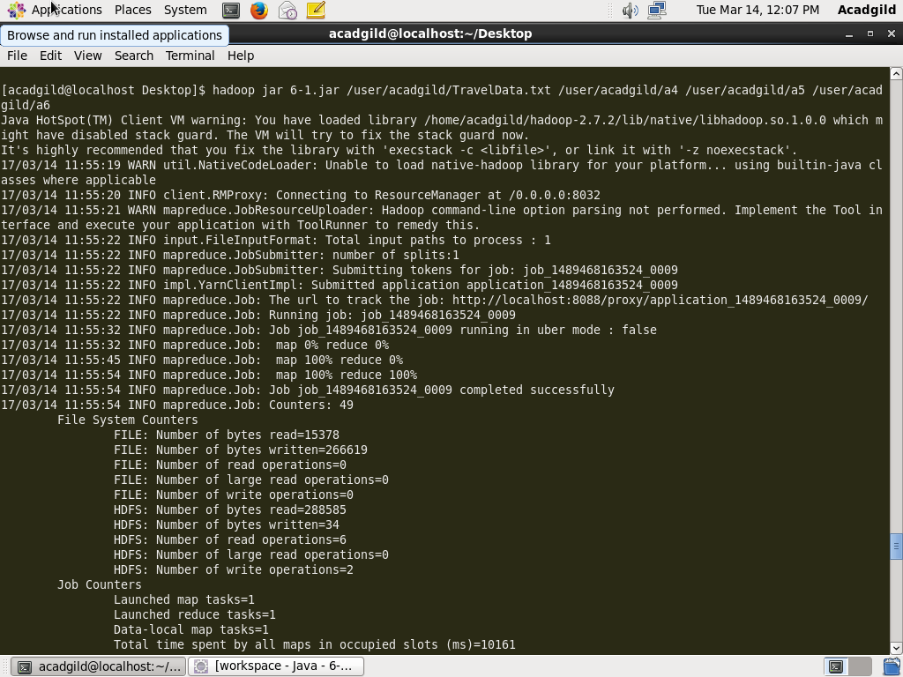

**While executing jar file, 4 arguments are given.**

**1st argument is the path of input file.**

**2, 3 and 4 are output directories for 3 Map Reduce tasks which are being executed.**

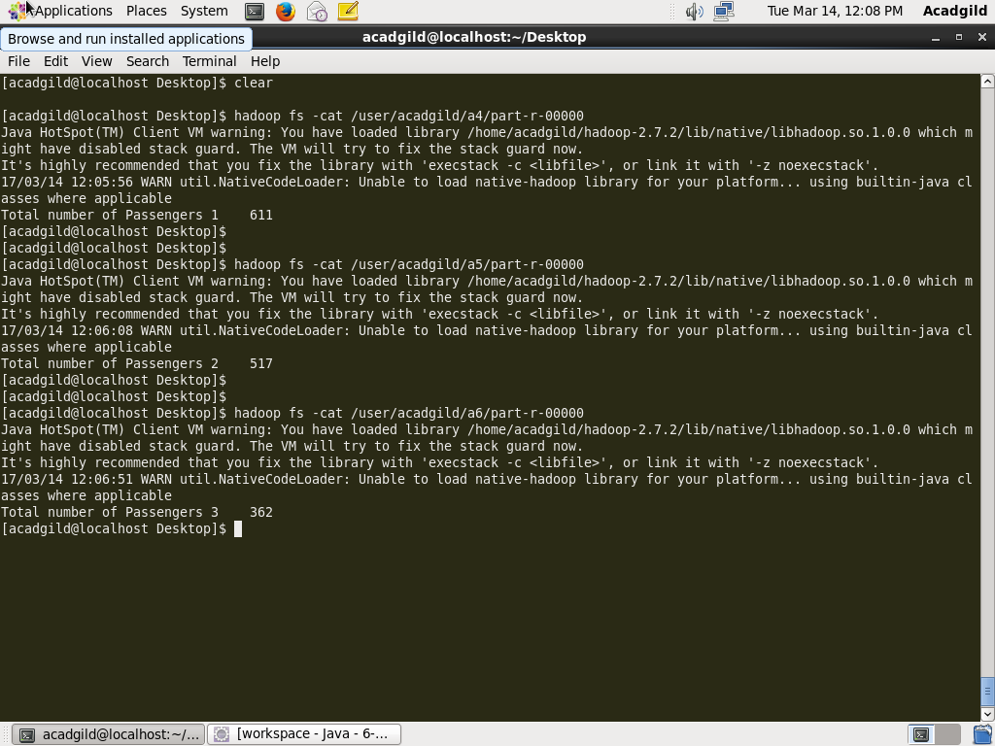

**Displaying the output of all 3 map reduce jobs using cat command.**