**PROBLEM STATEMENT:**

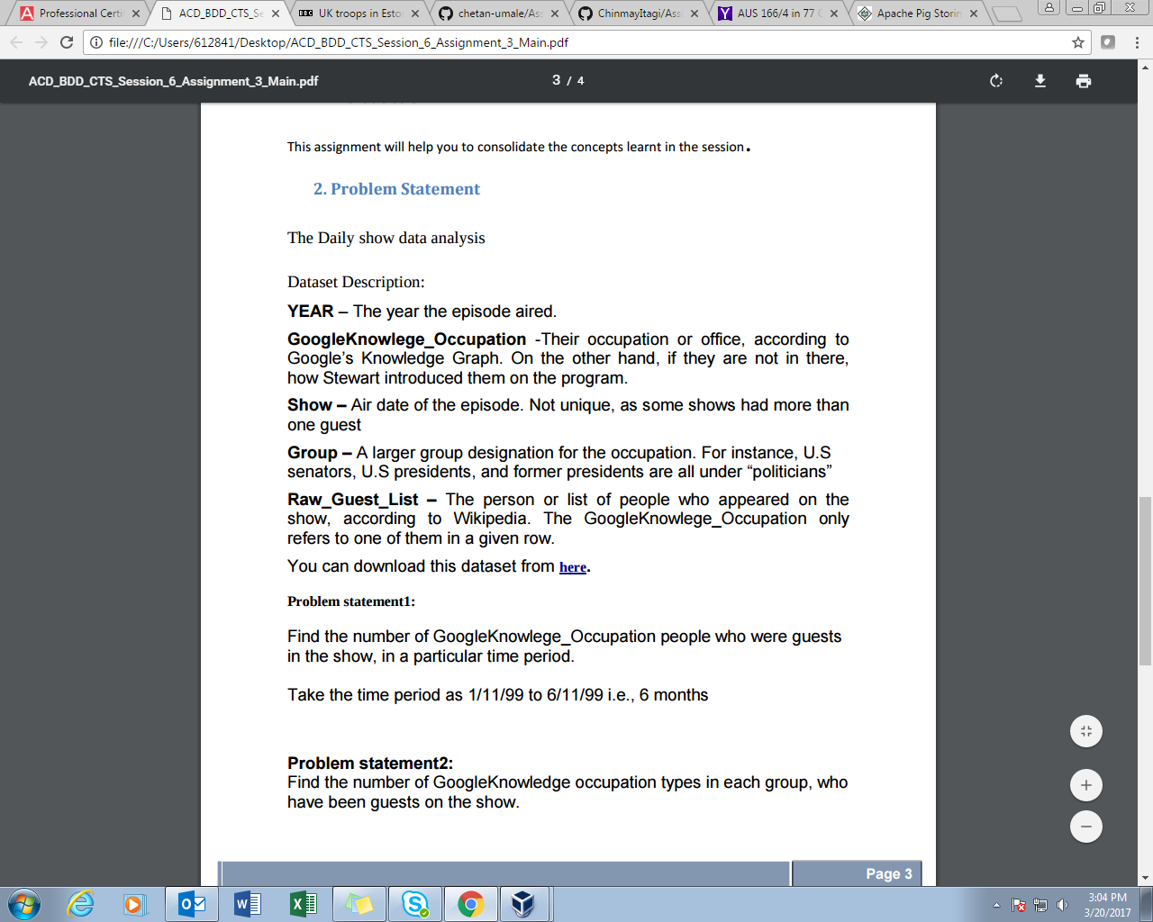

**SOLUTION:**

For this problem, instead of creating separate project for every task, both the tasks are implemented in a single project. So this project has 2 Mapper classes and 2 Reducer classes. Also, the driver class has 2 Job objects corresponding to 2 MapReduce jobs which are being executed.

**DRIVER CLASS**

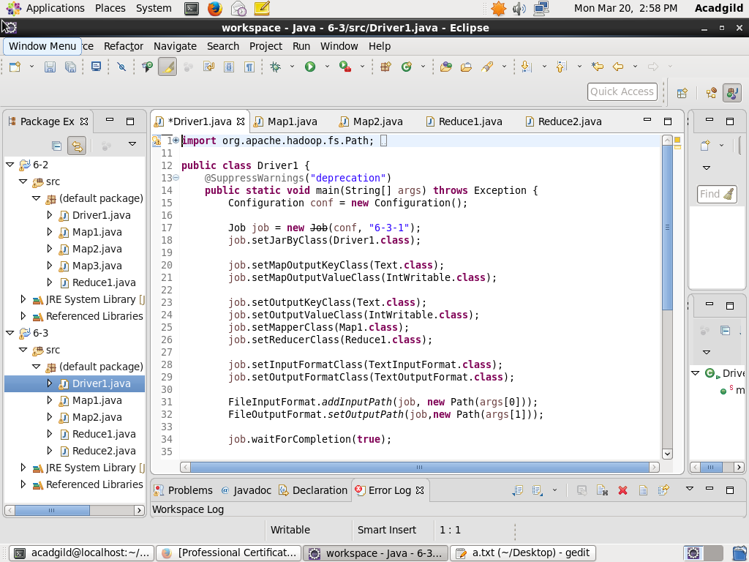

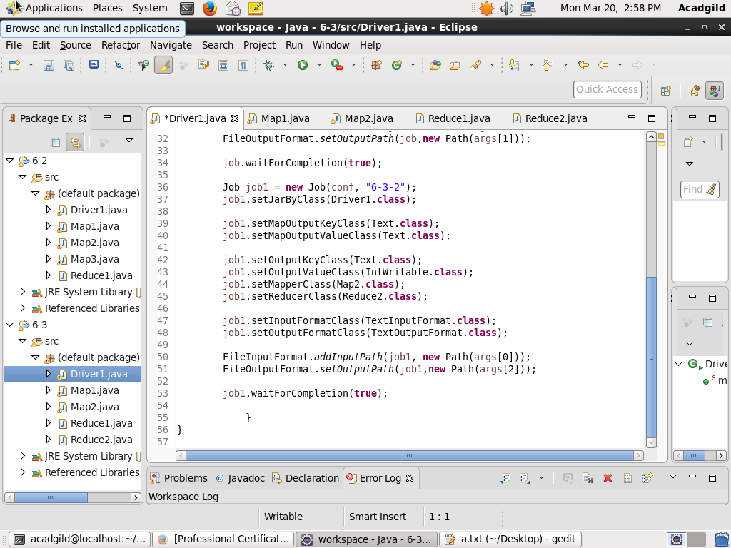

**MAPPER-1**

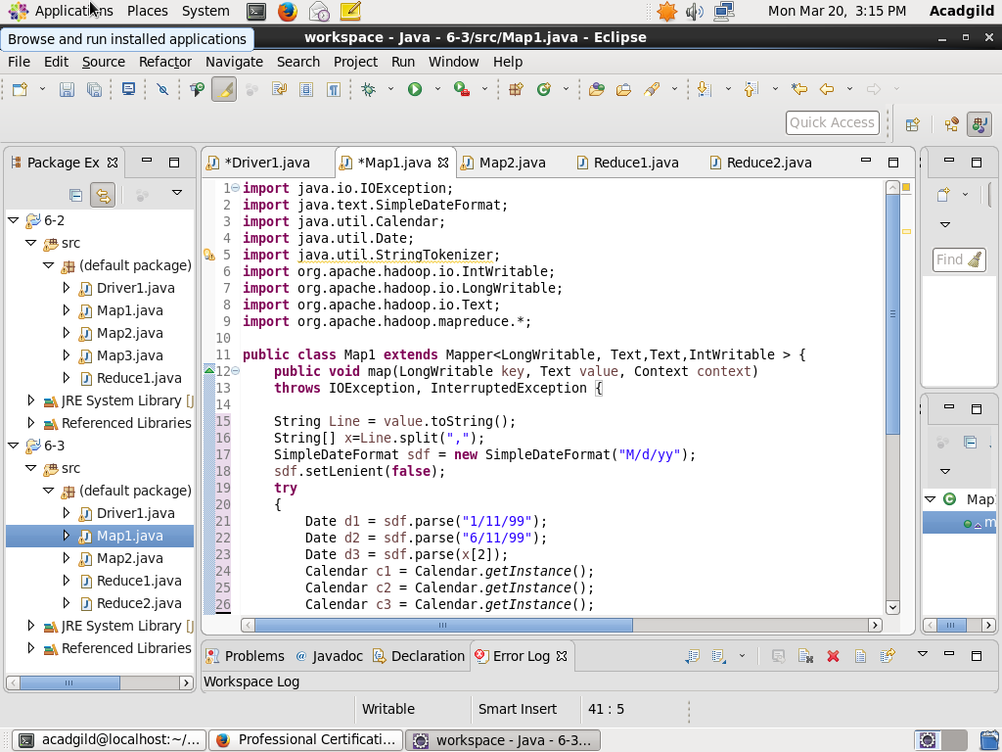

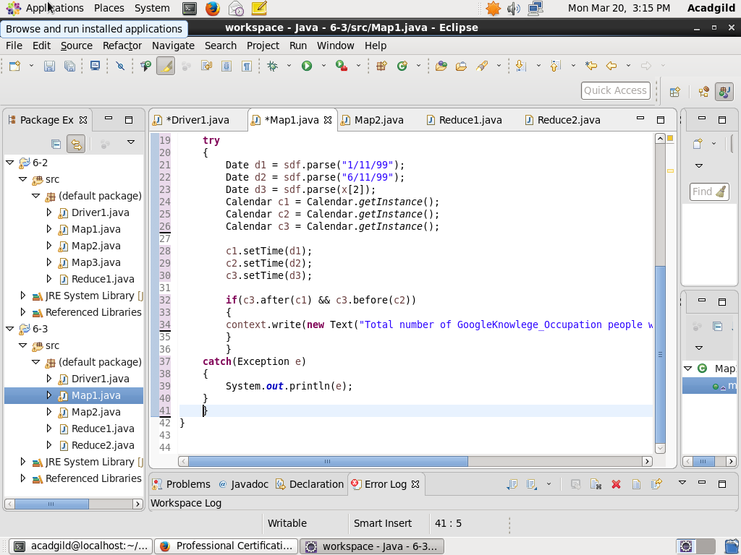

**REDUCER-1**

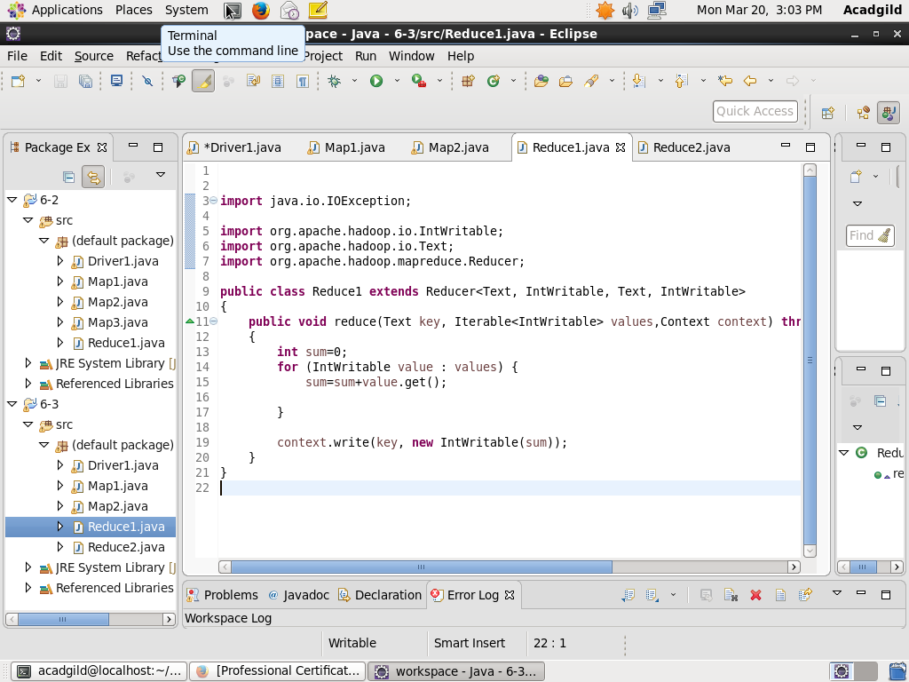

**MAPPER-2**

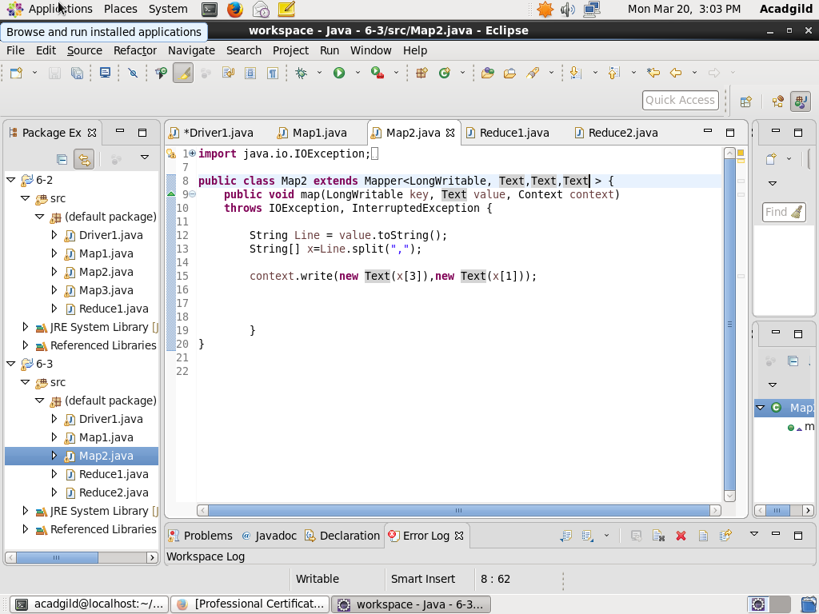

**REDUCER-2**

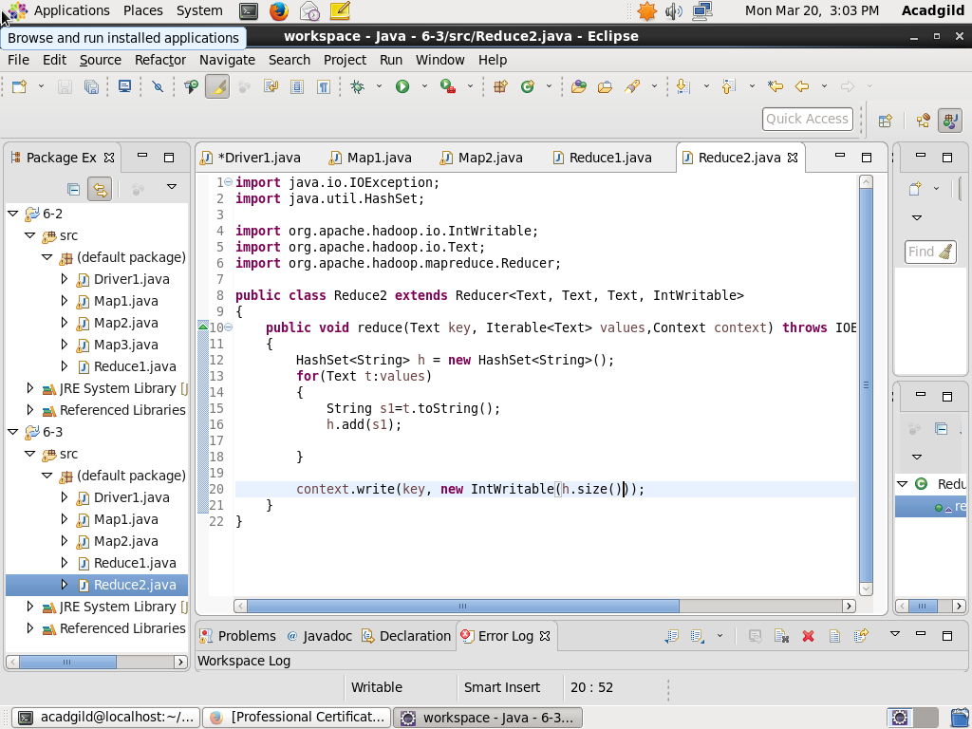

**OUTPUT:**

