**PROBLEM STATEMENT:**

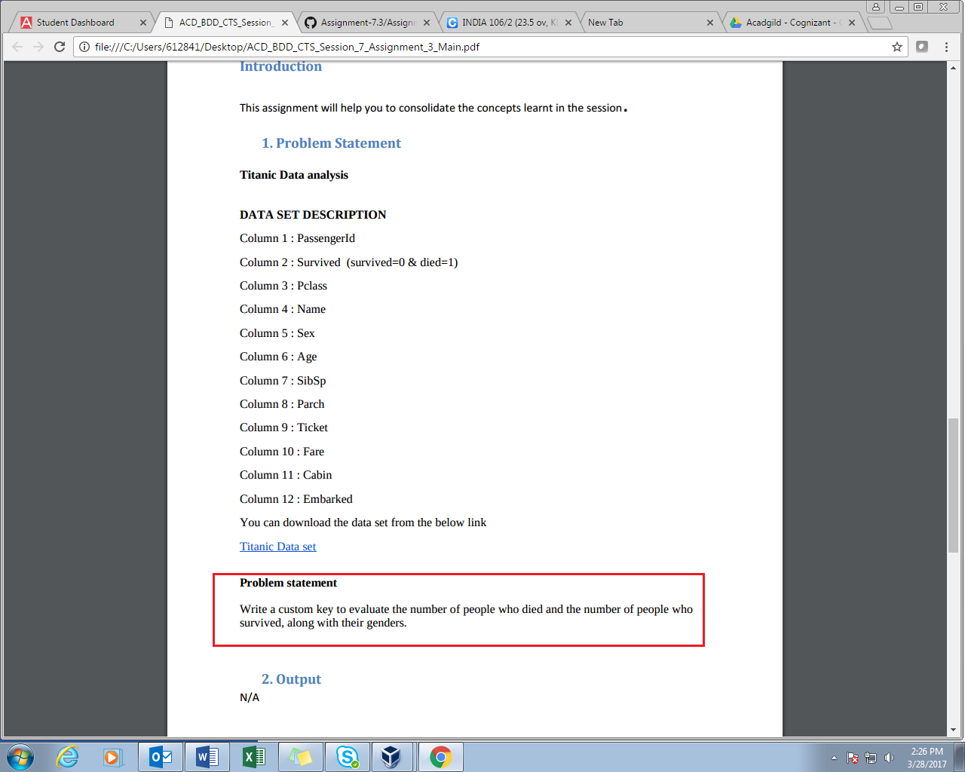

**PROGRAM:**

**DRIVER CLASS**

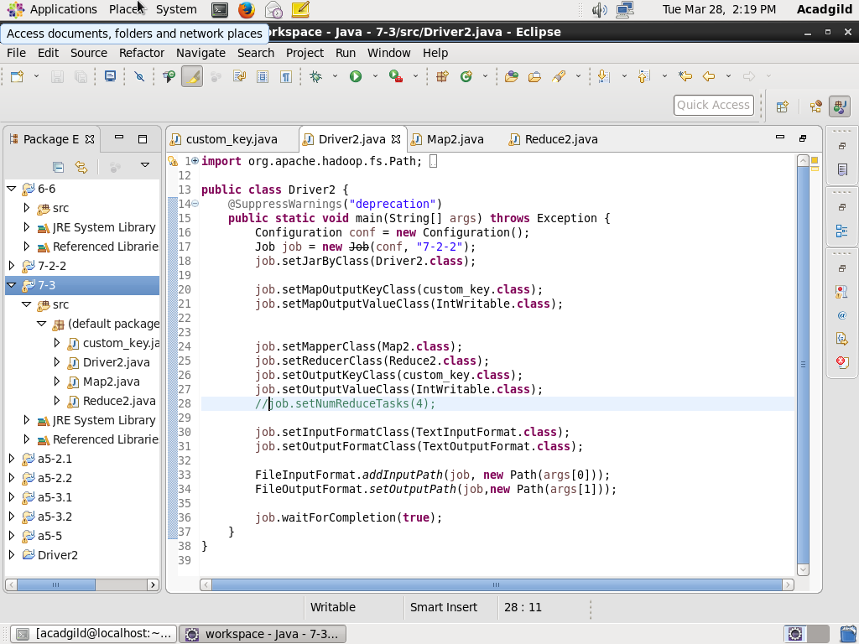

**MAPPER CLASS**

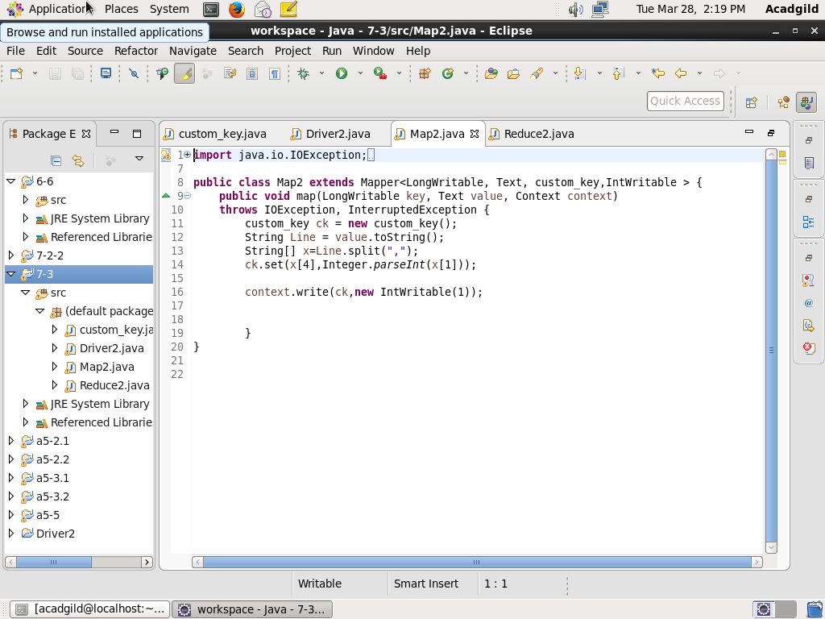

**REDUCER CLASS**

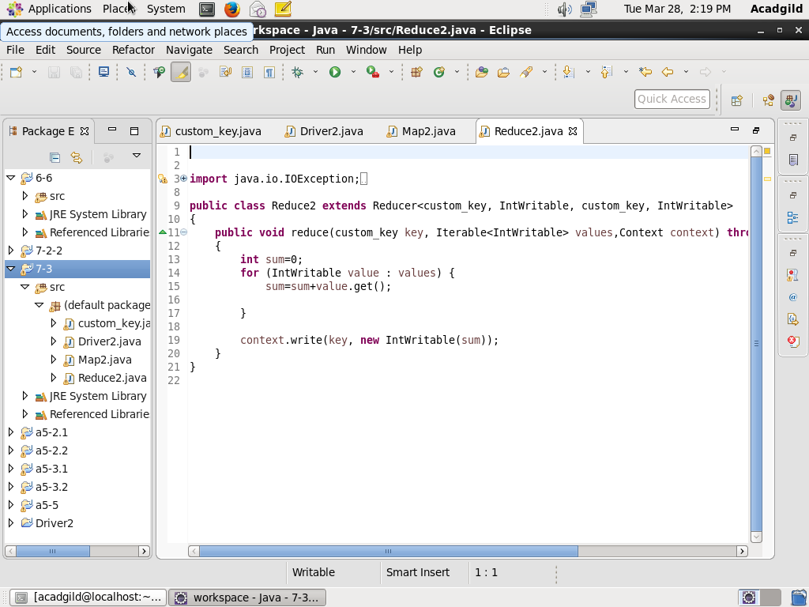

**CUSTOM_KEY CLASS IMPLEMENTS Writablecomparable Interface**

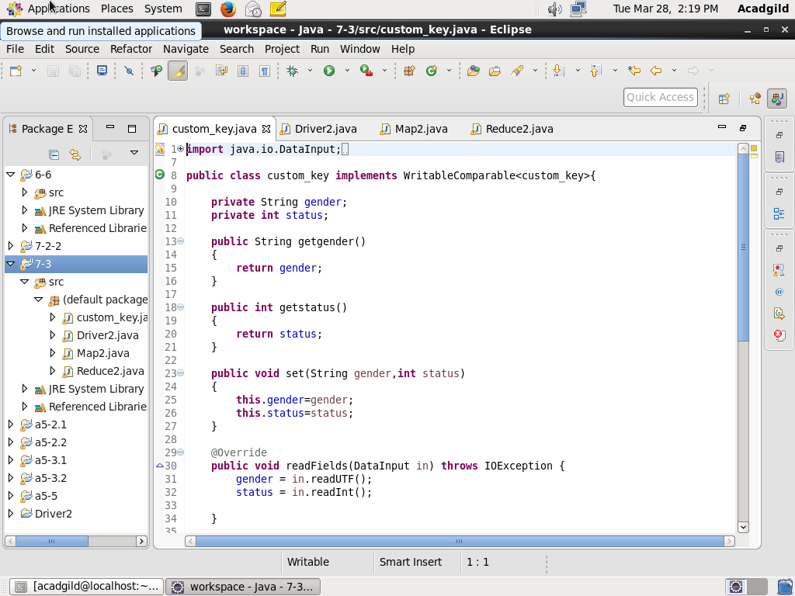

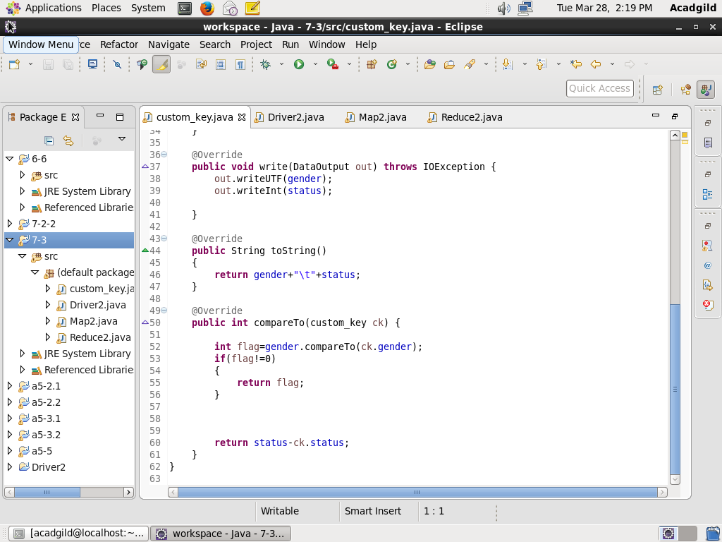

**OUTPUT:**

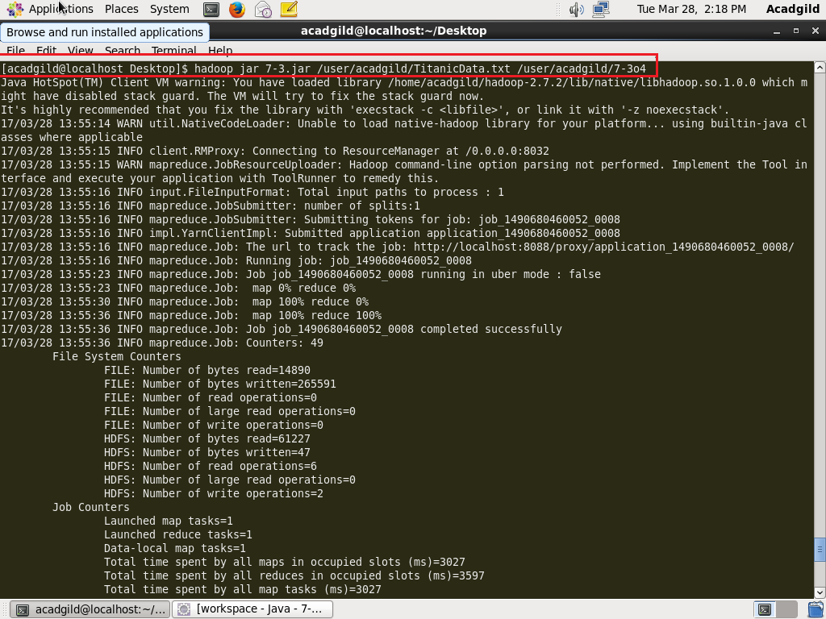

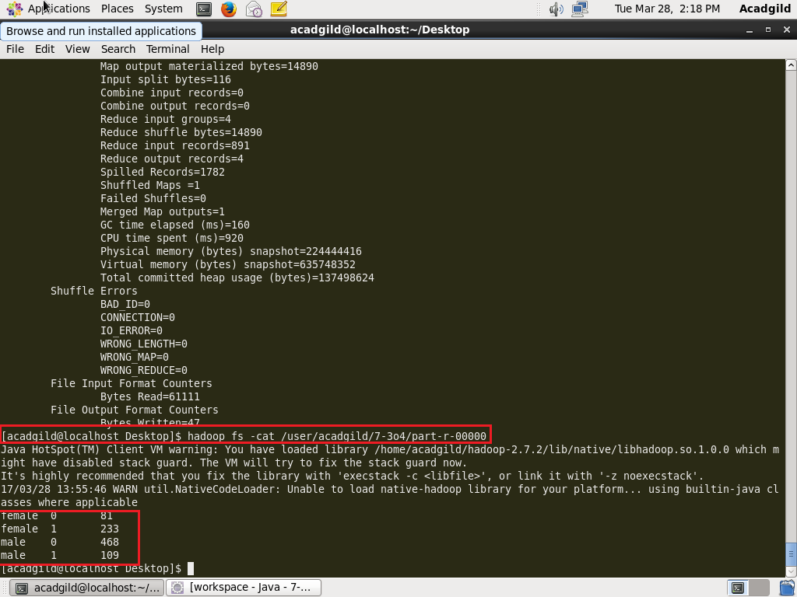

**1 = DEAD**

**0 = SURVIVED**