**PROBLEM STATEMENT:**

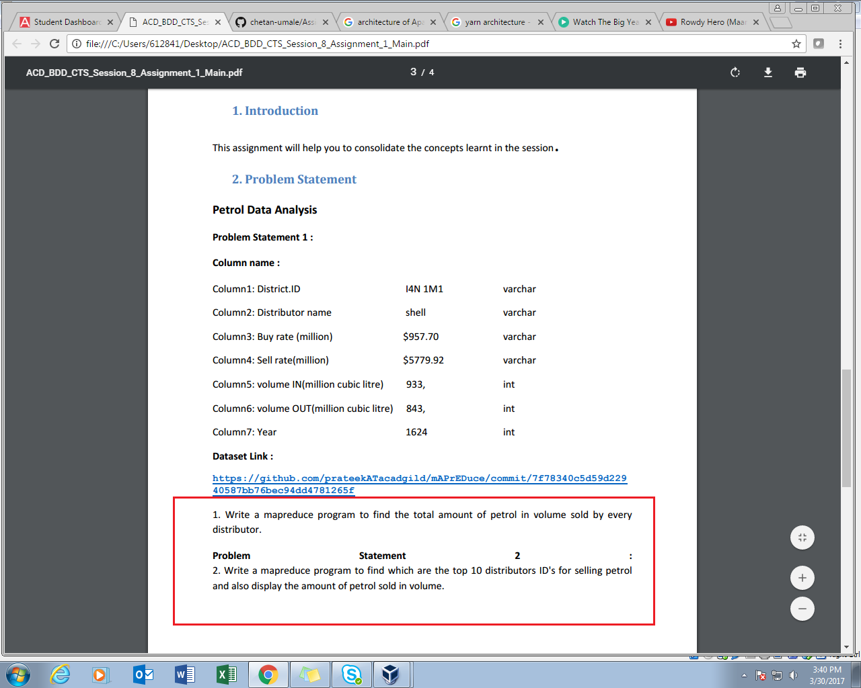

**Q1-**

**PROGRAM:**

**DRIVER PROGRAM:**

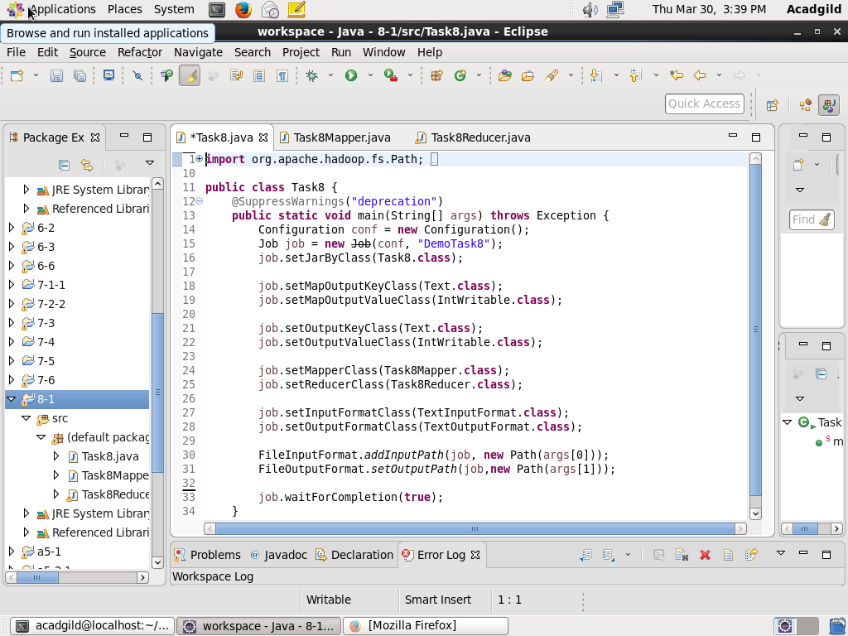

**MAPPER CLASS**

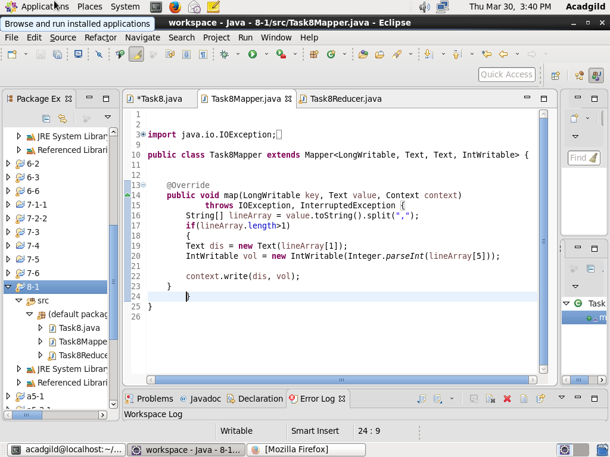

**REDUCER CLASS**

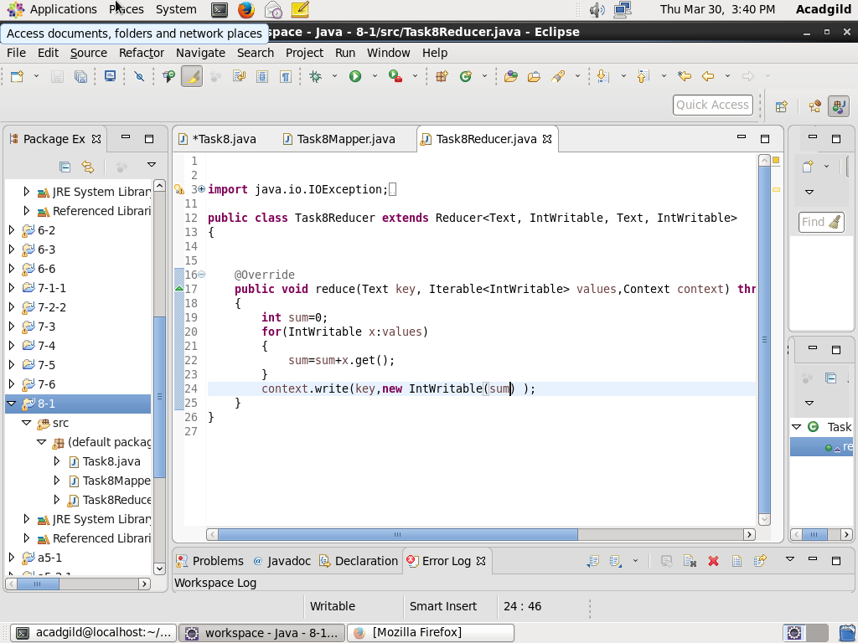

**OUTPUT:**

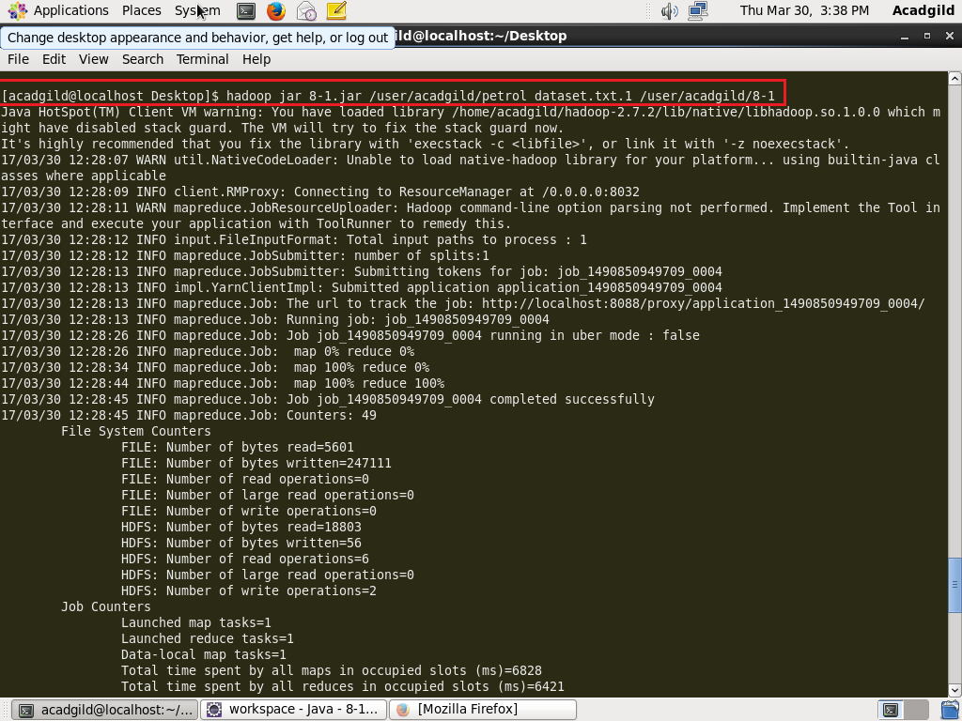

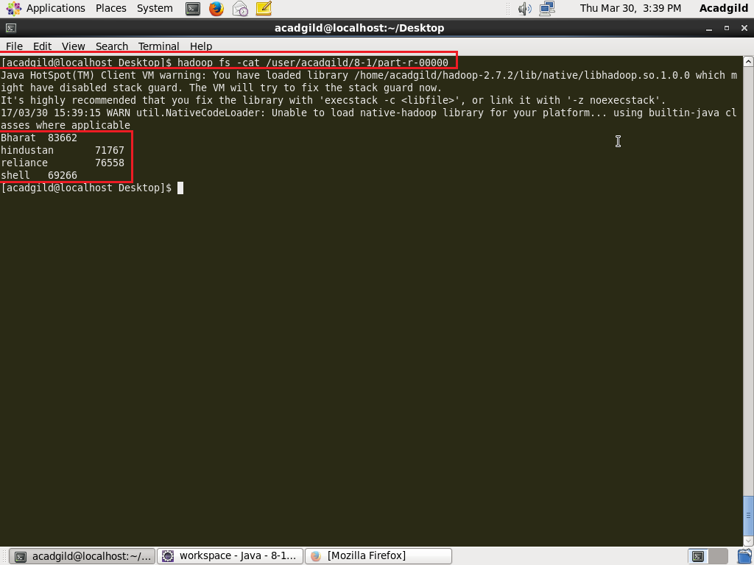

**Q2-**

**PROGRAM:**

**DRIVER CLASS**

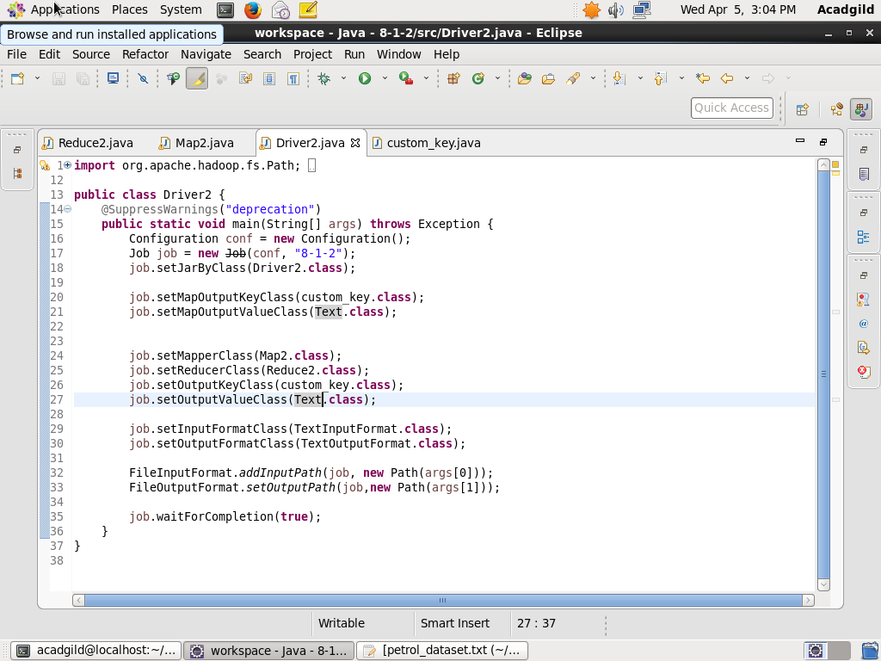

**MAPPER CLASS:**

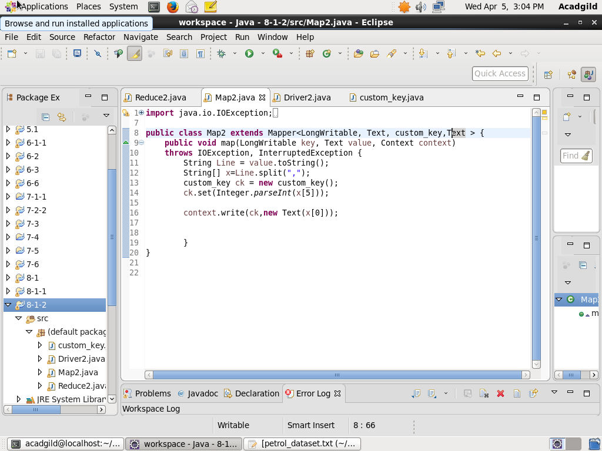

**REDUCER CLASS:**

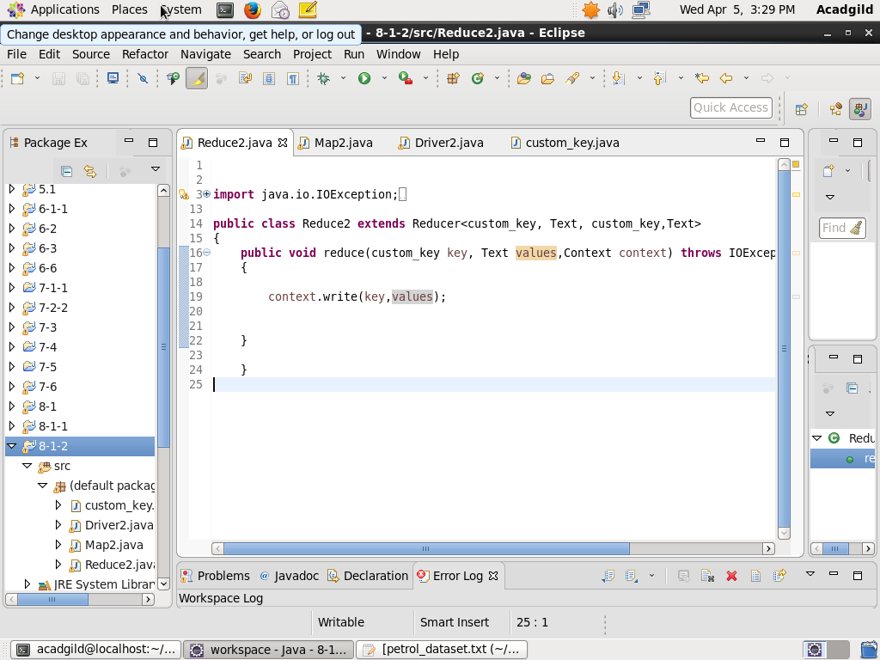

**CUSTOM_KEY CLASS (IMPLEMTS WRITABLECOMPARABLE INTERFACE)**

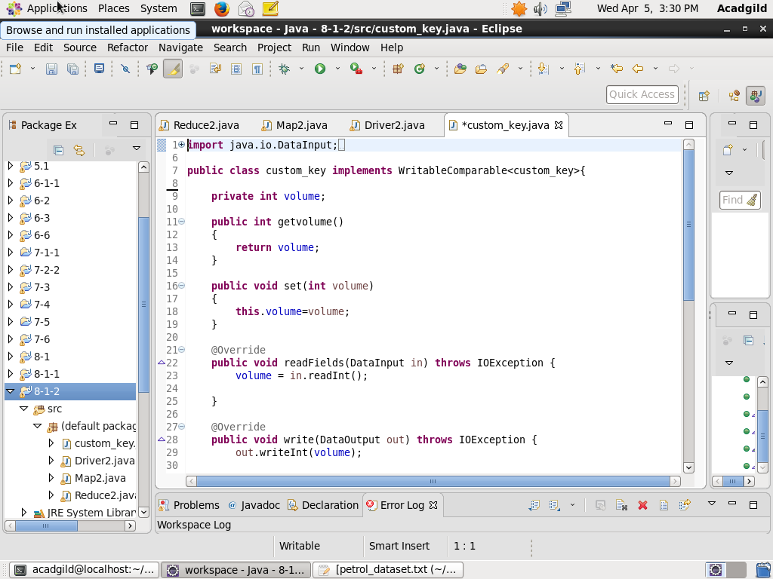

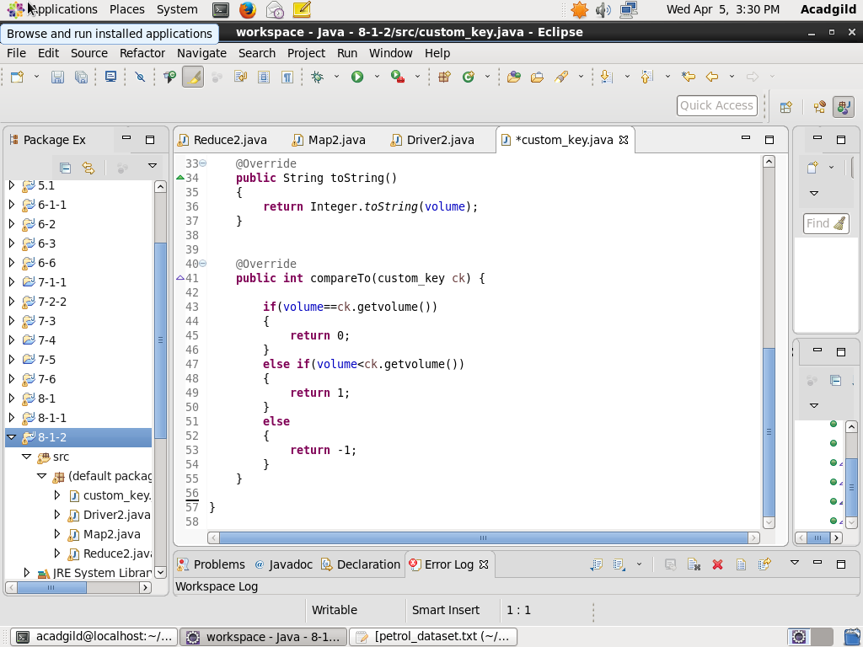

**OUTPUT:**

