1. Explain the difference between FIFO and Capacity scheduler.

2. Explain the difference between FIFO and Fair scheduler.

3. Explain the difference between Capacity and Fair scheduler.

Answer:

**FIFO Scheduler**

• The FIFO Scheduler places applications in a queue and runs them in the order of submission (first in, first out).

• Requests for the first application in the queue are allocated first; once its requests have been satisfied, the next application in the queue is served, and so on.

• The FIFO Scheduler has the merit of being simple to understand and not needing any configuration, but it’s not suitable for shared clusters.

• Large applications will use all the resources in a cluster, so each application has to wait its turn. On a shared cluster, it is better to use the Capacity Scheduler or the Fair Scheduler.

**Capacity Scheduler**

With the Capacity Scheduler, a separate dedicated queue allows the small job to start as soon as it is submitted.

• This is at the cost of overall cluster utilization since the queue capacity is reserved for jobs in that queue.

• If queues are not designed or used properly, some queues may be overloaded while some may be underutilized.

• Large job finishes late when compared with using the FIFO Scheduler.

**Fair Scheduler**

• With the Fair Scheduler, there is no need to reserve a set amount of capacity, since it will dynamically balance resources between all running jobs.

• Just after the first (large) job starts, it is the only job running, so it gets all the resources in the cluster.

• When the second (small) job starts, it is allocated half of the cluster resources, so that each job is using its fair share of resources.

• After the small job completes and no longer requires resources, the large job goes back to using the full cluster capacity again.

• The overall effect is both high cluster utilization and timely small job completion.

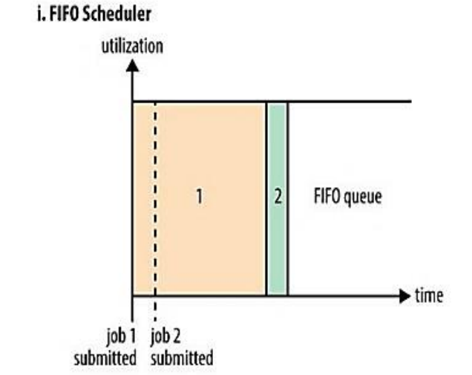 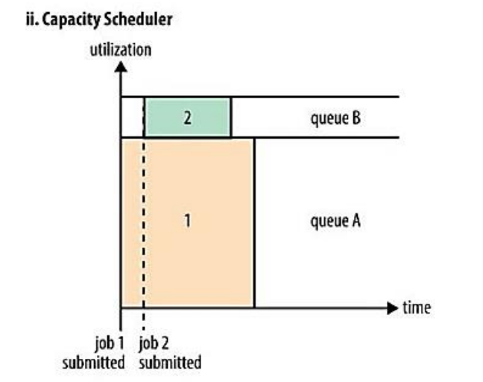

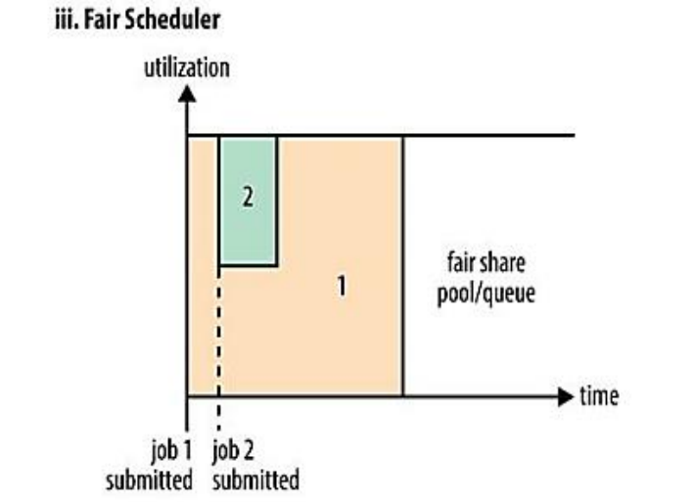

Q4- What are the limitations of hadoop 1.x and how they were overcome in hadoop 2.x.

Answer:

Hadoop 1.x has the following Limitations/Drawbacks:

* It is only suitable for Batch Processing of Huge amount of Data, which is already in Hadoop System.
* It is not suitable for Real-time Data Processing.
* It is not suitable for Data Streaming.
* It supports upto **4000 Nodes** per Cluster.
* It has a single component : JobTracker to perform many activities like Resource Management, Job Scheduling, Job Monitoring, Re-scheduling Jobs etc.
* JobTracker is the single point of failure.
* It does not support Multi-tenancy Support.
* It supports only one Name Node and One Namespace per Cluster.
* It does not support Horizontal Scalability.
* It runs only Map/Reduce jobs.
* It follows Slots concept in HDFS to allocate Resources (Memory, RAM, CPU). It has static Map and Reduce Slots. That means once it assigns resources to Map/Reduce jobs, it cannot re-use them even though some slots are idle.

Hadoop 2.x has resolved most of the Hadoop 1.x limitations by using new architecture.

* By decoupling MapReduce component responsibilities into different components.
* By Introducing new YARN component for Resource management.
* By decoupling component’s responsibilities, it supports multiple namespace, Multi-tenancy, Higher Availability and Higher Scalability.