**PROBLEM STATEMENT:**

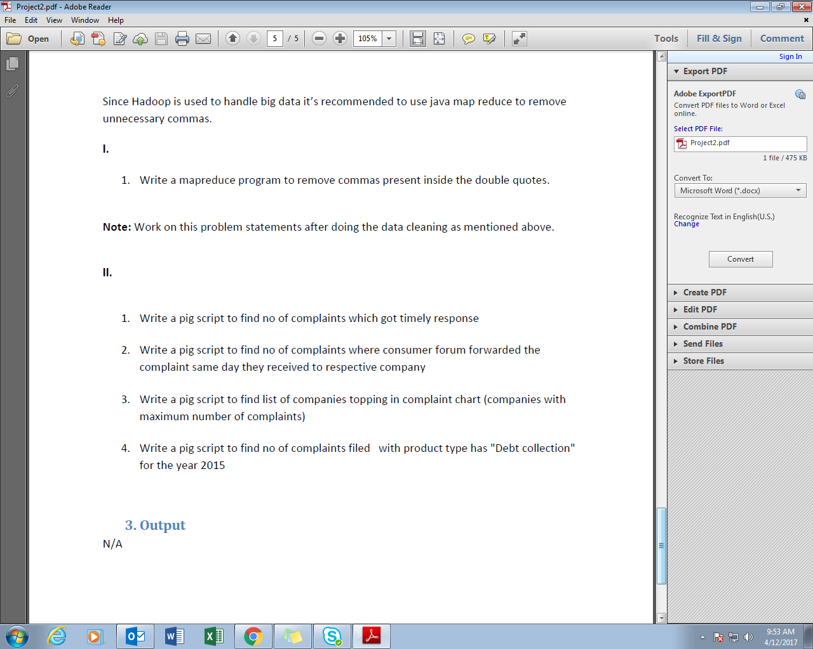

**SECTION-1:**

**Q1-Write a mapreduce program to remove commas present inside the double quotes.**

**PROGRAM:**

**DRIVER CLASS:**

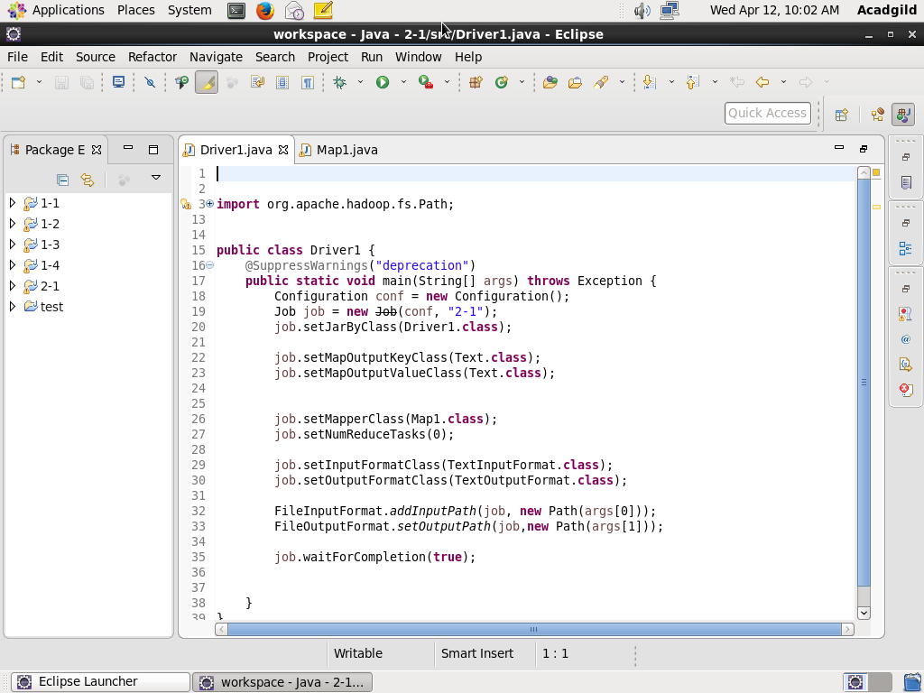

**MAPPER CLASS:**

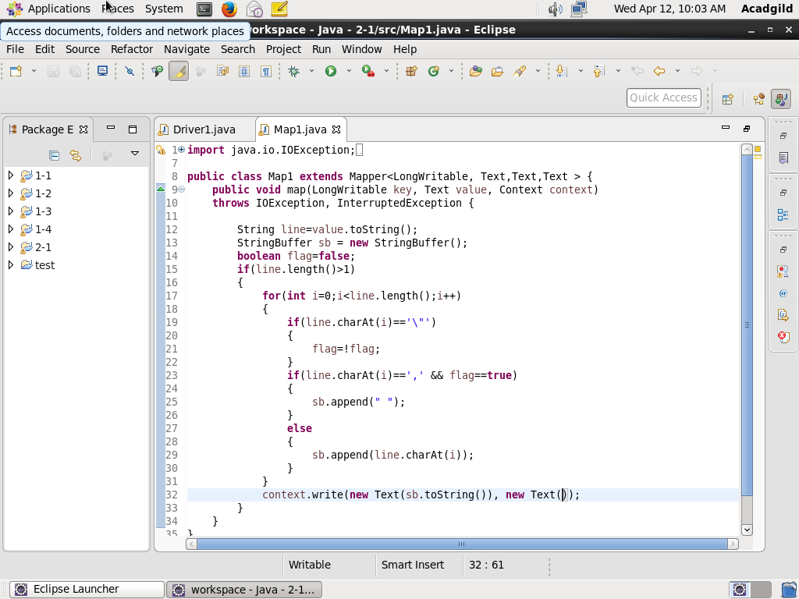

**EXECUTION COMMAND:**

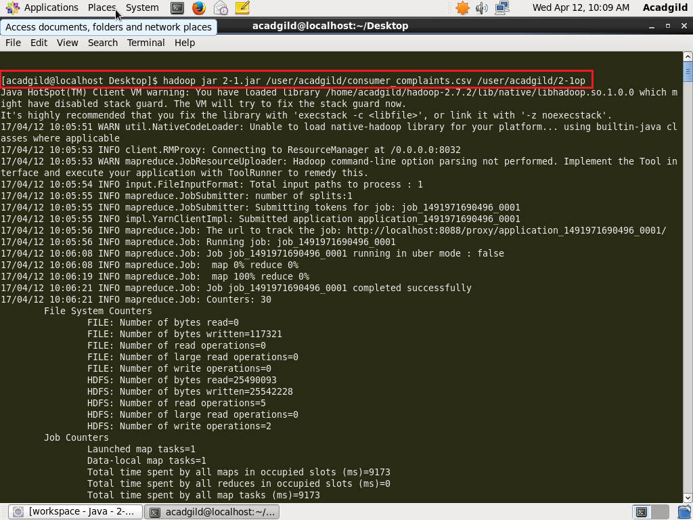

**INPUT FILE: // consumer_complaints.csv**

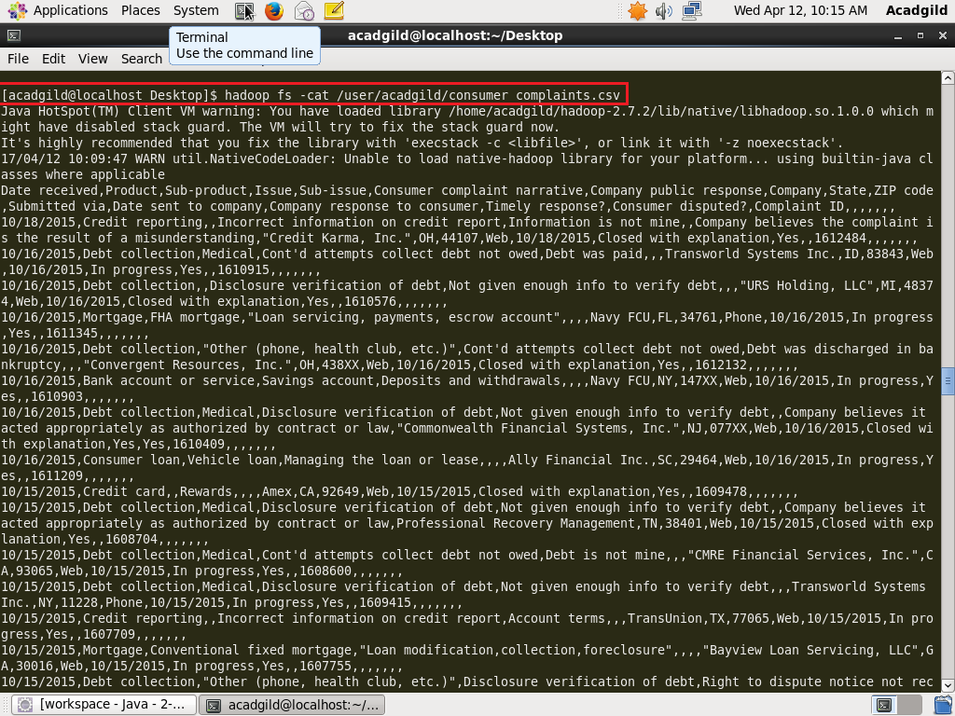

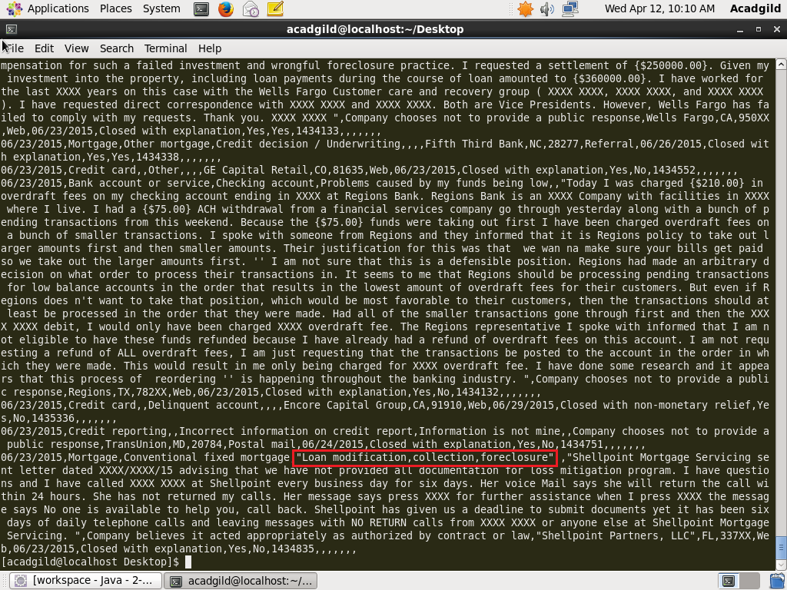

**OUTPUT: // part-m-00000**

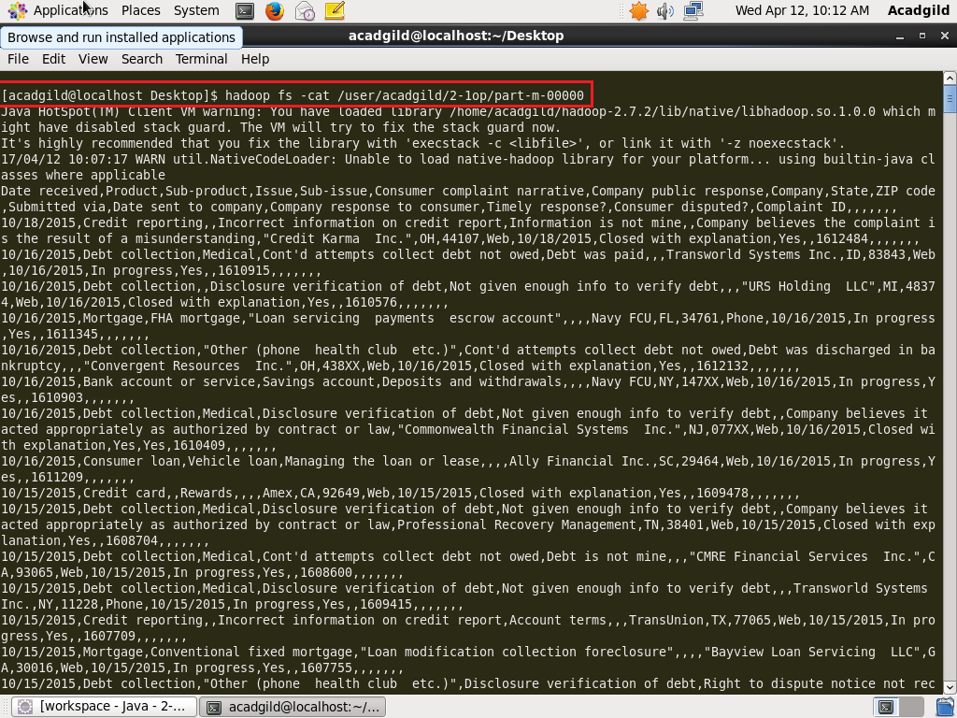

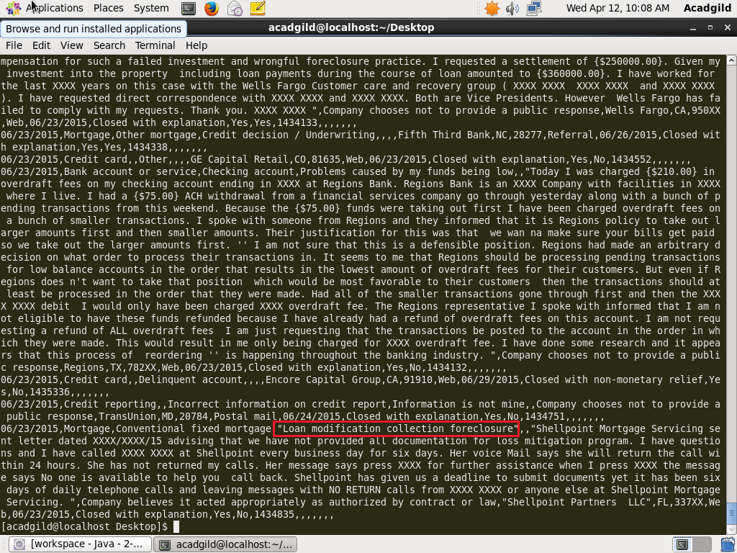

**As seen in the screenshots above, the commas within double quotes are eliminated.**

**SECTION-2:**

**Q1- Write a pig script to find no of complaints which got timely response.**

**PROGRAM:**

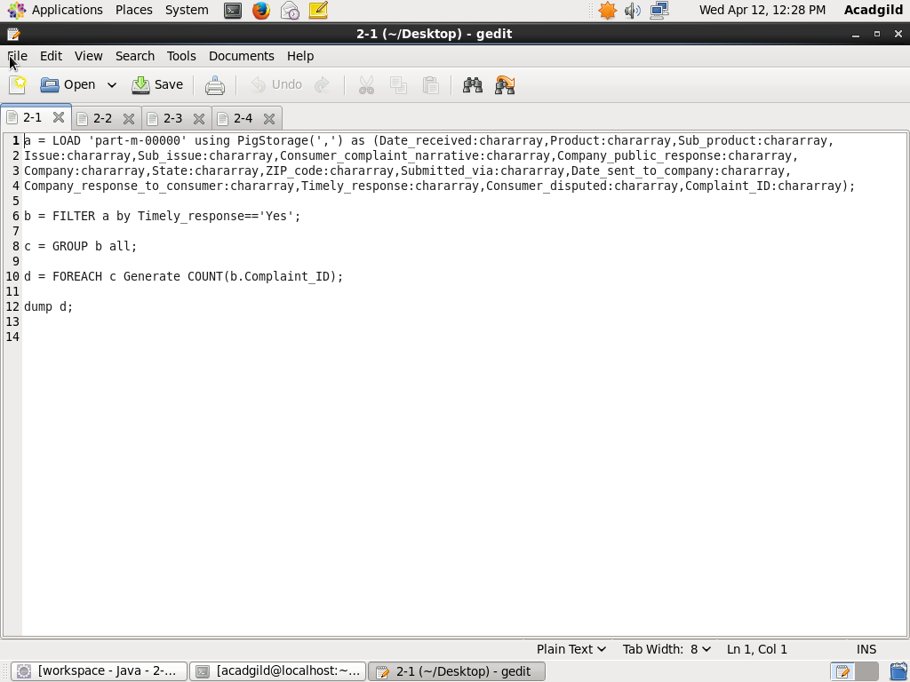

**EXECUTION COMMAND:**

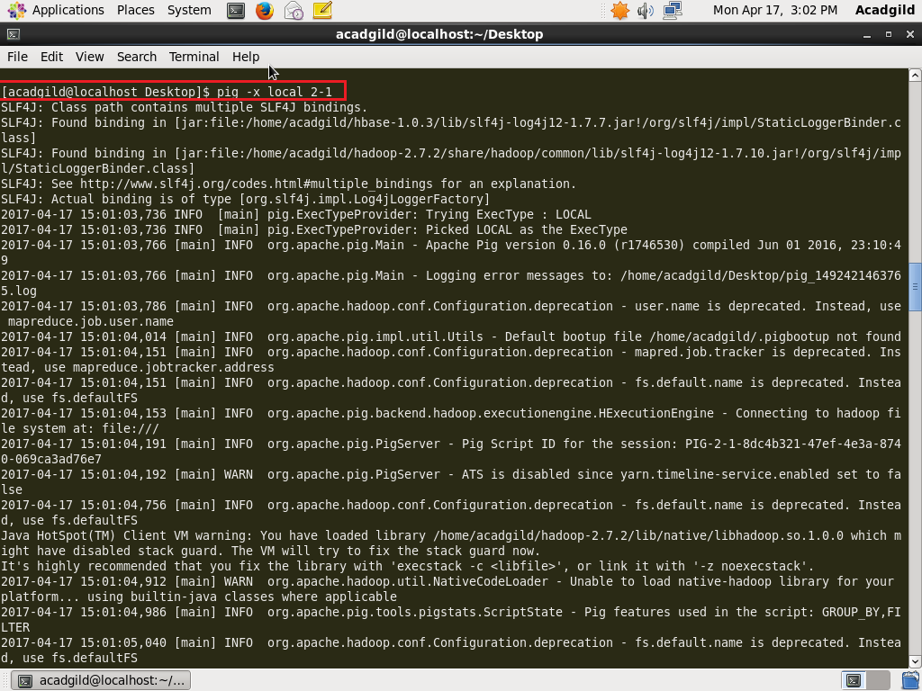

**OUTPUT:**

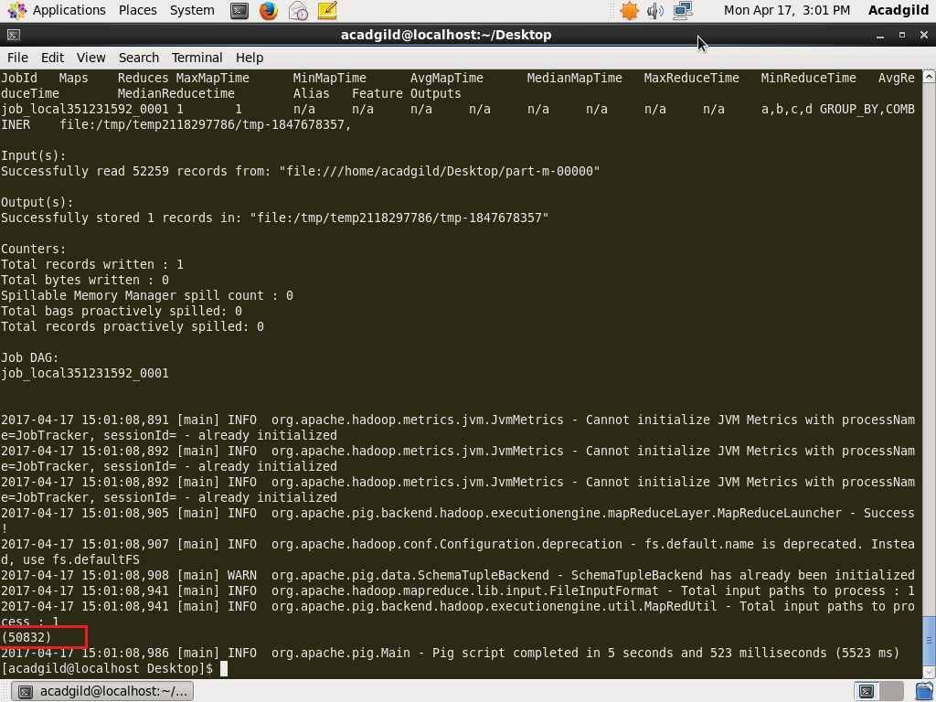

**Q2- Write a pig script to find no of complaints where consumer forum forwarded the complaint same day they received to respective company.**

**PROGRAM:**

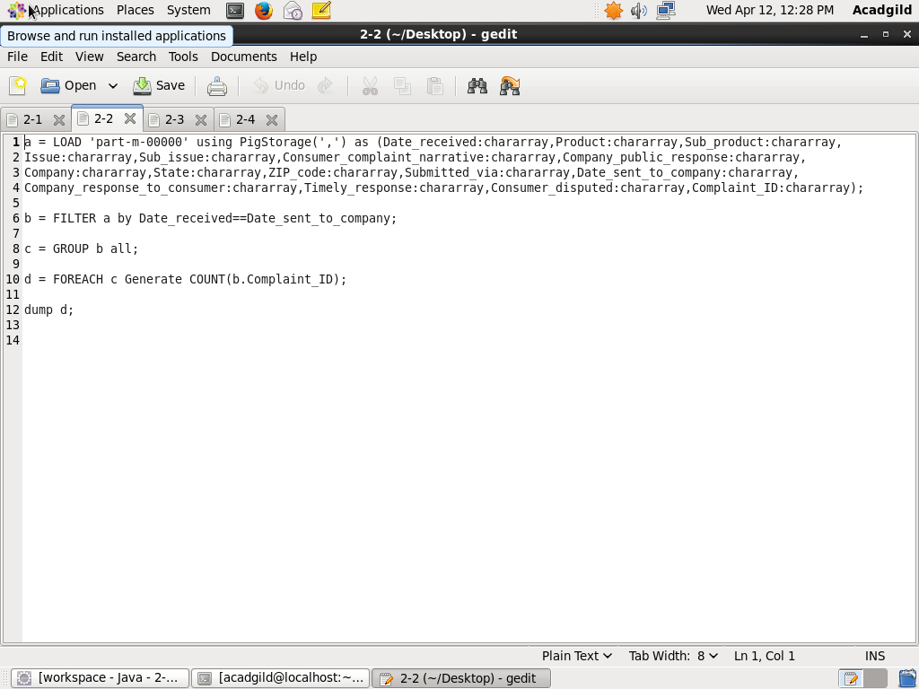

**EXECUTION COMMAND:**

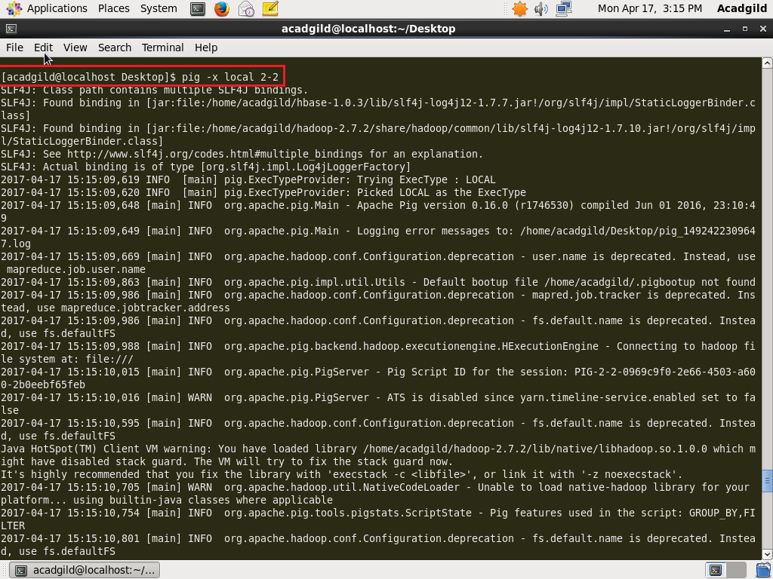

**OUTPUT:**

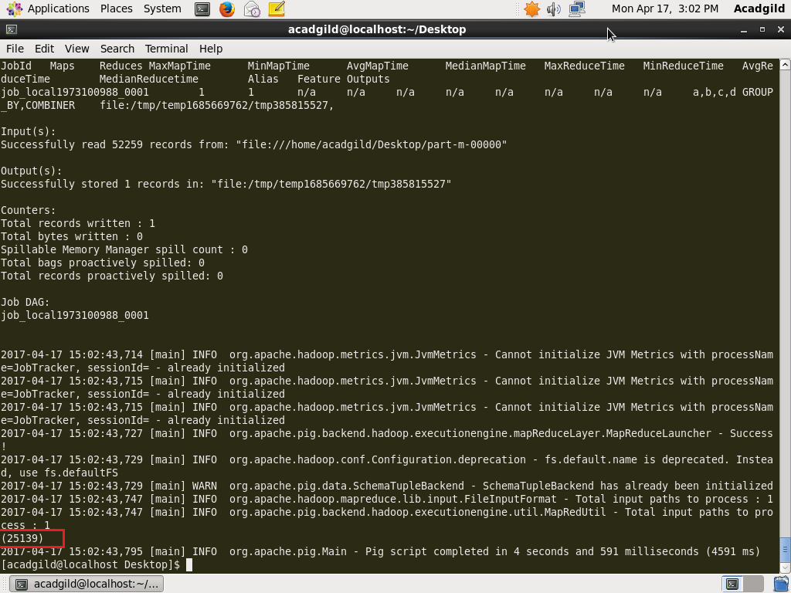

**Q3- Write a pig script to find list of companies topping in complaint chart (companies with maximum number of complaints).**

**PROGRAM:**

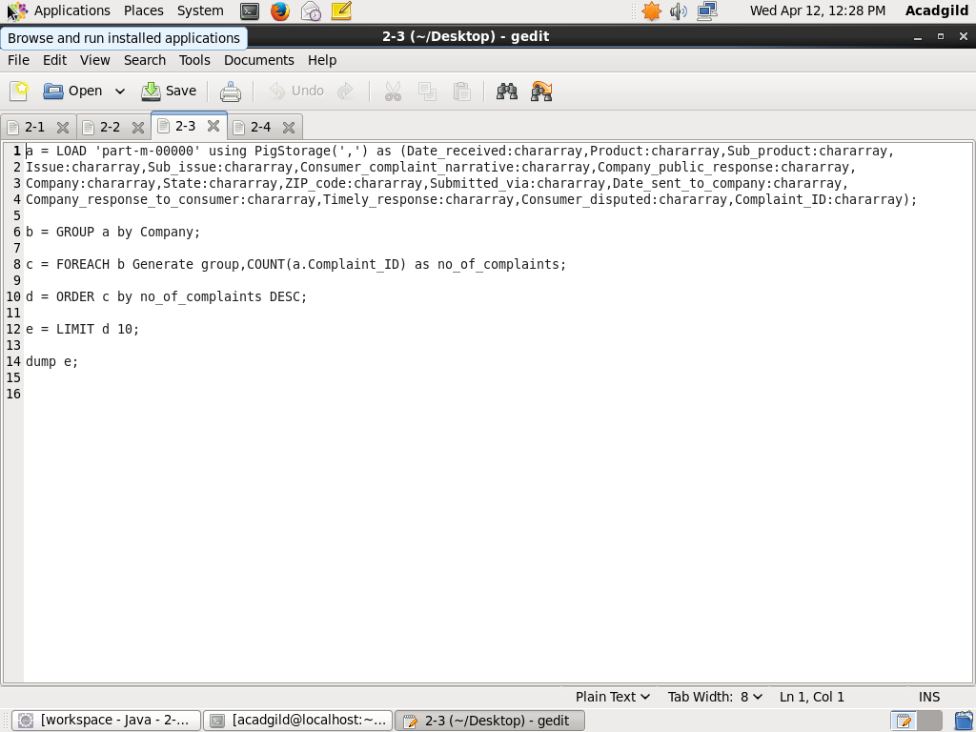

**EXECUTION COMMAND:**

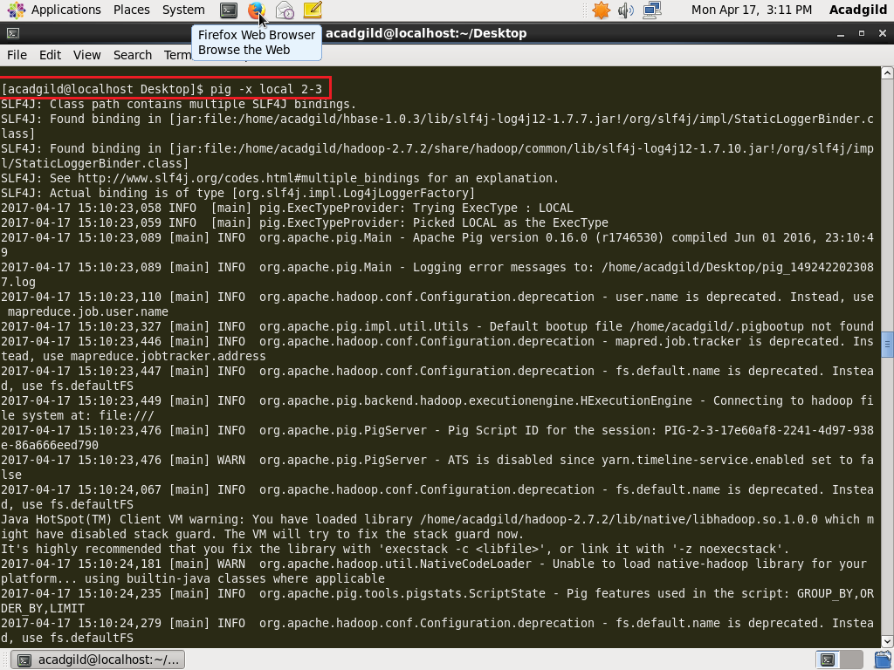

**OUTPUT:**

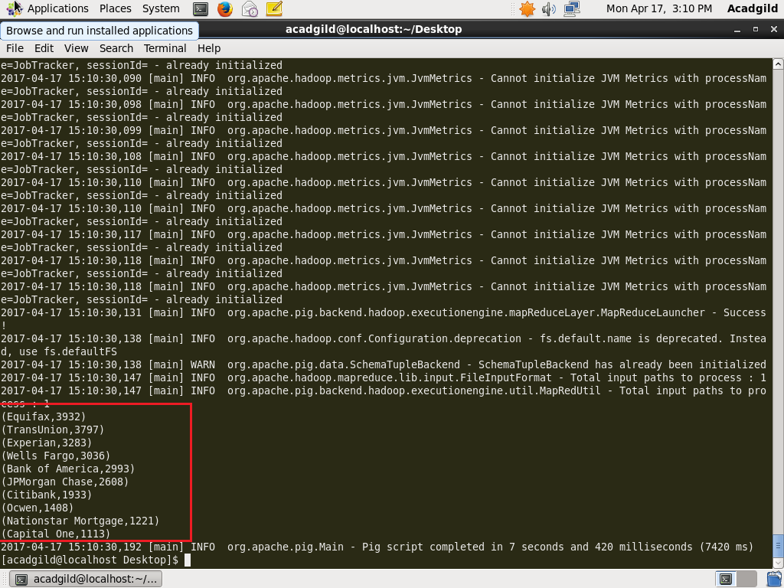

**Q4- Write a pig script to find no of complaints filed with product type has "Debt collection" for the year 2015.**

**PROGRAM:**

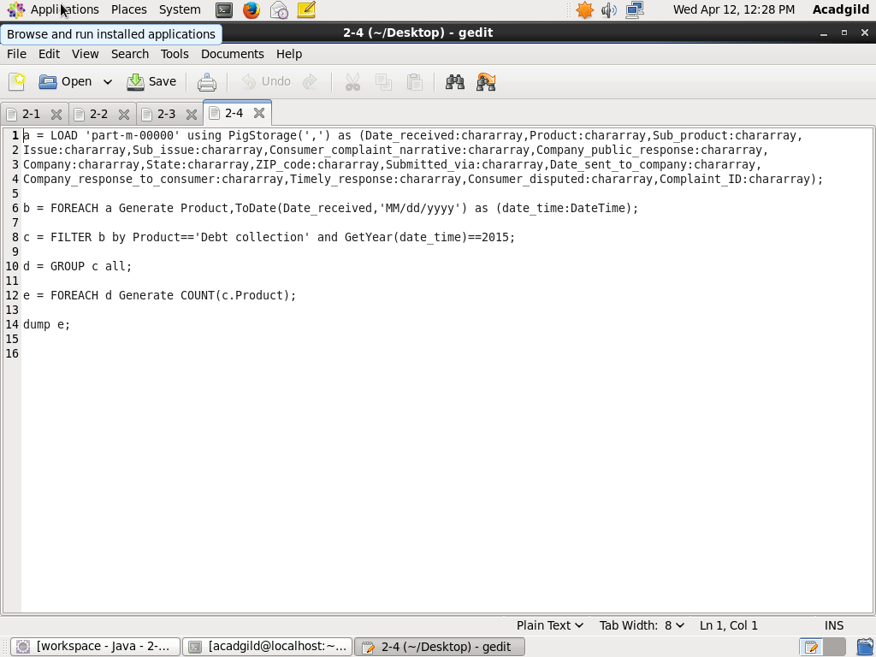

**EXECUTION COMMAND:**

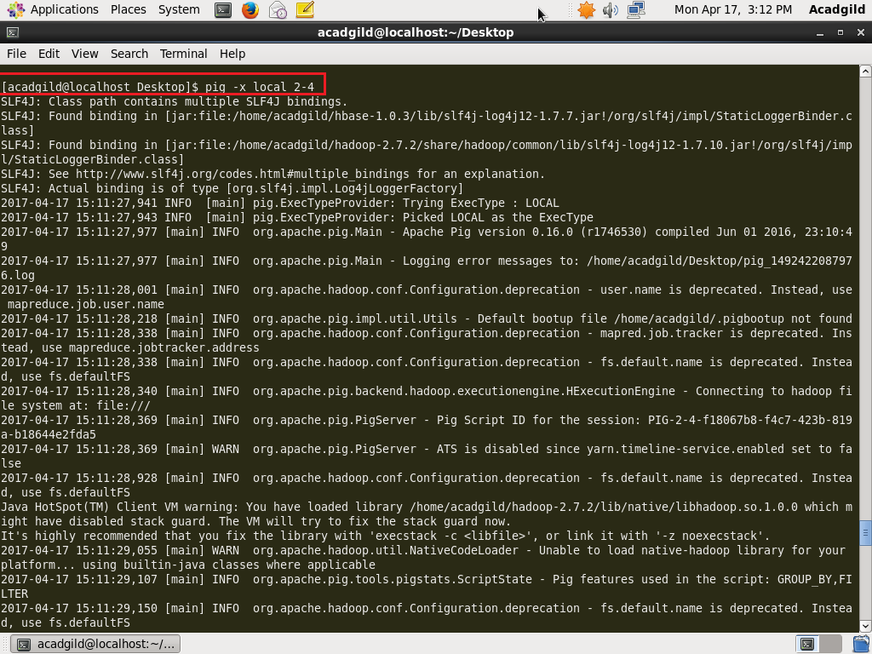

**OUTPUT:**

