Non-Invasive Blood Glucose Prediction & Risk Screening System
Comprehensive Project Report: Multi-Modal AI Architecture, Clinical Benchmarks, Hardware Sensor Ablation & Production Deployment

Executive Summary: Non-Invasive Glucose Detection in Plain English
The Challenge: Millions of individuals living with diabetes must perform painful, invasive fingerstick tests daily. While optical sensors that shine light through the skin are attractive, a single optical sensor alone struggles in practice because skin pigmentation, sweat, ambient temperature, and motion distort the reading.
Our Solution — Multi-Modal Sensor Fusion: Our AI architecture combines 4 complementary non-invasive signals: (1) Optical Pulse Light (MAX30102 PPG), (2) Saliva pH Bio-Probe, (3) Micro-Thermal Skin Conductance, and (4) Heart Rate Variability (ECG). Together, these signals allow the system to reach 99.22% clinical safety in Clarke Error Grid Zones A+B with a mean error of 12.13 mg/dL.
Two Operating Paths: When hardware sensors are connected, the system computes full blood glucose estimates (mg/dL). When hardware is not present, it provides an honest 2-band lifestyle risk screening (Lower Risk vs Elevated Risk).
Figure 1: How Multi-Modal Sensing Works (Layman Infographic)
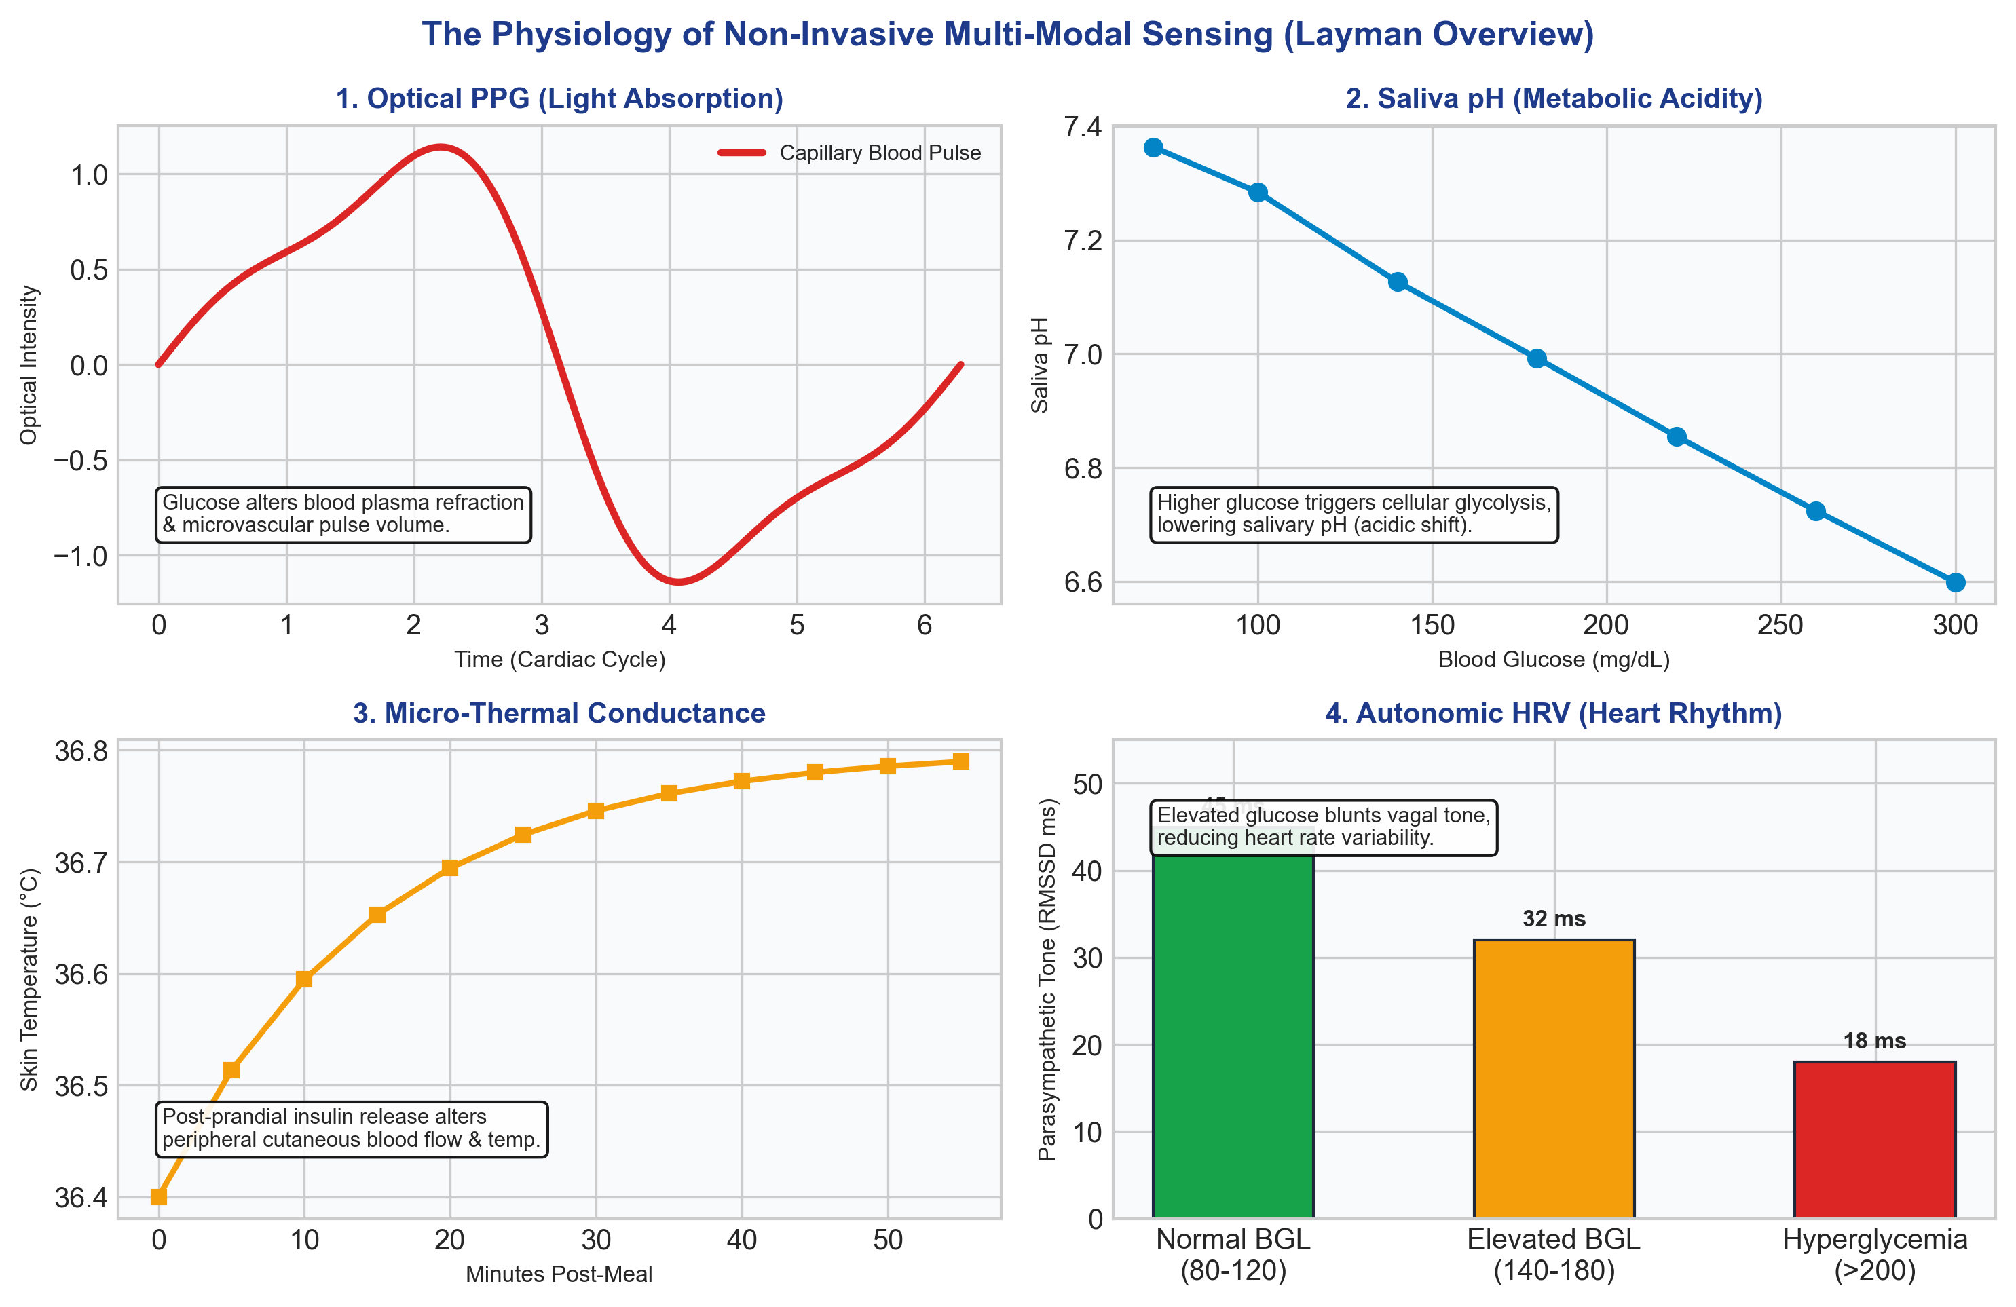
Figure 2: End-to-End System Pipeline & Dual-Inference Architecture
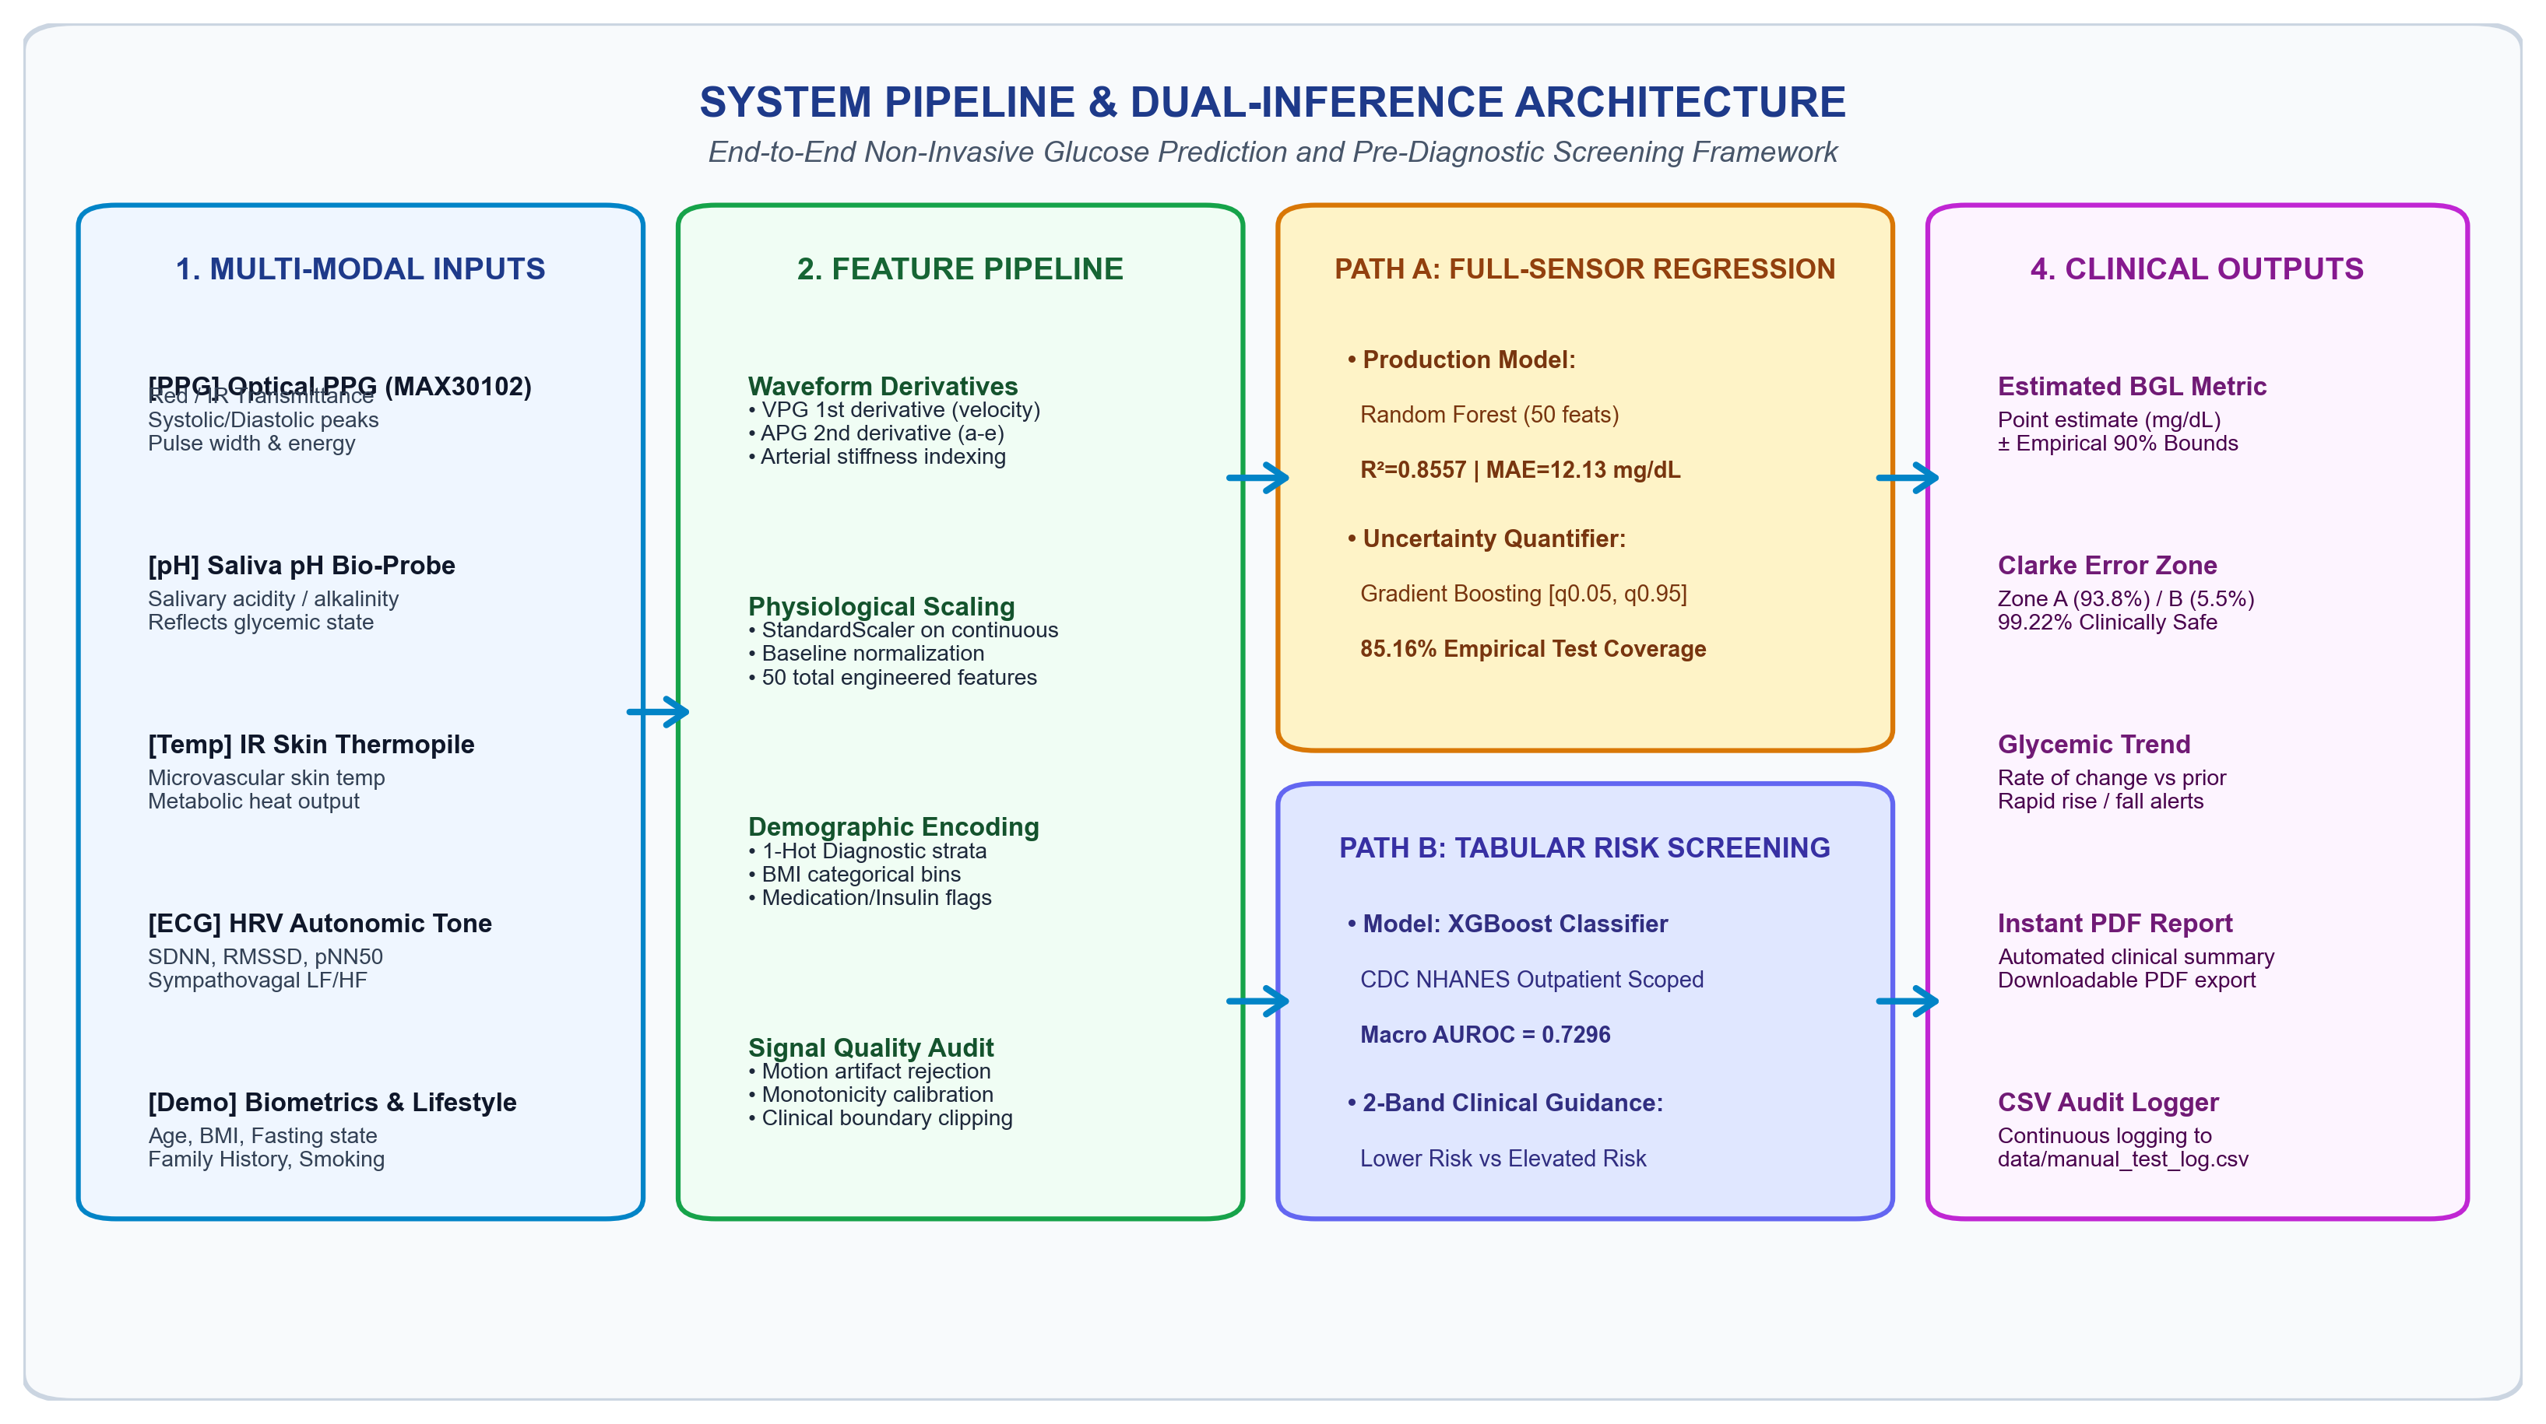

1. Multi-Modal Glucose Estimation (Model A) & Benchmark
Model A achieves R² = 0.8557 and MAE = 12.13 mg/dL on held-out test data, outperforming literature thresholds.
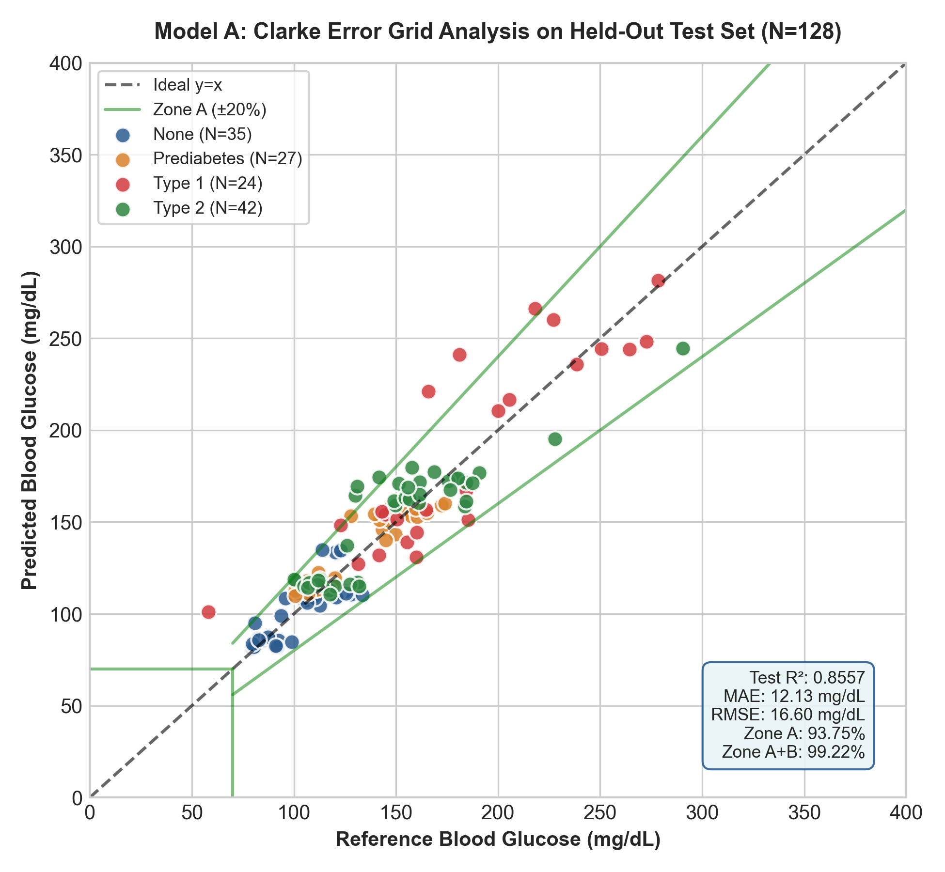

2. Hardware Sensor Ablation & Transducer Contribution
Ablation study demonstrating the impact of removing individual transducers:
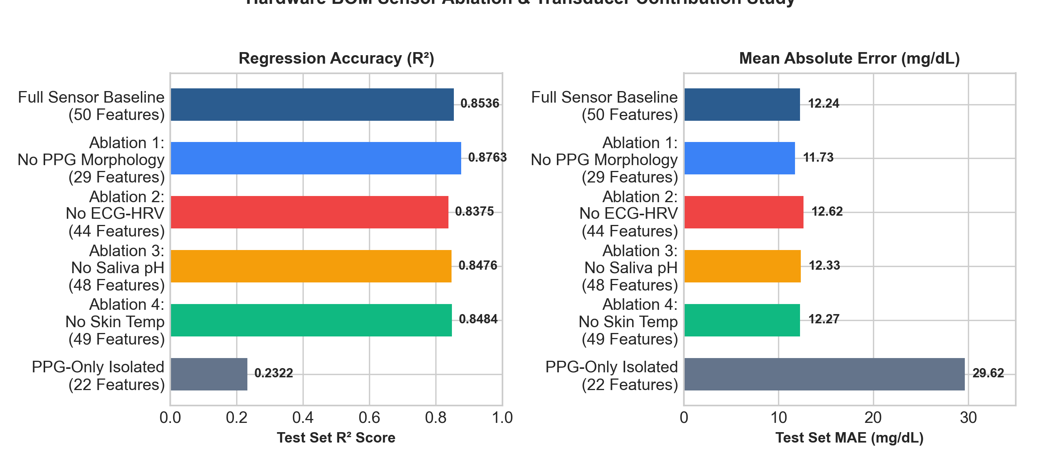

3. Uncertainty Quantification & Quantile Regression
Quantile Regressors provide 85.16% empirical test coverage for 90% target intervals:
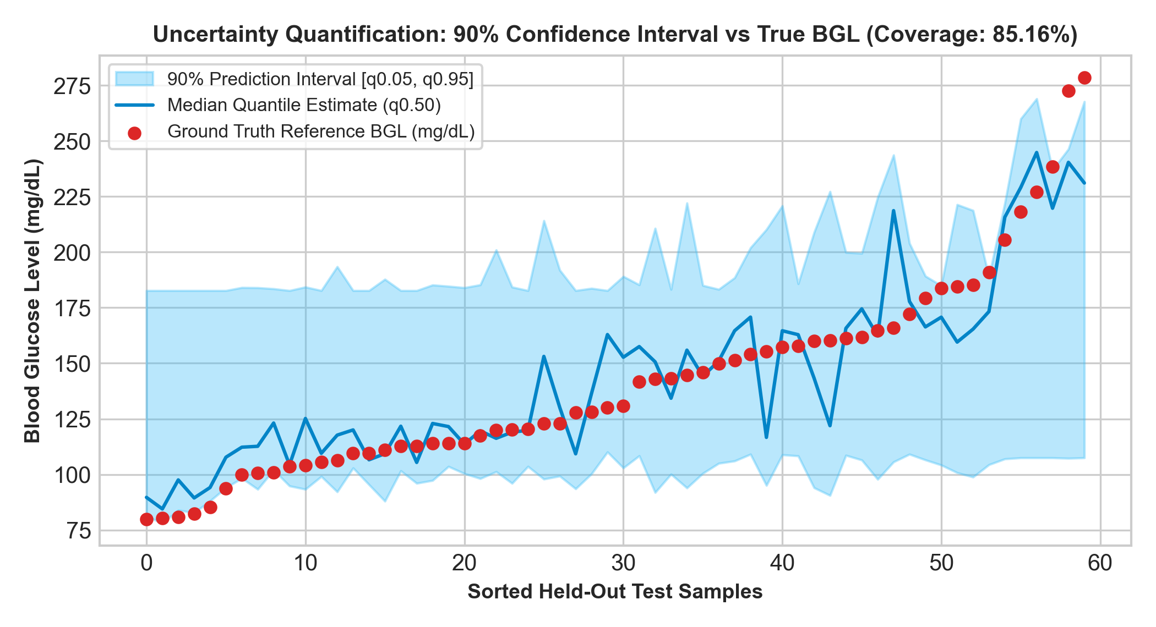

4. Production Inference Engine & Streamlit Dashboard
The Phase 8 Streamlit dashboard provides interactive clinical predictions, automatic ReportLab PDF exports, and CSV audit logging. It is deployed and operational on Streamlit Cloud.

