User Guide for



|  |  |
| --- | --- |
| **Reliance Call desk Management System** | |
| **Application Name :** | Call Desk V1.2 |
| **Application URL :** | http://calldesk.reliancegeneral.co.in |
| **Application User's :** | All Reliance employee’s, Agent etc. |
| **Production Date :** | 26th Feb, 2013 |
| **Updated As on :** | 1st Jan, 2016 |
| **Application User’s :** | RGICL Employees, Agents , BAS , Vendors etc. |

* **IMPORTANT NOTE - :**
* All Employees are given access to call desk to raise their application related queries by raising a Ticket in call desk.
* A Special Support team to attend your Call tickets with assigned TAT.

Contact details are available in Call desk application>>Contact Menu.

* Request you to go through the below manual and follow all the steps mentioned and give us an Opportunity to serve you better.
* Any User not having access to call desk can raise a mail to -

"Rgicl.Applnsupport@rcap.co.in.

Elements that are addressed under this User Manual are

* Step 1- How to get access for Reliance call desk application.
* Step 2- How to log a call in Reliance call desk application.
* Step 3- How to Track a call in Reliance Call desk.
* Step 4- How to Re-open your call.
* Step 5- How to contact support team / find escalation matrix.

**Step 1 - Call desk Login Page**

Enter Call desk URL <https://calldesk.reliancegeneral.co.in> in Internet Explorer.

* Google Chrome does not support few features of Call desk, hence it is recommended to use Internet Explorer Browser for call desk login.

Windows login user id and password will be used to login in call desk.

1. Please enter Employee code in User Name.
2. Please enter domain password.

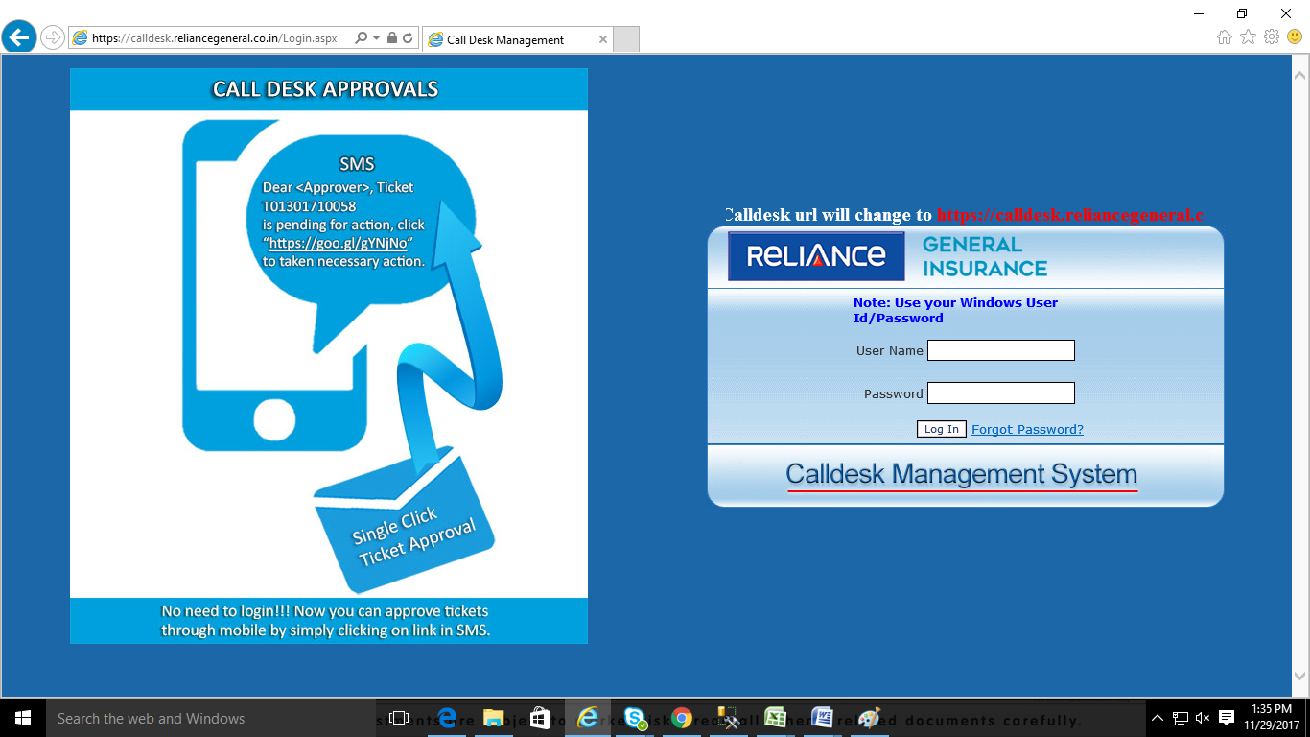

On Call desk Application Home page, User details such as User ID, User Name, Branch, Login Time and some notification will be displayed.

* Menu content will be displayed according to user’s role and designation.

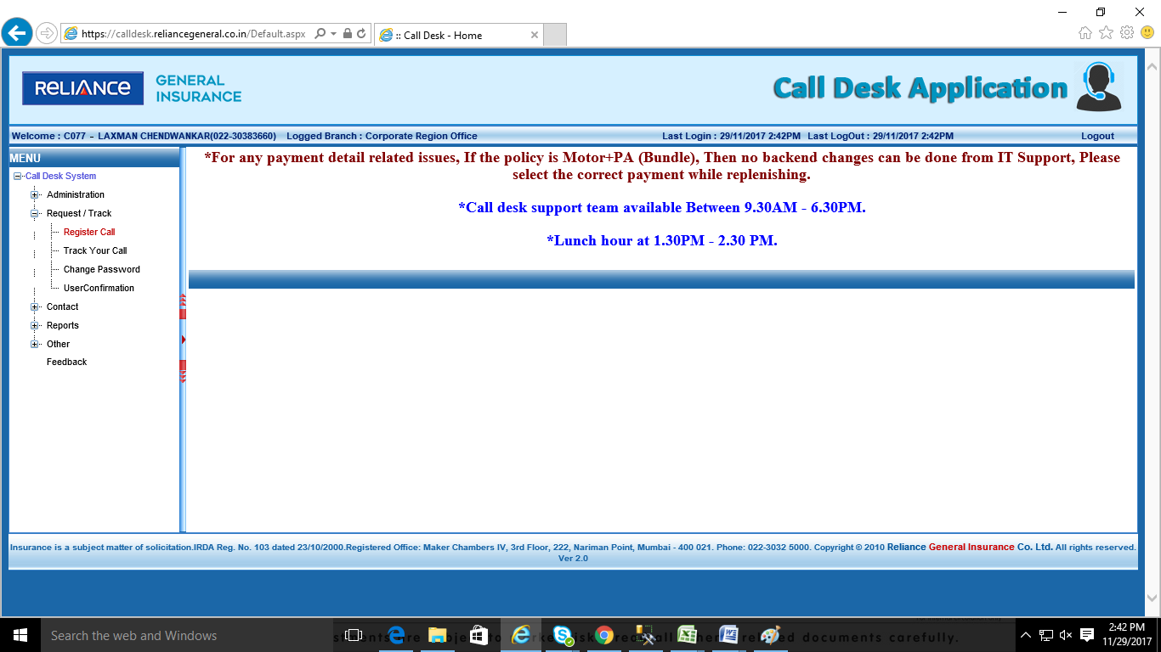

**Step 2 – How to Log a call In Calldesk.**

To register a new call,

1. Please click on expand symbol of **Request / Track** Menu.
2. Then from listed sub menu , click on **Register Call**

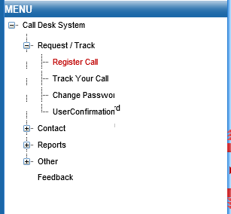

Click on Register Call

Click on + sing to expand the Menu

On clicking Register Call, Home Page will refresh and New Register Call page will be displayed.

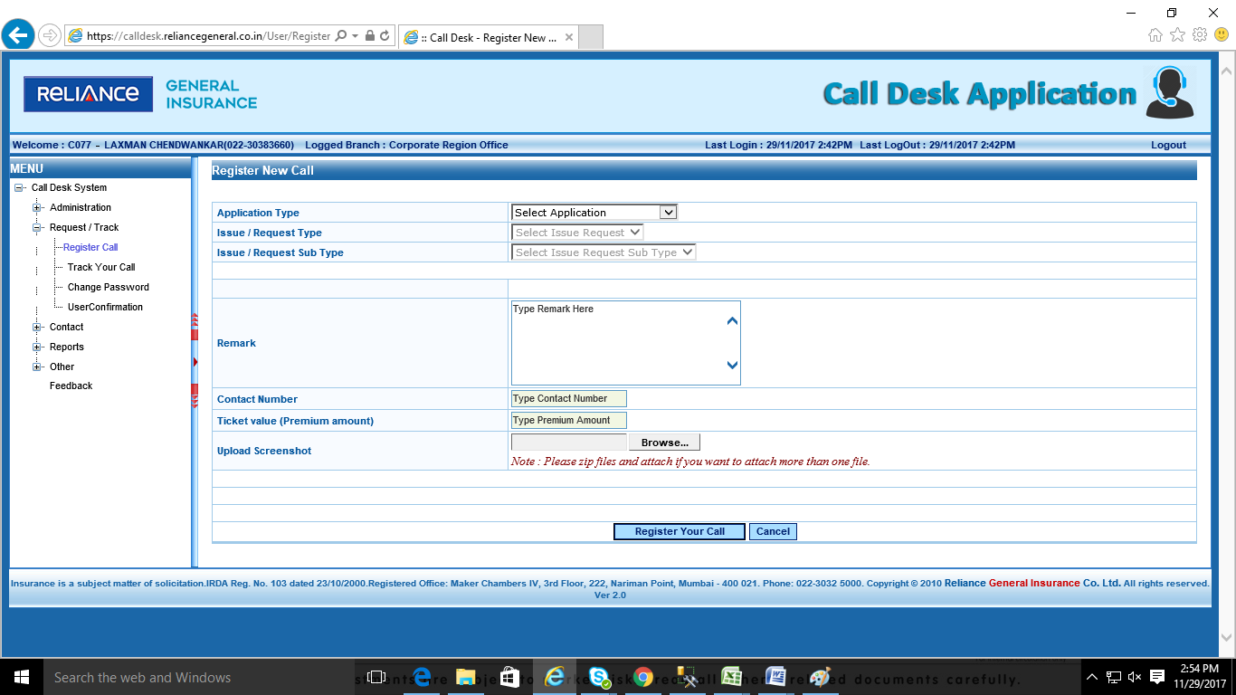

Select values from dropdown for each field.

1. Select the **Application Type** for which the call needs to be register.
2. Select **Issue / Request Type** as the issue faced by the User.
3. Select **Issue / Request Sub Type** on the basis of Main Category.
4. On the selection of Point no. 2 & 4 the description will get Popup for prerequisite and Remark which will describe the Category for which the call is getting logged (for user Understanding) also a template for the data required by Support team.
5. Enter description of error faced in the **Remark Column** (For support team to understand it in a better way)
6. Provide the correct Contact details in **Contact Number** option so that the support team can contact if required.
7. **Upload Screenshot** can be used to upload the error that user is facing as well as to upload template files with required data.
8. Click on **‘Register call’** button to submit the call details.

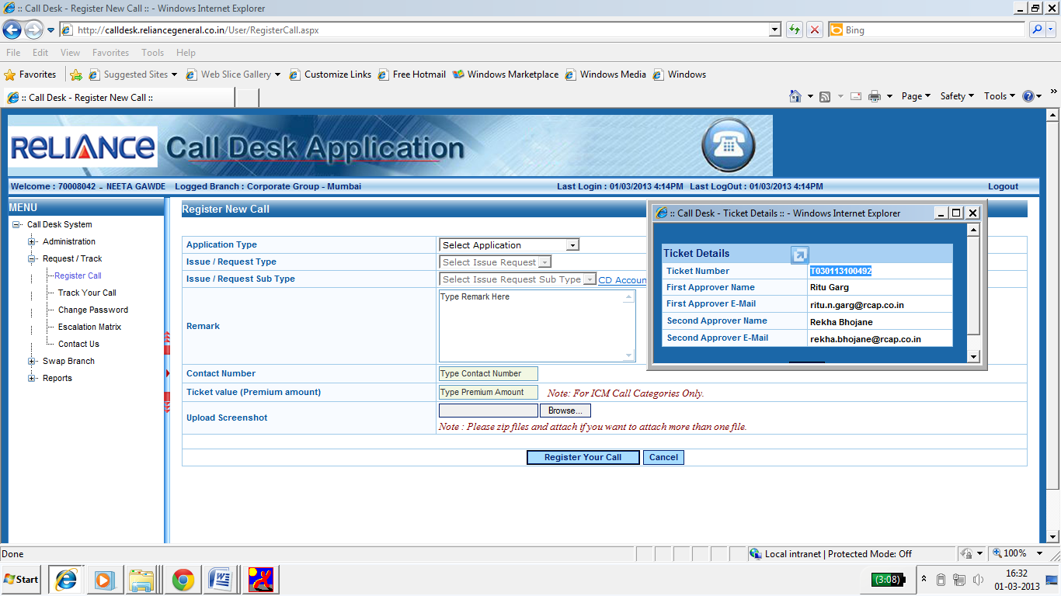

Pop up window with ticket number and approver details.

1. After clicking on Register your call option a Window will get popup providing the **Ticket No** which will start with letter **“T”, “R” Or “M”**.
2. Approver details such as email Id and name will get POP up in the POP massage for User reference.

* A Confirmation mail and SMS with ticket number and other details will be sent to the user once the call is register in call desk.
* For any kind of Follow ups related to call ticket raised in call desk, user needs to provide the ticket number to the support team for Reference.
* System generated email will also provide the expected closed time of the Ticket to understand the TAT assigned to Approver and Support team.

**Step 3 - How to track the raised Call in Reliance Call desk.**

To Track registered call,

1. Please click on expand symbol of Request / Track Menu.
2. Then from listed sub menu, click on Track Your Call .

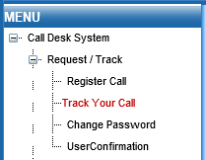

Click on Track Your Call

Click on + sing to expand the Menu

On **Track Your Call** link click, Home Page will refresh and New Register Call page will be displayed.

Search Criteria allows user to track a on the basis of

* Call Date
* Ticket Number
* Call Status
* Policy No.

1. Select Ticket Number from drop down list of search criteria.
2. Enter Ticket Number in Ticket Number Text Box.
3. Click on Track the Call Button.

On **Track the Call** Button click, Data grid will display call details such as Application+ Category, Call date and Call Status. User can get more details of call by clicking on Detail link.

Click on Details link to get all call details

Data grid will display limited ticket details.

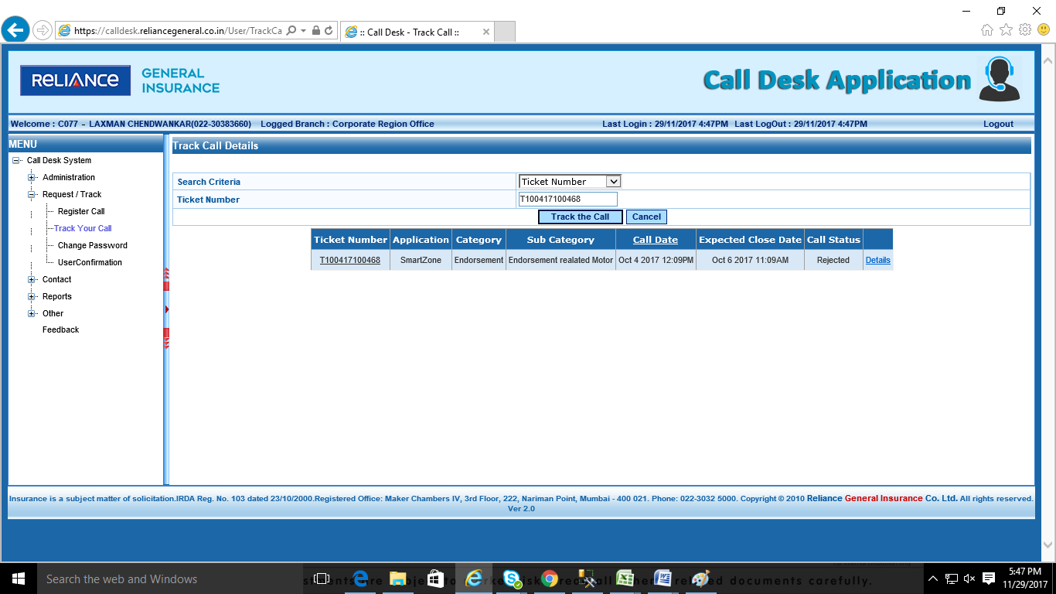

On Details link click, a window pop up with all call details.

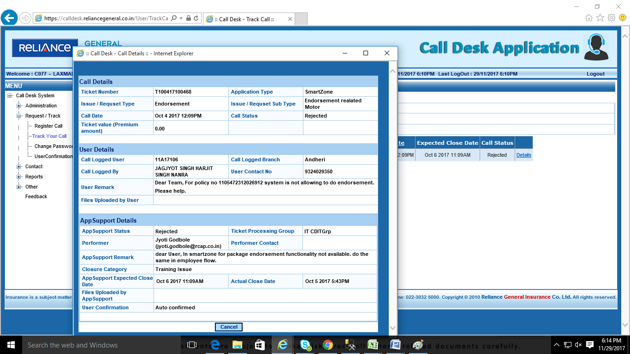

User details section

Pop up window with Call Details.

App Support Details section

1. **Call Details -** Provide the details related to the call that is logged by the user.
2. **User Details -** Provide all the details of the User with the branch/ User Id and remark for any kind of reference.
3. **Approver Details -** Provide the Information regarding the approver who is set for the category for approving purpose. With the Approver status and Expected Closer time (TAT for Approver).
4. **App Support Details -** Will provide the Reliance Support team details such as status and expected Closer time of the call.

**Step 4 - How to Re-open the call.**

If user not satisfied with the resolution provided by support team then user can re-open the call

1. All the calls that are closed from support team with the status as **Resolved,Rejected**  can be re-opened.
2. Re-opened option will be available only for **63 business hours.**
3. On re-opening a new attachment can be attached and new remark can be written with reference to the same call.
4. Call will again go for approval as a Process if approver is set for the category and then post approval will assign to support team Support team.
5. Fresh TAT will be assigned for the Re-opened call.

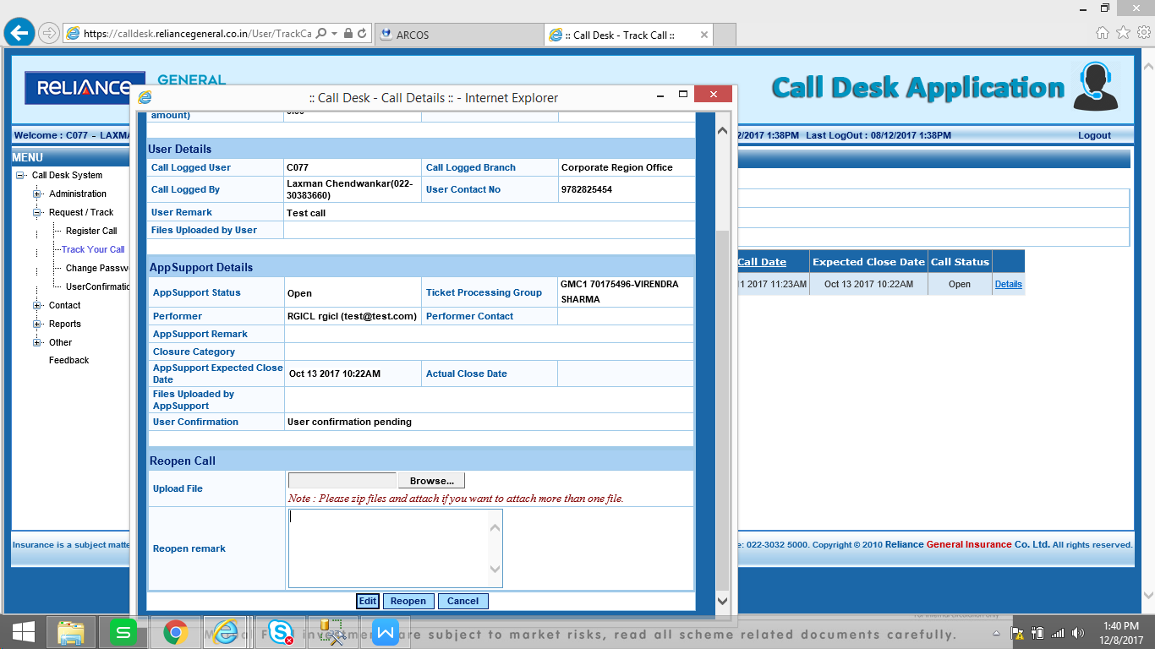

**Step 5 - Reliance Service Desk Contact details & Escalation Matrix**

* **1. Contact details** - For User Convenience Contact details are provided in Reliance call desk on the left hand side Menu. Please refer this to call the respective team member responsible for the application.
* **2. Escalation Matrix** - Issue that are not taken care within the TAT or not closed as per user expectation can be escalated to the respective manager as per level.

