**User Guide**

Reliance Call Desk Management system.

|  |  |
| --- | --- |
| **Reliance Call desk Management** | |
| **Application Name** | **Call Desk V1.2** |
| **Application URL** | **http://calldesk.reliancegeneral.co.in** |
| **Application User's** | **All Reliance employee’s, Agent Etc.** |
| **Production Date** | **26th Feb, 2013** |
| **Updated As on** | **1st Jan, 2016** |
| **Application User’s** | **All RGICL employee, Agents, BAS, Vendors etc.** |

* **IMPORTANT NOTE - :**
* All Employees’ are given access to call desk to raise their application related Queries by raising a Ticket in call desk.
* A Special Support team to attend your Call tickets with assigned TAT.
* Request you to go through the below manual and follow all the steps mentioned and give us an Opportunity to serve you better.
* Any User not having access to call desk can raise a mail to -

"Rgicl.Applnsupport@rcap.co.in.

* Elements that are addressed under this User Manual are - :
* Step 1- How to get access for Reliance call desk application.
* Step 2- How to log a call in Reliance call desk application.
* Step 3- How to Track a call in Reliance Call desk.
* Step 4- How to Re-open your call.
* Step 5- How to contact support team / find escalation matrix.
* **STEP 1 - Call desk Login Page**

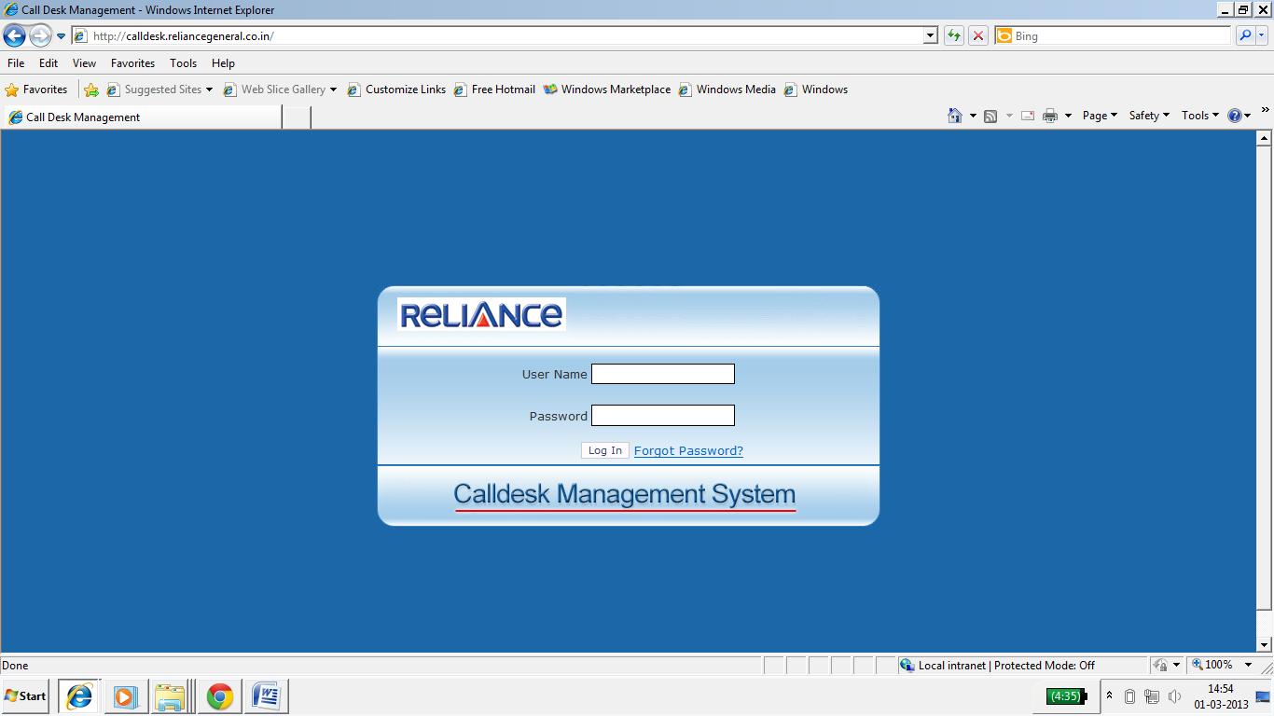

* All employee’s has to login **to** [**http://calldesk.reliancegeneral.co.in**](http://calldesk.reliancegeneral.co.in)
* Please provide your Employee code in User Name.
* Please put default password as **calldesk123** on first time login.

Registrasion Page

* **Forgot Password Option:**

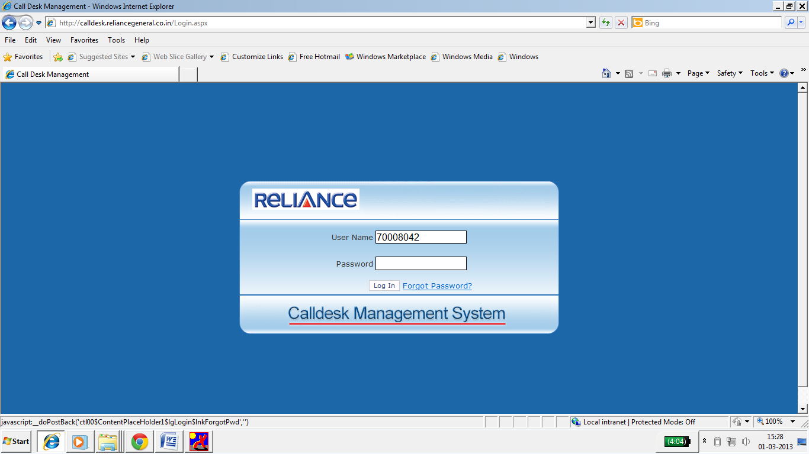

* **Forgot Password Option:**
* If user forgot the login Password of call desk, then user can use forgot Password option provided on Home page / login Page.
* A system generated Password will be sent to the user on his mail id.
* If the mail id is wrong which is register in call desk then please mark a mail to  **"Rgicl.Applnsupport@rcap.co.in”**
* User is requested to change the password by going in Change Password option after login to call desk.

* **STEP 2 – How to Log a call In Reliance call desk.**

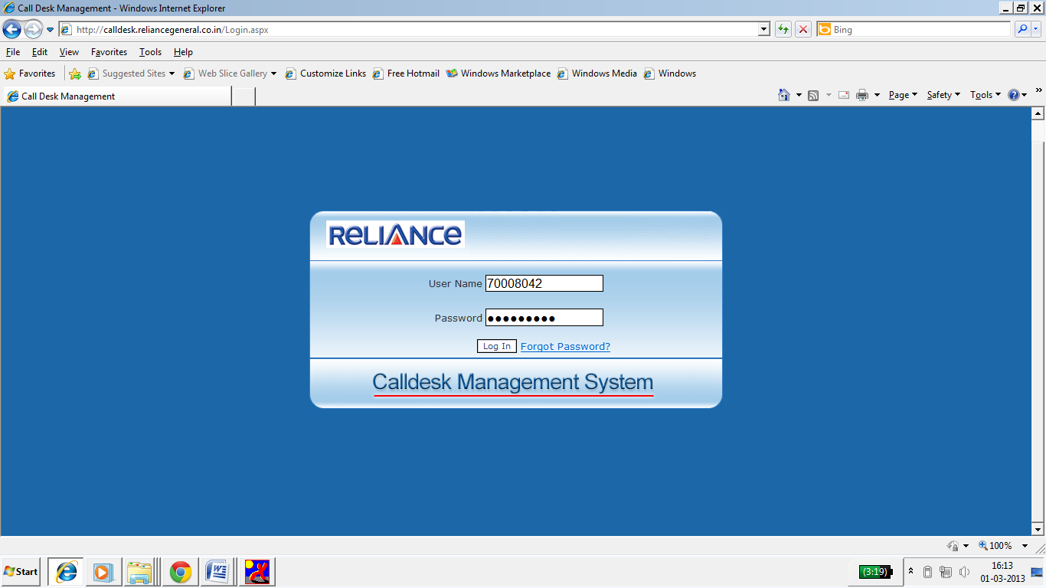

* **Steps to be followed for logging a call in Reliance call desk.**
* Please enter call desk URL- [**http://calldesk.reliancegeneral.co.in**](http://calldesk.reliancegeneral.co.in)
* Enter your User Id as your employee code and Password and click on **LOG IN**.

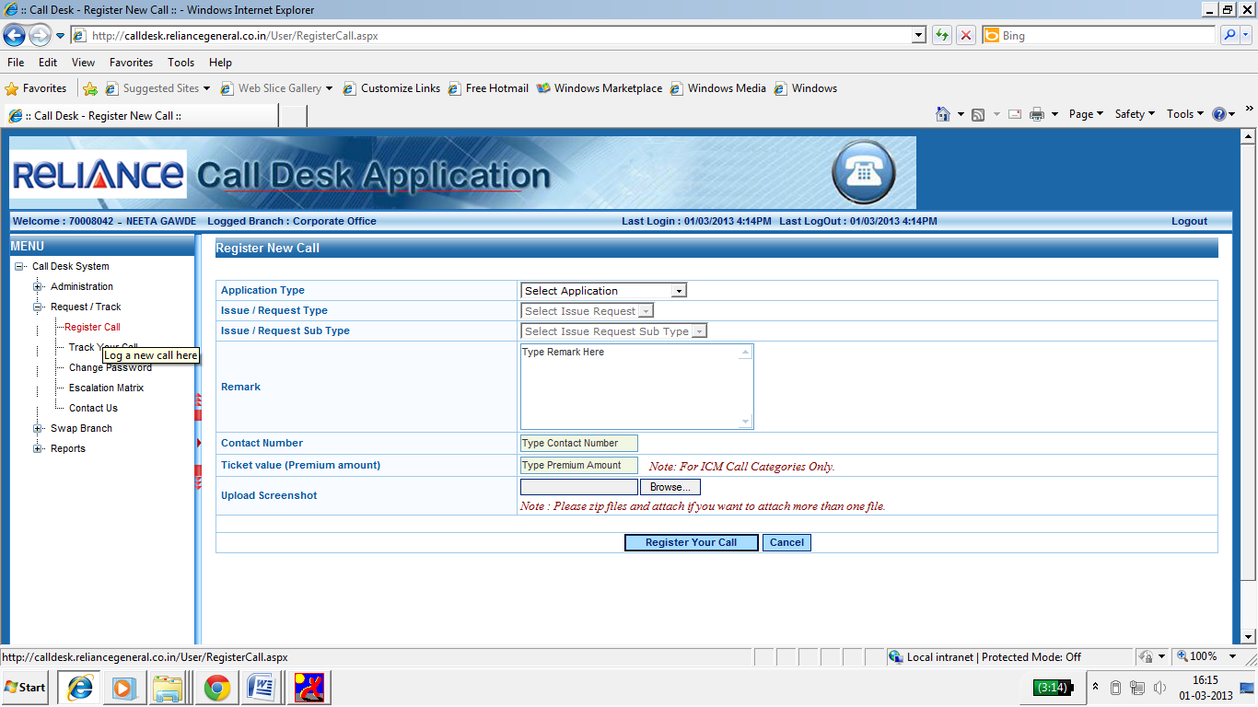

* After login the call registration page will get opened.
* Please click on the **Request / Track** call option.
* Click on Register call option available on the left hand side

Menu’s.

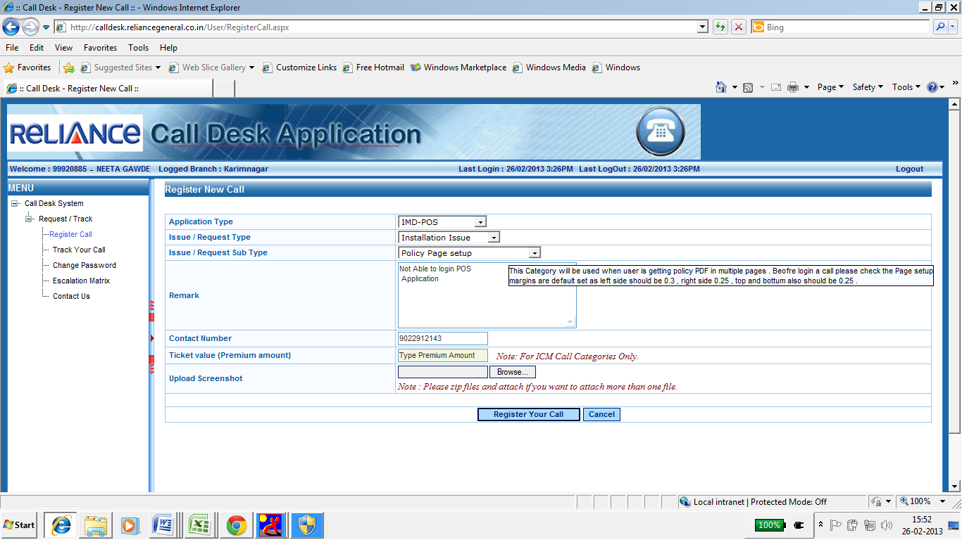

* 1. Select On **Register calls** Option.
* 2. Select the **Application Type** for which the Issue / request needs to be register.
* 3. Select **Issue / Request Type** as the issue faced by the User.
* 4. Select **Issue / Request Sub Type** on the basis of Main Category.
* 5. On the selection of Point no 3 & 4 the description will get Popup which will describe the Category for which the call is getting logged (for user Understanding).
* 6. User needs to describe / explain in details about the issue in the **Remark Column**

For support team to understand it better.

* 7. User Need to provide the correct Contact details in **Contact Number** option so that the support team can give a call if required.
* 8. **Upload Screenshot** can be used to upload the error that user is facing.
* 9. After all the details User need to click on ‘**Register call**’ option for submitting the details.

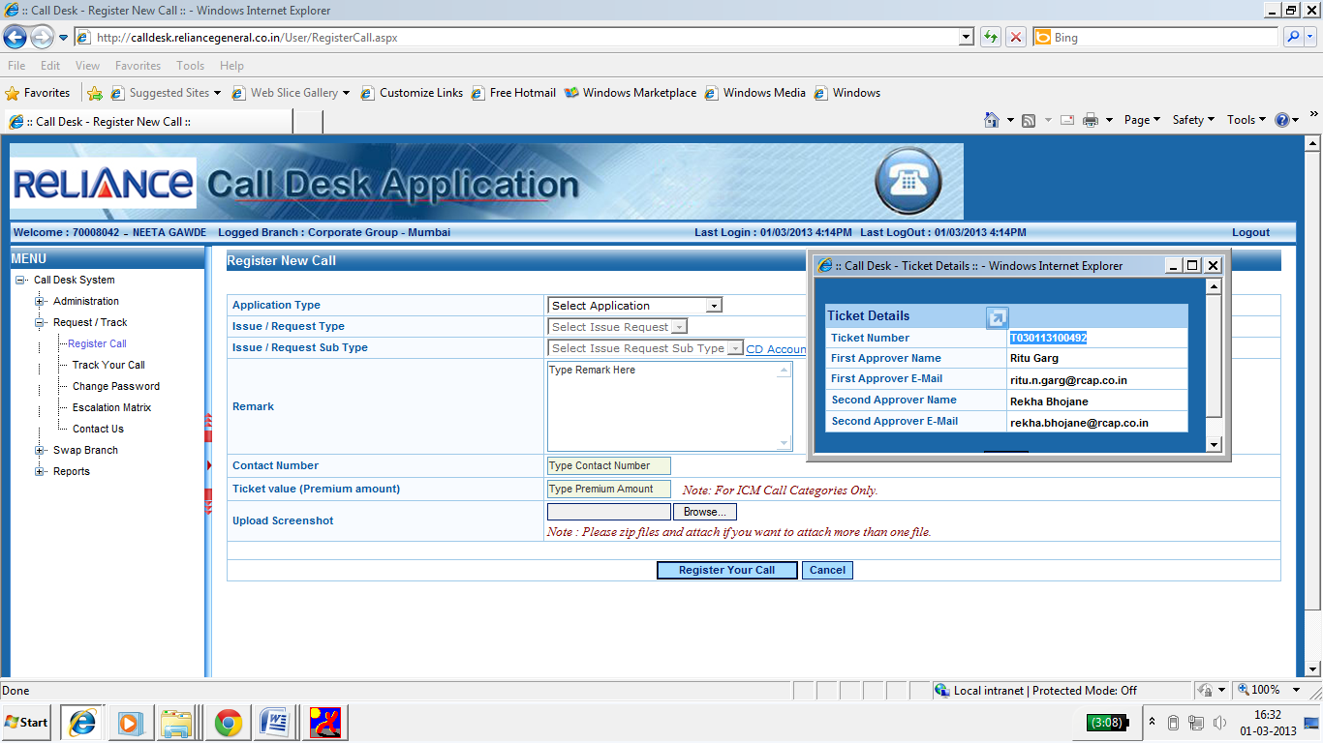

* After clicking on Register your call option a Window will get popup providing the **Ticket No** which will start with letter **“T”** or **“R”**.
* Approver details such as email Id and name will get POP up in the POP massage for User reference.
* A Confirmation mail and SMS with ticket number and other details will be sent to the user once the call is register in call desk.
* For any kind of Follow ups related to call ticket raised in call desk, user needs to provide the ticket number to the support team for Reference.
* System generated email will also provide the expected closed time of the Ticket to understand the TAT assigned to Approver and Support team.
* **STEP 3 - How to track the raised Call in Reliance Call desk.**

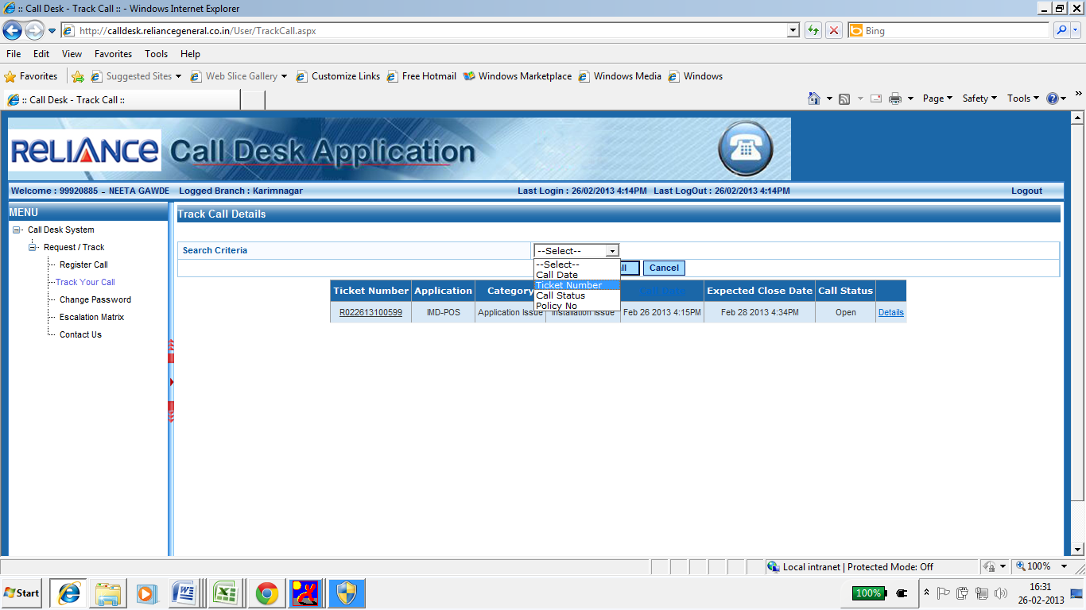

* **How to Track a call in Reliance Call desk.**
* Click on **Track your call** option available the left hand side Manu’s.
* Select the appropriate Criteria from the **search Criteria** option.
* User can search the Call related data on the basis of
* Call date
* Ticket number
* Call status
* Policy No

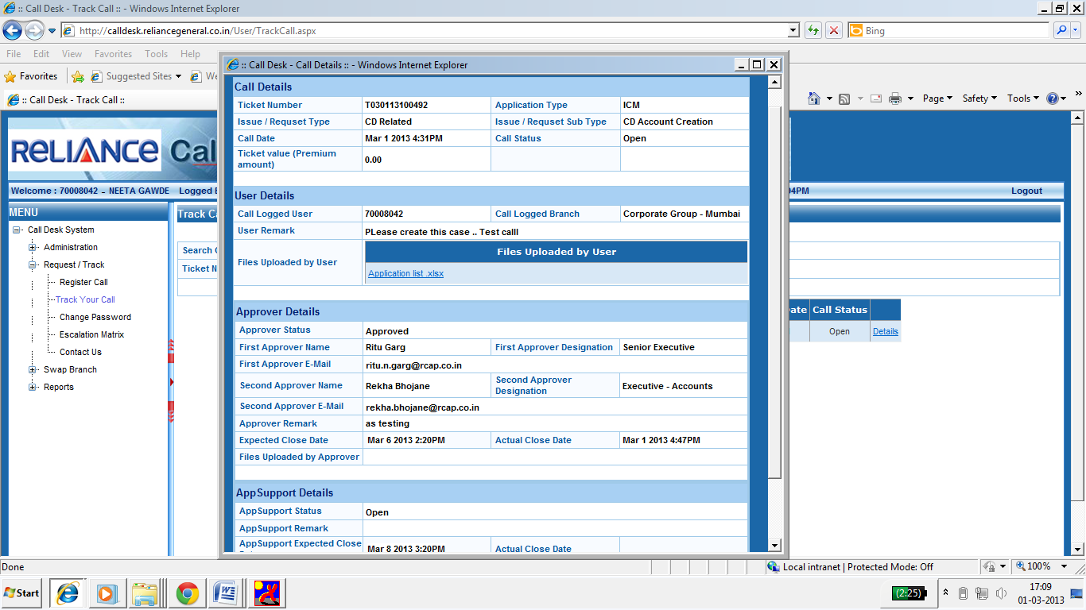

* 1. After the Criteria is selected Click on the **Details** of the Call which is searched on the inputs given, this option will be available on the right hand side.
* 2. Call Details - Will provide the details related to the call that is logged by the user.
* 3. User details - Will Provide all the details of the User with the branch/ User Id and remark for any kind of reference.
* 4. Approver details – Will give the Information regarding the approver who is set for the category for approving purpose. With the Approver status and Expected Closer time (TAT for Approver).
* 5. App Support details - Will provide the Reliance Support team details such as status and expected Closer time of the call.
* 6. After the Approval from the Approver the call will be sent to support Pool to get attended.
* 7. Once the call is Resolved and attended by support team a Confirmation email and SMS will be sent to User.
* **STEP 4 – How to Re-open the call.**

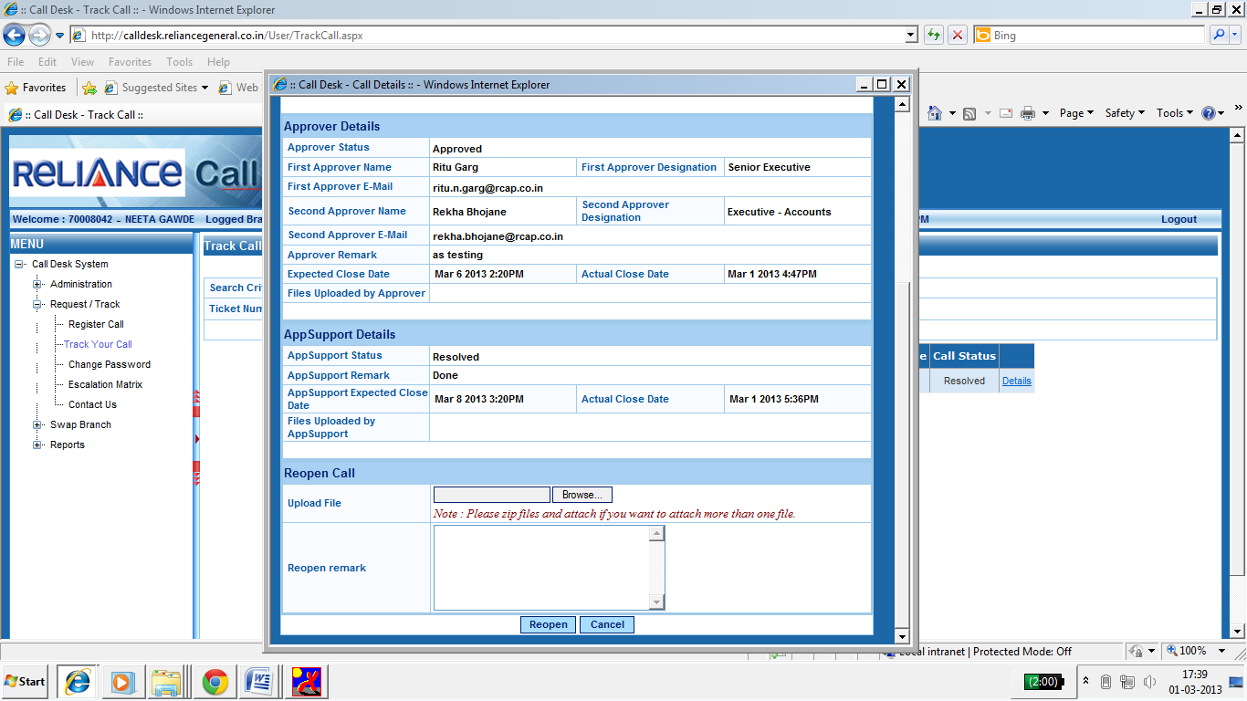

* **How to Re-open the call**
* Search the call and click on **Details.**
* All the call’s that are closed from support team with the status as **Resolved** can be re-opened.
* Re-opened option will be available only for **24hr (business hours)**.
* On re-opening a new attachment can be attached and new remark can be written with reference to the same call.
* Re-opening can be done only if the User is not satisfied with the support Resolution which is provided.
* Call will again go for approval as a Process if approver is set for the category and then to Support team.
* Fresh TAT will be assigned for the Re-opened call.

* **STEP 5- Reliance Service Desk Contact details & Escalation Matrix**

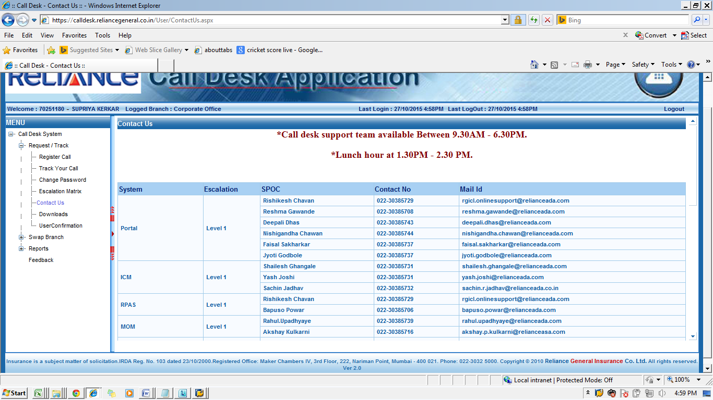

* **1. Contact details** - For User Convenience Contact details are provided in Reliance call desk on the left hand side Menu. Please refer this to call the respective team member responsible for the application.
* **2. Escalation Matrix** - Issue that are not taken care within the TAT or not closed as per user expectation can be escalated to the respective manager as per level.