DO’s AND DON’TS

# Do’s

* **Detailed Inputs to be given while logging a call – Do’s**
* **To Read the Remarks by support team when the call is kept in progress or closed - Do’s**
* **Whenever the call is raised make sure to check the Performer who will be resolving and providing Resolution (By clicking on call details) – Do’s**
* **Please read the call Description before logging a call to have a qualified ticket and get quick resolution – Do’s**

## **Application wise Do’s and Don’ts**

* **ICM**
  + **DO not Open multiple application instance in one browser- Don’ts**
* **Business type and RSD to be checked while accepting the document during in-warding process without fails – Do’s.**
* **For ICM ID unlocking calls contact ops team (for contact person check in call details and Performer) – Do’s.**
* **Change in System categories calls contact respective spocs (for contact person check in call details / Call description for Performer) – Do’s.**
* **Change in business type renewal cases – needs to be cancelled and rebooked - Do’s**
* **Cheque details can be edited before acceptance in ICM for POS / Portal policies – Do’s**
* **For POS / Portal CN and Policy not found in ICM after replenishment – User need to wait for minimum 2 hours before logging a call in Call desk – Do’s**
* **For change in Role/ Location of user category - make sure it is already updated in MOM by HR**

**Before logging a call (attach HR confirmation mail while logging a call) – Do’s**

* **Document upload can be done only up to 300 KB, Any document exceeding more than 300 KB Limit, Split the document and try to upload or archive the file – Do’s**
* **Contact ITIS team regarding Domain Password Reset issue.(On clicking ITIS option user will be routed to ITIS site) - Do’s**

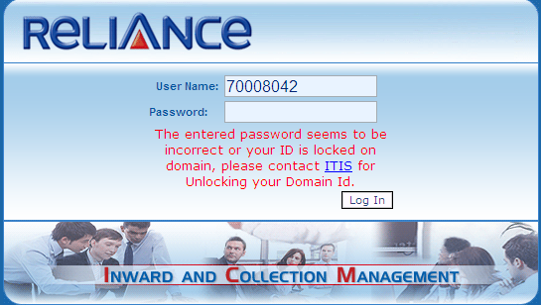

* **Renewal Notice**
* **Contact CO-RN team for any kind of Renewal Notice Queries (for contact person check in call details for Performer ID ) – Do’s**
* **Portal**
* **For processing proposal allocated to Portal (BSM login), Use F5 key to refresh the page in portal as Home or Back Button option is not provided.-Do’s**
* **Until Proposal is not accepted by SM / BSM, Do not log any call in call desk for Proposal related Changes. - Don’ts.**
* **For Portal CN and Policy not found in ICM after replenishment – User need to wait for minimum 2 hours before logging a call in Call desk – Do’s**
* **Cancellation of E-cover note to be followed up with CO- Ops team - Do’s**
* **Cancellation of unpaid Policy to be followed up with Underwriting Team – Do’s.**
* **DO not open multiple application instances in one browser- Don’ts.**
* **Request raised for changes under cash to cheque / cheque to cash**

**Recommendation:**

1. **While issuing policy, select the payment option as “IN FAVOR OF AGENT”**
2. **During Replenishment choose payment from option as “CUSTOMER”**

* **RPAS**
* **Contact ITIS team for all Password Reset issue – Do’s.**
* **All Issues / Updation related to Nil dep rates, NCB retention, OD Discount updations take it up with underwriting Team – DO’s**
* **POS**
* **Always do the application sync before quotation/policy issuance - Do’s**
* **While running pos application POS key should be connected to the PC - Do’s**
* **While installing POS application keep antivirus and firewall settings to be "Turned OFF" - Do’s**
* **While logging a call in call desk please share pos key no and error screen shot for the reference - Do’s**
* **Related to re installation / SM mismatch /payment not approved , please contact sales manager before logging a call in call desk - Do’s**
* **Any assistance or Guidance refer the FAQ available in POS application – Do’s**
* **For POS CN and Policy not found in ICM after replenishment – User need to wait for minimum 2 hours before logging a call in Call desk – Do’s**
* **Do not select the PAY TO OPTION as “self "in customer payment case – Don’ts**
* **Do not re-install POS application without confirmation from IT support team – Don’ts**
* **MOM**
* **Agent code should be updated in SAP before raising a call in call desk for SM vendor mapping in MOM – Do’s**
* **For CSO, DEO and Employee Related issue contact HR Team – Do’s**
* **Vehicle Related issues contact Ops Team (Shashikant Ambre - Corporate Office**.**) –Do’s**
* **For change in Branch Address contact (Admin Department- Somnath Kadam) – Do’s**
* **For any updation of IMD contact number, Mail ID and PAN No log a call in SAP Application (**chandrakant.misale@rcap.co.in**) –Do’s**
* **For any updation of IMD contact number, Mail ID and PAN No Do not log a call in MOM for IT –Don’ts.**