

- System Information
Reliance Call Desk is an IT support  software that provides the easiest  way to reach Application Support  Team and serve you better. | 

 IMPORTANT NOTE:

- All Users’ of POS and IMD Portal can raise their issue through Reliance call desk Application.
- A Special Support team to attend your Call tickets with a minimal time.
- SMS and Email facility Confirmation on Call raised and once resolved.
- Facility to Track all your Issue that are raised in call desk.
- Facility to know the expected Closer time of your raised call.
- Facility to Re-open your call if satisfactory resolution is not provided.

Call desk Login Page

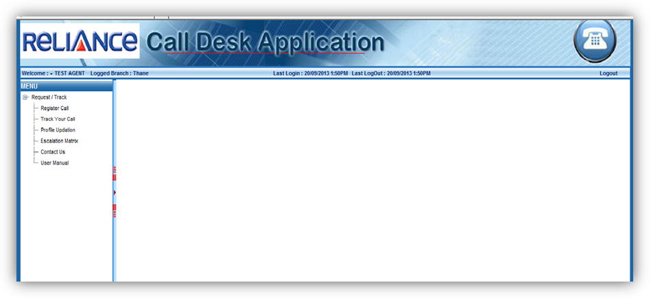

Note:
  - All IMD’s after clicking on Call desk Option made available in
POS and IMD PORTAL System will route you on the above page of call desk.
How to Log a call in Call desk

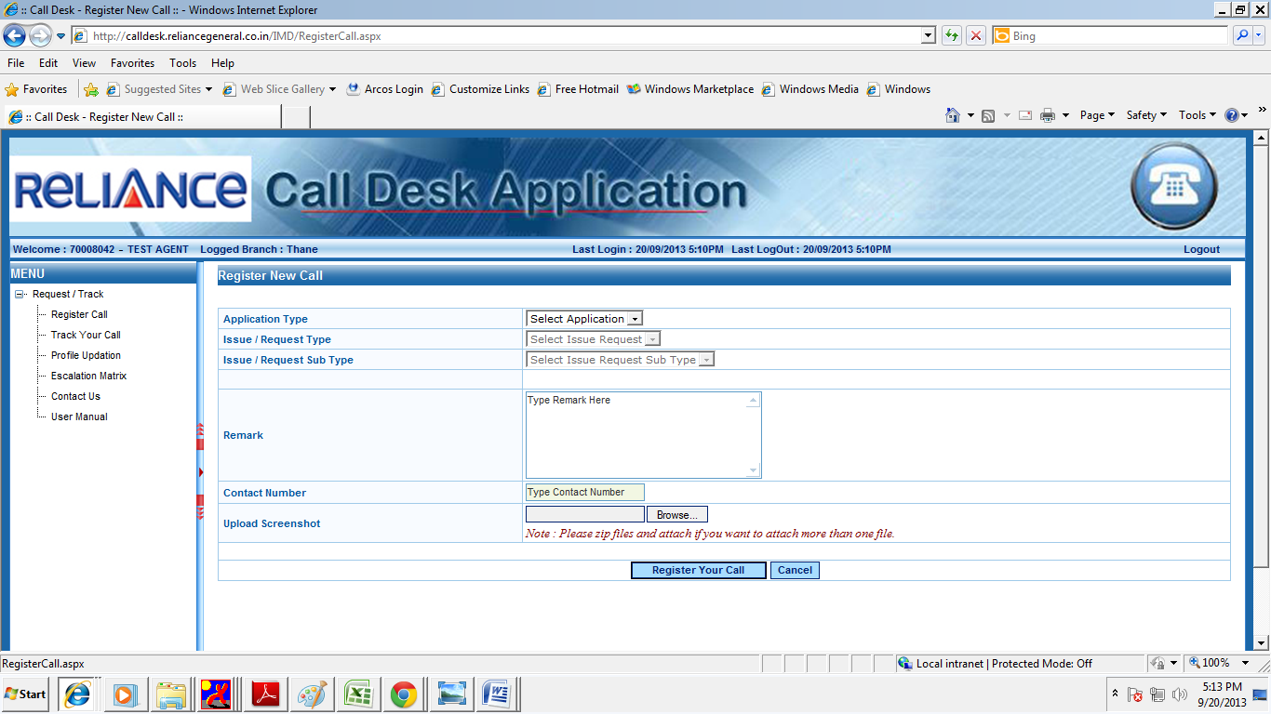

STEPS:
- After login the call registration page will get opened.
- Please click on the Request / Track call option.
- Click on Register call option available the left hand side for the Menu’s available

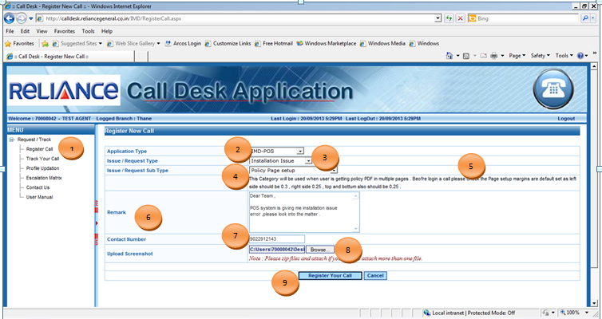
STEPS:
- 1. Select On Register Calls Option.
- 2. Select the Application Type as POS user - POS / Portal User - IMD PORTAL.
- 3. Select Issue / Request Type faced by the User.
- 4. Select Issue / Request Sub Type on the basis of Main Category.
- 5. On the selection of Point no 3 & 4 the description will get Popup which will describe the Category for which the call is getting logged (for Understanding).
- 6. User needs to describe / explain in details about the issue in the Remark Column.
For support team to understand the issue better.
- 7. User Need to provide the correct Contact details in Contact Number option so that the support team can give a call if required.
- 8. Upload Screenshot can be used to upload the error that user is facing or any relevant data needs to be uploaded.
- 9. After all the details User need to click on Register Call option for submitting the details.

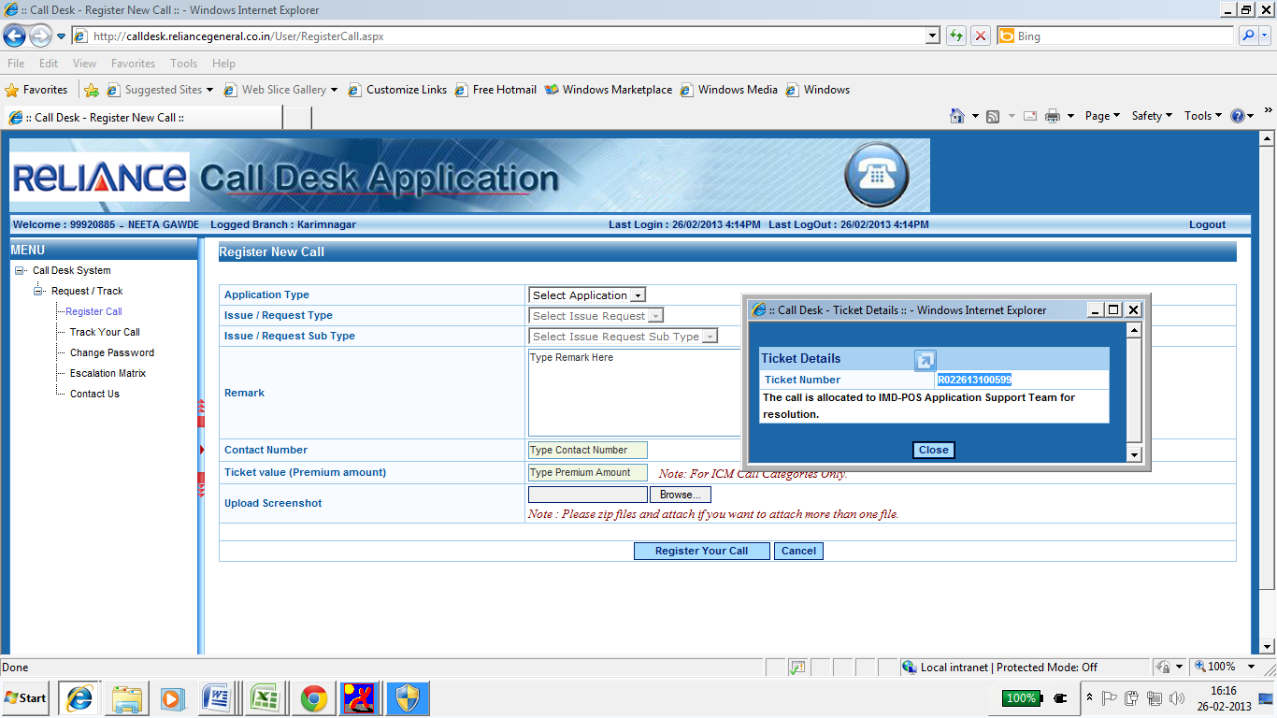
1

STEPS:
- After clicking on Register your call option the Window will get popup providing the Ticket No which will start with letter R.
- Once the call is Register the same will be sent to the support team to get Resolved.
- A Confirmation mail and SMS will be sent to the user on Call register.
- When User call the support team for any kind of Clarity or Support, please also Provide the Ticket No for Reference.

How to track the raised call

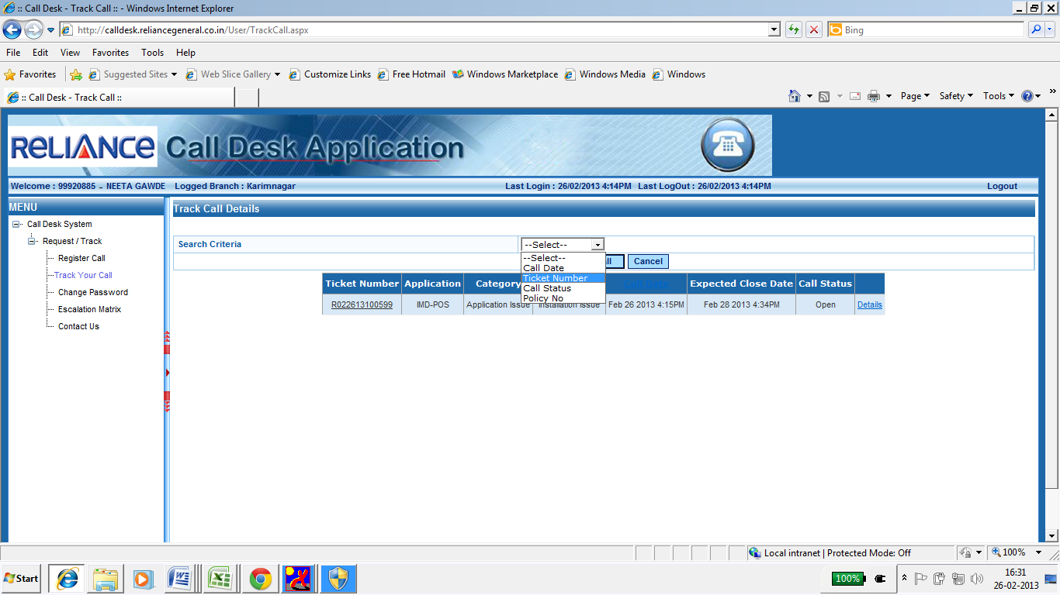
1
2
STEPS:
- Click on Track your call option available on the left hand side Manu’s.
- Select the appropriate Criteria from the Search Criteria option.
- User can search the Call related data on the basis of
- Call date
- Ticket number
- Call status
- Policy No (if mentioned in the Remark )

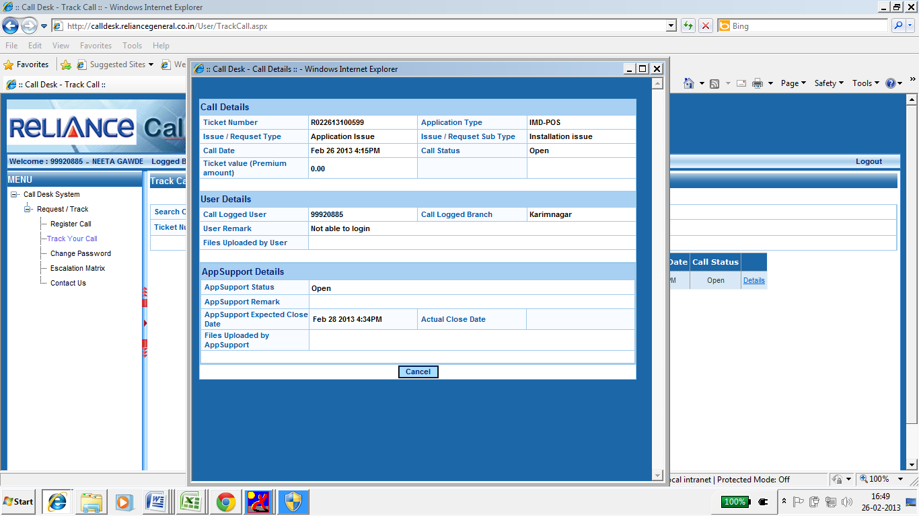
1
3
2
4
STEPS:
- 1. After the Criteria is selected Click on the Details of the Call which is searched on the inputs given, this option will be available on the right hand.
- 2. Call Details - Will provide the details related to the call that is logged by the user.
- 3. User details - Will Provide all the details of the User with the branch /User remark and User Id.
- App Support details - Will provide the Reliance Support details.
- User can get the expected Closer date and time for every call.
- Once the call is Resolved and attended by support team a Confirmation mail and SMS will be sent to User.
Call can be re-opened by user within 24hr (Business Hr) if it is found to be unresolved.

Update Profile Option

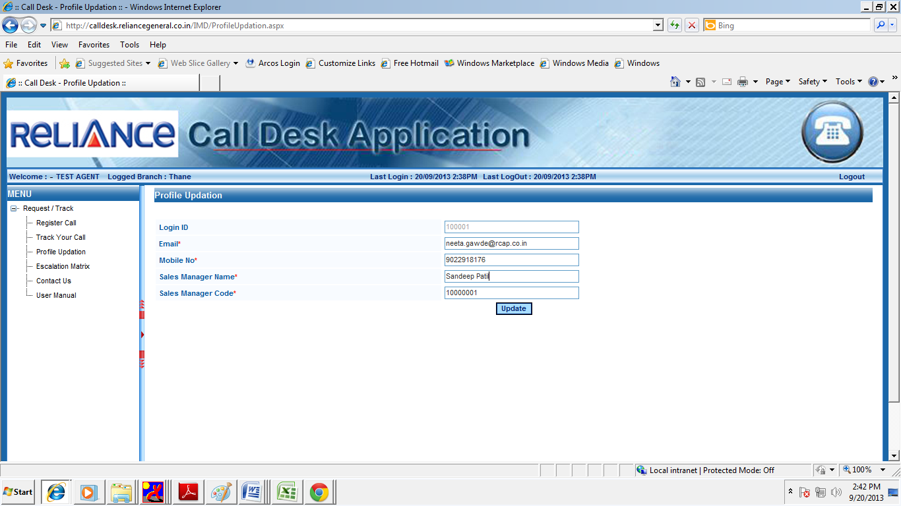

STEPS:
- Users are supposed to go and Update their profile with the updated mobile no and email Id.
- This profile will be limited only for Call desk purpose.
- Any change in the Mobile no or email Id can be updated in the update profile link.
- Email Id available in the Update Profile link will be used for sending call desk Email confirmation.

How to Contact Reliance Support Team

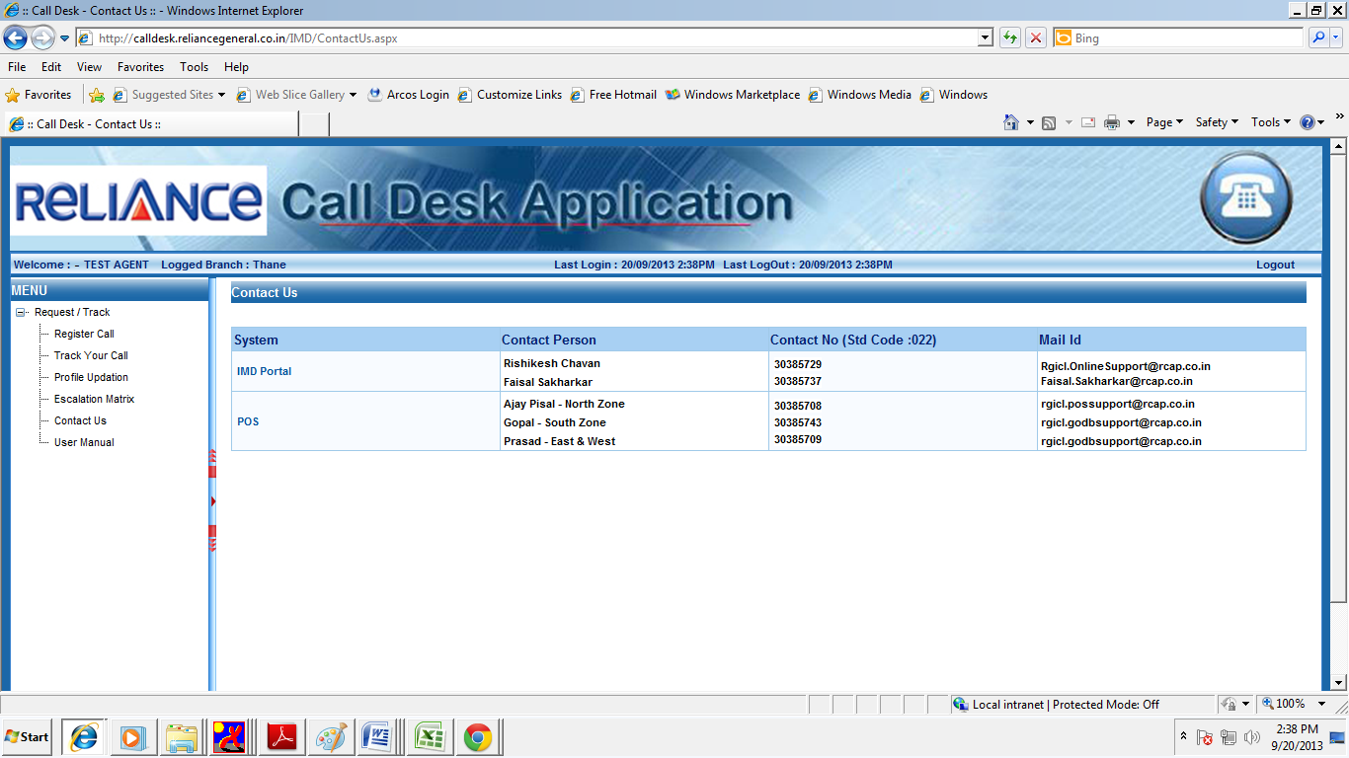
STEPS:

- Contact Details - For User Convenience Contact details are provided in Reliance call desk on the left hand side Manu’s.
- Escalation Matrix - User can also escalate the Matter to the respective Manger as per the Level mentioned for issue not taken care within the expected Closer time / Issue resolved wrongly.

