<https://leetcode.com/problems/sort-colors/>

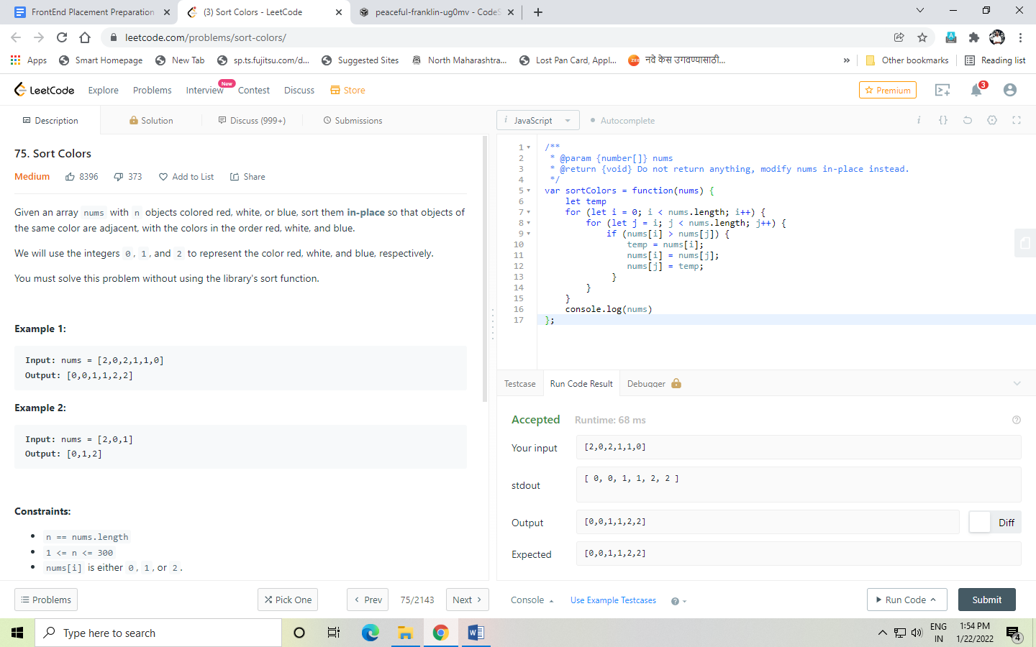

<https://leetcode.com/problems/longest-consecutive-sequence/>

