ABLESPACE — CHROME TEST REPORT
Caseload, Student, Goal, Data Capture & Responsive UI
Application | AbleSpace — Caseload
Tester | Chetan Dodal
Test date shown in screenshots | 15 October 2026

1. Objective
Review the supplied screenshots to document the visible Chrome workflow for the AbleSpace Caseload application, including student creation/editing, goal setup, data capture, notes, graph, statistics, information, goals list, and service time.

2. Test Environment
- Browser: Google Chrome
- Operating system: Windows (visible in screenshots)
- Responsive tooling: Chrome DevTools Device Mode
- Mobile viewport shown in the earlier screenshot: approximately 425 × 1134 pixels
- Session shown in the application: 15 October 2026, 02:30 PM–03:00 PM; another session was logged at 02:47 PM

3. Test Results Summary
Status is based on the user-provided screenshots. PASS means the relevant page, control, or result is visibly present and the described workflow is represented in the evidence. It does not mean every possible interaction or every browser has been independently retested.
Test case | Evidence reviewed | Status | Result
Caseload / student list | QATest QAlast and two demo students appear in the list; navigation and actions are visible. | PASS | Student list rendered.
Add Student / student record | Add Student workflow and the resulting QATest QAlast row are shown. | PASS | Test student appears in Caseload.
Edit Student | Edit Student form shows First Name and Last Name fields populated. | PASS | Edit form is visible with values.
Create Reading Accuracy goal | Goal title and description appear in View Data and Goals. | PASS | Goal appears with task details.
Take Data / select task | Capture screen shows Option 1 selected for the Reading Accuracy goal. | PASS | Task selection is represented.
Save data / Stats | Stats shows a session entry and Option 1 at 100% completion. | PASS | One recorded entry is displayed as 100%.
Graph | Graph view displays a bar reaching 100% for the recorded date. | PASS | Graph renders the recorded result.
Info / data points | Info shows Task Analysis, last updated 10/15/2026, and Data Points: 01. | PASS | Information panel displays one data point.
Notes | Notes panel shows the QA testing note; Info shows Notes Count 02 in the supplied workflow. | PASS | Notes are visible; count shown as 02.
Goals list | Goals page shows Reading Accuracy and other existing goal rows. | PASS | Goal list is visible.
Service Time | Service Time list displays sessions, attendance states, and duration values. | PASS | Session rows and values are visible.
Mobile Caseload view | Chrome DevTools mobile emulation screenshot shows the student list, search, Add Student and Take Data controls. | PASS — visual check | Visible controls fit the displayed phone viewport; deeper mobile interactions were not all shown.

4. Key Observations
- The test student QATest QAlast is visible in the Caseload list alongside Demo Student1 and Demo Student2.
- The Reading Accuracy goal description states that the student will read a short passage and answer comprehension questions with 80% accuracy across 4 out of 5 attempts.
- The Capture screen shows one task named Option 1. The Stats screen later shows the recorded task at 100% for the displayed session.
- The Graph view renders a 100% bar for the recorded date.
- The Info view shows Measurement: Task Analysis, Last data updated on 10/15/2026, Data Points: 01, and Notes Count: 02.
- The supplied mobile-emulation screenshot shows the Caseload list and its primary controls in the viewport. Full end-to-end mobile interactions should be considered covered only where the screenshots show them.
- A Chrome DevTools screenshot previously showed “Paused on exception — TypeError: Illegal invocation” in a minified JavaScript file. The screenshot alone does not prove that this exception breaks normal application use; investigate separately if it occurs during normal actions.

5. Browser and Device Scope
Browser / view | Status | Evidence / scope
Google Chrome desktop | PASS — screenshot review | Caseload, goals, View Data, Graph, Stats, Info, Goals list, Service Time, and Edit Student screenshots reviewed.
Google Chrome mobile emulation | PASS — visible layout check | Caseload list and primary controls are visible in the supplied 425 px-wide emulation screenshot.
This report is limited to Google Chrome evidence supplied by the tester. Firefox, iPad/tablet, and other browsers/devices are intentionally omitted because no results for them were provided.

6. Conclusion
The supplied Chrome screenshots support PASS for the listed visual/workflow checks: the student record is visible, the Reading Accuracy goal is present, a task was selected and recorded, Stats and Graph display the recorded result, and the Info, Notes, Goals, Service Time, and Edit Student screens are visible. The mobile result is a visual layout check of the Caseload page rather than proof that every feature was exercised on a phone.

Appendix A — Screenshot Evidence
Screenshots supplied for this report are included below as evidence.
Caseload — student list and main navigation
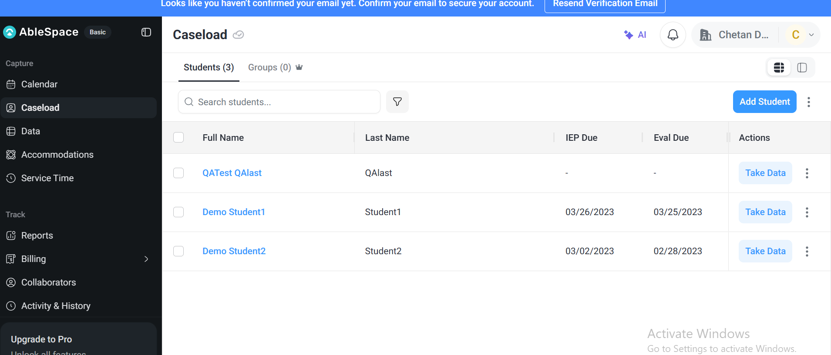
View Data — Reading Accuracy goal and overview
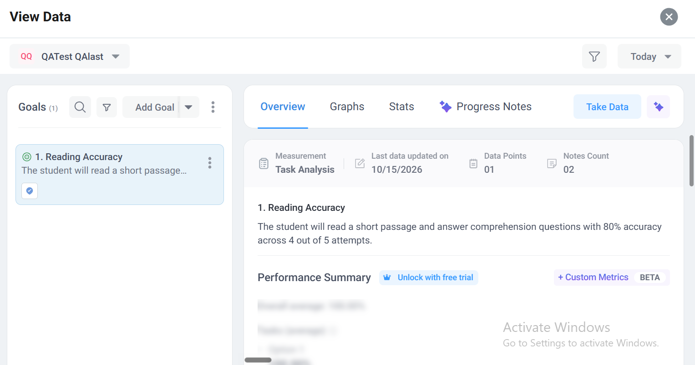
View Data — Graph result
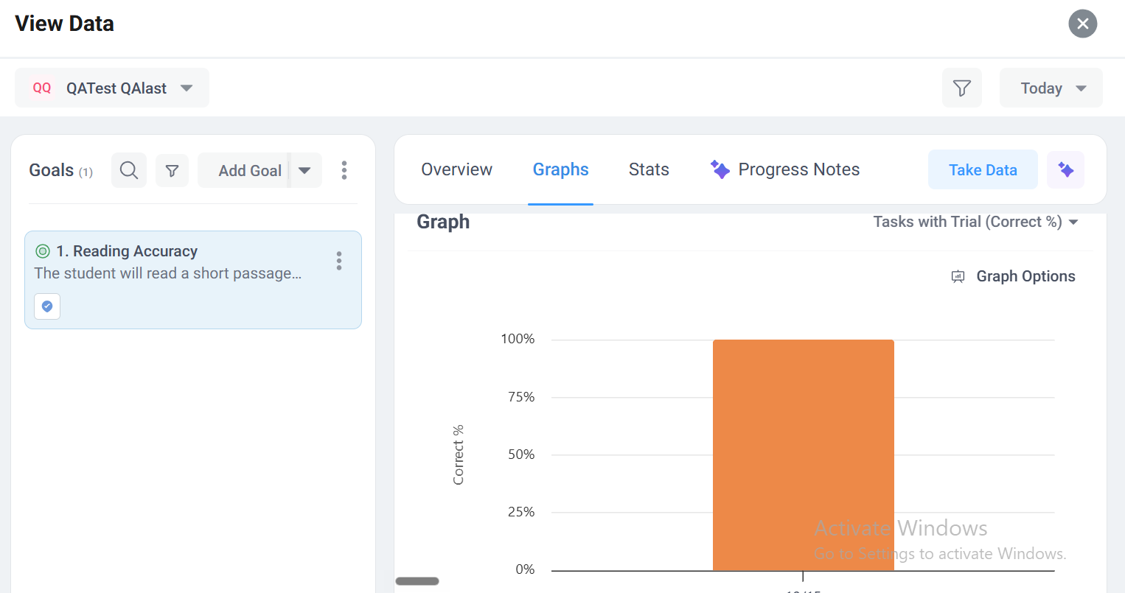
View Data — Stats and recorded sessions
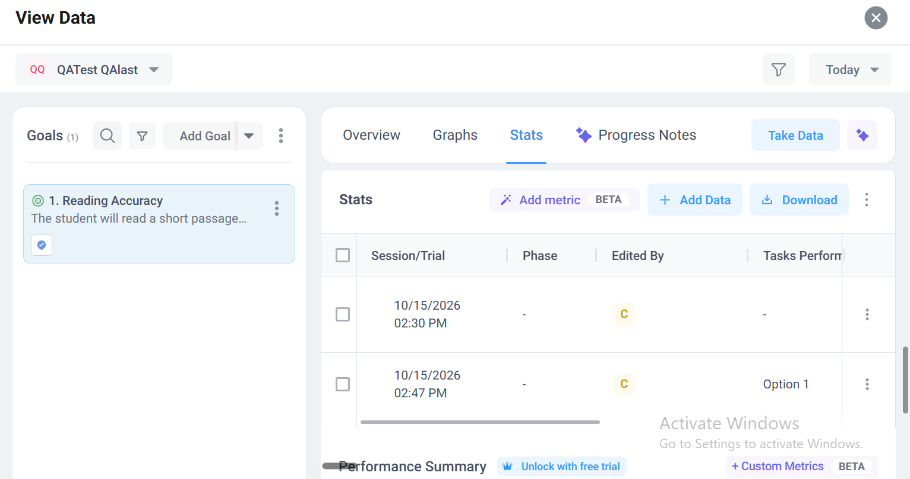
Goals — goal description and task details
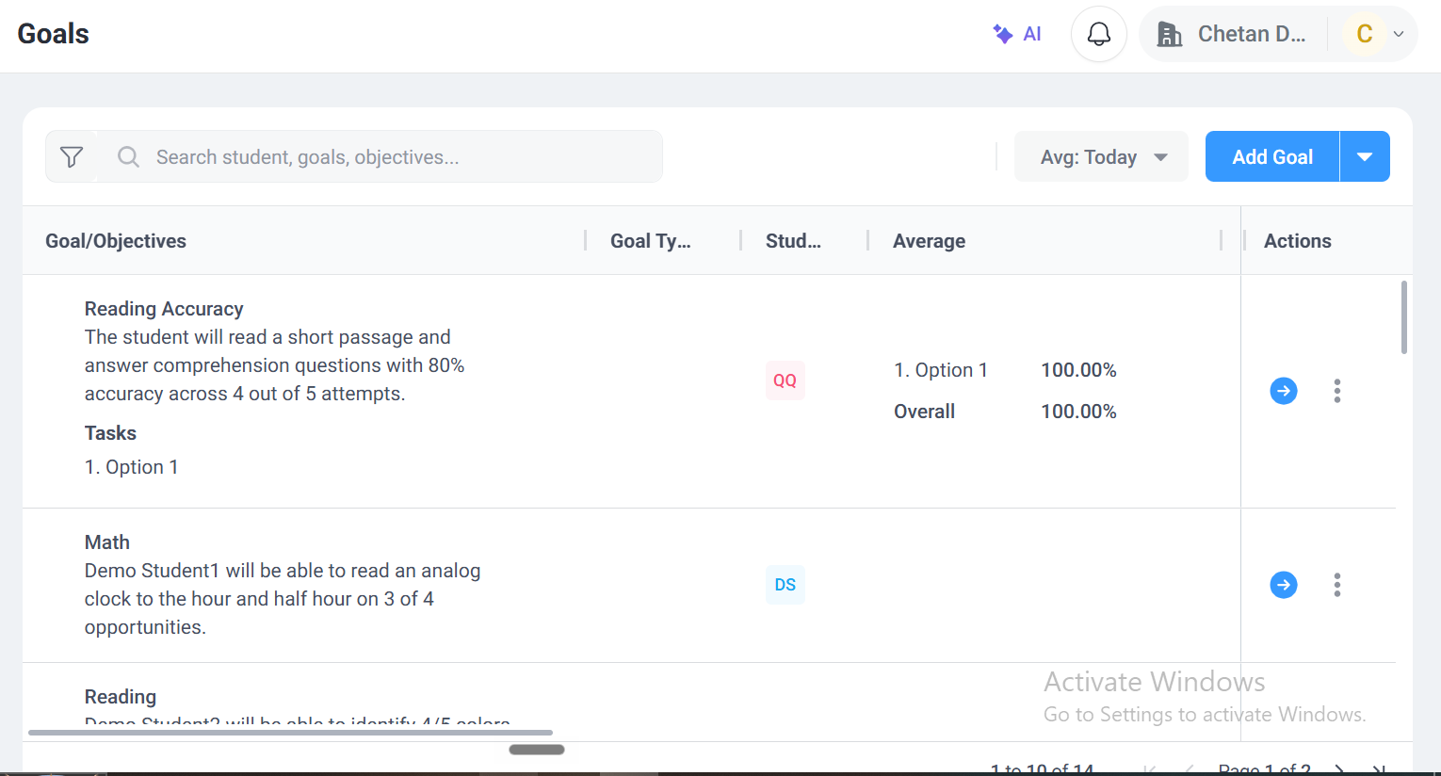
Service Time — session and attendance list
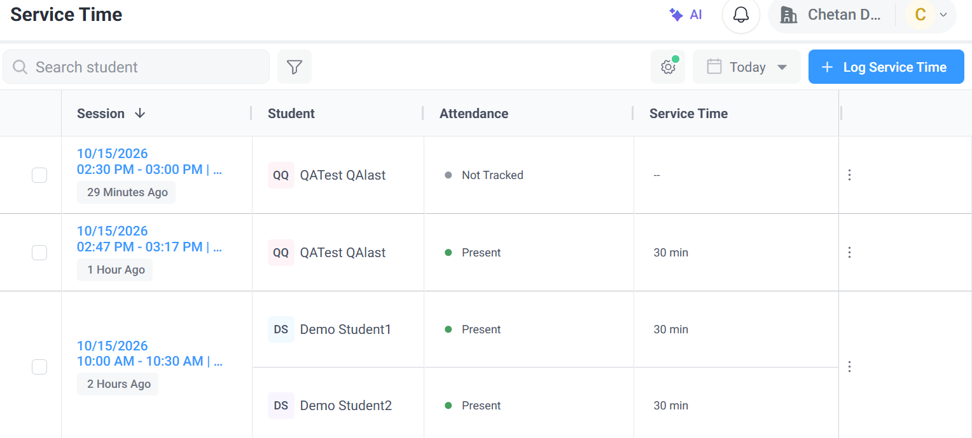
Edit Student — student details form
