1. **Access Data FTK Imager image capturing of Secondary storage and primary storage.**
2. **Secondary storage**

* **First we have open ftk imager software then select file >> create disk image open**

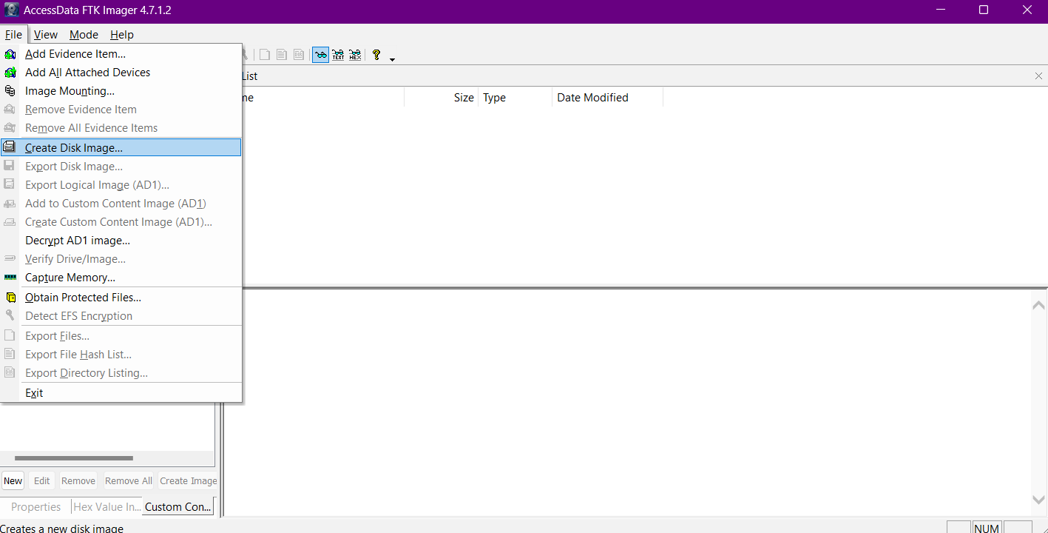

* **Now we have select physical drive for creating image file of Secondary storage**

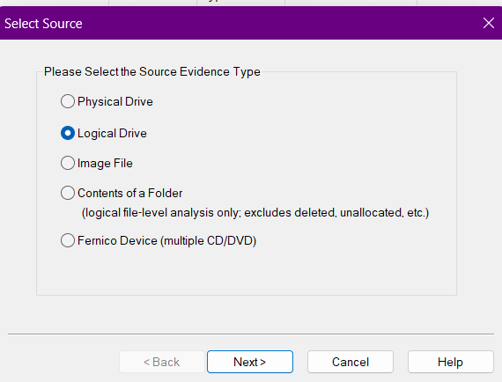

**Then we have to next >> select secondary storage and then finish**

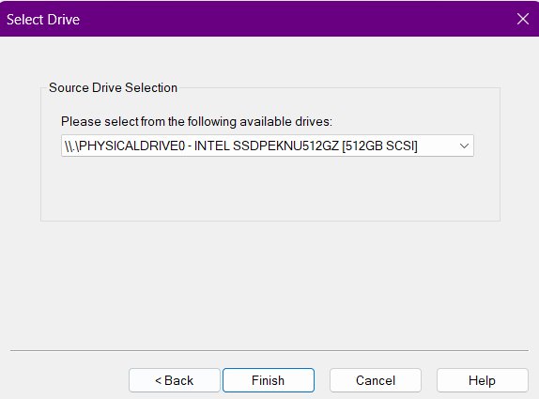

**Then we have to select image file destination where our image file will be save for that we have click on “add” button then we have select image file type**

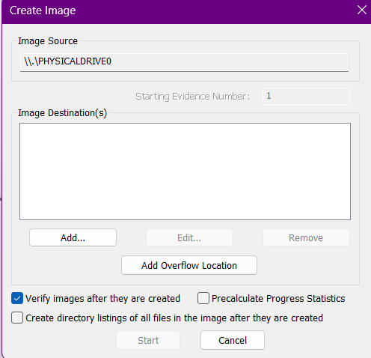 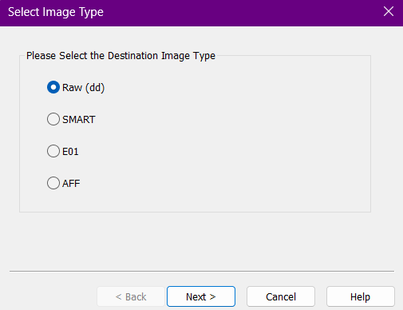

After that we have to select case number, name and location of the our image file and then click on to finish button and them click on start

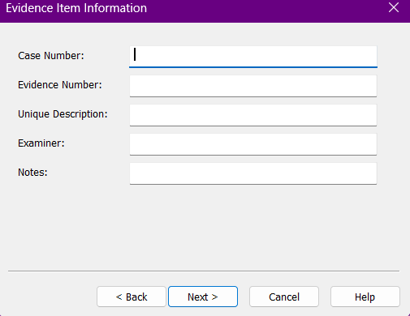 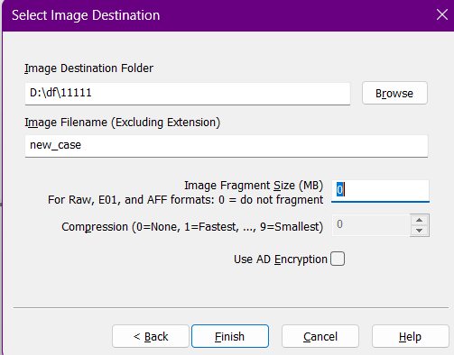

1. **Primary storage**

* **Go to File > Capture Memory.**

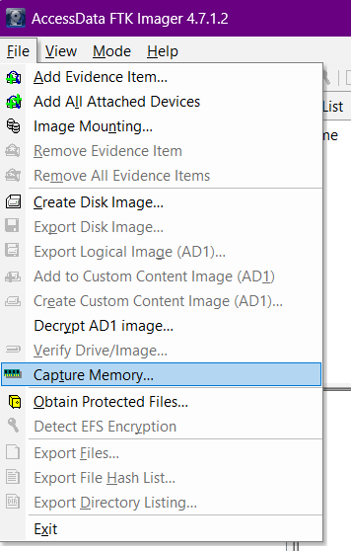

* **Select Output File Location:**
* **Choose the location where you want to save the RAM dump**

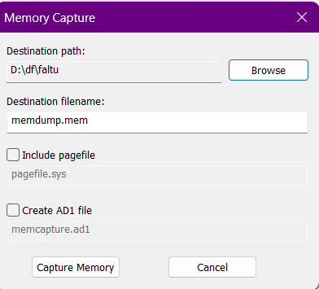

* **After we have click on capture memory button.**

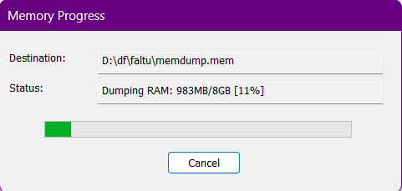 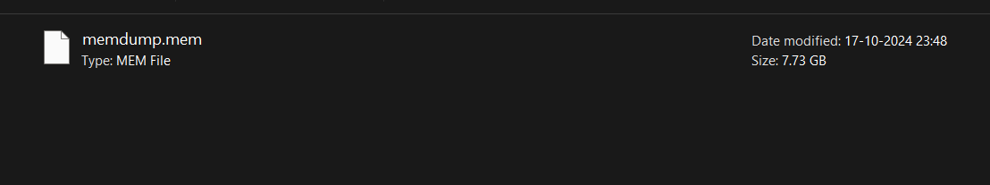

1. **Autopsy.**

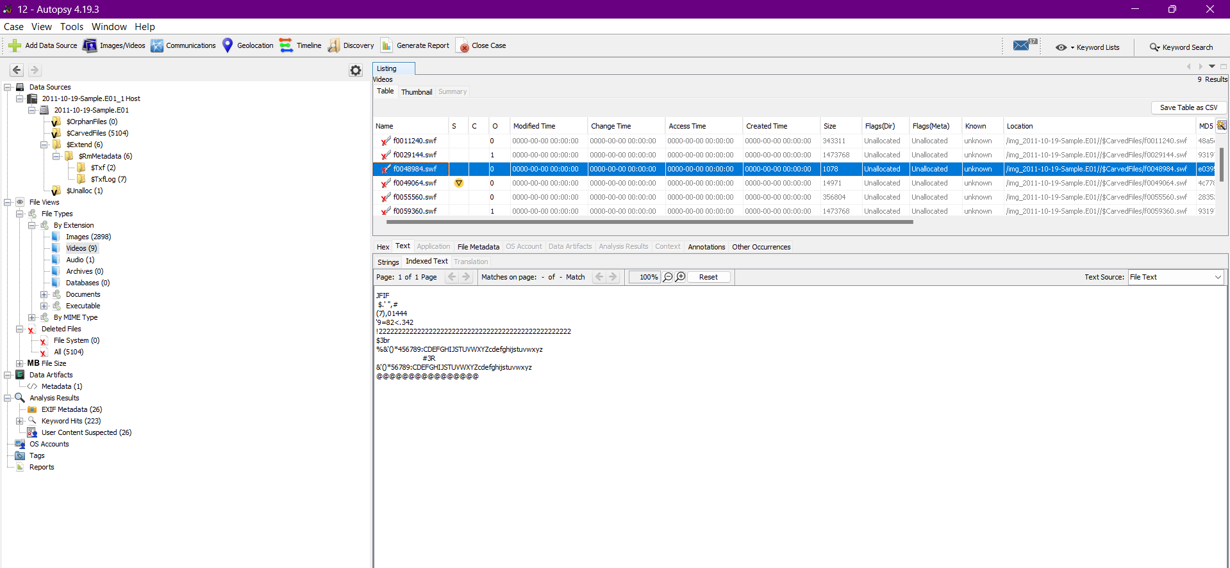

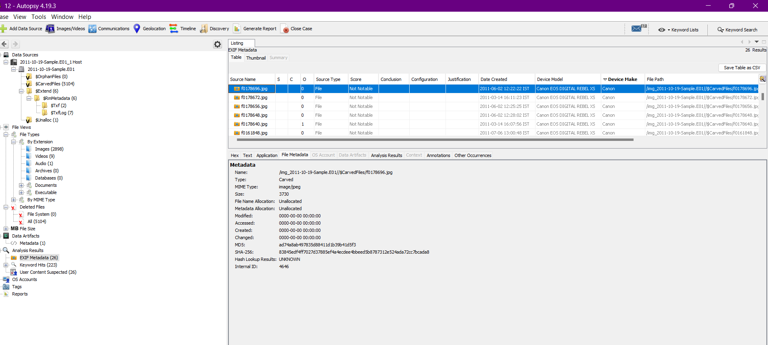

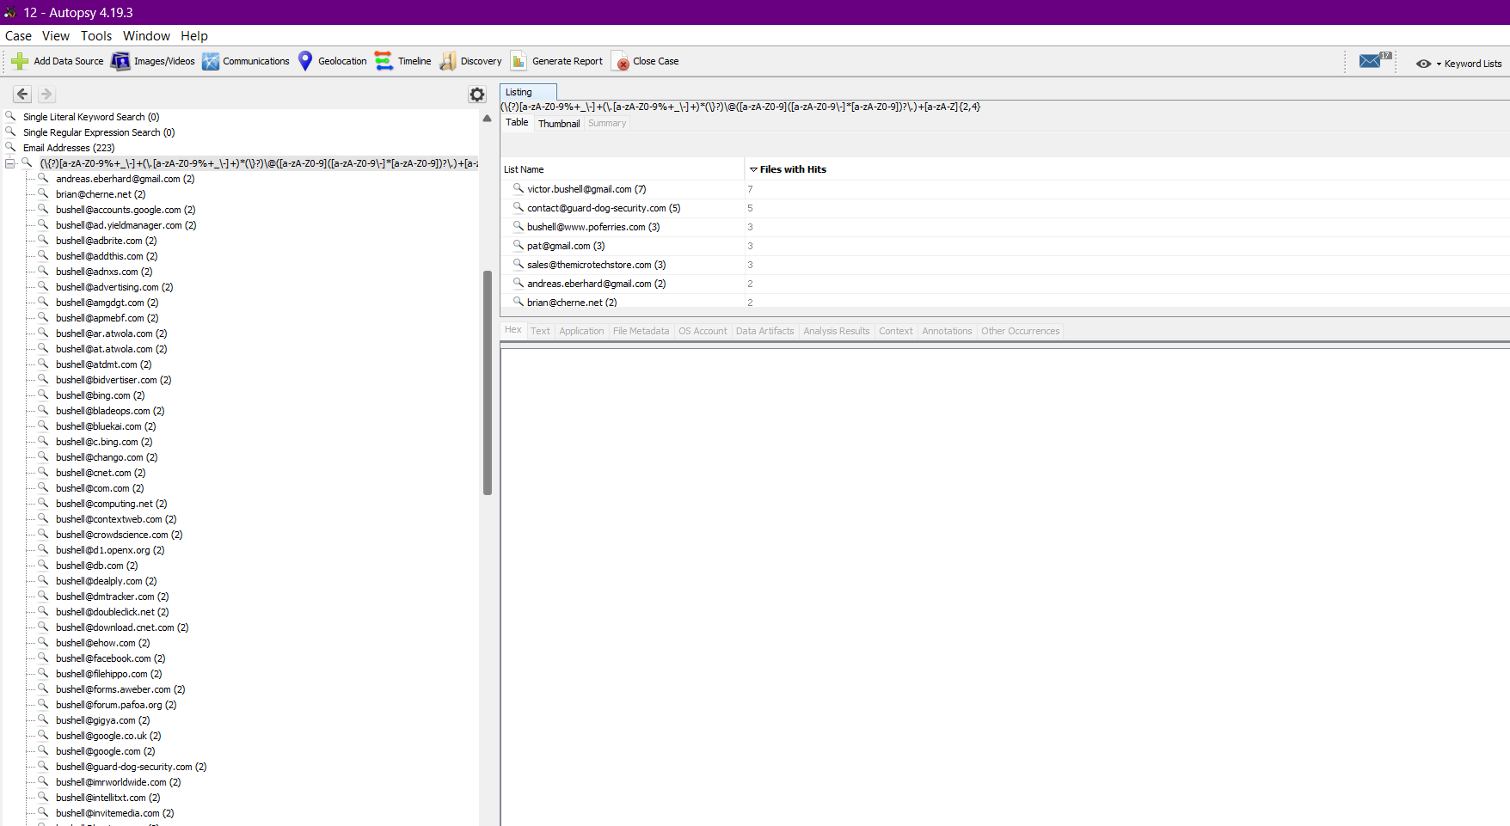

1. **HxD**

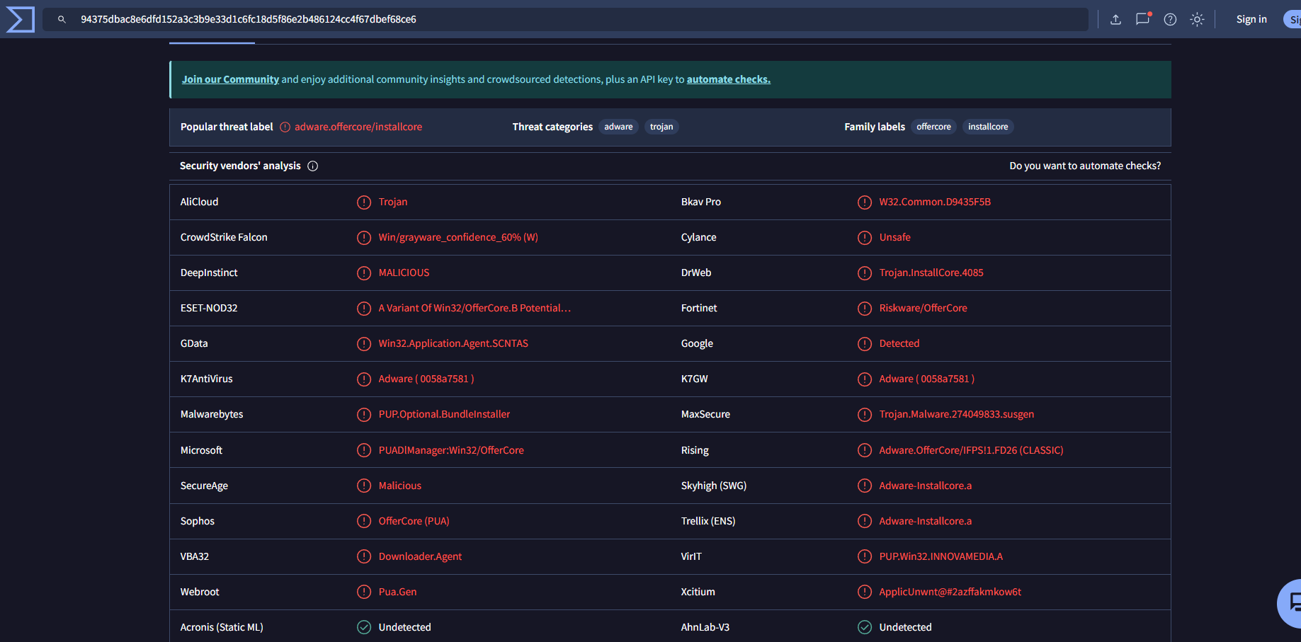

1. **Tools for perfect files, history and logs.**