- An FPU (Floating-Point Unit) is a dedicated hardware co-processor that executes non-integer (decimal) math
- In 32-bit and 64-bit microcontrollers, floating-point numbers are saved in memory using standard formats (like IEEE 754) split into a sign, exponent, and mantissa.
- The FPU consists of a group of control and status registers and 31 single-precision scalar registers. The scalar registers can also be viewed as 16 double-word registers
- While the FPU is designed for floating-point operations it is possible to load and store fixed point and integer values. It is also possible to convert between floating-point to fixed-point and integer values. This means “C” casting between floating-point and integer values can be done in a single cycle.
- While it is possible to consider the FPU as a coprocessor adjacent to the Cortex-M4 and M7 processors this is not really true. The FPU is an integral part of the Cortex-M processor, the floating-point instructions are executed within the FPU in a parallel pipeline to the Cortex-M processor instructions (Fig. 9.3). While this increases the FPU performance, it is “invisible” to the application code and does not introduce any strange side effects.
- 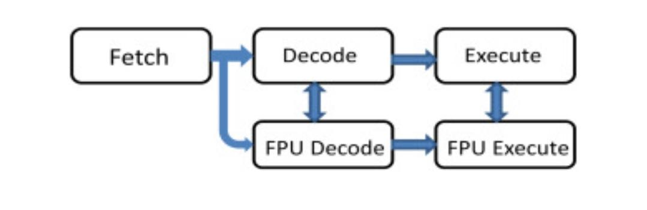
- STM32 with a hardware FPU (Cortex-M4/M7), the FPU starts disabled to save power. Using floats without enabling it will trigger a Hard Fault (crash)
- must set the Coprocessor Access Control Register (CPACR) during system startup.
- /* Enable FPU for floating point operations */
- SCB->CPACR |= ((3UL << 10*2) | (3UL << 11*2));
- the compiler must be told to use FPU instructions instead of software-emulated floats to reduce computation power.
- Set the Floating-point unit drop-down to Hardware (or FPv4-SP-D16 for Cortex-M4)
- Ensure the Floating-point ABI is set to FP instructions
- All of the FPU registers are memory-mapped except the Floating Point Status Control Register which is a CPU register accessed by the MRS and MSR instructions. Access to this function is supported by a CMSIS core function.

- uint32_t __get_FPSCR(void);

- void __set_FPSCR (uint32_t fpscr)

- The FPSCR register contains three groups of bits. The top four bits contain condition code flags N, Z, C, V that match the condition code flags in the xPSR. These flags are set and cleared in a similar manner by the results of floating-point operations. The next groups of bits contain configuration options for the FPU.
- Unless you have a strong reason to do this, it is recommended to leave them alone. The final group of bits is status flags for the FPU exceptions. If the FPU encounters an error during execution an exception will be raised and the matching status flag will be set. The exception line is permanently enabled in the FPU and just needs to be enabled in the NVIC to become active. When the exception is raised, you will need to interrogate these flags to work out the cause of the error. Before returning from the FPU exception the status flags must be cleared. How this is done depends on the FPU exception stacking method.
- Microcontrollers using the Cortex-M7 may be designed without an FPU or may be fitted with a single- or double-precision unit. The CMSIS-Core specification has been extended with a function to report the M7 processor configuration.

- uint32_t SBC_GetFPUType(void)

- 0 = No FPU

- 1 = Single-Precision

- 2 = Double Precision

- This function reads a configuration register in the System Control Block, the “Media and VFP feature register,” and then returns the configuration of the Cortex-M7 processor. This function can only be used with a Cortex-M7.
- When the FPU is enabled, an extended stack frame will be pushed when an exception is raised. In addition to the standard stack frame, the Cortex-M processor also pushes the first 16 FPU scalar registers and the FPSCR. This extends the stack frame from 32 to 100 bytes. Clearly pushing this amount of data onto the stack, every interrupt would increase the interrupt latency significantly. To keep the 12-cycle interrupt latency, the Cortex-M processor uses a technique called “lazy stacking.” When an interrupt is raised, the normal stack frame is pushed onto the stack and the stack pointer is incremented to leave space for the FPU registers, but their values are not pushed onto the stack. This leaves a void space in the stack. The start address of this void space is automatically stored in the “Floating Point Context Address Register” (FPCAR). If the interrupt routine uses floating-point calculations, the FPU registers will be pushed into this space using the address stored in the FPCAR as a base address.
- FPCR is used to select the stacking method used
- Lazy stacking is enabled by default when the FPU is first enabled. The stacking method is controlled by the most significant 2 bits in the “Floating Point Context Control Register”; these are the Automatic State Preservation Enable (ASPEN) and Lazy State Preservation Enable (LSPEN).