

**MVJ COLLEGE OF ENGINEERING, BENGALURU-560067**

**(Autonomous Institution Affiliated to VTU, Belagavi)**

**DEPARTMENT OF ELCTRICAL AND ELECTRONICS ENGINEERING**

**CERTIFICATE**

Certified that the main project work titled ***‘Development And Implementation Of Cloud Platform For IoT Devices’*** is carried out by **Chetan C (1MJ19EE006), Shruthi K (1MJ19EE032), Sumanth M (1MJ20EE0404) and Vinay K S (1MJ19EE039)** who are confide students of MVJ College of Engineering, Bengaluru, in partial fulfilment for the award of Degree of **Bachelor of Engineering** **in Electrical and Electronics Engineering** of the Visvesvaraya Technological University, Belagavi during the year 2022-2023. It is certified that all corrections/suggestions indicated for the Internal Assessment have been incorporated in the main project report deposited in the departmental library. The main project report has been approved as it satisfies the academic requirements in respect of main project work prescribed by the institution for the said Degree.

|  |  |  |  |
| --- | --- | --- | --- |
|  | **Signature of Guide** | **Signature of HOD** | **Signature of Principal** |
|  | **Dr. Suresh S Rao** | **Dr. Soumya Mishra**    **External Viva** | **Dr. P Mahabaleswarappa** |
|  | **Name of the Examiners** |  | **Signature with date** |
| **1).** |  |  |  |
| **2).** |  |  |  |

**MVJ COLLEGE OF ENGINEERING, BENGALURU-560067**

**(Autonomous Institution Affiliated to VTU, Belagavi)**

**DEPARTMENT OF ELECTRICAL AND ELECTRONICS ENGINEERING**

**DECLARATION**

**We, Chetan C (1MJ19EE006), Shruthi K (1MJ19EE032), Sumanth M (1MJ20EE0404) and Vinay K S (1MJ19EE039)** students of seventh semester B.E., Department of Electrical and Electronics Engineering, MVJ College of Engineering, Bengaluru, hereby declare that the major project titled ***‘Development And Implementation Of Cloud Platform For IoT Devices’*** has been carried out by us and submitted in partial fulfilment for the award of Degree of **Bachelor of Engineering** in **Electrical and Electronics Engineering** during the year 2022-2023.

Further we declare that the content of the dissertation has not been submitted previously by anybody for the award of any Degree or Diploma to any other University.

We also declare that any Intellectual Property Rights generated out of this project carried out at MVJCE will be the property of MVJ College of Engineering, Bengaluru and we will be one of the authors of the same.

Place: Bengaluru

Date:

**Name** **Signature**

1. **Sumanth M (1MJ20EE404)**
2. **Vinay K S (1MJ19EE039)**
3. **Shruthi K (1MJ19EE032)**
4. **Chetan C (1MJ19EE006)**

**ACKNOWLEDGEMENT**

We are indebted to our guide**, Dr. Suresh S Rao,** Assistant Professor, **Department of Electrical and Electronics Engineering, MVJ College of Engineering** for his wholehearted support, suggestions, and invaluable advice throughout our project work and for the help in the preparation of this report.

We also express our gratitude to our panel members **Dr. Soumya Mishra,** Associate Professor**, Dr. R Rajarajan**, Assistant Professor, **Dr. Suresh S Rao**, Assistant Professor, and **Mrs. Renjini E Nambiar**, Assistant Professor, **Mrs. Gayathri R**, Assistant Professor, **Mr. P Harish Kumar**, Assistant Professor, Departmen**t** of Electrical and Electronics Engineering,for their valuable comments and suggestions.

We express sincere gratitude to our beloved Principal, **Dr. P Mahabaleswarappa** for all his support towards this project work.

Lastly, we take this opportunity to thank our **family** members and **friends** who provided all the backup support throughout the project work.

**ABSTRACT**

Internet of things may be a growing network of everyday object-from industrial machine to client home appliances which will share data and complete tasks whereas you are busy with different activities. The IoT aims to unify everything in our world below a typical infrastructure, giving United States of America not solely management of things around United States of America, however conjointly keeping United States of America knowing of the state of the items. Home automation with the proliferation of IoT is changing into a reality currently, and a range of players like Apple, Amazon, Google, Samsung, are all convergence into this area to produce the platform and solutions for sensible homes. In lightweight of this, gift study addresses IoT ideas through systematic review of pedantic analysis papers, company white papers, skilled discussions with specialists and on-line databases. The most objective of this paper is to produce an outline of web of Things, architectures, and very important technologies and their usages in our standard of living.

An IoT (Internet of Things) platform is a crucial component in today's connected world, serving as the backbone for the management and analysis of data collected from connected devices and sensors. It enables organizations and individuals to gain insights and make better decisions, as well as automate processes and improve efficiency.

A typical IoT platform includes various features such as device management, data storage and analytics, and the ability to build and deploy custom applications. Device management allows for the easy and secure connection, monitoring, and control of devices, while data storage and analytics provide the means to process and analyze large amounts of data in real-time. Additionally, the ability to build and deploy custom applications allows organizations to create and implement their own solutions tailored to their specific needs.

In summary, IoT platforms play a vital role in managing and analyzing data from connected devices and sensors, providing organizations with the necessary tools and services to gain insights, automate processes and improve efficiency. They are an essential component of the digital transformation process and are increasingly being adopted across various industries.

**CHAPTER 1**

**INTRODUCTION**

* 1. **BACKGROUND**

The main concept of a network of smart devices was discussed as early as 1982.The concept of the "Internet of things" appeared in a speech by Peter T. Lewis.

The **Internet of things** (**IoT**) describes physical objects with sensors, processing ability, software and other technologies that connect and exchange data with other devices and systems over the Internet or other communications networks.

The field has evolved due to the convergence of multiple technologies, including ubiquitous, computing, commodity sensors, increasingly powerful embedded systems, as well as machine learning Traditional fields of embedded systems, wireless sensor networks, control systems, automation (including home and building automation), independently and collectively enable the Internet of things.

The extensive set of applications for IoT devices is often divided into consumer, commercial, industrial, infrastructure spaces, Medical and healthcare and home automation.

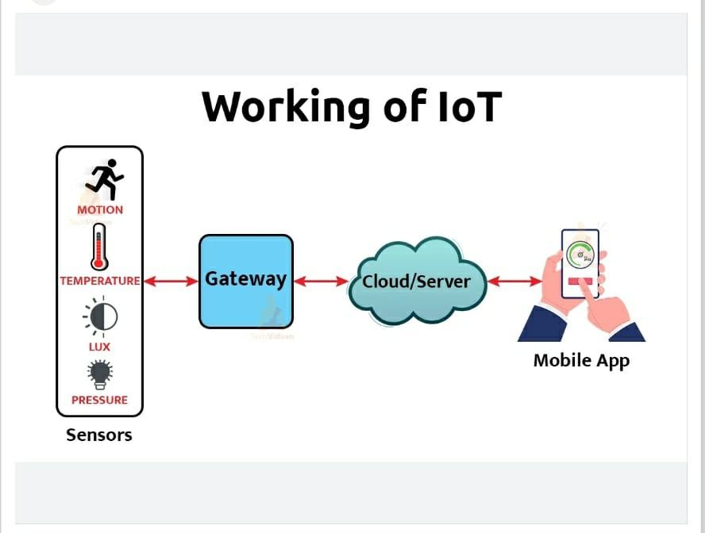

**Thing Speak** is an open-source software written in Ruby which allows users to communicate with internet enabled devices. It facilitates data access, retrieval, and logging of data by providing an API to both the devices and social network websites.

BLYNK- The Main focus of the Blynk platform is to make it super-easy to develop the mobile phone application.

It can control an LED or a motor from your mobile phone with literally zero programming.

With the help of new technology, people demand more comfort in their lives. In this new era of automated things such as automatic cars, automatic dishwashers, automatic bots and so on, comes the need of automated homes where people have the luxury of doing things with least possible effort.

Internet of things may be a growing network of everyday object-from industrial machine to client home appliances which will share data and complete tasks.

The Internet of Things commonly known as IOT, refers to any device that be connected to Internet and further controlled using it.

IOT is a new and a very revolutionizing concept and the progress in competencies in mobile devices and networking and cloud technologies drives this concept.

Taking into consideration the large number of benefits that IoT offers, the project aims at controlling devices with the help of web applications in phone.

Today’s era is such where automation plays a vital role in human life. This not only reduces human efforts but also makes their life simpler and easier to live.

The project aims at controlling electrical appliances using a web-based interface.

The main aim of the project is to develop and implement IOT platform which facilitates communication, data flow, device management, and the functionality of applications and allows one to wirelessly control lights, fans, air conditioners, television sets, security cameras, electronic doors, computer systems, audio/visual equipment’s etc.

Firstly, this ensures that users are not required to manually switch off the appliance, and secondly, it allows control of appliances from the main switch board.

These appliances usually have to be specially designed to be compatible with each other and with the control unit for most commercially available home automation systems.

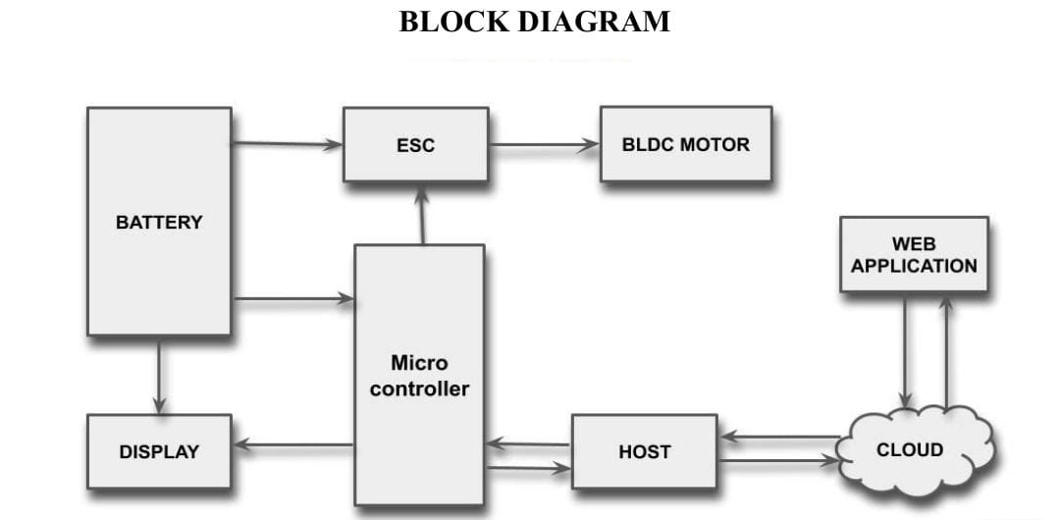

The web application behaves as a middleware between the user and the server, the information sent in the sequence of text file to the server and microcontroller (ESP32) receives the data.

* Communication- Smart devices communicate with each other, exchange data, perform some tasks without any human involvement. These devices are embedded with electronics, software, network, and sensors which help in communication.

There are different types of communications namely

1. Device-to-Device Communications, i.e., two or more devices

that directly connect and communicate between one another.

b) Device-to-Cloud Communications, where the IoT device connects directly to an Internet cloud service like an application service provider to exchange data and control message traffic.

c) Device-to-Gateway Model, where there is an application software operating on a local gateway device, which acts as

an intermediary between the device and the cloud service and provides security and other functionality such as data or protocol.

* Device management: It provides the solution, allowing to better monitor and control.
* Bulk registering and deploying connected devices
* Organizing devices into relevant groups
* Device logging
* Remotely managing and updating devices
* Customizable dashboards for centralized device control
  1. **LITERATURE REVIEW**

|  |  |  |  |  |
| --- | --- | --- | --- | --- |
| Author & Year | Title | Review | Advantages | Disadvantages |
| Luca Calderoni, Antonio Magnani and Dario Maio.  2019 | IoT Manager: a Case Study of the Design and Implementation of an Open Source IoT Platform | a full stack IoT platform relying on open source technologies. Their main aim was to provide security and tangible implementation of solution, along with a detailed description of design strategies at each level of the stack | It's a full stack IOT platform which governs the IoT manager Employing Http and Https protocal makes it even more secure. | They relay/ depend on open source technologies (blynk) and the companies do not tend to unveil the reasearch and hidden details |
| Aayush Doshi, Deep Vakharia  2021 | Iot based Home Automation | It uses Raspberry Pi instead of Arduino and PIR sensors which are more effective than normal IR sensors for home security.  User reliable wireless connection.  use of an LDR sensor for light intensity and IR sensor to detect human presence and  control automatically. | Easy to use and saves unnecessary. Low cost compared to other automation and power consumption  systems.  Easy to implement.  Has good processing power and can handle multiple functions at the same time.  Uses reliable wireless connection. | Usage of Google firebase which is a real time database makes the project cost inefficient and data transfer when devices are offline is not possible. |
| Miguel Angel López Peña and Isabel Muñoz Fernández  2019 | SAT-IoT: An Architectural Model for a High-Performance Fog/Edge/Cloud IoT Platform | This uses a new concepts for IoT architectures and a reference model that is being implemented in a new IoT Platform named SAT-IoT.  It also integrates IoT Computing Topology Management i.e cloud, edge, devices and their wireless or wired links as part of the IoT Platforms. | The embedded applications can access to all internal services of the platform, and not only those exposed externally in the API Gateway.It takes advantage of the platform in terms of access to its internal services, application setup functions and/or automated deployment processes. | As edge cloud computing is utilised, It requires more storage capacity. Security challenges in edge computing is high due to huge amount of data. It only analyses the data. Cost of edge computing is very high. It requires advanced infrastructure |
| Sameer Alani, Sarmad Nozad Mahmood  2021 | IoT based implemented comparison analysis of two well-known network platforms for smart home automation | This research is purely based to compare the applicability and the cost limitation of NETPI and BLYNK network platforms.  NETPI is almost like BLYNK except with a bit programming complication than BLYNK.  BLYNK Framework, which can be configured easily by IOS or Android apps to control Arduino, Raspberry Pi and the other microcontrollers that work over the internet. And NETPI framework can be the optimum choice to fulfill the specifications. | It gives complete design and implementation of an innovative, efficient, and low-cost smart house system. This research project compares the applicability and the cost limitation of NETPI and BLYNK network platforms | Restrictions to design with respect to GUI and usage of Blynk (open source). |
| Tanvi G Pareek, Raksha Padaki, Anuradha Iyer and Priya G  2022 | APP BASED DEVICE CONTROLLING SYSTEM | This paper focuses on Controlling the intensity of the LED via the slider on the app. Controlling Speed of the fan  depending on the room’s temperature.  And Storage of data onto Blynk Server, analysis of the results and representation in the form of a graph. | Prevent high expenditure on electricity and make our campus more environment friendly and energy efficient. The connection via Wi-Fi makes things much more beneficial as we can control the appliances from a great distance too. | Usage of Blynk's server for storage of data and analysis making it unsecured and delay occurs |

**1.3 Motivation**

As the increasing number of devices, there is a need to develop and implementation a python powered cloud platform for IoT devices.

IoT and cloud computing emerged to solve the issues, since it is capable to solve challenges such as management, aggregation, and storage for large scale IoT platforms.one of the possible drawbacks of this rapid evolution is the uncontrolled proliferation of heterogenous sensor network lacking interoperability features, even when they are deployed within the same context.

In order to improve the performance of an IoT system, the cloud Computing model aims to process the massive data generated from different IoT devices. Only the processing results are transmitted to the cloud infrastructure or to the IoT devices, reducing the bandwidth consumption, the response latency and/or the storage needed.

Two different platforms cannot assure the users security of data this platform provides secure and reliable for registration of different IoT devices. The registration process requires authorization and verification for security purposes.

This web application also provides customization which is hard to find in an open-source website.

The security and privacy is also one of the major aspect in Iot project to handle with. Keeping the data gathered and transmitted by IoT devices safe is challenging, as they evolve and expand in use and hence overcoming is another major task. The reduction technical complexity is required in order to make simple and understandable.

The power dependence and integration has been maximized in current IoT environment

The integration and higher cost (time and money) is required which has led to the primary motivation to build an environment which overcomes all these demerits.

**1.4 OBJECTIVES**

The main objective of the IoT platform is to overcome the obstacles between layers and combine them to ensure efficient and seamless cooperation.

The IoT platform connects hardware to the cloud by using a flexible connection and provides a security mechanism and broad data processing powers.

The IoT platform is solely used for following features:

• Authentication

• Authorization

• Accessibility

• Develop Web application for accessing the cloud

• Interface between IOT device and cloud

The user accesses username and password for authorization. Authorization is required so that the user can retrieve data from the server.

The registration process requires authorization and verification for security purposes. The authorization process will only allow authorized persons to register IoT devices and avoid unnecessary usage of the IoT platform.

Verification of IoT devices will validate the existence of an IoT device by checking the model, IP address, MAC address. The proposed system also provides the discovery and sharing of registered IoT devices.

web interface of the IoT platform in which a registered user can add IoT devices to which they can monitor and control.

Developing web application for accessing the server because the current status of the device is being stored in the sever so that we can have the access on the server.

**CHAPTER 2**

**IoT Platform for Load Control**

**2.1.** **SYSTEM DESCRIPTION**

An IoT platform is a system that enables the connection, management, and communication of devices and sensors through the internet. It typically includes features such as device management, data collection and analysis, and the ability to create and execute rules and actions based on the collected data. Additionally, an IoT platform should be scalable, secure, and able to integrate with other systems and devices. It should have the ability to handle large volumes of data and be able to integrate with other data sources, such as cloud storage, in order to provide real-time insights and analytics.

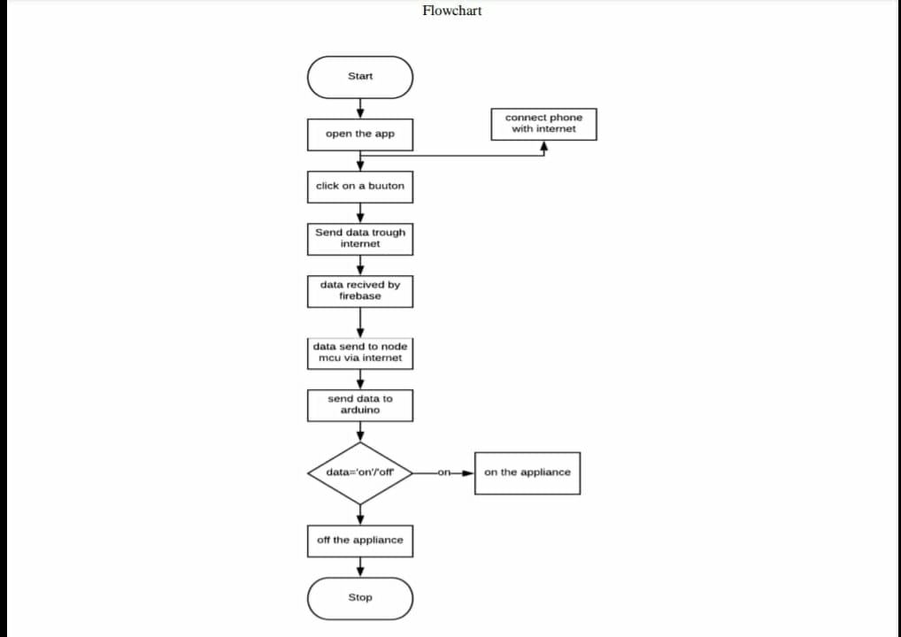

**An IoT platform typically includes the following key components:**

**Device Management:** This component allows for the registration, provisioning, and management of devices and sensors connected to the platform. It includes features such as over-the-air updates, remote device management, and monitoring of device health and status.

**Data Collection and Analysis:** This component allows for the collection and storage of data from connected devices and sensors, as well as the ability to analyse and visualize this data. It includes features such as real-time data streaming, data storage, and data visualization tools.

**Rule Engine and Actions:** This component allows for the creation of rules and actions based on the data collected from the connected devices and sensors. For example, if a sensor detects a temperature above a certain threshold, an action could be triggered to turn on a cooling system.

**Security:** An IoT platform should include robust security features to protect against unauthorized access, data breaches, and other security threats. This includes features such as device authentication, data encryption, and secure communication protocols.

**Scalability and Interoperability:** An IoT platform should be able to handle large volumes of data and devices and be able to integrate with other systems and devices. This includes the ability to easily connect to other data sources, such as cloud storage, and to work with a wide range of devices and protocols.

**User Interface and Management**: The platform should have a user-friendly interface, allowing the user to access and manage the devices, sensor, and data.

**Integration with other systems:** The platform should have the capability to integrate with other systems like ERP, CRM, or other industry-specific systems.

**Predictive Maintenance:** Platform should have the capability to predict the maintenance of devices based on the data collected.

Overall, an IoT platform should provide a comprehensive solution for connecting, managing, and communicating with devices and sensors through the internet, and should be designed to be scalable, secure, and easy to use.

**2.2. Work Done:**

* **Sign-in**:

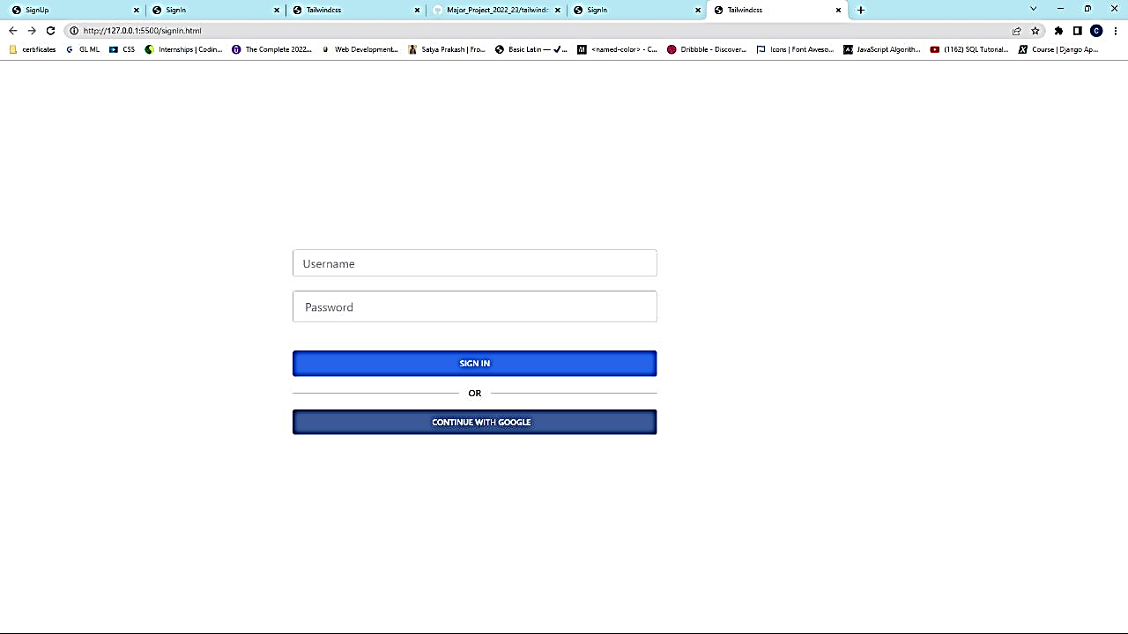

The login form/sign-in from gives access to your website or web application and therefore to your data. This form fulfils a fundamental task of security and redirects the page to the control panel form where the status of the switch can be altered.

The login page allows a user to gain access to an application by entering their username and password or by authenticating using a social media login that is google.

The Login page asks you to enter your credentials which is then validated by the application and after successful validation you are presented with the secured part of the application.

* **Sign-up:**

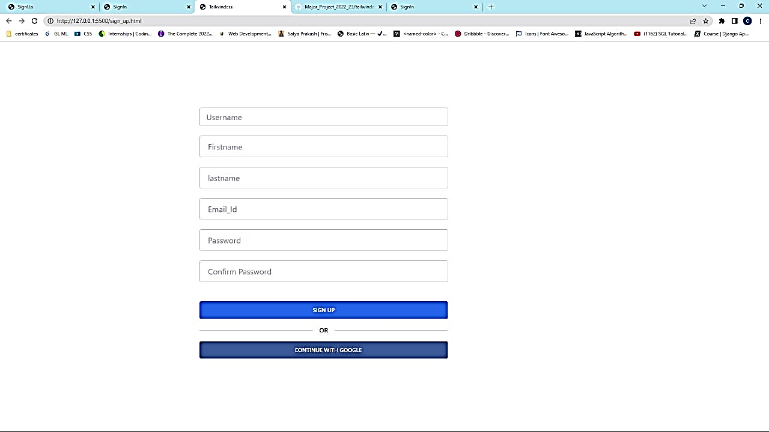

key length between 6 and 8 characters.

•entropy is 2 uppercase letters, 2 lowercase letters, 1

digit and 1 special character.

•two identical characters together as part of the key.

•an encryption method such as md5, sha, kb3, cryp

ey length between 6 and 8 characters.

•entropy is 2 uppercase letters, 2 lowercase letters, 1

digit and 1 special character.

•two identical characters together as part of the key.

•an encryption method such as md5, sha, kb3, crypt.

ey length between 6 and 8 characters.

•entropy is 2 uppercase letters, 2 lowercase letters, 1

digit and 1 special character.

•two identical characters together as part of the key.

•an encryption method such as md5, sha, kb3, crypt.

This provides the user a quick and efficient process to get registered without going into the hassle of creating a new account and providing all the information from scratch. The users feel more comfortable since they need to just click on a sign-up button to get connected with the application.

Rule for creating an account

* Password must be at least 8 characters long but if its more, the account gets more secured.
* A combination of uppercase letters, lowercase letters, numbers, and symbols make the password complex and secured.
* Validation of a word that is not found in a dictionary.
* Password must be significantly different from your previous passwords.
* Your username should be simple enough to remember but hard to guess.
* Never use easy-to-guess numbers with your usernames (for example, address or date of birth). Don't use your Social Security number or ID number as your username.
* The email mentioned on the signup form receives a mail regarding the confirmation creating an account.
* **Home:**

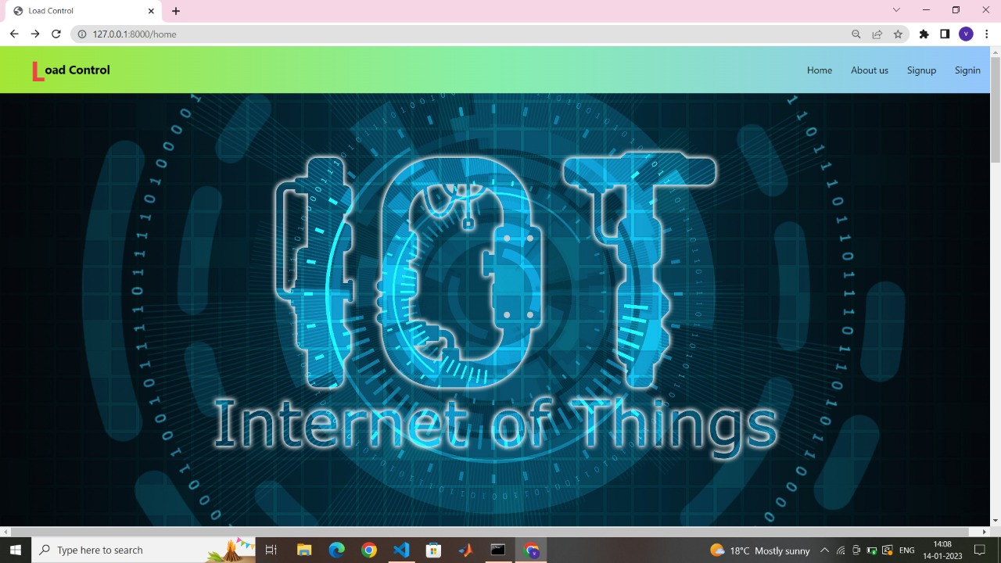

They take that first impression and is used to judge, either positive or negative, your load control web application. It has become the front window for our web application.

A well-designed website can help us form a good impression on your prospective clients/ costumers. It can also help us nurture our leads and get more conversions. But, more importantly, it provides good user experience and helps your website visitors access and navigate your website with ease.

This home page consists of the hypertext reference of sign-up, login/sign-in form, about form the team. All the about attributes allows the user to reach the destination of the respective attribute.

A good starting point is the home page. This is the first thing most visitors will see and just as in real life, first impressions count. As the initial contact point your site provides to visitors, a homepage must perform three major roles simultaneously.

* **To attract and engage visitors:**
* **To educate visitors on your brand**

## ****To encourage visitors to view other pages****

* **About us Page:**

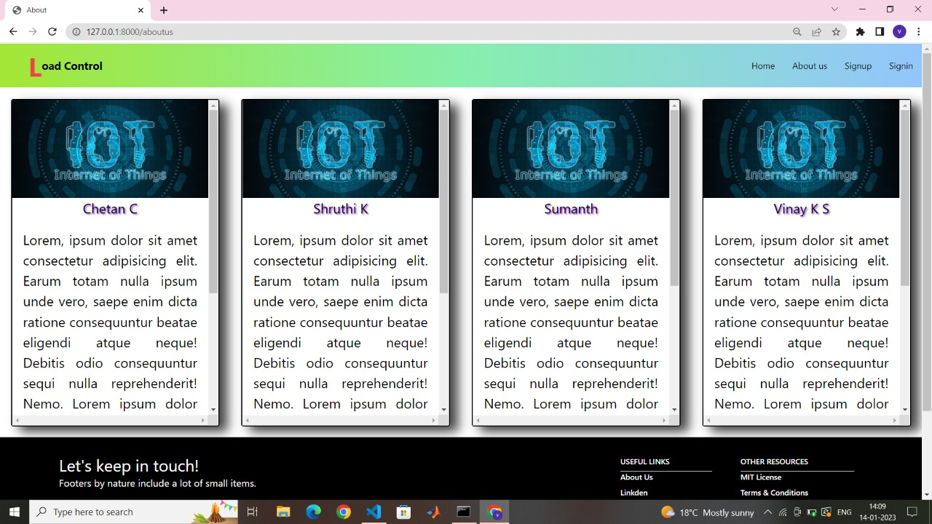

The about us page is often a reflection of the purpose and personality of the application and the team worked on the same. Finally, the page can also incorporate contact or locational information. One way to view the about us concept is as a text self-portrait or short autobiography created by a business.

This about us page is not only used by all types of businesses to give customers more insight into who is involved with a given business and exactly what it does but also in the newly developed applications/projects. The history of the application is often provided, and the histories of the people in charge are usually expressed through short articles, usually accompanied by photographs.

Some information about goals, attitude or other aspects of culture that are strictly tied to building a website are included as well. The about us page is often a reflection of the purpose and personality of the website and its team or top workers. Finally, the page can also incorporate contact or locational information.

**Control Switch Panel:**

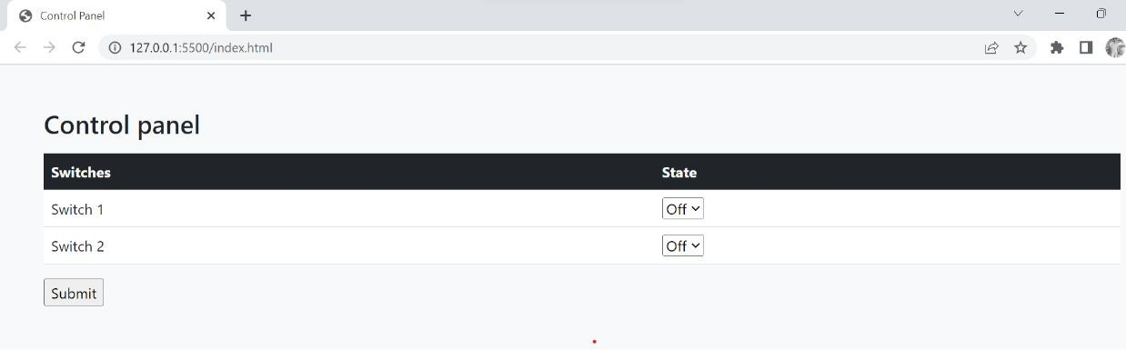

The control panel manages the peripheral devices and communicates between the host computer and the peripheral devices. The control panels have the following functions: Consolidation of all connections to peripheral devices. Provision of power, as needed, to peripheral devices.

The significance of this control switches is that they send the data in the form of text file to the microcontroller where actual work is done. The submit button is placed under the switches where once the submit icon is clicked the status of the load is changed to the required status of the switch by the user.