1. Introduction to SQL
LAB EXERCISES:
• Lab 1: Create a database called library_db and a table books with columns: book_id, title, author, publisher, year_of_publication, and price. Insert five records into the table.
CREATE DATABASE library_db;
USE library_db;
CREATE TABLE books (
book_id INT AUTO_INCREMENT PRIMARY KEY,
title VARCHAR(100),
author VARCHAR(100),
publisher VARCHAR(100),
year_of_publication INT,
price DECIMAL(10,2)
);
INSERT INTO books (title, author, publisher, year_of_publication, price)
VALUES
('The Alchemist', 'Paulo Coelho', 'HarperCollins', 1988, 399.00),
('Wings of Fire', 'A.P.J. Abdul Kalam', 'Universities Press', 1999, 250.00),
('Harry Potter and the Philosopher\'s Stone', 'J.K. Rowling', 'Bloomsbury', 1997, 450.00),
('The Power of Your Subconscious Mind', 'Joseph Murphy', 'Penguin', 1963, 299.00),
('Rich Dad Poor Dad', 'Robert Kiyosaki', 'Warner Books', 1997, 350.00);
select *from books;
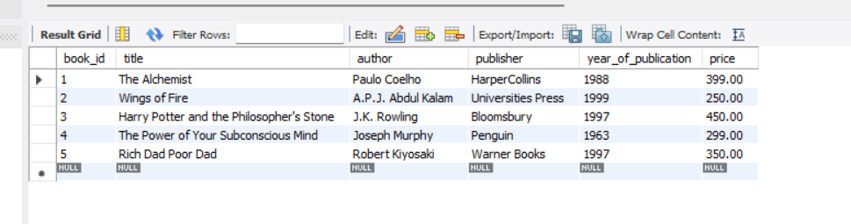
• Lab 2: Create a table members in library_db with columns: member_id, member_name, date_of_membership, and email. Insert five records into this table.
CREATE TABLE members (
member_id INT AUTO_INCREMENT PRIMARY KEY,
member_name VARCHAR(100),
date_of_membership DATE,
email VARCHAR(100)
);
INSERT INTO members (member_name, date_of_membership, email)
VALUES
('Rohan Shah', '2024-01-15', 'rohan.shah@example.com'),
('Sneha Patil', '2024-02-10', 'sneha.patil@example.com'),
('Vikas Mehta', '2024-03-05', 'vikas.mehta@example.com'),
('Aditi Rao', '2024-04-22', 'aditi.rao@example.com'),
('Amit Kulkarni', '2022-01-12', 'amit.kulkarni@example.com'),
('Pooja Desai', '2022-06-18', 'pooja.desai@example.com'),
('Rahul Joshi', '2022-11-25', 'rahul.joshi@example.com'),
('Kunal Verma', '2024-05-30', 'kunal.verma@example.com');
Select *from members;
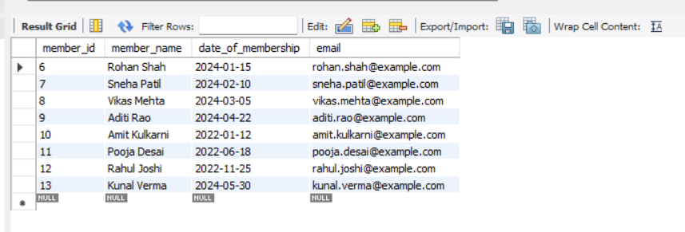
2. SQL Syntax LAB EXERCISES:
• Lab 3: Retrieve all members who joined the library before 2022. Use appropriate SQL syntax with WHERE and ORDER BY.
Query :
SELECT *
FROM members
WHERE date_of_membership BETWEEN '2022-01-01' AND '2022-12-31'
ORDER BY date_of_membership ASC;
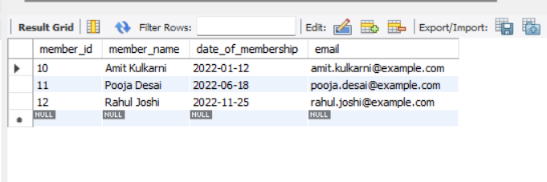

• Lab 4: Write SQL queries to display the titles of books published by a specific author. Sort the results by year_of_publication in descending order.
Query:
SELECT title, year_of_publication
FROM books
WHERE author = 'Paulo Coelho'
ORDER BY year_of_publication DESC;

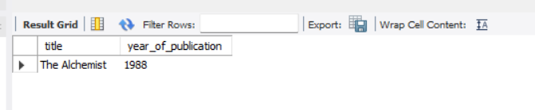

3. SQL Constraints
LAB EXERCISES:
• Lab 3: Add a CHECK constraint to ensure that the price of books in the books table is greater than 0.
ALTER TABLE books
ADD CONSTRAINT chk_book_price
CHECK (price > 0);

INSERT INTO books (title, author, publisher, year_of_publication, price)
VALUES ('Test Book', 'Test Author', 'Test Pub', 2024, -100);
Output Error
-- Prevents invalid data entry
• Lab 4: Modify the members table to add a UNIQUE constraint on the email column, ensuring that each member has a unique email address.
ALTER TABLE members
ADD CONSTRAINT unique_member_email
UNIQUE (email);
- Prevents duplicate member registrations

