You have been hired by CarsAndCars to write a Car payment calculator application. The UI mockups are getting done by the customer and you are required to follow the requirements once they are complete. **However, the decision has not yet been made if this application will be a desktop application, a web application, or a mobile application. What you know is that backend business logic needs to be implemented using latest java and should be able to be called by any driver application.**

Following are the know requirements now:

1. The system will let the user enter any three values from available four a) Loan Amount, b) Number of Payments, c) Annual Interest Rate, and lastly d) Payment Amount. Once any three values are entered into the system; your software should calculate the fourth value.
2. Payment Amount of “zero” is not acceptable
3. Number of Payments need to be greater than two and not greater than 72
4. A negative Annual Interest rate is not allowed to be entered
5. Zero % is a legal interest rate

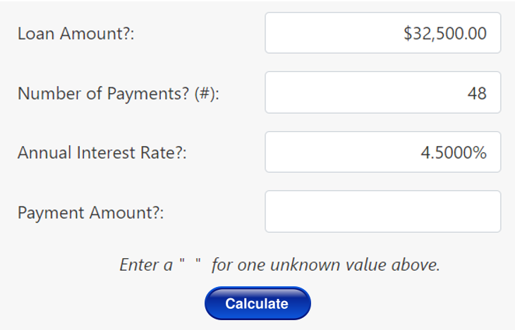

Your need to design a class called FinanceCalculator which will expose at least four overloaded methods called Calculate. Each Calculate will take different parameters and will return different return types as needed.