/*********************************************************************************

* UNX511-Lab1

* I declare that this lab is my own work in accordance with Seneca Academic Policy.

* No part of this assignment has been copied manually or electronically from any other source

* (including web sites) or distributed to other students.

*

* Name: Chetan Arora

* Student ID: 100976240

* Date: May 18, 2025

********************************************************************************/

1. Write and execute a C/CPP program that will scan every directory in **/proc** that represents a process (each directory that begin with a number represents a process). Open the file **status**. If **VmRSS:** is greater than 10000 kB, then print out the process name, the process id and the memory used. See the code at the following link as an example on how to get all files in a directory: https://www.unix.com/programming/33263-unix-c-get-files-folder.html.

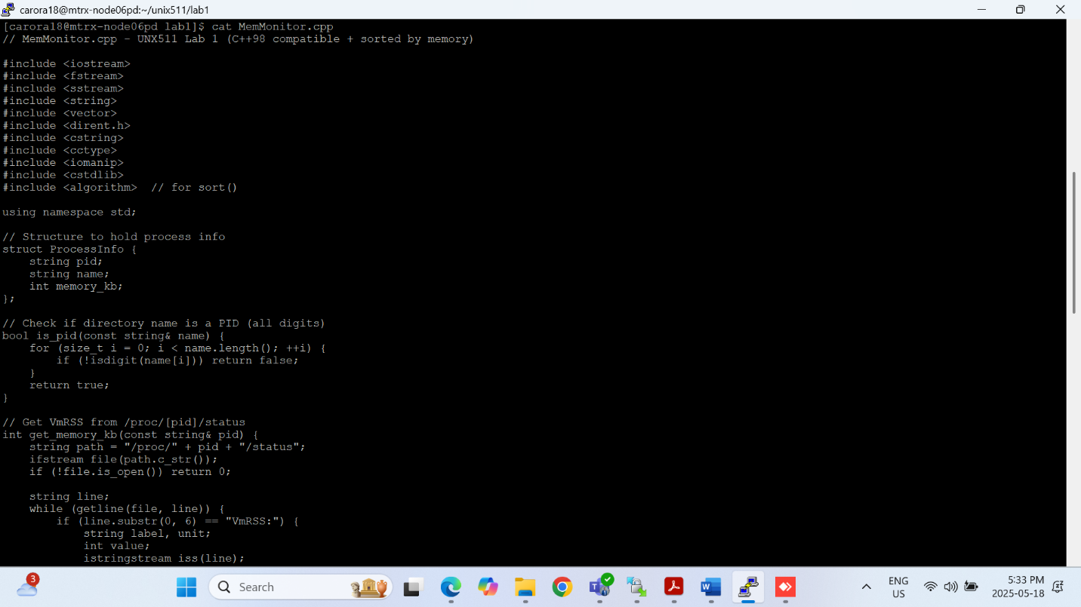

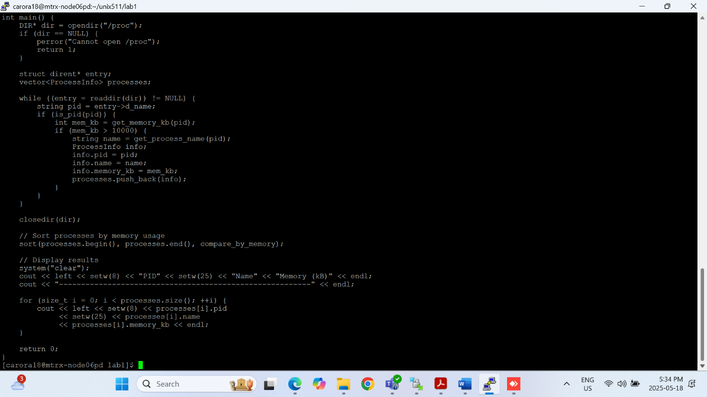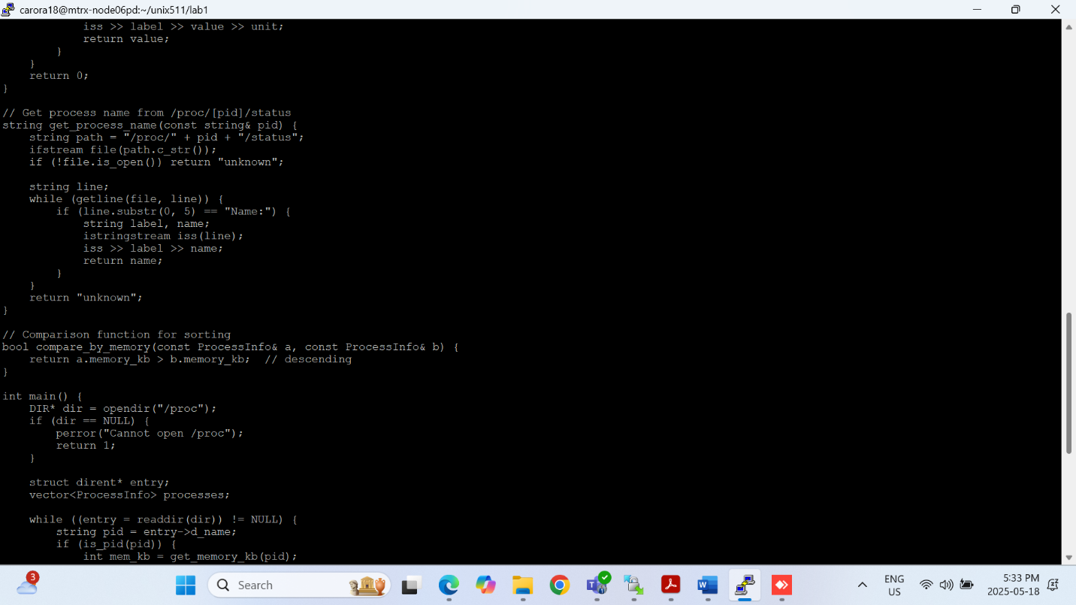

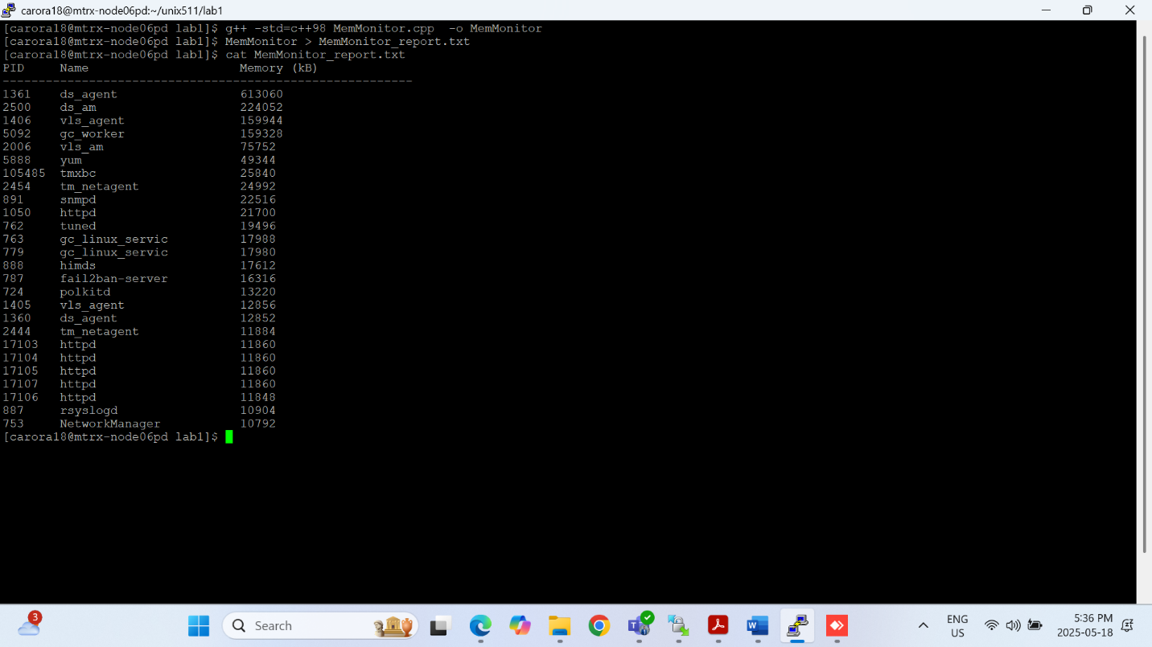

1. Open a second command line and execute the command **top** which orders processes by cpu usage. **$ top** Compare the processes reported in **top** with those reported by your program. You can cancel the execution of **top** with ***ctrl-c***. See the following link for an explanation

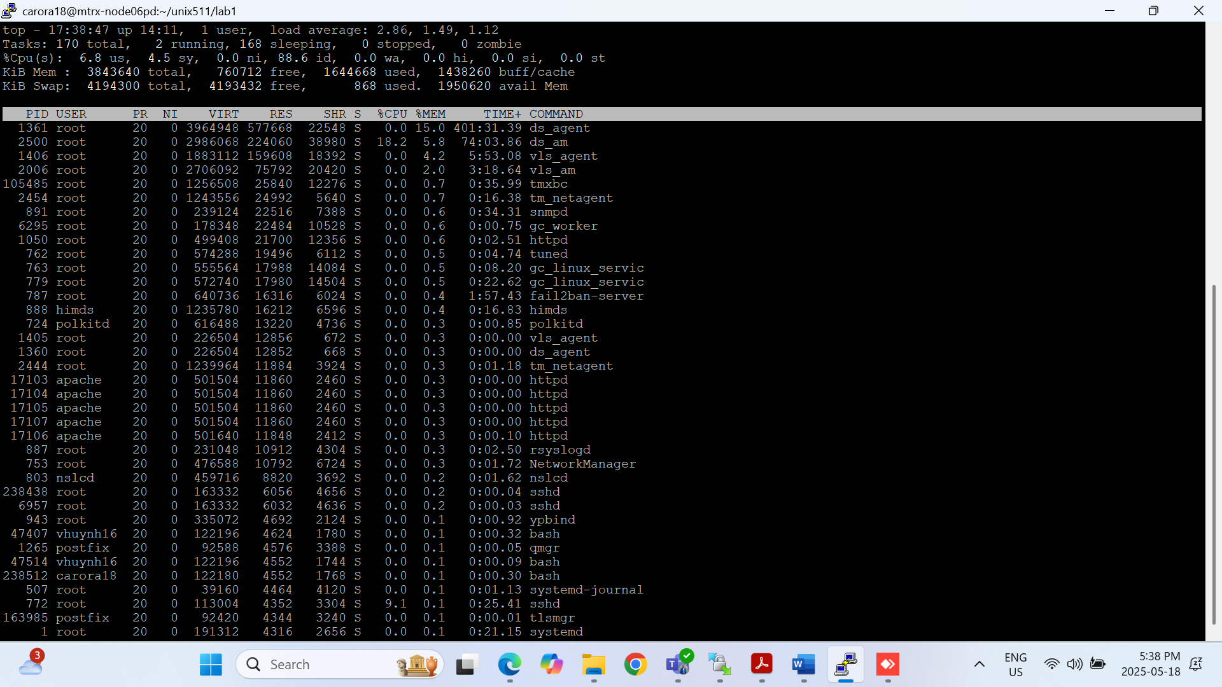

3. Explain the difference between virtual memory and resident memory. What is virtual memory? What is resident memory?

Virtual Memory (VmSize) is the total memory a process is allowed to use, including code, data, shared libraries, and swap space. It includes memory that may not be actively used or even loaded into RAM.

Resident Memory (VmRSS) is the actual amount of physical RAM that a process is currently using. It excludes swapped or unused memory and represents the real memory load on the system.

In short, VmSize shows the full memory allocation, while VmRSS shows what’s actively in use.

4.Research and report on any of the three of the processes returned by your program. Simply explain what these processes do.

1. ds_agent (PID 1361)

This is the Trend Micro Deep Security Agent, used for endpoint protection like anti-malware, firewall, intrusion prevention, and integrity monitoring.

2. ds_am (PID 2500)

Likely another component of Trend Micro, specifically the Anti-Malware module.

3. vls_agent (PID 1406)

This could refer to Veritas Licensing Services Agent or a similar vendor-specific agent.