/\*\*\*\*\*\*\*\*\*\*\*\*\*\*\*\*\*\*\*\*\*\*\*\*\*\*\*\*\*\*\*\*\*\*\*\*\*\*\*\*\*\*\*\*\*\*\*\*\*\*\*\*\*\*\*\*\*\*\*\*\*\*\*\*\*\*\*\*\*\*\*\*\*\*\*\*\*\*\*\*\*

\* UNX511-Lab2

\* I declare that this lab is my own work in accordance with Seneca Academic Policy.

\* No part of this assignment has been copied manually or electronically from any other source

\* (including web sites) or distributed to other students.

\*

\* Name: Chetan Arora

\* Student ID: 100976240

\* Date: May 24, 2025

\*\*\*\*\*\*\*\*\*\*\*\*\*\*\*\*\*\*\*\*\*\*\*\*\*\*\*\*\*\*\*\*\*\*\*\*\*\*\*\*\*\*\*\*\*\*\*\*\*\*\*\*\*\*\*\*\*\*\*\*\*\*\*\*\*\*\*\*\*\*\*\*\*\*\*\*\*\*\*\*/

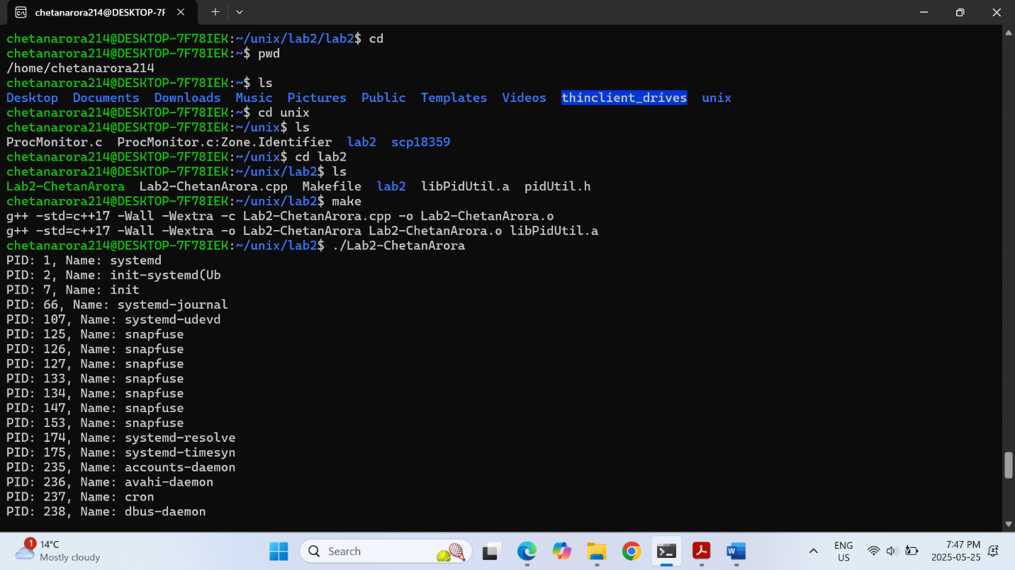

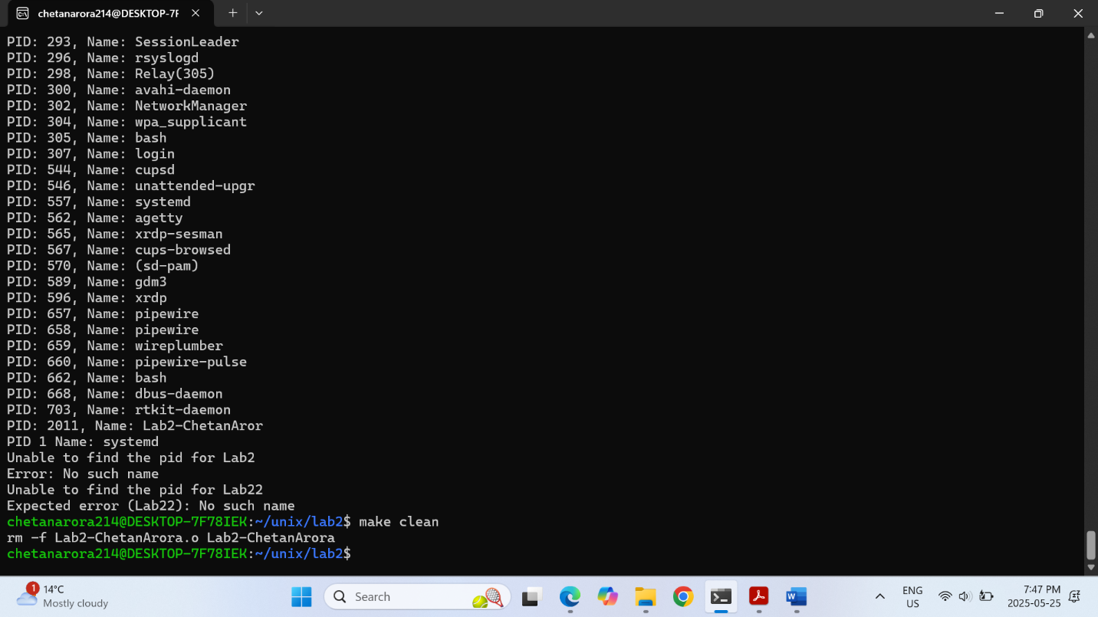

Please answer the following two declarations:

o D1) On a scale from 1 to 5, How much did you use generative AI to complete this assignment?

▪

where:

▪

1 means you did not use generative AI at all

▪

2 means you used it very minimally

▪

3 means you used it moderately

▪

4 means you used it significantly

▪

5 means you relied on it almost entirely

▪

Your answer :2

o D2) On a scale from 1 to 5, How confident are you in your understanding of the generative AI support you utilized in this assignment, and in your ability to explain it if questioned?

▪

where:

▪

1 means "Not confident at all – I do not understand the generative AI support I used and cannot explain it."

▪

2 means "Slightly confident – I understand a little, but I have many uncertainties."

▪

3 means "Moderately confident – I understand the majority of the support, though some parts are unclear."

▪

4 means "Very confident – I understand most of the AI support well and can explain it with minor gaps."

▪

5 means "Extremely confident – I fully understand the generative AI support I used and can clearly explain or justify it if asked."

▪

Your answer :5