/\*\*\*\*\*\*\*\*\*\*\*\*\*\*\*\*\*\*\*\*\*\*\*\*\*\*\*\*\*\*\*\*\*\*\*\*\*\*\*\*\*\*\*\*\*\*\*\*\*\*\*\*\*\*\*\*\*\*\*\*\*\*\*\*\*\*\*\*\*\*\*\*\*\*\*\*\*\*\*\*\*

\* UNX511-Lab6

\* I declare that this lab is my own work in accordance with Seneca Academic Policy.

\* No part of this assignment has been copied manually or electronically from any other source

\* (including web sites) or distributed to other students.

\*

\* Name: Chetan Arora

\* Student ID: 100976240

\* Date: July 19, 2025

\*\*\*\*\*\*\*\*\*\*\*\*\*\*\*\*\*\*\*\*\*\*\*\*\*\*\*\*\*\*\*\*\*\*\*\*\*\*\*\*\*\*\*\*\*\*\*\*\*\*\*\*\*\*\*\*\*\*\*\*\*\*\*\*\*\*\*\*\*\*\*\*\*\*\*\*\*\*\*\*/

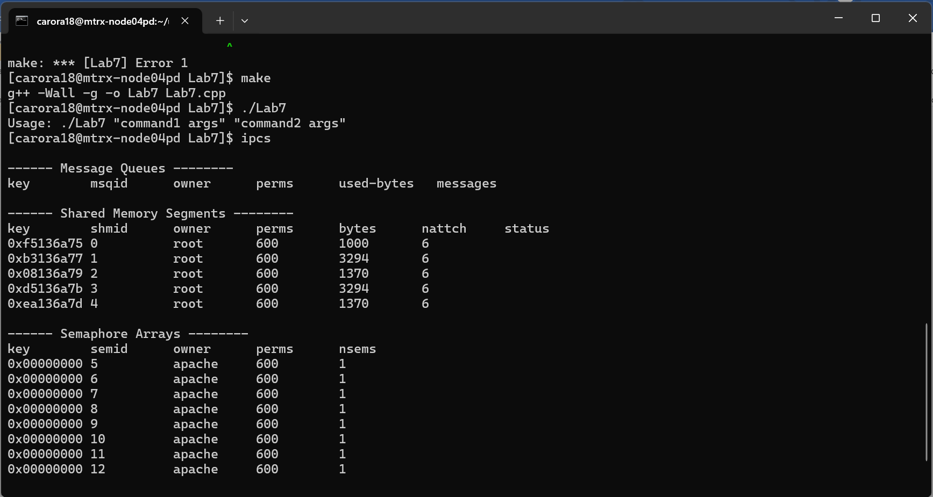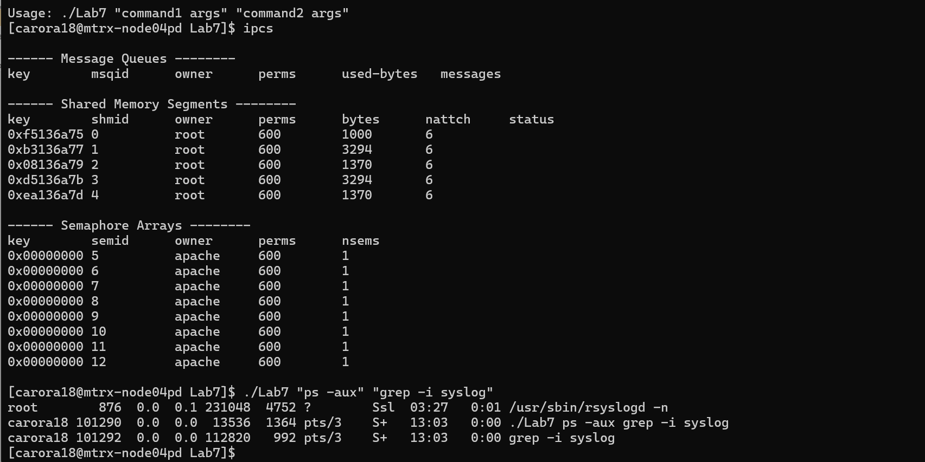

1. How does dup() work?

- dup(int oldfd) creates a copy of the old file descriptor and returns the new file descriptor.

Both file descriptors refer to the same file description. Changes like file offset affect both.

2. How does dup2() work?

- dup2(oldfd, newfd) duplicates oldfd onto newfd. If newfd is open, it is first closed.

This is useful for redirecting standard input/output streams like stdin or stdout.

3. How does execlp() work?

- execlp() replaces the current process with a new program. It takes the executable name

and arguments and searches for it in the system PATH. It does not return unless there is an error.

Please answer the following two declarations:

o D1) On a scale from 1 to 5, How much did you use generative AI to complete this assignment?

▪

where:

▪

1 means you did not use generative AI at all

▪

2 means you used it very minimally

▪

3 means you used it moderately

▪

4 means you used it significantly

▪

5 means you relied on it almost entirely

▪

Your answer :2

o D2) On a scale from 1 to 5, How confident are you in your understanding of the generative AI support you utilized in this assignment, and in your ability to explain it if questioned?

▪

where:

▪

1 means "Not confident at all – I do not understand the generative AI support I used and cannot explain it."

▪

2 means "Slightly confident – I understand a little, but I have many uncertainties."

▪

3 means "Moderately confident – I understand the majority of the support, though some parts are unclear."

▪

4 means "Very confident – I understand most of the AI support well and can explain it with minor gaps."

▪

5 means "Extremely confident – I fully understand the generative AI support I used and can clearly explain or justify it if asked."

▪

Your answer :5