/\*\*\*\*\*\*\*\*\*\*\*\*\*\*\*\*\*\*\*\*\*\*\*\*\*\*\*\*\*\*\*\*\*\*\*\*\*\*\*\*\*\*\*\*\*\*\*\*\*\*\*\*\*\*\*\*\*\*\*\*\*\*\*\*\*\*\*\*\*\*\*\*\*\*\*\*\*\*\*\*\*

\* UNX511-Lab8

\* I declare that this lab is my own work in accordance with Seneca Academic Policy.

\* No part of this assignment has been copied manually or electronically from any other source

\* (including web sites) or distributed to other students.

\*

\* Name: Chetan Arora

\* Student ID: 100976240

\* Date: July 25, 2025

\*\*\*\*\*\*\*\*\*\*\*\*\*\*\*\*\*\*\*\*\*\*\*\*\*\*\*\*\*\*\*\*\*\*\*\*\*\*\*\*\*\*\*\*\*\*\*\*\*\*\*\*\*\*\*\*\*\*\*\*\*\*\*\*\*\*\*\*\*\*\*\*\*\*\*\*\*\*\*\*/

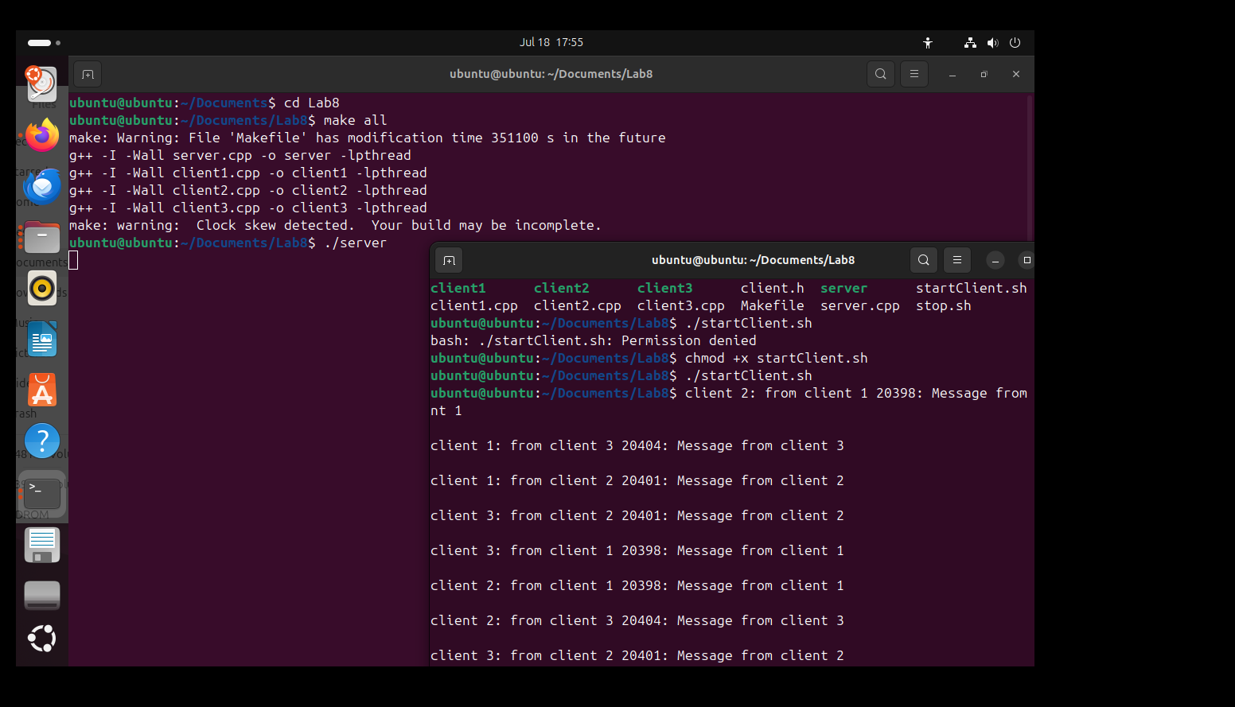

1. Between sockets, pipes, FIFOs, and messages, which is your favorite and why?

Personally, I’d say message queues are my favorite. What I really like about them is how they let different processes talk to each other in a way that’s organized and direct. Unlike pipes or FIFOs, you don’t need to worry about which process is connected to which — the messages just go into a shared space and are delivered based on the type. That made it really handy in this lab, where the server handles everything and each client only looks for its own messages. It just felt cleaner and less messy compared to the others.

2. Which is your least favorite and why?

I found pipes to be the most limiting. They’re okay for very simple setups, like passing data from a parent to a child process, but beyond that, they get clunky fast. They don’t support two-way communication without setting up two separate pipes, and there’s no real way to identify where a message came from or who it’s for. When compared to message queues or even sockets, pipes just feel outdated and kind of restrictive.

3. For the scenario presented in this lab, is there a need for a server? Why?

Yes, definitely. In this setup, the server plays a crucial role — it’s not just an extra piece. Without it, every client would need to somehow know where to send its message and how to receive messages from others, which would be super chaotic. The server takes care of receiving all messages and sending them to the right place. It basically keeps the system organized and avoids a big mess of clients all trying to talk to each other directly. It made the whole thing work smoothly.

Please answer the following two declarations:

o D1) On a scale from 1 to 5, How much did you use generative AI to complete this assignment?

▪

where:

▪

1 means you did not use generative AI at all

▪

2 means you used it very minimally

▪

3 means you used it moderately

▪

4 means you used it significantly

▪

5 means you relied on it almost entirely

▪

Your answer :2

o D2) On a scale from 1 to 5, How confident are you in your understanding of the generative AI support you utilized in this assignment, and in your ability to explain it if questioned?

▪

where:

▪

1 means "Not confident at all – I do not understand the generative AI support I used and cannot explain it."

▪

2 means "Slightly confident – I understand a little, but I have many uncertainties."

▪

3 means "Moderately confident – I understand the majority of the support, though some parts are unclear."

▪

4 means "Very confident – I understand most of the AI support well and can explain it with minor gaps."

▪

5 means "Extremely confident – I fully understand the generative AI support I used and can clearly explain or justify it if asked."

▪

Your answer :5