/\*\*\*\*\*\*\*\*\*\*\*\*\*\*\*\*\*\*\*\*\*\*\*\*\*\*\*\*\*\*\*\*\*\*\*\*\*\*\*\*\*\*\*\*\*\*\*\*\*\*\*\*\*\*\*\*\*\*\*\*\*\*\*\*\*\*\*\*\*\*\*\*\*\*\*\*\*\*\*\*\*

\* UNX511-Lab9

\* I declare that this lab is my own work in accordance with Seneca Academic Policy.

\* No part of this assignment has been copied manually or electronically from any other source

\* (including web sites) or distributed to other students.

\*

\* Name: Chetan Arora

\* Student ID: 100976240

\* Date: August 1, 2025

\*\*\*\*\*\*\*\*\*\*\*\*\*\*\*\*\*\*\*\*\*\*\*\*\*\*\*\*\*\*\*\*\*\*\*\*\*\*\*\*\*\*\*\*\*\*\*\*\*\*\*\*\*\*\*\*\*\*\*\*\*\*\*\*\*\*\*\*\*\*\*\*\*\*\*\*\*\*\*\*/

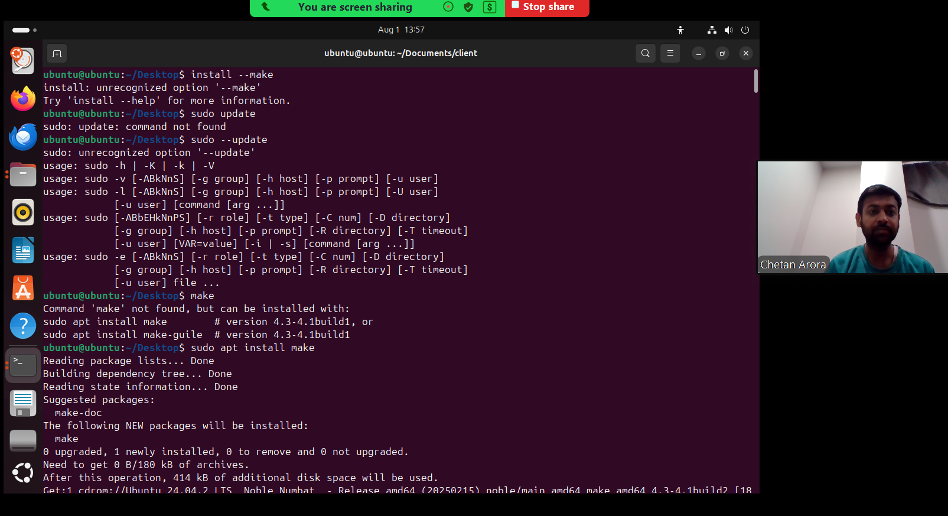

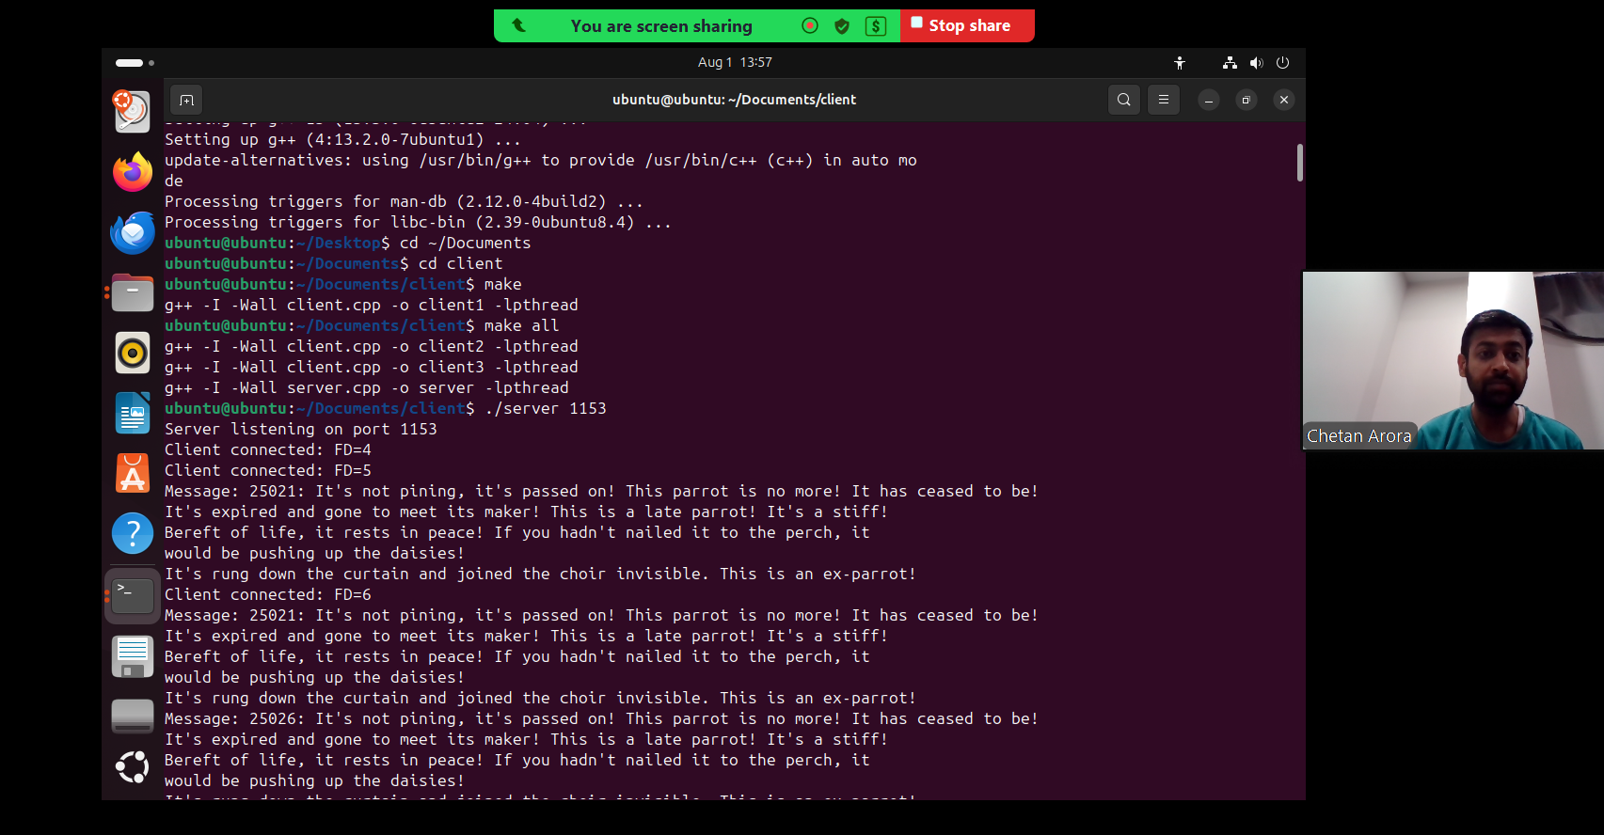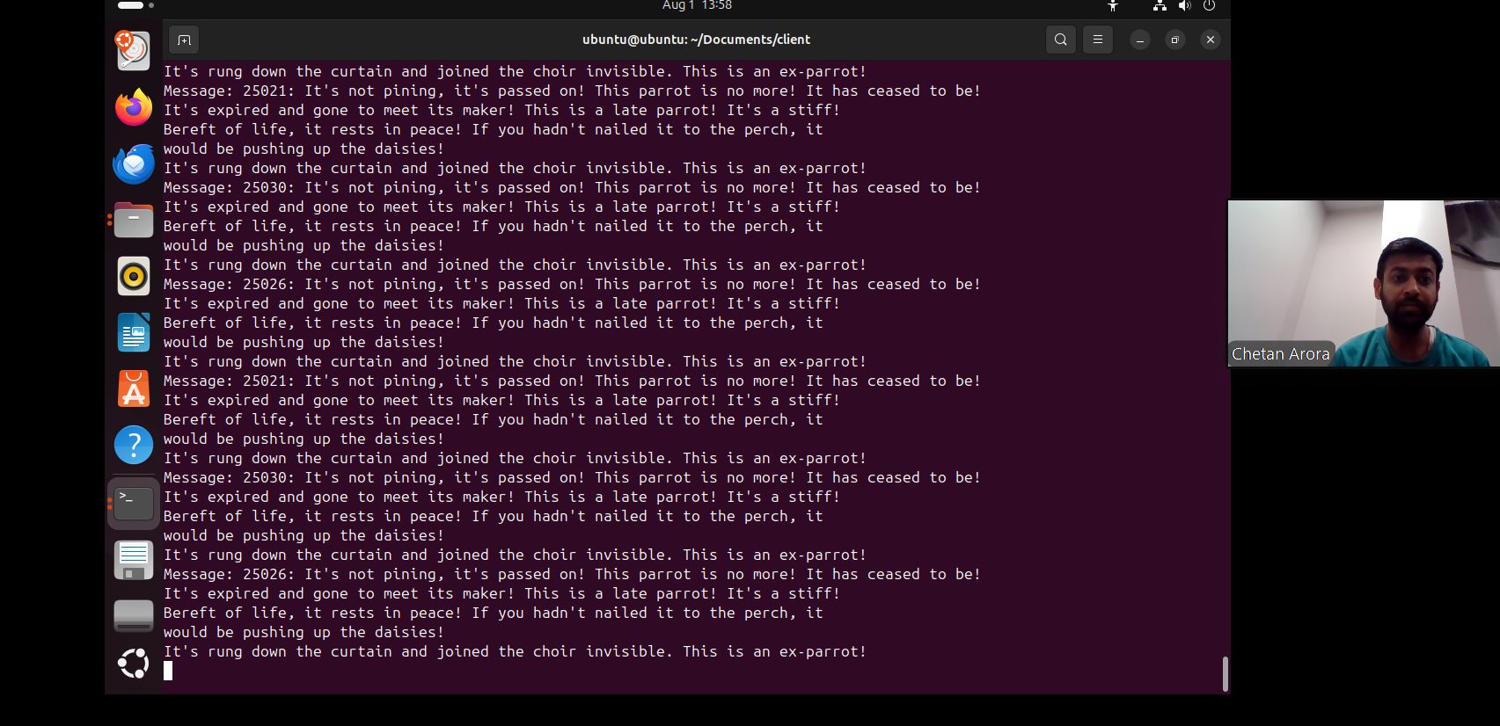

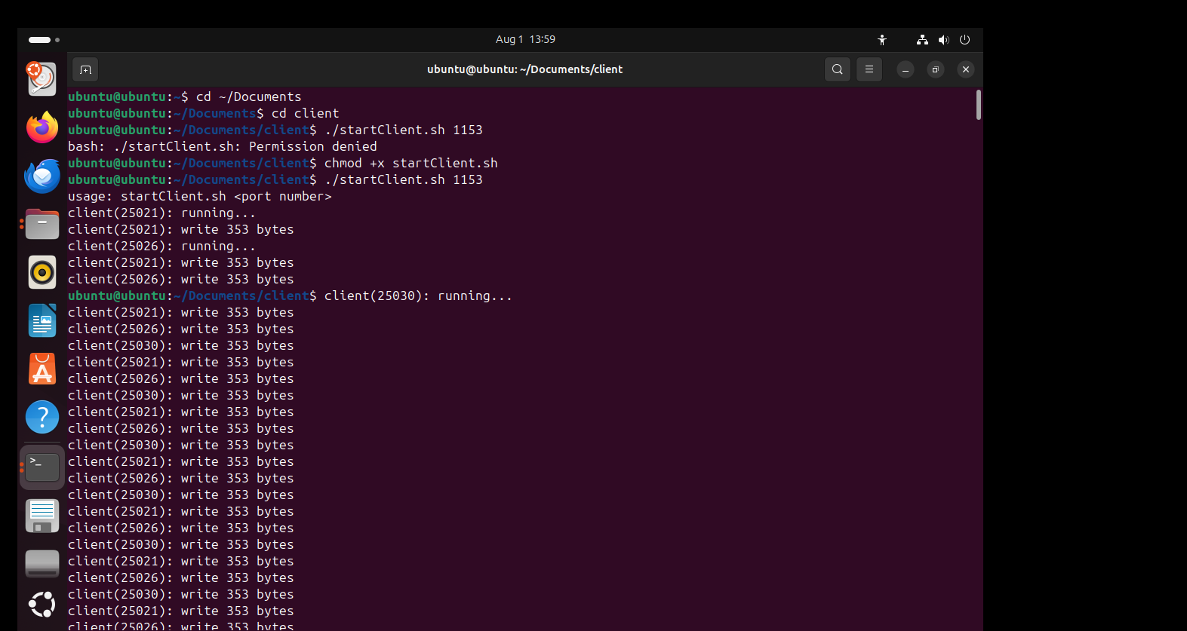

1.What is the difference between synchronous and asynchronous communication?

Ans:- The main difference is in timing.

In synchronous communication, both sides have to be ready at same time, one side sends data and waits for the other to respond right away. It’s kind of like a live conversation or a phone call.

With asynchronous communication, the sender doesn’t wait for the receiver to be ready. It sends the data and moves on. The receiver can deal with it whenever it’s ready. It’s more like sending an email or a text. we don’t have to be online at the same time. This is helpful in programming because it keeps things running smoothly without getting stuck waiting for a reply.

2.Do you prefer socket reads in a receive thread or do you prefer both socket read and write to be in the main() function? Why?

Ans:- I personally prefer doing socket reads in a separate receive thread. It just makes the program more responsive and organized, especially when dealing with multiple clients. If everything is in main(), it becomes harder to manage, and the main loop can get blocked while waiting for input from one client, which slows everything down.

With receive threads, each client is handled separately, so the server can keep accepting new connections or doing other tasks without getting stuck. It also makes it easier to set timeouts or handle slow clients without affecting the whole server. So overall, using threads for reading just feels cleaner and more efficient.

Please answer the following two declarations:

o D1) On a scale from 1 to 5, How much did you use generative AI to complete this assignment?

▪

where:

▪

1 means you did not use generative AI at all

▪

2 means you used it very minimally

▪

3 means you used it moderately

▪

4 means you used it significantly

▪

5 means you relied on it almost entirely

▪

Your answer :2

o D2) On a scale from 1 to 5, How confident are you in your understanding of the generative AI support you utilized in this assignment, and in your ability to explain it if questioned?

▪

where:

▪

1 means "Not confident at all – I do not understand the generative AI support I used and cannot explain it."

▪

2 means "Slightly confident – I understand a little, but I have many uncertainties."

▪

3 means "Moderately confident – I understand the majority of the support, though some parts are unclear."

▪

4 means "Very confident – I understand most of the AI support well and can explain it with minor gaps."

▪

5 means "Extremely confident – I fully understand the generative AI support I used and can clearly explain or justify it if asked."

▪

Your answer :5