/\*\*\*\*\*\*\*\*\*\*\*\*\*\*\*\*\*\*\*\*\*\*\*\*\*\*\*\*\*\*\*\*\*\*\*\*\*\*\*\*\*\*\*\*\*\*\*\*\*\*\*\*\*\*\*\*\*\*\*\*\*\*\*\*\*\*\*\*\*\*\*\*\*\*\*\*\*\*\*\*\*\* \*

I declare that this lab is my own work in accordance with Seneca Academic Policy.  \*  No part of this assignment has been copied manually or electronically from any other source\*  (including web sites) or distributed to other students.\* \*

Name: Chetan Arora Student ID: 100976240 Date: 29 July 2025

\*\*\*\*\*\*\*\*\*\*\*\*\*\*\*\*\*\*\*\*\*\*\*\*\*\*\*\*\*\*\*\*\*\*\*\*\*\*\*\*\*\*\*\*\*\*\*\*\*\*\*\*\*\*\*\*\*\*\*\*\*\*\*\*\*\*\*\*\*\*\*\*\*\*\*\*\*\*\*\*\*\*/

1. In a few sentences, describe the general architecture of your entire layout with the network monitor and interface monitors. What does each do?

Ans:- The general architecture consists of a central Network Monitor process and multiple Interface Monitor processes—one for each network interface. The Network Monitor acts as the controller: it queries the user for interface names, launches the Interface Monitors using fork() and exec(), and communicates with them through Unix domain sockets in /tmp. Each Interface Monitor is responsible for reading and displaying real-time statistics from /sys/class/net/<interface-name> every second. If an interface goes down, the Interface Monitor alerts the Network Monitor, which then instructs it to bring the link back up. Both components handle graceful shutdown via signal interception.

1. Could the interface monitor and network monitor all be contained within one process, if so how?

Ans:- Yes, the interface monitor and network monitor could be combined into one process. Instead of creating separate processes, the program could use threads—one thread per interface to read and display stats, while the main thread manages control logic like restarting links or shutting down. It could also be done with a single loop that checks all interfaces one by one. While this would work, separating them into processes makes the system more organized and easier to manage, especially if something goes wrong with one interface.

1. Could the interface monitor and network monitor all be contained within one process, assuming 128 network interfaces running at several Giga-bits per second, which require a polling interval of one millisecond per interface.

Ans:- No, combining everything into one process wouldn't work well in that case. With 128 interfaces needing to be checked every millisecond, a single process wouldn’t be fast enough to keep up. The system would fall behind because it would take too long to loop through all interfaces. Using multiple processes or threads allows the work to be done in parallel, which is much better for high-speed environments like this. So, for performance and scalability, it’s better to keep them separate.

1. What is a software defined network? In doing so, describe the applications layer, the control layer, and the forwarding layer.

Ans:- A Software Defined Network (SDN) is a modern approach to networking where the control of the network is separated from the physical hardware. Instead of each router or switch making its own decisions, SDN puts the "intelligence" in one central place, which makes the network easier to manage and more flexible.

The Application Layer is where the user-facing programs live—things like traffic monitoring tools, firewall managers, or load balancers. These apps define what the network should do.

The Control Layer is the brain of the network. It takes instructions from the applications and decides how to apply them across the network. This layer uses controllers to manage the hardware devices.

The Forwarding Layer is the physical part—switches, routers, and devices that actually move data from one point to another based on the control layer’s instructions.

Together, these layers allow networks to be programmable, dynamic, and easier to update without touching physical hardware.

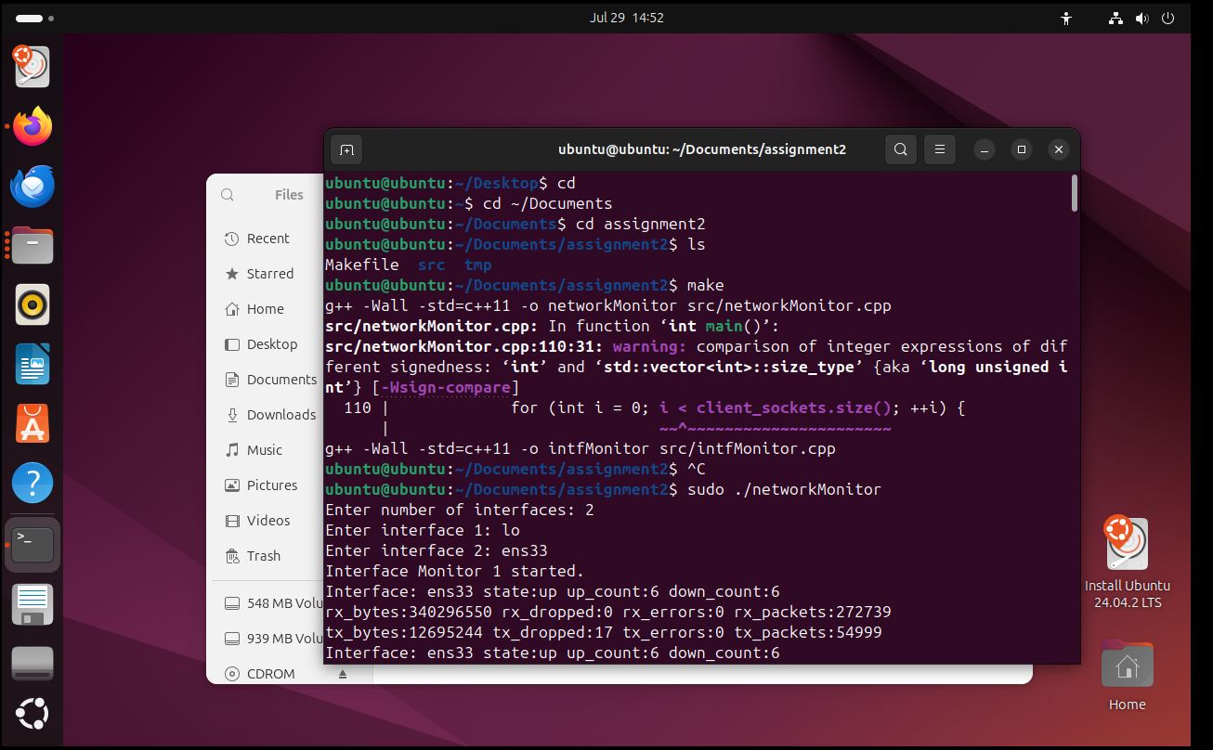

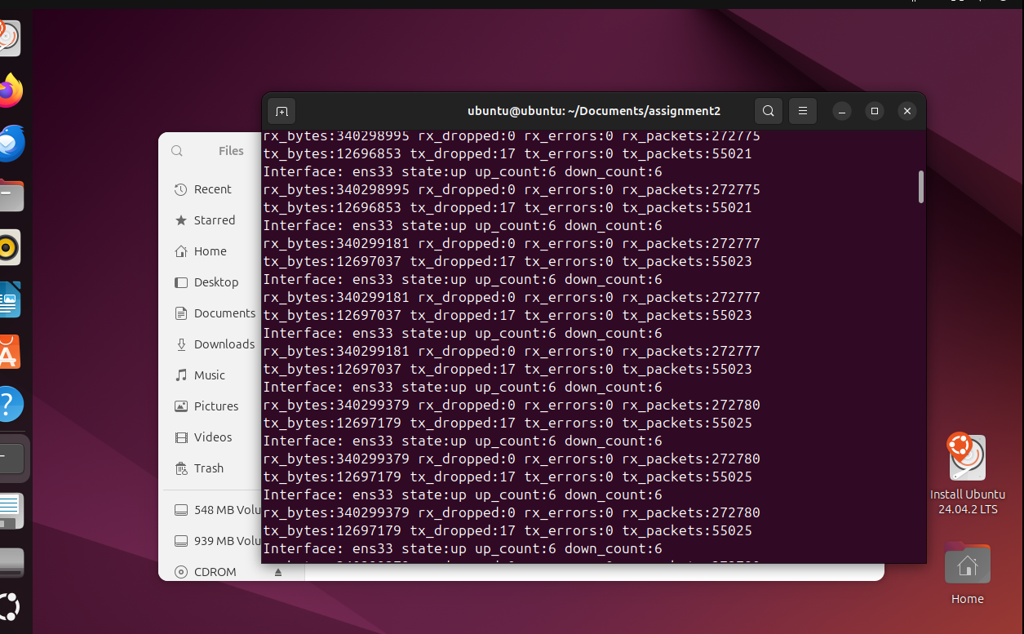

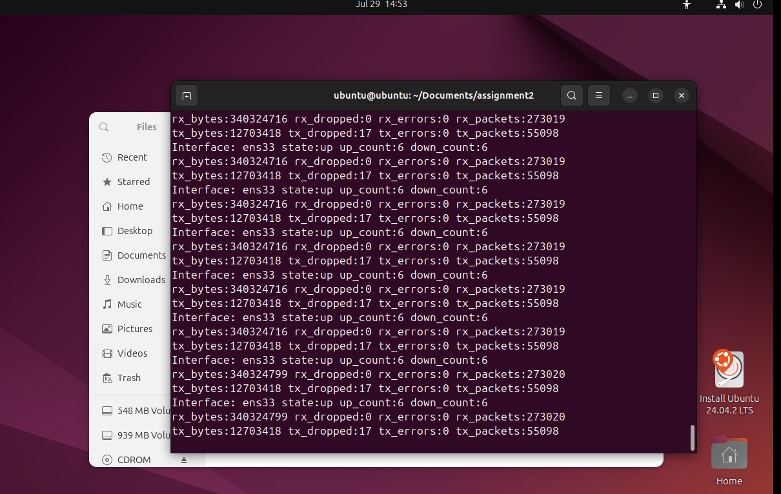

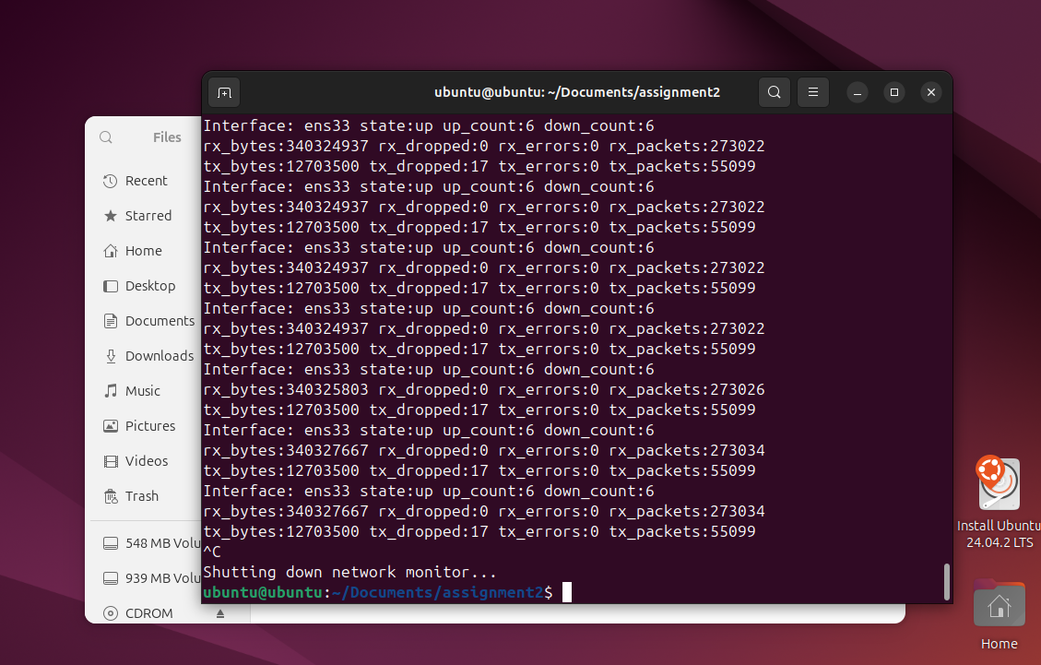

Please answer the following two declarations:

o D1) On a scale from 1 to 5, How much did you use generative AI to complete this assignment?

▪

where:

▪

1 means you did not use generative AI at all

▪

2 means you used it very minimally

▪

3 means you used it moderately

▪

4 means you used it significantly

▪

5 means you relied on it almost entirely

▪

Your answer :2

o D2) On a scale from 1 to 5, How confident are you in your understanding of the generative AI support you utilized in this assignment, and in your ability to explain it if questioned?

▪

where:

▪

1 means "Not confident at all – I do not understand the generative AI support I used and cannot explain it."

▪

2 means "Slightly confident – I understand a little, but I have many uncertainties."

▪

3 means "Moderately confident – I understand the majority of the support, though some parts are unclear."

▪

4 means "Very confident – I understand most of the AI support well and can explain it with minor gaps."

▪

5 means "Extremely confident – I fully understand the generative AI support I used and can clearly explain or justify it if asked."

▪

Your answer :5