**CONTENTS:**

1. INTRODUCTION TO MEDIA ACCESS PROTOCOLS
2. ALOHA AND CSMA
3. RANDOM ACCESS V/S CONTROLLED ACCESS
4. PERSISTANT FORMS
5. DIAGRAM
6. FLOW DIAGRAM
7. APPLICATIONS
8. EXPRESSIONS/EQUATIONS
9. CODE SCREENSHOT, WORKSPACE, COMMAND WINDOW, FIGURES

**INTRODUCTION TO MEDIA ACCESS PROTOCOLS:**

The medium access control (MAC) sublayer is the layer that controls the hardware responsible for interaction with the wired, optical or wireless [transmission medium](https://en.wikipedia.org/wiki/Transmission_medium). The MAC sublayer and the [logical link control](https://en.wikipedia.org/wiki/Logical_link_control) (LLC) sublayer together make up the [data link layer](https://en.wikipedia.org/wiki/Data_link_layer). Within the data link layer, the LLC provides [flow control](https://en.wikipedia.org/wiki/Flow_control_(data)) and [multiplexing](https://en.wikipedia.org/wiki/Multiplexing) for the logical link, while the MAC provides flow control and multiplexing for the transmission medium. These two sublayers together correspond to layer 2 of the OSI (Open Systems Interconnection) model.

For compatibility reasons, LLC is optional for implementations of IEEE 802.3, but compulsory for implementations of other IEEE 802 physical layer standards. Within the hierarchy of the OSI model and IEEE 802 standards, the MAC sublayer provides a [control abstraction](https://en.wikipedia.org/wiki/Control_abstraction) of the physical layer such that the complexities of physical link control are invisible to the LLC and upper layers of the network stack. Thus, any LLC sublayer (and higher layers) may be used with any MAC. In turn, the medium access control block is formally connected to the [PHY](https://en.wikipedia.org/wiki/PHY) via a [media-independent interface](https://en.wikipedia.org/wiki/Media-independent_interface). Although the MAC block is today typically integrated with the PHY within [the same device package](https://en.wikipedia.org/wiki/System_in_package), historically any MAC could be used with any PHY, independent of the transmission medium.

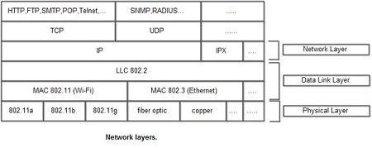

* **OSI (Open Systems Interconnection):**

The **Open Systems Interconnection model** (**OSI model**) is a [conceptual model](https://en.wikipedia.org/wiki/Conceptual_model) that characterizes and standardizes the communication functions of a [telecommunication](https://en.wikipedia.org/wiki/Telecommunication) or computing system without regard to its underlying internal structure and technology. Its goal is the interoperability of diverse communication systems with standard [communication protocols](https://en.wikipedia.org/wiki/Communication_protocols). The model partitions a communication system into [abstraction layers](https://en.wikipedia.org/wiki/Abstraction_layer). The original version of the model had seven layers.

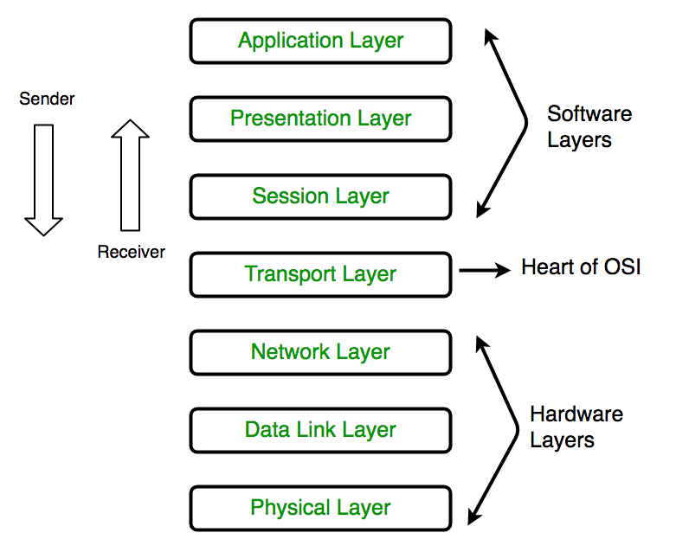

**COMPARISION B/W ALOHA AND CSMA:**

* ALOHA, the earliest random access method, was developed at the University of Hawaii in early 1970. It was designed for a radio (wireless) LAN, but it can be used on any shared medium.
* The medium is shared between the stations. When a station sends data, another station may attempt to do so at the same time.
* To minimize the chance of collision and, therefore, increase the performance, the CSMA method was developed. The chance of collision can be reduced if a station senses the medium before trying to use it.
* Carrier sense multiple access (CSMA) requires that each station first listen to the medium (or check the state of the medium) before sending. In other words, CSMA is based on the principle "sense before transmit" or "listen before talk

**Pure Aloha:**

* If all these stations try to resend their frames after the time-out, the frames will collide again.
* Pure ALOHA dictates that when the time-out period passes, each station waits a random amount of time before resending its frame. The randomness will help avoid more collisions.
* We call this time the back-off time *TB.*
* Pure ALOHA has a second method to prevent congesting the channel with retransmitted frames.
* After a maximum number of retransmission attempts Kmax' a station must give up and try later.

**RANDOM ACCESS V/S CONTROLLED ACCESS:**

|  |  |
| --- | --- |
| **RANDOM ACCESS** | **CONTROLLED ACCESS** |
| * In a random-access method, there is no control; access is based on connection. | * Either a central authority or other stations control the access. |
| * Collison exists. | * Collision free. |
| * Stations can transmit data. | * Only a station can transmit the data at a time. |
| * Simple and quick transfer at very low load. | * Quick transfer and high efficiency for low delay bandwidth product. |
| * Accommodates larger number of low traffic burst users. | * Can accommodate large number of burst users. |
| * High variable delay at moderate loads. | * Variable and unpredictable delay. |

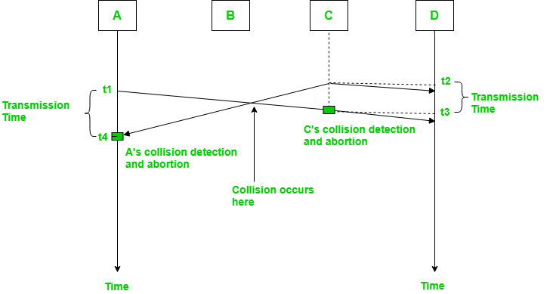**DIAGRAM:**

**I-Persistent** I**-persistent method** is simple and straightforward. **In** this method, after the station finds the line idle, it sends its frame immediately

* This method has the highest chance of collision because two or more stations may find

The line idle and send their frames immediately.

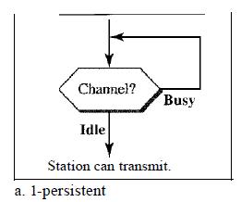

**Nonpersistent In** the **nonpersistent method,** a station that has a frame to send

Senses the line. If the line is idle, it sends immediately. The line is not idle, it waits a random amount of time and then senses the line again.

* The nonpersistent approach reduces the chance of collision because it is unlikely that two or more stations will wait the same amount of time and retry to send simultaneously.
* However, this method reduces the efficiency of the network because the medium remains idle when there may

Be stations with frames to send.

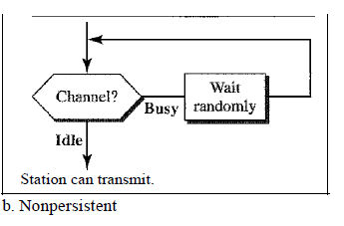

**P-Persistent The-persistent method** is used if the channel has time slots with a slot

duration equal to or greater than the maximum propagation time.

The p-persistent approach combines the advantages of the other two strategies. It reduces the chance of collision and improves efficiency.

In this method, after the station finds the line idle it follows these steps:

1. With probability *p,* the station sends its frame.

2. With probability *q* = 1 - *p,* the station waits for the beginning of the next time slot

and checks the line again.

A. If the line is idle, it goes to step 1.

B. the line is busy, it acts as though a collision has occurred and uses the back off

Procedure.

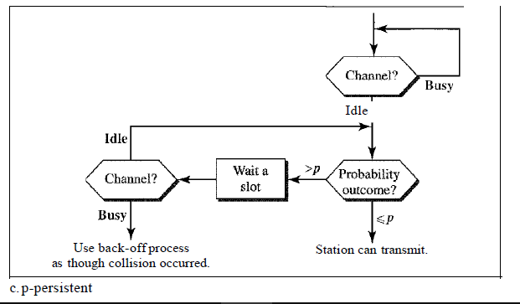

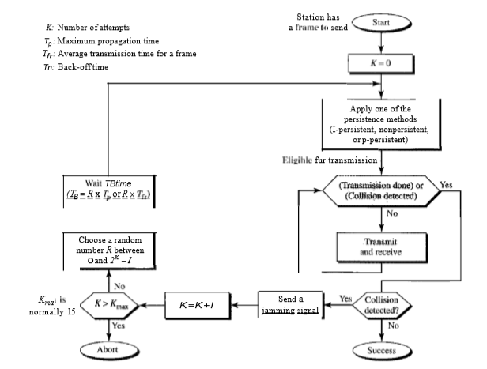**FLOW DIAGRAM:**

**APPLICATIONS:**

CSMA/CD was used in now-obsolete [shared media Ethernet](https://en.wikipedia.org/wiki/Ethernet#Shared_media) variants ([10BASE5](https://en.wikipedia.org/wiki/10BASE5), [10BASE2](https://en.wikipedia.org/wiki/10BASE2)) and in the early versions of [twisted-pair Ethernet](https://en.wikipedia.org/wiki/Twisted-pair_Ethernet) which used [repeater hubs](https://en.wikipedia.org/wiki/Repeater_hub). Modern Ethernet networks, built with [switches](https://en.wikipedia.org/wiki/Ethernet_switch) and [full-duplex](https://en.wikipedia.org/wiki/Full-duplex) connections, no longer need to use CSMA/CD because each Ethernet segment, or [collision domain](https://en.wikipedia.org/wiki/Collision_domain), is now isolated. CSMA/CD is still supported for backwards compatibility and for half-duplex connections. The [IEEE 802.3](https://en.wikipedia.org/wiki/IEEE_802.3) standard, which defines all Ethernet variants, for historical reasons still bore the title "Carrier sense multiple access with collision detection (CSMA/CD) access method and physical layer specifications" until 802.3-2008, which uses new name "IEEE Standard for Ethernet".

**EXPRESSIONS/EQUATIONS:**

* Waiting time if the collision time is detected (Tb) =R*Tp.
* Where Tp is the propagation time of data frame from a base station.
* And R is random number between 0 and 2^k -1.

**CODE SCREENSHOT:**

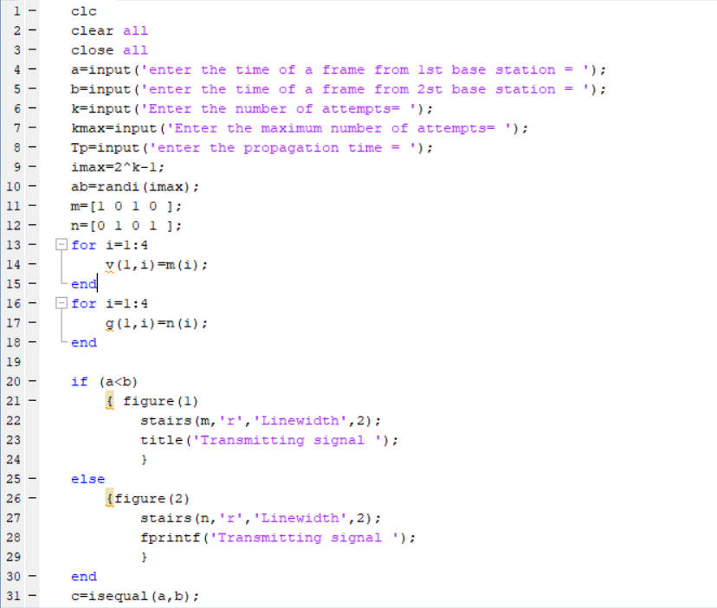

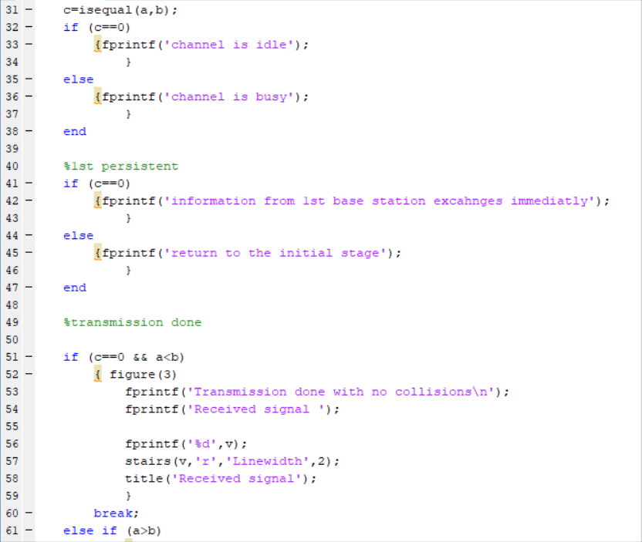

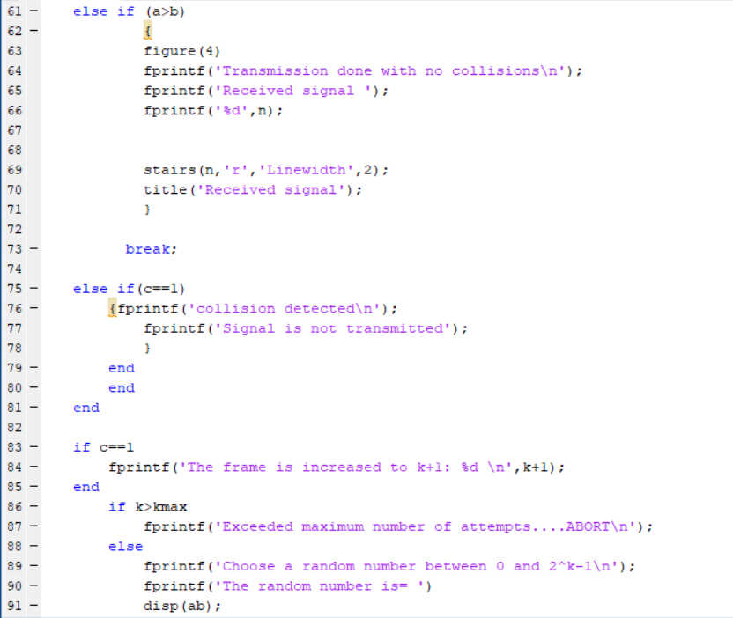

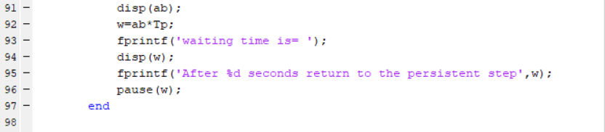

**WORKSPACE:**

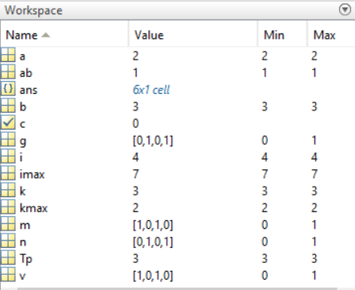

**COMMAND WINDOW:**

Case 1: Successful transmission

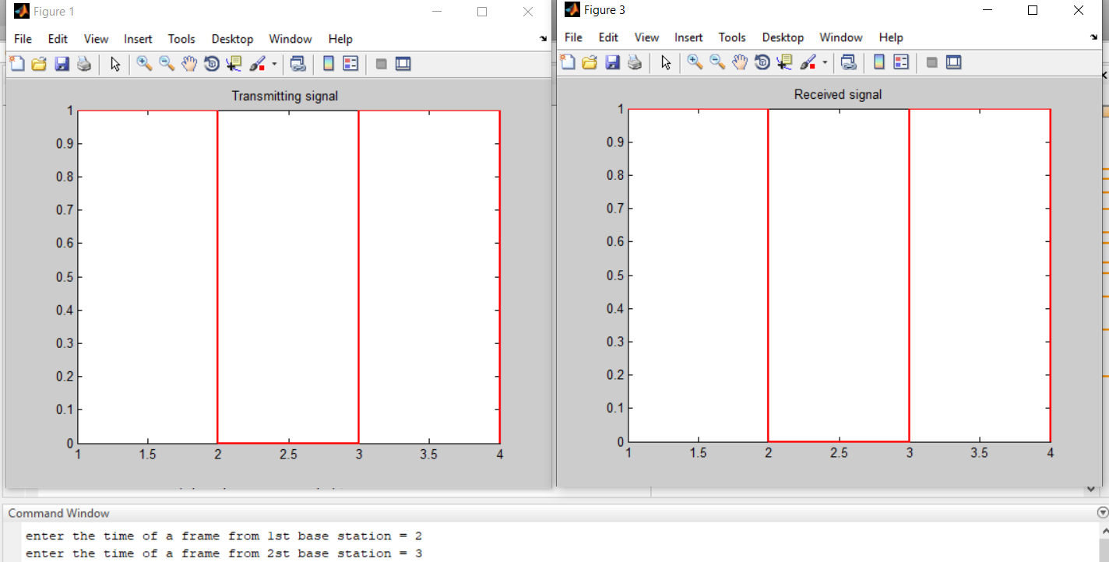

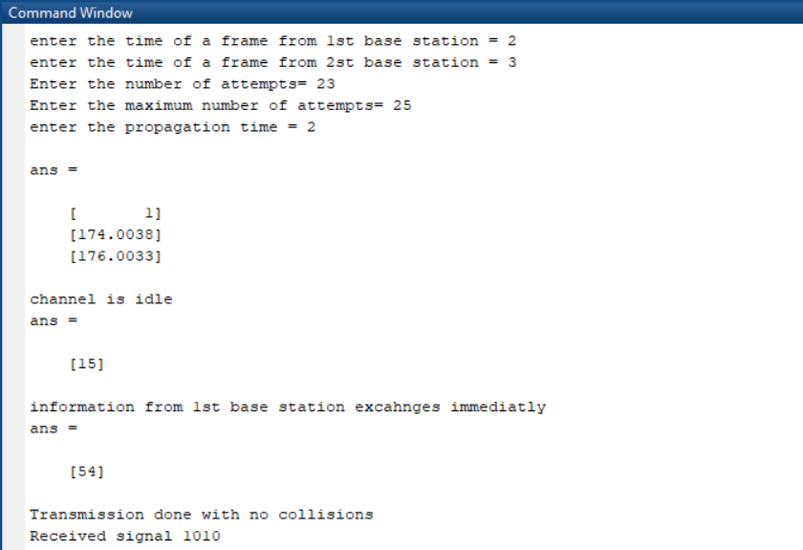

Case 2:Collision detection when number of attempts (k) is less than maximum number of attempts (kmax)

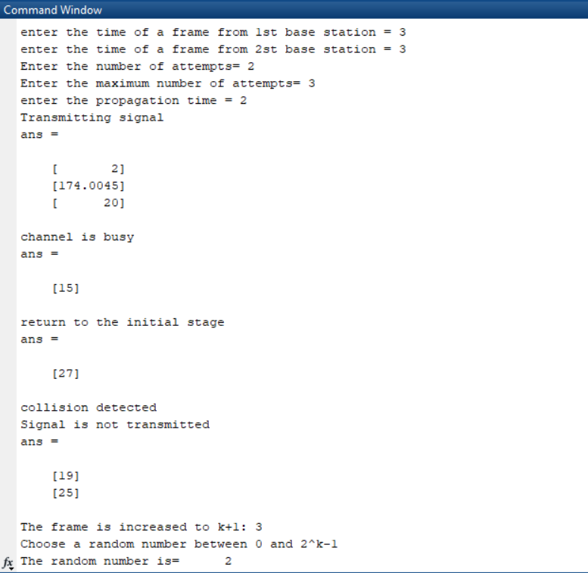

Case 3: Collision detection when no of attempts (k) is greater than maximum number of attempts (kmax)

