**BREAKOUT**

***Week 1***

**Team 3**

**Name: Vrishali, Rohan and Murtaza**

**Date: 08/27/18**

Breakout is a game consisting of a ball, paddle and a brick. The goal of the game is to hit all bricks with the ball. A player may fail to achieve this goal if the ball touches the ground. The paddle is moved by the user (using right and left arrow keys) and is used to prevent the ball hitting the ground.

**Architecture Diagram:**

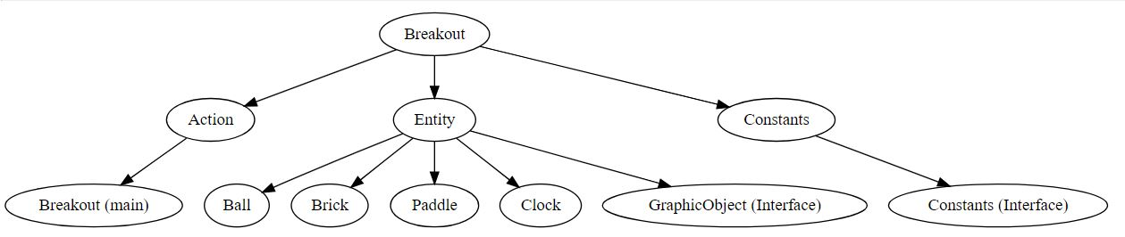

The project (Breakout) is divided into 3 packages

1. Action
2. Entity
3. Constants

**Action:** Consist of Breakout (main) class which invokes other entity classes.

**Entity:** Consist of classes which control the ball, paddle, brick and the clock.

**Constants:** Interface used to store all constants used by other classes.

Our project implements observer pattern wherein, there is an observer and observable. The clock is the observable – On each clock tick the ball, brick and paddle is notified and they change their positions.

**Class Diagram:**

**A close up of a map

Description generated with high confidence**