**Tutorial No. 1**

**Aim**:- Implement a calculator based on monolithic and client-server architecture.

**Theory**:-

**Monolithic Architecture**

A monolithic architecture is the traditional unified model for the design of a software program.

[Monolithic](http://whatis.techtarget.com/definition/monolithic), in this context, means composed all in one piece. Monolithic software is designed to be self-contained; components of the program are interconnected and interdependent rather than [loosely coupled](http://searchnetworking.techtarget.com/definition/loose-coupling) as is the case with [modular](http://searchenterpriselinux.techtarget.com/definition/module) software programs. In a tightly-coupled architecture, each component and its associated components must be present in order for code to be executed or compiled.

Furthermore, if any program component must be updated, the whole application has to be rewritten, whereas in a modular application, any separate module (such as a [microservice](http://searchsoa.techtarget.com/definition/microservices)) can be changed without affecting other parts of the program. Modular architectures reduce the risk that a change made within one element will create unanticipated changes within other elements, because modules are relatively independent. Modular programs also lend themselves to [iterative](http://searchsoftwarequality.techtarget.com/definition/iterative) processes more readily than monolithic programs.

However, there are benefits to monolithic architectures as well. Monolithic programs typically have better throughput than modular approaches, such as the microservice architecture ([MSA](http://whatis.techtarget.com/definition/microservice-architecture-MSA)) and they can be easier to test and debug because, with fewer elements there are fewer variables that come into play

**Client-Server Architecture**

In Computer science, client-server is a software architecture model consisting of two parts, client systems and server systems, both communicating over a computer network or on the same computer. A client-server application is a distributed system made up of both client and server software. Client server application provide a better way to share the workload. The client process always initiates a connection to the server, while the server process always waits for requests from any client. When both the client process and server process are running on the same computer, this is called a single seat setup.

Another type of related software architecture is known as peer-to-peer, because each host or application instance can simultaneously act as both a client and a server (unlike centralized servers of the client-server model) and because each has equivalent responsibilities and status. Peer-to-peer architectures are often abbreviated using the acronym P2P.

The client-server relationship describes the relation between the client and how it makes a service request to the server, and how the server can accept these requests, process them, and return the requested information to the client. The interaction between client and server is often described using sequence diagrams. Sequence diagrams are standardized in the Unified Modeling Language.

The basic type of client-server software architecture employs only two types of hosts: clients and servers. This type of architecture is sometimes referred to as two-tier. The two-tier architecture means that the client acts as one tier and server process acts as the other tier. The client-server software architecture has become one of the basic models of network computing. Many types of applications have been written using the client-server model. Standard networked functions such as E-mail exchange, web access and database access, are based on the client-server model. For example, a web browser is a client program at the user computer that may access information at any web server in the world

**Let us now know what a client is and what is a server?**

**Client** –

A client is a single-user workstation that provides presentation services and the appropriate computing, connectivity and the database services and the interfaces relevant to the business need.

**Server**-

A server is one or more multi-user processors with share memory providing computing, connectivity and the database services and the interfaces relevant to the business need.

services and the interfaces relevant to the business need. The Client/Server computing is an environment that satisfies the business need by appropriately allocating the application processing between the client and the server processors.

The protocol is the client requests the services from the server; the server processes the request and returns the result to the client. The communication mechanism is a message passing InterProcess communication (IPC) that enables the distributed placement of the client and server processes

The Client/Server is the generic model and fits what is know in the industry as the “cooperating processing” or “peer-to-peer”. The client/server computing is fundamentally platform independent.

The user of an application wants the functionality (business) it provides; the computing platform provides access to this business functionality. There are no benefits but a considerable amount of risk of exposing the platform to the users.

The changes in the platform and the underlying technology should be transparent to the user, as it is understood that the systems built with transparency to the technology, for the entire user offer the highest probability of solid ongoing return for the technology investment.

It is also easily demonstrable that is the developers become aware of the target platform, development will be bound to that platform and they will use special tricks and feature found in that specific platform. The figure 1.1 shown below depicts the modern client/server architecture.

**Class Diagram** :-

Monolithic Architecture:

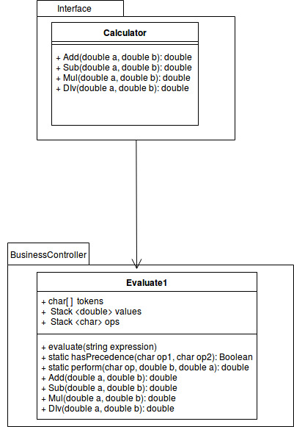

Client Server Architecture:

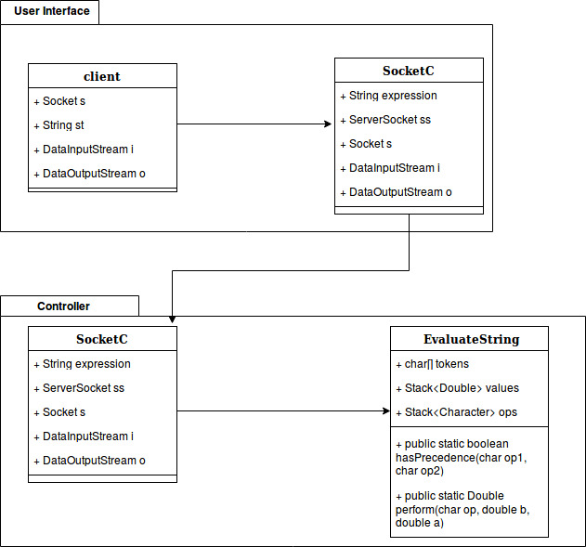

**Conclusion**:-

Thus we studied Monolithic Architecture and client server architecture and implemented same for calculator.