Roll number: 1929

Topic: Photography Booking System

Aim:

This project is aim at computerizing the manual process of photography booking system. Front
end and backend are implemented using HTML and MySQL respectively.

Overview:
The website is for people who are looking forward to hire a photographer for differnt occasions.
The website will allow users to view the categories of photoshoot by clicking on “services” like birthday photography, wedding photography, engagement photography etc Also on clicking see portfolio button of that category, one can view our gallery which has previously clicked photos.
Customer has previlages to view the website and book the photoshoot. About us will have information aboout the photographer. Contact option on the nav bar will show contatct info like phone number and email, office location address of the photographer.

Purpose(requriment):

The purpose of this project is to outline photoshoot data and requirements, to
recommend data management solutions and to provide a information regarding the
photoshoot. The purpose of this project is to develop a data management system to
consolidate, organize, document, store and distribute information related to photography
booking system.

Scope
The scope of the project is managing a consistency and storage of data by dedicated
data administrator. It provides most of the features that a Database Management System
should have. It is developed by using MySQL database. It has been implemented in
windows platform.

Design of the project
This project has been developed using MySQL software which is queries oriented. Changes
at the queries and the way in which it uses a system state may cause anticipated changes in
the behaviour of other result.

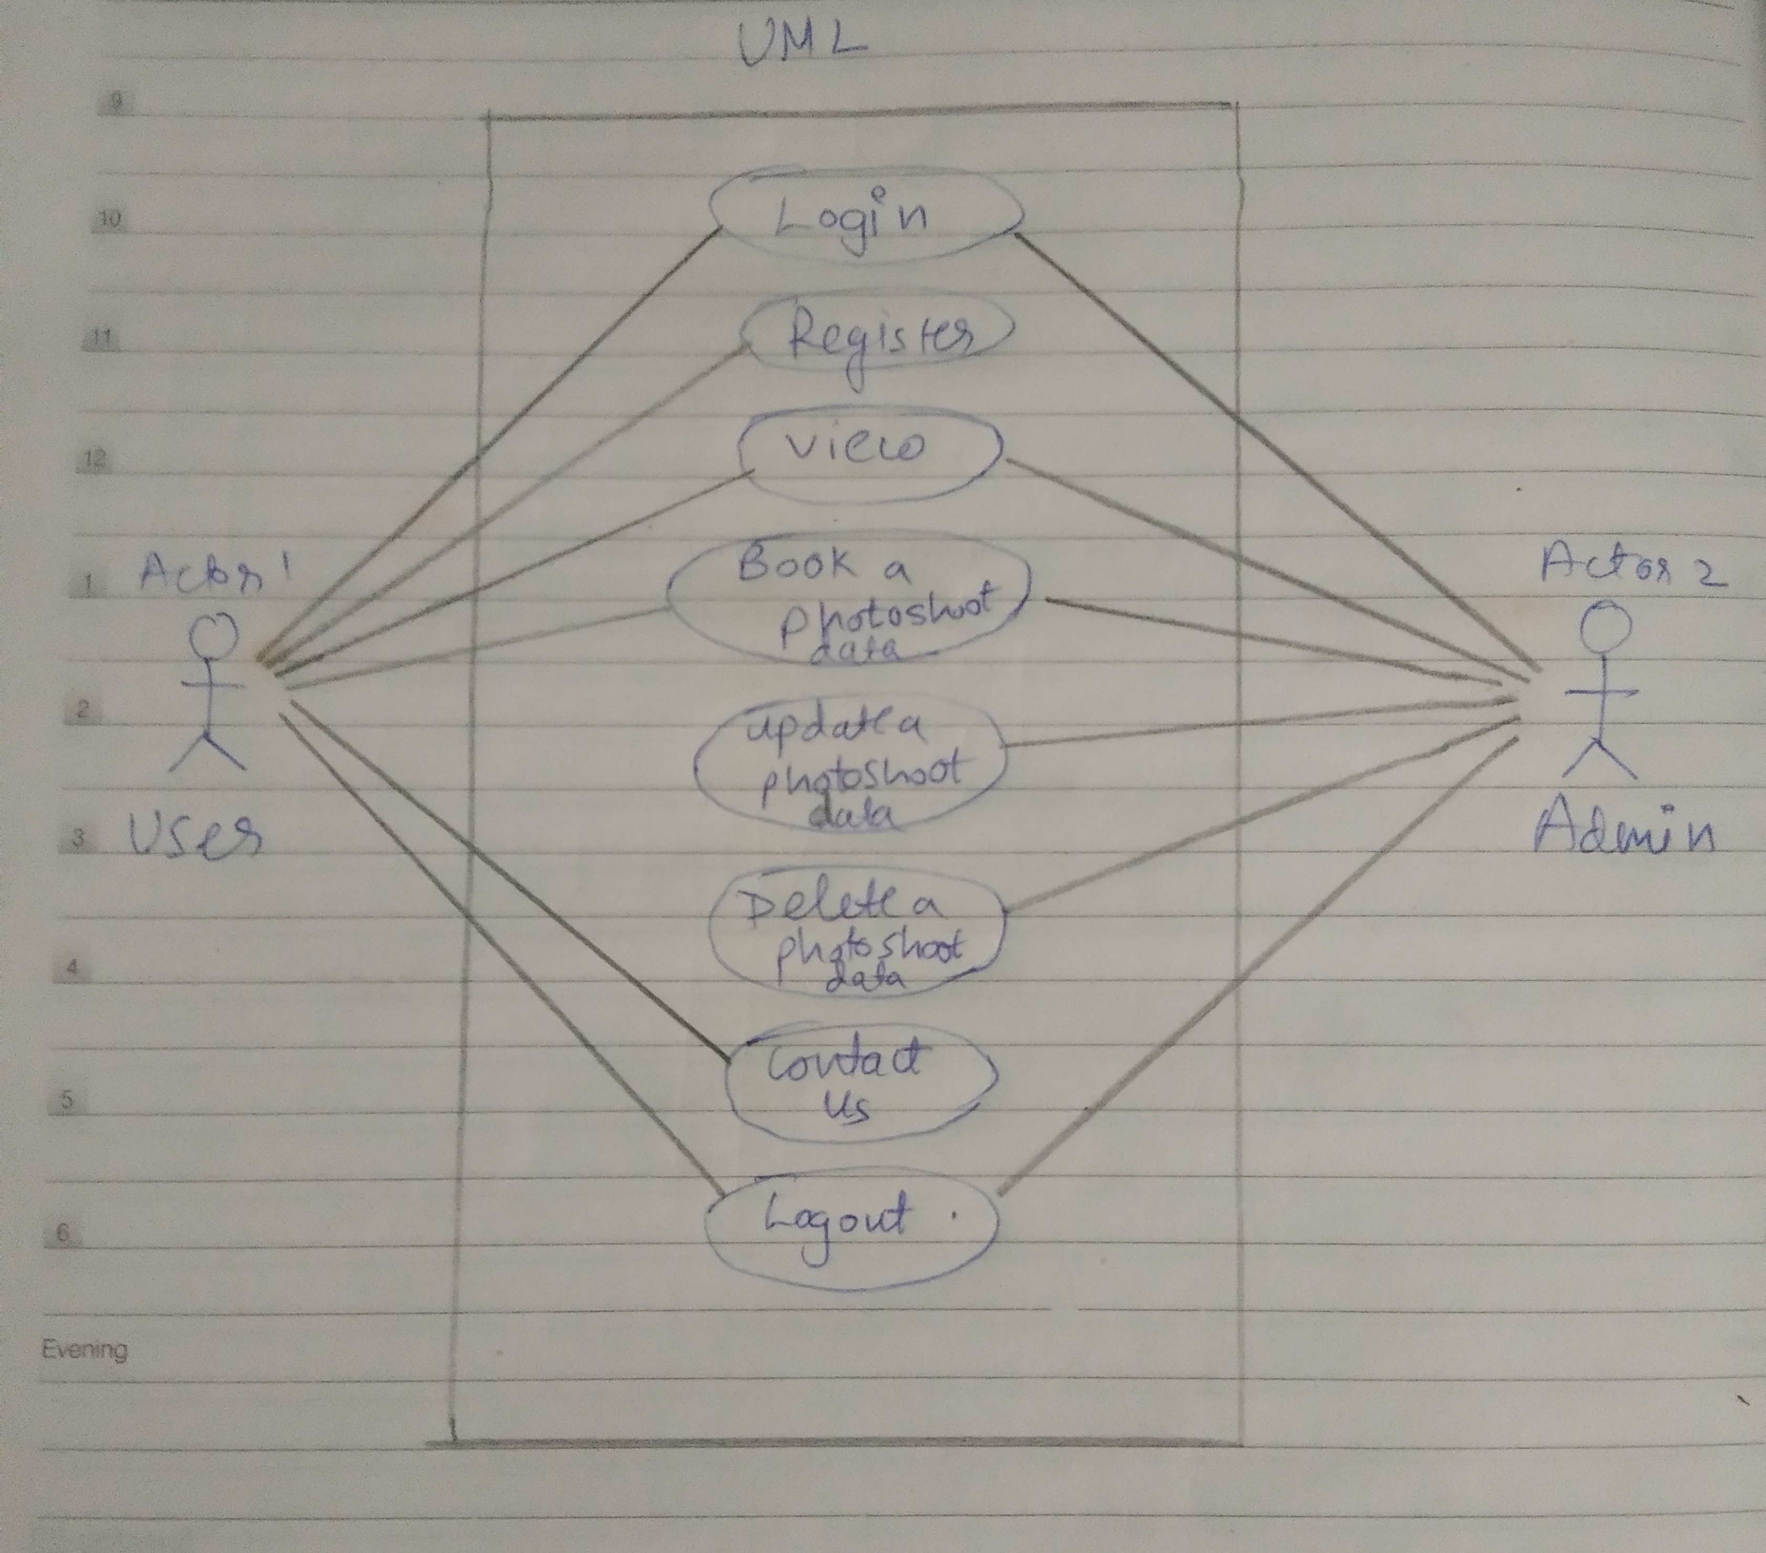
Note: This diagram i will be modifying again based on project requirement.

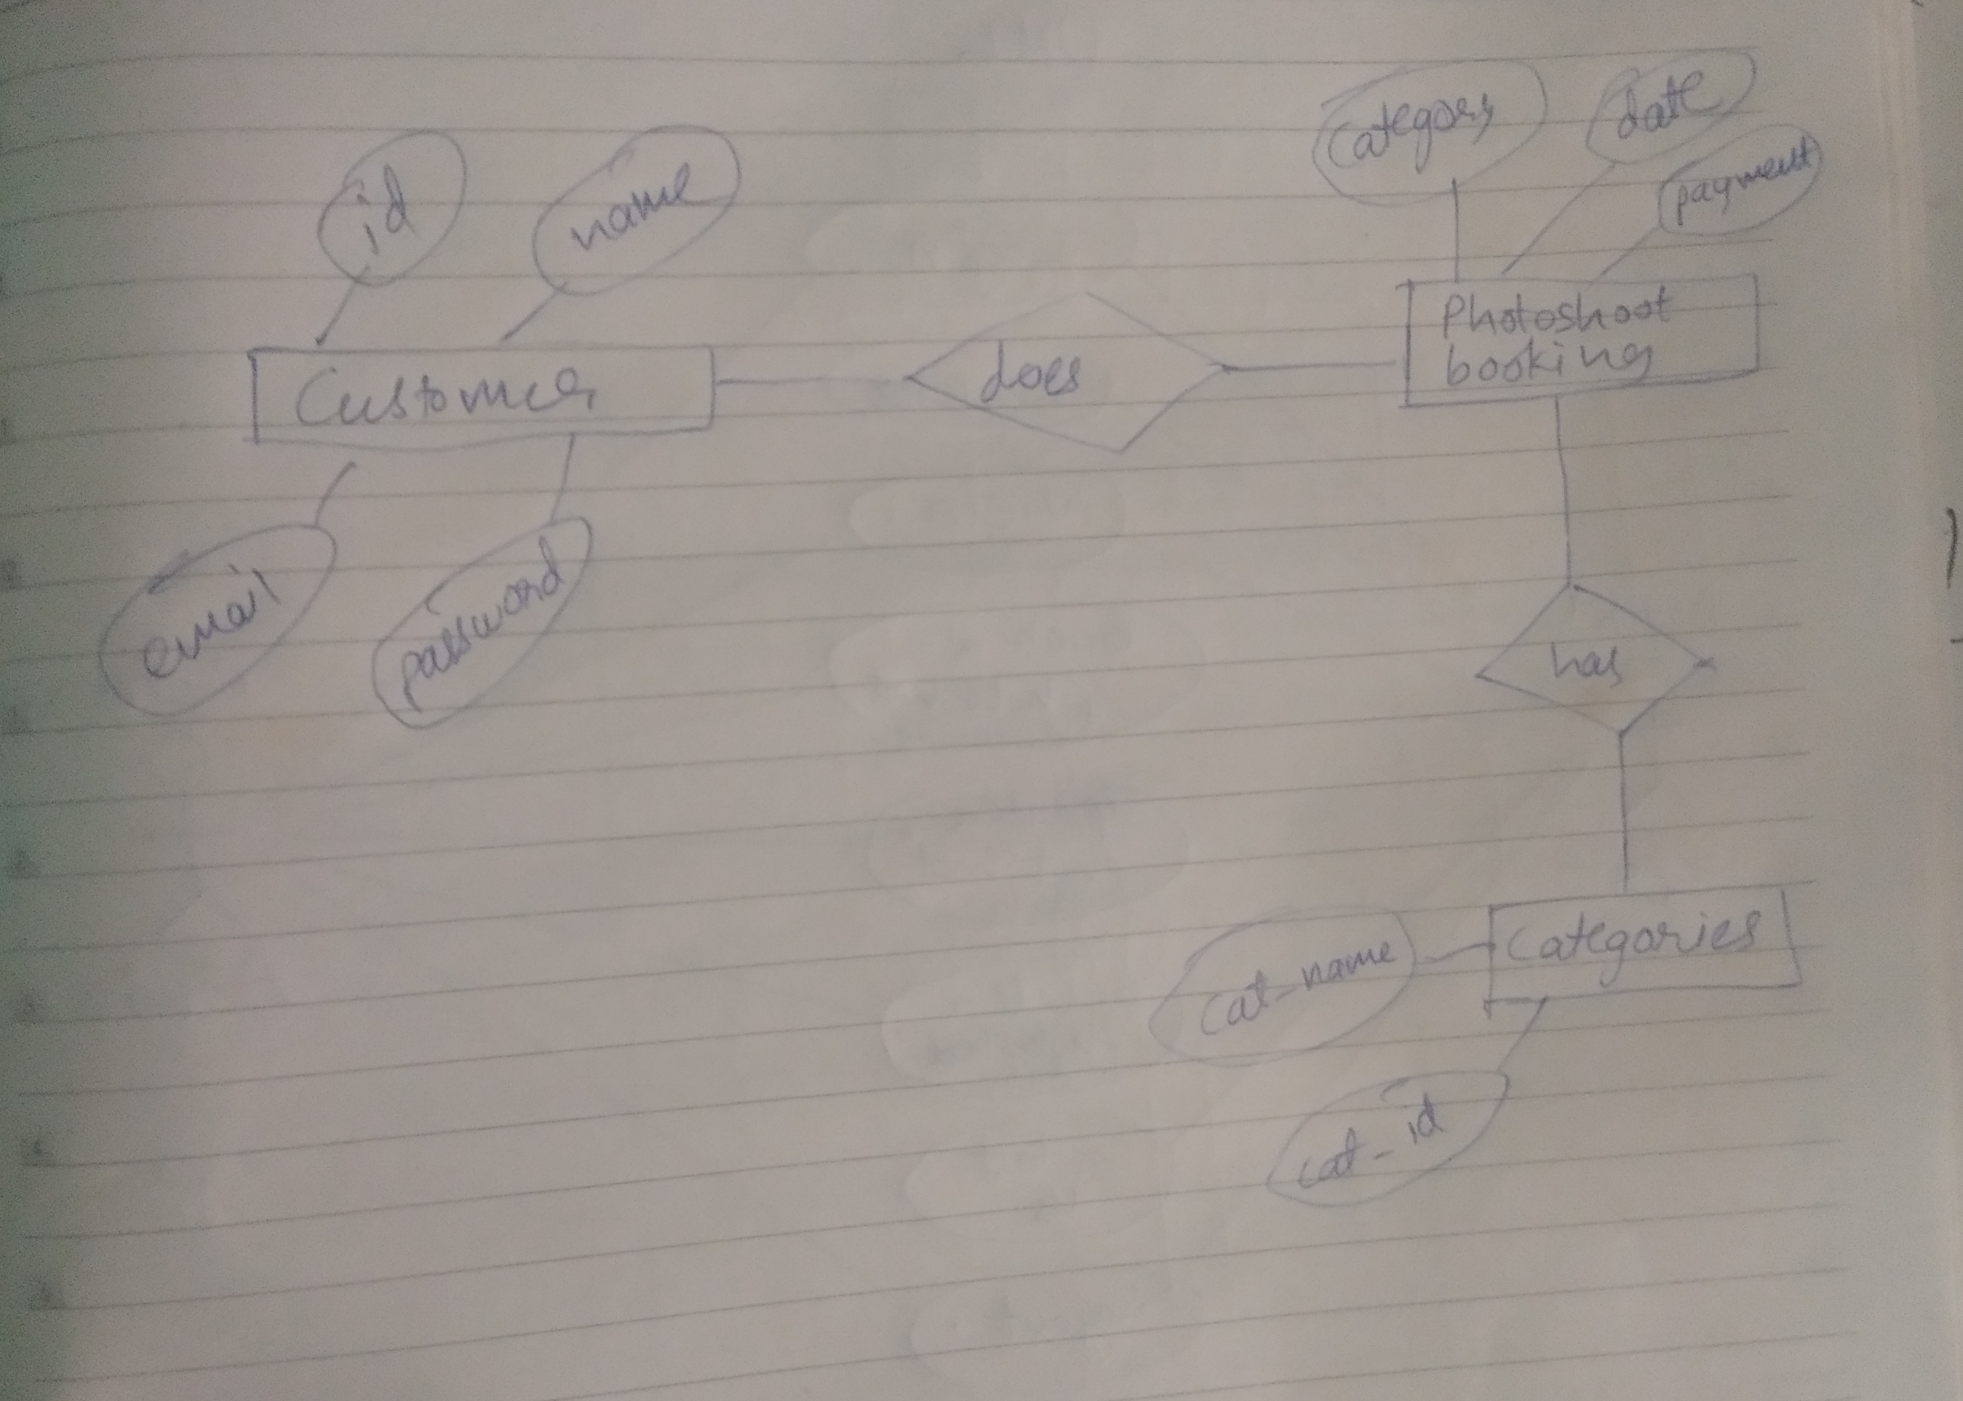

Note: i may add more entities or attributes depending upon the requirement.

