System Requirements Statement (SRS) –

Doctor Appointment Application

Created by : Suraj Giram, Sourabh Namdeo, Jagruti Patil, Chetana Patil

Date :04-Sept-2023

1. Introduction 3

2. Functional Requirements 4

2.1 Patient Module 5

2.2 Doctor Module 10

2.3 Admin Module 15

2.4 Use Case Diagram 18

THIS DOCUMENT CONTAINS 20 NUMBERED PAGES

# Introduction

This document explains the system requirements and scope for developing Doctor appointment application

Doctor appointment application could divide the three main parts, Patient part, Doctor part, Admin part.

This document describes the system requirement of the Account part.

# Functional Requirements

The Account part of Doctor Appointment Application has three modules which are divided 13 processes described as below.

|  |  |  |
| --- | --- | --- |
| **No** | **BRS requirement ID** | **Description** |
| **2.1** | **Patient Module** | |
| **2.1.1** | **F1** | **Account Creation Process** |
| **2.1.2** | **F2** | **Login Process** |
| **2.1.6** | **F6** | **Search and Select Doctor** |
| **2.1.7** | **F7** | **Browse details of `Doctor** |
| **2.1.8** | **F8** | **Get Appointment** |
| **2.2** | **Doctor Module** | |
| **2.2.1** | **F10** | **Account Creation Process** |
| **2.2.2** | **F11** | **Login Process** |
| **2.2.3** | **F12** | **Add Availability** |
| **2.2.4** | **F13** | **View Scheduled appointment** |
| **2.2.5** | **F15** | **Confirm & Cancel Appointment** |
| **2.2.7** | **F17** | **View Scheduled appointment** |
| **2.3 Admin Module** | | |
| **2.3.1** | **F21** | **Login Process** |
| **2.3.4** | **F24** | **Update Account Process** |
| **2.3.5** | **F25** | **Report Generation** |
| **2.3.6** | **F26** | **Account Management** |

## Patient Module

* Patient is the user of system who wants to seek medical consultations and treatments.
* He/She is also able to view the doctor details after registering.

### Account Creation Process

* Doctor Appointment Application compels to create the account before using it. So, Doctor Appointment Application should provide the function which makes patients creates new account.
* When patient creates new account, the function demands information described as below.

1. Registration

* The Registration information consists of some items described as below.

1. First Name
2. Last name
3. E-mail ID
4. Password
5. User Type
   1. All items are compulsory demanded.
   2. First Name

* The First Name has constraints described as below.

1. Capital alphabet (A-Z)(first letter should be capital)
2. Small alphabet (a-z)(remaining letter should be small)
   1. Last Name

* The Last Name has constraints described as below.

1. Capital alphabet (A-Z)(first letter should be capital)
2. Small alphabet (a-z)(remaining letter should be small)
   1. E-mail ID

* If the Email ID correspond with not case-sensitive to other which is previously registered, the Email-ID should not be registered as an account.
  1. Password
* The Password has constraints which makes the Password consists of more than or

equal 8 and less than or equal 16 characteristics including characters described as below.

1. Numeric figure (at least one)
2. Capital alphabet (A-Z)(at least one)
3. Small alphabet (a-z)(at least one)
4. Special character (#, $, %, &, etc.) (at least one)

* The Password is masked by dummy characters. The re-entering Password is demanded.
* The Password must be encrypted in Online PG Rental System.
  1. User Type

The User Type falls into two categories described as below.

1. Patient
2. Doctor

* The User Type defines two types of users; "Patient", "Doctor".
* In an Account Creation Process, the user can select Patient or Doctor.
* Registration information should be entered on one screen and Login information should be entered on another screen after confirmed registration.

### Login Process

* Doctor Appointment Application always compels user authentication before using itself except when a new account is successfully created.
* The Login information
  1. Email-ID
  2. Password
* The user authentication demands Email-ID and Password. The Email-ID and the Password should be checked in three ways.
  1. First, The Email-ID and the Password should be existed and correct.
* If The Email-ID and the Password are not equal to what the user has registered, the user authentication cannot be provided.
  1. Second, the User Type linked to the Email-ID should be "Patient".
* When the User Type is "Patient”, then user can be placed on “Patient’s Dashboard”.
  1. Finally, Email-ID should be available.
* The Administrator can decide whether the Email-ID is available or suspended – Refer to the SRS of the Admin part.
* If Patient registration is timed out, user authentication is not provided for system user.
  1. Password
* The Password has constraints which makes the Password consists of more than or equal 8 and less than or equal 16 characteristics including characters described as below.

1. Numeric figure (at least one)
2. Capital alphabet (A-Z)(at least one)
3. Small alphabet (a-z)(at least one)
4. Special character (#, $, %, &, etc.) (at least one)

* The Password is masked by dummy characters. The re-entering Password is demanded.
* The Password must be encrypted in Doctor Appointment Application.
  1. The Patient account should alive for so long as the duration decided by Admin.
  2. Only when all the checks are successfully completed, Patient can be placed on respected page.
  3. The “Patient Dashboard” provides some of the features described as below.

1. A trigger to logout
2. A trigger to update Account
3. A trigger to Change Password
4. A trigger to Search and Select Doctor
5. A trigger to Fetch the details of Doctor

### Update Account Process

* Doctor Appointment Application should provide the function which makes the account updated for patient.
* The information tenant could update is described below.

1. Login information
2. User information

* The Login information

The updatable items as described below.

1. First Name
2. Last Name
3. E-mail address

* All items are compulsory demanded, but updating is optional.
* The User information

The updatable items as described below.

1. Patient Name
2. Patient Contact No
3. E-mail address

* All items are compulsory demanded, but updating is optional.

### Search and Select Doctor

* Search conditions are described as below.

1. Doctor Specialization
2. Hospital Name
3. Area
4. City
5. State

* Select conditions: Only one doctor can be selected at a time and after the doctor approval the payment can be processed.

### Browse Details of Doctor

* The patient will be able to see the doctor specialization, hospital name, area, facilities available, appointment fees, status and contact details.

### 2.1.6 Get Appointment Process

* Appointment will be fixed on the basis of doctor availability.

**2.2 Doctor Module**

* Doctor / Medical professional is the user of system who wants to offer their services through the platform.
* He/She is able to manage the appointments after registering.

### Account Creation Process

* Doctor Appointment Application compels to create the account before using it. So, Doctor Appointment Application should provide the function which makes doctor creates new account.
* When doctor creates new account, the function demands information described as below.
  + 1. Registration
* The Registration information consists of some items described as below.
  + - First Name
    - Last name
    - E-mail ID
    - Password
    - Registration ID
    - Phone number
    - Address
    - Work experience
    - Specialist/category

1. All items are compulsory demanded.
2. First Name

* The First Name has constraints described as below.
* Capital alphabet (A-Z)(first letter should be capital)
* Small alphabet (a-z)(remaining letter should be small)

1. Last Name

* The Last Name has constraints described as below.
* Capital alphabet (A-Z)(first letter should be capital)
* Small alphabet (a-z)(remaining letter should be small)

1. E-mail ID

* If the Email ID correspond with not case-sensitive to other which is previously registered, the Email-ID should not be registered as an account.

1. Password

* The Password has constraints which makes the Password consists of more than or

equal 8 and less than or equal 16 characteristics including characters described as below.

* Numeric figure (at least one)
* Capital alphabet (A-Z)(at least one)
* Small alphabet (a-z)(at least one)
* Special character (#, $, %, &, etc.) (at least one)
* The Password is masked by dummy characters. The re-entering Password is demanded.
* The Password must be encrypted in Doctor Appointment Application.

1. User Type

The User Type falls into two categories described as below.

1. Patient
2. Doctor

* The User Type defines two types of users; "Patient", "Doctor".
* In an Account Creation Process, the user can select Patient or Doctor.
* Registration information should be entered on one screen and Login information should be entered on another screen after confirmed registration.

### Login Process

* Doctor Appointment Application always compels user authentication before using itself except when a new account is successfully created.
* The Login information
  1. Email-ID
  2. Password
* The user authentication demands Email-ID and Password. The Email-ID and the Password should be checked in three ways.
  1. First, The Email-ID and the Password should be existed and correct.
* If The Email-ID and the Password are not equal to what the user has registered, the user authentication cannot be provided.
  1. If the User Type linked to the Email-ID is linked with "Doctor".
* When the User Type is " Doctor ", then user can be placed on “Doctor Dashboard”.
  1. Finally, Email-ID should be available.
* The Administrator can decide whether the Email-ID is available or suspended – Refer to the SRS of the Admin part.
* If Doctor’s registration is timed out, user authentication is not provided for system user.
  1. Password
* The Password has constraints which makes the Password consists of more than or equal 8 and less than or equal 16 characteristics including characters described as below.

1. Numeric figure (at least one)
2. Capital alphabet (A-Z)(at least one)
3. Small alphabet (a-z)(at least one)
4. Special character (#, $, %, &, etc.) (at least one)

* The Password is masked by dummy characters. The re-entering Password is demanded.
* The Password must be encrypted in Doctor Appointment Application.
  1. The Doctor account should alive for so long as the duration decided by Admin.
  2. Only when all the checks are successfully completed, Doctor can be placed on respected page.
  3. The “Doctor Dashboard” provides some of the features described as below.
     1. A trigger to logout
     2. A trigger to update Account

### Update Account Process

* Doctor Appointment Application should provide the function which makes the account updated for patient.
* The information doctor could update is described below.
  + 1. Login information
    2. Registration information
* The Login information

The updatable items as described below.

* + 1. First Name
    2. Last Name
    3. E-mail address
* All items are compulsory demanded, but updating is optional.
* The Registration information

The updatable items as described below.

* + 1. Doctor Name
    2. Doctor Contact No
    3. E-mail address
    4. Address
* All items are compulsory demanded, but updating is optional.

**2.2.6 Add availability**

Add availability are described as below.

1. Timing

2. Date

**2.2.7 View Schedule appointment**

* The Doctor will be able to see the Appointment request list and he/she can accept/reject/reschedule the appointment.
* This information updated patient dashboard too.

## Admin Module

* Admin is the user of system who will manage the site and database.
* He/she is able manage and handle all the users and data provided by them. He/she is able view the users registered, generate report for the list or registered users, users who finalized any property, properties which are finalized by landlord also admin can view the properties added by all the doctors and can generate the report for that after logging in.

### Login Process

* Doctor Appointment Application always compels user authentication before using itself except when a new account is successfully created.
* The Login information
  + 1. Email-ID
    2. Password
* The user authentication demands Email-ID and Password. The Email-ID and the Password should be checked in three ways.
  1. First, The Email-ID and the Password should be existed and correct.
* If The Email-ID and the Password are not equal to what the user has registered, the user authentication cannot be provided.
  1. If the User Type linked to the Email-ID is linked with "Admin".
* When the User Type is " Admin ", then user can be placed on “Admin’s Dashboard”.
  1. Finally, Email-ID should be available.
* The Administrator can decide whether the Email-ID is available or suspended – Refer to the SRS of the Admin part.
* If Doctor’s registration is timed out, user authentication is not provided for system user.
  1. Password
* The Password has constraints which makes the Password consists of more than or equal 8 and less than or equal 16 characteristics including characters described as below.
  + - 1. Numeric figure (at least one)
      2. Capital alphabet (A-Z)(at least one)
      3. Small alphabet (a-z)(at least one)
      4. Special character (#, $, %, &, etc.) (at least one)
* The Password is masked by dummy characters. The re-entering Password is demanded.
* The Password must be encrypted in Doctor Appointment Application.
  1. The “Admin Dashboard” provides some of the features described as below.
     1. A trigger to logout
     2. A trigger to update Account
     3. A trigger to Change Password
     4. A trigger to view users
     5. A trigger to view added property list
     6. A trigger to generate report of users
     7. A trigger to generate report of properties

### Update Account Process

* Doctor Appointment Application should provide the function which makes the account updated for patient.
* The information admin could update is described below.
  + 1. Login information
    2. User information
* The Login information

The updatable items as described below.

* + 1. First Name
    2. Last Name
    3. E-mail address
* All items are compulsory demanded, but updating is optional.
* The User information

The updatable items as described below.

* + 1. Admin Contact No
    2. E-mail address
* All items are compulsory demanded, but updating is optional.

### Admin should able to manage all the accounts with following activities,

### 1. Enable accounts

### 2. Disable accounts

3. Generate Reports

### View/generate report of Patient

* He/she can view all the users registered, logged in and can generate report of them.
* One can view deals finalized by patient as well as doctor

### View/generate report of Doctor

* An Admin can view and generate the report of all the doctors.

## Use Case Diagram

**Admin:**

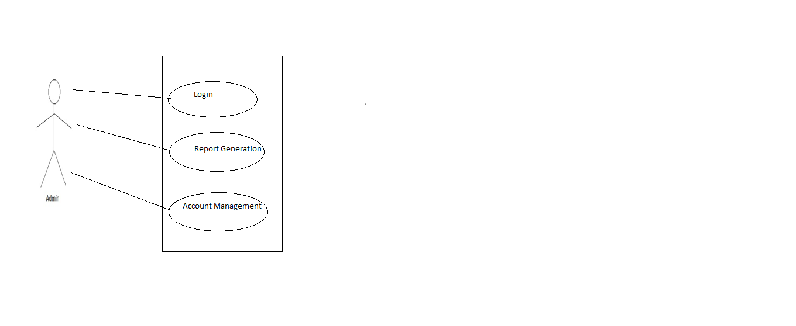

*Fig. Use case diagram for admin*

1. In Admin use case diagram Admin is the Actor.
2. Admin can handle following use cases:
3. Login
4. Report Generation
5. Account Management

**Patient:**

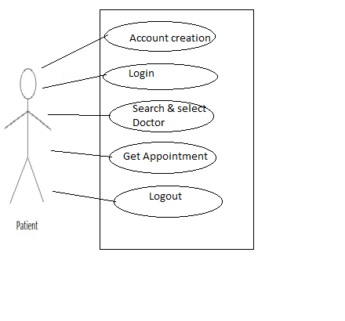

*Fig. Use case diagram for Patient*

1. In Patient use case diagram Patient is the Actor.
2. Patient can handle following use cases:
3. Register
4. Login
5. Search and Select doctor
6. Get Appointment
7. Logout

**Doctor:**

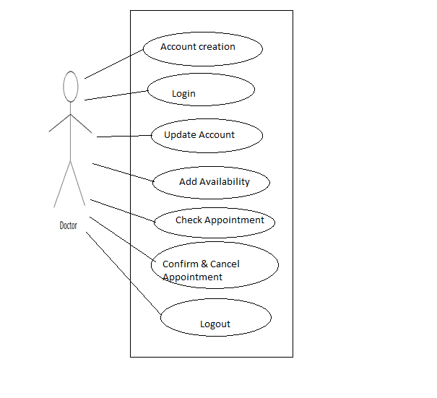

*Fig. Use case diagram for Doctor*

1. Doctor use case diagram doctor is the Actor**.**
2. Doctor can handle following use cases:
3. Register
4. Login
5. Forget Password
6. Change Password
7. Update Account
8. Add Availability
9. Check Appointment
10. Confirm & cancel Appointment