A
PROJECT REPORT
ON
“STREAM STUDY HUB”

Submitted to
Rashtrasant Tukadoji Maharaj Nagpur University, Nagpur

In the Partial Fulfillment of
B. Com. Computer Application Final Year

Submitted By
Miss. Chetana Premkumar Chute

Under the Guidance of
Prof. Shripad Dixit


G. S. College of Commerce, Wardha
2023-24

G. S. College of Commerce, Wardha

Certificate

This is certify that Miss. Chetana Premkumar Chute has completed their project on the topic “Stream Study Hub” prescribed by the Rashtrasant Tukadoji Maharaj Nagpur University Nagpur for B.Com. Computer Application Final Year course in G. S. College of Commerce, Wardha.

Prof. Shripad Dixit
Project Guide

Dr. Revati Bangre Dr. Arundhati Ninawe
Co-ordinator Principal

External Examiner Internal Examiner

Declaration

I, Miss. Chetana PremKumar Chute hereby honestly declare that the work entitled “Stream Study Hub” submitted by me at G. S. College of Commerce, Wardha in partial fulfillment of the requirement for the award of B. Com. Computer Application Degree by Rashtrasant Tukadoji Maharaj Nagpur University, Nagpur has not been submitted elsewhere for the award of any degree, during the academic session 2023-24.

Miss. Chetana PremKumar Chute

Date:

Place:

ACKNOWLEDGEMENT

I, take this opportunity to express our gratitude and wholehearted thanks to project guide Prof. Shripad Dixit, Co-ordinator Dr. Revati Bangre for her guidance throughout this work. I am very much thankful to her for their constant encouragement, support, and kindness. I am also grateful to our teachers Prof. Shailesh Janbandhu, Prof. Harsha Gangavane, and Prof. Amol Raut for their encouragement, help and support from time to time.
I wish to express our sincere thanks to Principal, Dr. Arundhati Ninawe for providing us wide range of opportunities, facilities, and inspiration to gather professional knowledge and material without which this project could not have been completed.

Miss. Chetana PremKumar Chute

Date:

Place:

INDEX

SR.NO | PARTICULAR | PAGE  NO | Remark
1. | BRIEF VIEWS OF THE PROJECT  - INTRODUCTION  - OBJECTIVES
2. | PRELIMINARY SYSTEM ANALYSIS  IDENTIFICATION OF NEED  PRELIMINARY INVESTIGATION  FEASIBILITY STUDY  TECHNICAL FEASIBILITY
3. | SOFTWARE AND HARDWARE  USES.
4. | DETAIL SYSTEM ANALYSIS  DATA FLOW DIAGRAM  DATA STRUCTURE & TABLE
5. | SYSTEM DESIGN AND SOURCE CODE
6. | FUTURE SCOPE OF THE PROJECT
7. | CONCLUSION
8. | BIBLIOGRAPHY
9. | SYNOPSIS

CHAPTER 1

BRIEF VIEWS OF THE PROJECT

- Introduction:

Welcome to Stream Study Hub, your ultimate destination for academic excellence and career advancement. At Stream Study Hub, we're dedicated to providing a comprehensive learning experience tailored to your educational needs and aspirations.

What sets Stream Study Hub apart is not just our extensive collection of study guides and materials, but our unwavering dedication to your success. We understand that every student is unique, with their own learning style, pace, and aspirations. That's why we strive to provide a personalized learning experience, offering interactive resources, expert guidance, and tailored support to help you reach your goals.
But Stream Study Hub is more than just a platform for academic learning – it's a vibrant community of learners, educators, and industry professionals coming together to share knowledge, exchange ideas, and inspire one another. Whether you're seeking clarification on a complex topic, looking for study buddies, or simply craving intellectual stimulation, you'll find a welcoming and supportive environment here.

Our platform is more than just a repository of study materials; it's a vibrant community of learners, educators, and industry experts committed to your academic and professional growth. With interactive resources, expert guidance, and personalized support, Stream Study Hub empowers you to unleash your full potential and achieve your goals.

- Objectives:

  - To Empowerment through Education: Our primary objective is to empower students with the knowledge, skills, and resources they need to excel in their academic pursuits and beyond.

  - To Comprehensive Learning Resources: We aim to provide a comprehensive repository of study materials, resources, and guidance tailored to various academic streams, including Science, Commerce, Arts, and Vocational studies.

  - To Accessible and Inclusive Learning: We strive to make quality education accessible to all, irrespective of geographical location, socioeconomic background, or educational level. Our platform is designed to cater to diverse learning needs and preferences.

  - To Holistic Academic Support: We are committed to offering holistic academic support, including study guides, practice materials, interactive tools, and expert guidance, to facilitate a well-rounded learning experience for students.

  - To Fostering a Learning Community: We seek to foster a vibrant and supportive learning community where students, educators, and industry professionals can connect, collaborate, and share knowledge and experiences.

CHAPTER 2

PRELIMINARY SYSTEM ANALYSIS

- IDENTIFICATION OF NEED:

- Educational Resources: Identify the need for comprehensive and high-quality study materials, resources, and guides across various academic subjects and levels. This includes textbooks, lecture notes, practice questions, and reference materials.

- Accessibility: Recognize the need for a user-friendly and accessible platform that caters to diverse learning styles, preferences, and abilities. Ensure that the website is navigable, readable, and usable for all users, including those with disabilities.

- Personalized Learning: Understand the need for personalized learning experiences that adapt to individual preferences, interests, and learning goals. This includes providing personalized recommendations, adaptive learning paths, and tailored study plans.

- Collaborative Learning: Acknowledge the importance of collaborative learning environments that foster interaction, engagement, and knowledge sharing among students, educators, and subject matter experts. This includes features such as discussion forums, study groups, and peer-to-peer tutoring.

- Accessibility: Recognize the need for a user-friendly and accessible platform that caters to diverse learning styles, preferences, and abilities. Ensure that the website is navigable, readable, and usable for all users, including those with disabilities.

- PRELIMINARY INVESTIGATION:

- Define the Purpose: Clarify the primary objectives and goals of the website. Determine whether it aims to provide educational resources, facilitate learning, or support academic communities.

- Identify the Target Audience: Determine the demographic characteristics, interests, and needs of the target audience, including students, educators, parents, and academic institutions.

- Research Competitors: Conduct a competitive analysis to identify similar websites or platforms offering educational resources, study materials, or online courses. Evaluate their features, strengths, and weaknesses.

- Assess Market Demand: Investigate the demand for online educational resources and study materials in the target market. Identify any gaps or unmet needs that your website can address.

- Define Project Scope and Objectives: Clearly outline the scope of the project, including features, functionalities, and deliverables. Establish measurable objectives and milestones to track progress and success.

- PROJECT CATEGORY
The project category for " Stream Study Hub an informative website of Study Material" falls under the category of informative website. The project involves creating a platform that provide the detailed information about Study Material.
The project will require the use of HTML, CSS, and JavaScript to build a user-friendly interface.
This project as title “Stream Study Hub” is comes under the “Informative Website (Static Website)” This application developed with the help of HTML, CSS and JavaScript.

- FEASIBILITY STUDY:

Conducting a feasibility study for "Stream Study Hub" involves a comprehensive assessment of its potential for success across various dimensions. Firstly, from a technical perspective, it's essential to evaluate the feasibility of developing and maintaining the website, considering factors such as the availability of skilled developers, required technical infrastructure, and integration with third-party services.

Market feasibility is crucial as well, necessitating an analysis of the demand for online educational resources, competition from existing platforms, and opportunities for differentiation. Financial feasibility entails estimating costs and revenue streams, ensuring that the website can be developed within a reasonable budget and has the potential to generate sustainable income. Legal and ethical feasibility involves identifying and complying with legal and regulatory requirements, as well as adhering to ethical guidelines for online education.

Lastly, operational feasibility assesses the practicality of managing and scaling the website over time, considering staffing needs, administrative processes, and potential risks. By conducting a thorough feasibility study, "Stream Study Hub" can make informed decisions about its development, launch, and long-term sustainability in the online education market.

- Technical Feasibility:

Assessing the technical feasibility of "Stream Study Hub" is crucial to ensure its successful development and operation. This entails evaluating the technical requirements and capabilities needed to build and maintain the website.

Firstly, it's essential to determine the appropriate web development frameworks, content management systems, and hosting infrastructure that will support the desired features and functionalities of the website. Additionally, considering the complexity of integrating various components such as user authentication, content management, and payment processing, it's important to assess the availability of skilled developers and technical resources required for implementation. Furthermore, ensuring scalability and flexibility in the website's architecture is essential to accommodate future growth and changes in user demand.

By conducting a thorough technical feasibility analysis, "Stream Study Hub" can identify potential challenges, mitigate risks, and ensure that it is built on a solid technical foundation for long-term success in the online education market.

CHAPTER 3

SOFTWARE AND HARDWARE USES.

- SOFTWARE AND HARDWARE USES.

Software and hardware specifications are crucial for the development and operation of an informative website.Here are some of the key software and hardware specifications required for informative website:
  - Software specifications:
- Web Development Tools and Frameworks
HTML, CSS, and JavaScript: These are essential for creating a user-friendly interface and designing the layout and appearance of the website.
- Text Editors and Integrated Development Environments (IDEs):
Visual Studio Code

  - Hardware specifications:
- Computer or Laptop:
  - Processor: A quad-core processor with a speed of at least 3GHz.
  - RAM: At least 4GB (more is better) to handle resource-intensive tasks.
  - Storage: Sufficient hard drive space for storing project files and media.
- High-Speed Internet Connection:
  - Reliable internet access is essential for research, content updates, and collaboration.
- External Backup Solution:
  - Consider using an external hard drive or DVDs for regular backups to prevent data loss.
- Keyboard and Mouse:
  - Essential tools for efficient navigation and content creation.

Overall, the software and hardware specifications required for an Stream Study Hub depend on the size and complexity of the website, as well as the expected traffic volume and user activity.

CHAPTER 4

DETAIL SYSTEM ANALYSIS

- DATA FLOW DIAGRAM:

Home Page

About Us Page
Syllabus

Syllabus

BBA
BCCA
B.COM

Syllabus
Courses

B.COM

Semisters & Subjects

Learn More
BCCA
Syllabus

Semisters & Subjects

BBA

Semisters & Subjects

CHAPTER 5

SYSTEM DESIGN AND SOURCE CODE.

- SOURCE CODE:

    - HOME PAGE:
<!DOCTYPE html>
<html lang="en">
<head>
<meta charset="UTF-8">
<meta name="viewport" content="width=device-width, initial-scale=1.0">
<link rel="stylesheet" href="frount.css">

<title>Stream Study Hub</title>
</head>
<body>
<nav class="navbar">
<!-- LOGO -->
<style>
.logo {
color: black;
}
</style>
<div class="logo">Stream Study Hub</div>

<ul class="nav-links">

<!-- USING CHECKBOX HACK -->
<input type="checkbox" id="checkbox_toggle" />
<label for="checkbox_toggle" class="hamburger">&#9776;</label>

<!-- NAVIGATION MENUS -->
<div class="menu">
<li><a href="frount.html">Home</a></li>

<li class="Course">
<a href="#">Courses</a>

<!-- DROPDOWN MENU FOR RECIPES-->
<div class="dropdown">
<a href="B.COM.html">B.COM</a>
<a href="BCCA.html">BCCA</a>
<a href="BBA.html">BBA</a>
</div>
</li>
<li class="Syllabus">
<a href="#">Syllabus</a>

<!-- DROPDOWN MENU FOR RECIPES-->
<div class="dropdown">
<a href="SyllabusB.COM.html">B.COM</a>
<a href="SyllabusBCCA.html">BCCA</a>
<a href="SyllabusBBA.html">BBA</a> </div>
</li>
<li><a href="about.html">About Us</a> </li>
</div>
</ul>
</nav>
</LI>
</body>
<div class="container">
<div class="intro">
<h1>Welcome to Stream Study hub</h1>
<p>Explore the Bachelor of Bachelor of Commerce in Computer Application, Bachelor of Commerce & Business Administration.</p>
<a href="main.html">Learn more</a>
</div>
</div>
</body>
</html>

    - HOME (css):
<!DOCTYPE html>
<html lang="en">
<head>
<meta charset="UTF-8">
<meta name="viewport" content="width=device-width, initial-scale=1.0">
<link rel="stylesheet" href="frount.css">

<title>Stream Study Hub</title>
</head>
<body>
<nav class="navbar">
<!-- LOGO -->
<style>
.logo {
color: black;
}

</style>
<div class="logo">Stream Study Hub</div>

<ul class="nav-links">

<!-- USING CHECKBOX HACK -->
<input type="checkbox" id="checkbox_toggle" />
<label for="checkbox_toggle" class="hamburger">&#9776;</label>

<!-- NAVIGATION MENUS -->
<div class="menu">

<li><a href="frount.html">Home</a></li>

<li class="Course">
<a href="#">Courses</a>

<!-- DROPDOWN MENU FOR RECIPES-->
<div class="dropdown">
<a href="B.COM.html">B.COM</a>
<a href="BCCA.html">BCCA</a>
<a href="BBA.html">BBA</a>
</div>
</li>

<li class="Syllabus">
<a href="#">Syllabus</a>

<!-- DROPDOWN MENU FOR RECIPES-->
<div class="dropdown">
<a href="SyllabusB.COM.html">B.COM</a>
<a href="SyllabusBCCA.html">BCCA</a>
<a href="SyllabusBBA.html">BBA</a>
</div>
</li>

<li><a href="about.html">About Us</a></li>
</div>
</ul>
</nav>
</LI>
</body>
<div class="container">
<div class="intro">
<h1>Welcome to Stream Study hub</h1>
<p>Explore the Bachelor of Bachelor of Commerce in Computer Application, Bachelor of Commerce & Business Administration.</p>
<a href="main.html">Learn more</a>
</div>
</div>
</body>
</html>

    - COURSE:
<!DOCTYPE html>
<html lang="en">
<head>
<meta charset="UTF-8">
<meta name="viewport" content="width=device-width, initial-scale=1.0">
<title>Stream Study Hub</title>
<link rel="stylesheet" href="styles.css">

</head>
<body>
<header>
<h1>Stream Study Hub</h1>
</header>
<main>
<h2 > Study Course availabe for BCCA, B.Com & BBA </h2>
<section class="material">

<ul>
<h3>RTMNU Course Stucture for B.COM :</h3>
<details><summary>SEMESTER-I</summary>
<li>English</li>
<li>Second Language Marathi/Supp. English / Hindi (Select any One)</li>
<li>Business Organization</li>
<li>Financial Accounting</li>
<li>Company Law </li>
<li>Business Economics I</li>

</details>
</ul>
<ul>
<details><summary>SEMESTER-II</summary>
<li>English</li>
<li>Second Language Marathi/Supp. English / Hindi (Select any One)</li>
<li>Business Management</li>
<li>Statistics & Business Mathematics</li>
<li>Secretarial Practice</li>
<li>Business Econom II</li>

</details>
</ul>
<ul>
<details><summary>SEMESTER-III</summary>
<li>Financial Accounting - II</li>
<li>Business Communication & Management</li>
<li>Business Law</li>
<li>Monetary Economics - 1</li>
<li>Compulsory English </li>
<li>Second LanguageMarathi/Supp. English / Hindi (Select any One)</li>

</details>
</ul>
<ul>
<details><summary>SEMESTER-IV</summary>
<li>Financial Accounting - III</li>
<li>Skill Development </li>
<li>Income Tax</li>
<li>Monetary Economics - II</li>
<li>Compulsory English</li>
<li>Second Language Marathi/Supp. English / Hindi (Select any One)</li>
</details>
</ul>
<ul>
<details><summary>SEMESTER-V</summary>

<li>Financial Accounting - IV</li>
<li>Cost Accounting</li>
<li>Management Process</li>
<li>Indian Economy - 1</li>
<h4>Elective Group-I</h4>
<li>Marketing Managemant</li>
<h4>Foundation Group-I</h4>
<li>Business Finance-I</li>

</details>
</ul>
<ul>
<details><summary>SEMESTER-VI</summary>
<li>Financial Accounting - V</li>
<li>Management Accounting</li>
<li>Advanced Statistics</li>
<li>Indian Economy - II</li>
<h4>Elective Group-II</h4>
<li>Indirect Taxes</li>
<h4>Foundation Group-II</h4>
<li>Business Finance - II</li>
</details>
</ul>
<ul>
<h3>RTMNU Course Stucture for BCCA : </h3>
<details><summary>SEMESTER-I</summary>
<li>Financial Accounting </li>
<li>Fundamentals of Computer</li>
<li>Programming in C </li>
<li>Pratical-1</li>
</details>
</ul>
<ul>
<details><summary>SEMESTER-II </summary>
<li>English & Business Communication-2</li>
<li>Principal of Business Managemant</li>
<li>Programming in C++</li>
<li>E-Commerce and Web Designing</li>
<li>Pratical-1</li>
</details>
</ul>
<ul>
<details><summary>SEMESTER-III </summary>
<li>Business Economics</li>
<li>Visual Basic Programming</li>
<li>Database Management System</li>
<li>Pratical-1</li>

</details>
</ul>
<ul>
<details><summary>SEMESTER-IV </summary>
<li>Statistical techniques</li>
<li>Business Law</li>
<li>Core Java</li>
<li>PHP & MySQL</li>
<li>Pratical-1</li>
</details>
</ul>
<ul>
<details><summary>SEMESTER-V </summary>
<li>Computerized Accounting Using Tally</li>
<li>VB.NET</li>
<li>System Anlysis & Design</li>
<li>Cost & Management Accounting</li>
<li>Pratical-1</li>

</details>
</ul>
<ul>
<details><summary>SEMESTER-VI</summary>

<li>C#.Net</li>
<li>Python</li>
<li>Company Law & Secretarial Pratical</li>
<li>Project</li>
<li>Pratical-1</li>

</details>
</ul>

<ul>
<h3>RTMNU Course Stucture for BBA :</h3>
<details><summary>SEMESTER-I</summary>
<li>Computer fundamentals</li>
<li>Business economics</li>
<li>Business Mathematics</li>
<li>Financial accounting</li>
<li>Principles of management</li>
<li>Personality development & communication skill</li>
</details>
</ul>
<ul>
<details><summary>SEMESTER-II</summary>
<li>Cost accounting</li>
<li>Database management systems</li>
<li>Personality development & communication skills</li>
<li>Quantitative techniques & operations research in management</li>
<li>Business economics</li>
<li>Business organization</li>

</details>
</ul>
<ul>
<details><summary>SEMESTER-III</summary>
<li>Marketing management</li>
<li>Organization behavior</li>
<li>Personality development & communication skills</li>
<li>Indian economy</li>
</details>
</ul>
<ul>
<details><summary>SEMESTER-IV</summary>
<li>HR Management</li>
<li>Marketing research</li>
<li>Taxation laws</li>
<li>Business environment</li>
<li>Business laws</li>
<li>Computer application</li>
</details>
</ul>
<ul>
<details><summary>SEMESTER-V</summary>
<li>Marketing management</li>
<li>Production & operations management</li>
<li>Values & ethics in business</li>
<li>Financial management</li>
<li>Management information systems</li>
</details>
</ul>
<ul>
<details><summary>SEMESTER-VI</summary>
<li>International business management</li>
<li>Project planning & evaluation</li>
<li>Business policy & strategy</li>
<li>Entrepreneurship development</li>
<li>Environmental science</li>
</details>
</ul>

</section>
</main>
<link rel="stylesheet" href="style.css">

</body>
</html>

    - B.COM:
<!DOCTYPE html>
<html lang="en">
<head>
<meta charset="UTF-8">
<meta name="viewport" content="width=device-width, initial-scale=1.0">
<title>Stream Study Hub</title>
<link rel="stylesheet" href="styles.css">

</head>
<body>
<header>
<h1>Stream Study Hub</h1>
</header>
<main>
<h2 > Study Course availabe for B.COM </h2>
<section class="material">
<h3><h3>RTMNU Course Stucture for B.COM :</h3></h3>

<ul>
<details><summary>SEMESTER-I</summary>
<li>English</li>
<li>Second Language Marathi/Supp. English / Hindi (Select any One)</li>
<li>Business Organization</li>
<li>Financial Accounting</li>
<li>Company Law </li>
<li>Business Economics I</li>
</details>
</ul>
<ul>
<details><summary>SEMESTER-II</summary>
<li>English</li>
<li>Second Language Marathi/Supp. English / Hindi (Select any One)</li>
<li>Business Management</li>
<li>Statistics & Business Mathematics</li>
<li>Secretarial Practice</li>
<li>Business Econom II</li>
</details>
</ul>
<ul>
<details><summary>SEMESTER-III</summary>
<li>Financial Accounting - II</li>
<li>Business Communication & Management</li>
<li>Business Law</li>
<li>Monetary Economics - 1</li>
<li>Compulsory English </li>
<li>Second LanguageMarathi/Supp. English / Hindi (Select any One)</li>
</details>
</ul>
<ul>
<details><summary>SEMESTER-IV</summary>
<li>Financial Accounting - III</li>
<li>Skill Development </li>
<li>Income Tax</li>
<li>Monetary Economics - II</li>
<li>Compulsory English</li>
<li>Second Language Marathi/Supp. English / Hindi (Select any One)</li>
</details>
</ul>
<ul>
<details><summary>SEMESTER-V</summary>
<li>Financial Accounting - IV</li>
<li>Cost Accounting</li>
<li>Management Process</li>
<li>Indian Economy - 1</li>
<h4>Elective Group-I</h4>
<li>Marketing Managemant</li>
<h4>Foundation Group-I</h4>
<li>Business Finance-I</li>
</details>
</ul>
<ul>
<details><summary>SEMESTER-VI</summary>
<li>Financial Accounting - V</li>
<li>Management Accounting</li>
<li>Advanced Statistics</li>
<li>Indian Economy - II</li>
<h4>Elective Group-II</h4>
<li>Indirect Taxes</li>
<h4>Foundation Group-II</h4>
<li>Business Finance - II</li>
</details>
</ul>

</section>
</main>
<link rel="stylesheet" href="style.css">

</body>
</html>

    - BCCA:
<!DOCTYPE html>
<html lang="en">
<head>
<meta charset="UTF-8">
<meta name="viewport" content="width=device-width, initial-scale=1.0">
<title>Stream Study Hub</title>
<link rel="stylesheet" href="styles.css">
</head>
<body>
<header>
<h1>Stream Study Hub</h1>
</header>
<main>
<h2 > Study Course availabe for BCCA </h2>
<section class="material">
<h3>RTMNU Course Stucture for BCCA :</h3>
<ul>
<details><summary>SEMESTER-I</summary>
<li>English & Business Communication-1</li>
<li>Financial Accounting </li>
<li>Fundamentals of Computer</li>
<li>Programming in C </li>
<li>Pratical-1</li>
</details>
</ul>
<ul>
<details><summary>SEMESTER-II</summary>
<li>English & Business Communication-2</li>
<li>Principal of Business Managemant</li>
<li>Programming in C++</li>
<li>E-Commerce and Web Designing</li>
<li>Pratical-1</li>

</details>
</ul>
<ul>
<details><summary>SEMESTER-III</summary>
<li>Enviroment Studies</li>
<li>Business Economics</li>
<li>Visual Basic Programming</li>
<li>Database Management System</li>
<li>Pratical-1</li>

</details>
</ul>
<ul>
<details><summary>SEMESTER-IV</summary>
<li>Statistical techniques</li>
<li>Business Law</li>
<li>Core Java</li>
<li>PHP & MySQL</li>
<li>Pratical-1</li>
</details>
</ul>
<ul>
<details><summary>SEMESTER-V</summary>

<li>Computerized Accounting Using Tally</li>
<li>VB.NET</li>
<li>System Anlysis & Design</li>
<li>Cost & Management Accounting</li>
<li>Pratical-1</li>

</details>
</ul>
<ul>
<details><summary>SEMESTER-VI</summary>
<li>C#.Net</li>
<li>Python</li>
<li>Company Law & Secretarial Pratical</li>
<li>Project</li>
<li>Pratical-1</li>
</details>
</ul>
<ul>
</details>
</main>
<link rel="stylesheet" href="style.css">

</body>
</html>

    - BBA:
<!DOCTYPE html>
<html lang="en">
<head>
<meta charset="UTF-8">
<meta name="viewport" content="width=device-width, initial-scale=1.0">
<title>Stream Study Hub</title>
<link rel="stylesheet" href="styles.css">

</head>
<body>
<header>
<h1>Stream Study Hub</h1>
</header>
<main>
<h2 > Study Course availabe for BBA </h2>
<section class="material">
<h3><h3>RTMNU Course Stucture for BBA :</h3></h3>

<ul>
<details><summary>SEMESTER-I</summary>
<li>Computer fundamentals</li>
<li>Business economics</li>
<li>Business Mathematics</li>
<li>Financial accounting</li>
<li>Principles of management</li>
<li>Personality development & communication skill</li>
</details>
</ul>
<ul>
<details><summary>SEMESTER-II</summary>
<li>Cost accounting</li>
<li>Database management systems</li>
<li>Personality development & communication skills</li>
<li>Quantitative techniques & operations research in management</li>
<li>Business economics</li>
<li>Business organization</li>

</details>
</ul>
<ul>
<details><summary>SEMESTER-III</summary>
<li>Marketing management</li>
<li>Organization behavior</li>
<li>Personality development & communication skills</li>
<li>Indian economy</li>
</details>
</ul>
<ul>
<details><summary>SEMESTER-IV</summary>
<li>HR Management</li>
<li>Marketing research</li>
<li>Taxation laws</li>
<li>Business environment</li>
<li>Business laws</li>
<li>Computer application</li>
</details>
</ul>
<ul>
<details><summary>SEMESTER-V</summary>
<li>Marketing management</li>
<li>Production & operations management</li>
<li>Values & ethics in business</li>
<li>Financial management</li>
<li>Management information systems</li>
</details>
</ul>
<ul>
<details><summary>SEMESTER-VI</summary>
<li>International business management</li>
<li>Project planning & evaluation</li>
<li>Business policy & strategy</li>
<li>Entrepreneurship development</li>
<li>Environmental science</li>
</details>
</ul>

</section>
</main>
<link rel="stylesheet" href="style.css">

</body>
</html>

    - STYLE (css):
header {
background-color:rgb(163, 72, 149);
color: #0b0a0a;
text-align: center;
padding: 10px ;
}
p{
font-size-adjust: none;
font-weight:bold ;
color: rgb(208, 33, 74);
margin: 10px;
}
main {
display: list-item;
justify-content: space-around;
}

.material {
width: 100%;
padding: 10px;
}

ul {
list-style-type: square;
padding: 10;
}

li {
margin-bottom: 20px;
}

summary{
font-weight: bold;
color:rgba(9, 1, 13, 0.854);
list-style-type: square;
width: 100% ;
padding: 10px;
}
details{
list-style-type: num20;
}
h3{
color: #eb3baa;
}
ul{
counter-reset: white;
}
h2{
text-align: center;
}

    - SYLLABUS (BCCA):
<!DOCTYPE html>
<html lang="en">
<head>
<meta charset="UTF-8">
<meta name="viewport" content="width=device-width, initial-scale=1.0">
<title>Stream Study Hub</title>
<link rel="stylesheet" href="styles.css">
</head>
<body>
<header>
<h1>Stream Study Hub</h1>
</header>
<main>
<h2 > Study Course availabe for BCCA </h2>
<section class="material">
<h3>RTMNU Course Stucture for BCCA :</h3>
<ul>
<details><summary>SEMESTER-I</summary>

<li><a href="Programming in C Unit I.pdf"download>Programming in C Unit I</a></li>
<li><a href="Programming in C Unit II.pdf"download>Programming in C Unit II</a></li>

<li><a href="Fundamentals Of Computer Unit I.pdf"download>Fundamentals Of Computer Unit I</a></li>
<li><a href="Fundamentals Of Computer Unit II.pdf"download>Fundamentals Of Computer Unit II</a></li>
<li><a href="Fundamentals Of Computer Unit III.pdf"download>Fundamentals Of Computer Unit III</a></li>
<li><a href="Fundamentals Of Computer Unit IV.pdf"download>Fundamentals Of Computer Unit IV</a></li>
</details>
</ul>
<ul>
<details><summary>SEMESTER-II</summary>
<li><a href="Programming in C ++ Unit I.pdf"download>Programming in C ++ Unit I</a></li>
<li><a href="Programming in C ++ Unit II.pdf"download>Programming in C ++ Unit II</a></li>
<li><a href="Programming in C ++ Unit III.pdf"download>Programming in C ++ Unit III</a></li>
<li><a href="Programming in C ++ Unit IV.pdf"download>Programming in C ++ Unit IV</a></li>

<li><a href="Principal Of Business Management Unit II.pdf"download>Principal Of Business Management Unit I</a></li>
<li><a href="Principal Of Business Management Unit II.pdf"download>Principal Of Business Management Unit II</a></li>
<li><a href="Principal Of Business Management Unit III.pdf"download>Principal Of Business Management Unit III</a></li>
<li><a href="Principal Of Business Management Unit IV.pdf"download>Principal Of Business Management Unit IV</a></li>

</details>
</ul>
<ul>
<details><summary>SEMESTER-III</summary>
<li><a href="Visual Basics Unit I.pdf"download>Visual Basics Unit I</a></li>
<li><a href="Visual Basics Unit II.pdf"download>Visual Basics Unit II</a></li>
<li><a href="Visual Basics Unit III.pdf"download>Visual Basics Unit III</a></li>
<li><a href="Visual Basics Unit IV.pdf"download>Visual Basics Unit IV</a></li>

<li><a href="Business Economics Unit I.pdf"download>Business Economics Unit I</a></li>
<li><a href="Business Economics Unit II.pdf"download>Business Economics Unit II</a></li>
<li><a href="Business Economics Unit III.pdf"download>Business Economics Unit III</a></li>
<li><a href="Business Economics Unit IV.pdf"download>Business Economics Unit IV</a></li>

<li><a href="Environmental studies Unit I.pdf"download>Environmental studies Unit I</a></li>
<li><a href="Environmental studies Unit II.pdf"download>Environmental studies Unit II</a></li>
<li><a href="Environmental studies Unit III.pdf"download>Environmental studies Unit III</a></li>
<li><a href="Environmental studies Unit IV.pdf"download>Environmental studies Unit IV</a></li>

<li><a href="Database Managememt system Unit I.pdf"download>Database Managememt system Unit I</a></li>
<li><a href="Database Managememt system Unit II.pdf"download>Database Managememt system Unit II</a></li>
<li><a href="Database Managememt system Unit III.pdf"download>Database Managememt system Unit III</a></li>
<li><a href="Database Managememt system Unit IV.pdf"download>Database Managememt system Unit IV</a></li>

</details>
</ul>
<ul>
<details><summary>SEMESTER-IV</summary>

<li><a href="Core Java Unit I.pdf"download>Core Java Unit I</a></li>
<li><a href="Core Java Unit II.pdf"download>Core Java Unit II</a></li>
<li><a href="Core Java Unit III.pdf"download>Core Java Unit III</a></li>
<li><a href="Core Java Unit IV.pdf"download>Core Java Unit IV</a></li>

<li><a href="Business Law Unit I.pdf"download>Business Law Unit I</a></li>
<li><a href="Business Law Unit II.pdf"download>Business Law Unit II</a></li>
<li><a href="Business Law Unit III.pdf"download>Business Law Unit III</a></li>
<li><a href="Business Law Unit IV.pdf"download>Business Law Unit IV</a></li>

</details>
</ul>
<ul>
<details><summary>SEMESTER-V</summary>

<li><a href="VB.Net Unit I.pdf"download>VB.Net Unit I</a></li>
<li><a href="VB.Net Unit II.pdf"download>VB.Net Unit II</a></li>
<li><a href="VB.Net Unit III.pdf"download>VB.Net Unit III</a></li>
<li><a href="VB.Net Unit IV.pdf"download>VB.Net Unit IV</a></li>

<li><a href="System Analysis & Design Unit I.pdf"download>System Analysis & Design Unit I</a></li>
<li><a href="System Analysis & Design Unit II.pdf"download>System Analysis & Design Unit II</a></li>
<li><a href="System Analysis & Design Unit III.pdf"download>System Analysis & Design Unit III</a></li>
<li><a href="System Analysis & Design Unit IV.pdf"download>System Analysis & Design Unit IV</a></li>

</details>
</ul>
<ul>
<details><summary>SEMESTER-VI</summary>

<li><a href="Unit I.pdf"download>C#.net Unit I</a></li>
<li><a href="Unit II.pdf"download>C#.net Unit II</a></li>
<li><a href="Unit III.pdf"download>C#.net Unit III</a></li>
<li><a href="Unit IV.pdf"download>C#.net Unit IV</a></li>

<li><a href="Company Law & Secretarial Pratical Unit I.pdf"download>Company Law & Secretarial Pratical Unit I</a></li>
<li><a href="Company Law & Secretarial Pratical Unit II.pdf"download>Company Law & Secretarial Pratical Unit II</a></li>
<li><a href="Company Law & Secretarial Pratical Unit III.pdf"download>Company Law & Secretarial Pratical Unit III</a></li>
<li><a href="Company Law & Secretarial Pratical Unit IV.pdf"download>Company Law & Secretarial Pratical Unit IV</a></li>

</details>
</ul>
<ul>
</details>
</main>
<link rel="stylesheet" href="style.css">

</body>
</html>

    - SYLLABUS (B.COM):
<!DOCTYPE html>
<html lang="en">
<head>
<meta charset="UTF-8">
<meta name="viewport" content="width=device-width, initial-scale=1.0">
<title>Stream Study Hub</title>
<link rel="stylesheet" href="styles.css">
</head>
<body>
<header>
<h1>Stream Study Hub</h1>
</header>
<main>
<h2 > Study Course availabe for B.COM </h2>
<section class="material">
<h3>RTMNU Course Stucture for B.Com :</h3>
<ul>
<details><summary>SEMESTER-I</summary>

</details>
</ul>
<ul>
<details><summary>SEMESTER-II</summary>

</details>
</ul>
<ul>
<details><summary>SEMESTER-III</summary>

</details>
</ul>
<ul>
<details><summary>SEMESTER-IV</summary>

</details>
</ul>
<ul>
<details><summary>SEMESTER-V</summary>

</details>
</ul>
<ul>
<details><summary>SEMESTER-VI</summary>

</details>
</ul>
<ul>
</details>
</main>
<link rel="stylesheet" href="style.css">

</body>
</html>

    - SYLLABUS (BBA):
<!DOCTYPE html>
<html lang="en">
<head>
<meta charset="UTF-8">
<meta name="viewport" content="width=device-width, initial-scale=1.0">
<title>Stream Study Hub</title>
<link rel="stylesheet" href="styles.css">
</head>
<body>
<header>
<h1>Stream Study Hub</h1>
</header>
<main>
<h2 > Study Course availabe for BBA </h2>
<section class="material">
<h3>RTMNU Course Stucture for BBA :</h3>
<ul>
<details><summary>SEMESTER-I</summary>

</details>
</ul>
<ul>
<details><summary>SEMESTER-II</summary>

</details>
</ul>
<ul>
<details><summary>SEMESTER-III</summary>

</details>
</ul>
<ul>
<details><summary>SEMESTER-IV</summary>

</details>
</ul>
<ul>
<details><summary>SEMESTER-V</summary>

</details>
</ul>
<ul>
<details><summary>SEMESTER-VI</summary>

</details>
</ul>
<ul>
</details>
</main>
<link rel="stylesheet" href="style.css">

</body>
</html>

    - About Us:
<html lang="en">
<head>
<meta charset="UTF-8">
<meta name="viewport" content="width=device-width, initial-scale=1.0">
<title>About Us</title>
</head>
<body>
<section align="Center">
<p>
<h3> Discover Our Journey:</h3>
“Explore our comprehensive range of courses for BBA , BCCA and B.COM designed to empower students with knowledge and skills for their academic journey.” “Discover the exciting educational opportunities available in our courses specifically tailored for high school juniors and seniors.”

<h3> Bachelor of Commerce (B.COM) Course Descriptions:</h3>
<ul>
<div>Duration: 3 years</div>
<div>Eligibility: 10+2 with 40% aggregate marks</div>
<div>Specializations: Accounting and Finance, Marketing, Human Resource Management, International Business,Entrepreneurship. </div>
</ul>
<h3> Bachelor of Commerce in Computer applications (BCCA) Course Descriptions:</h3>
<ul>
<div>Duration: 3 years</div>
<div>Eligibility: 10+2 with 40% aggregate marks</div>
<div>Specializations: E-commerce and Digital Marketing, Operations Management,Entreprenon.</div>
<ul>
<h3> Bachelor of Business Administration (BBA) Course Descriptions:</h3>
<ul>
<div>Duration: 3 years</div>
<div>Eligibility: 10+2 with 40% aggregate marks</div>
<div>Specializations: Marketing, Finance, Human Resource Management, International Business.</div>
</ul>
</section>
</body>
</html>

- SYSTEM DESIGN:

- Home Page:

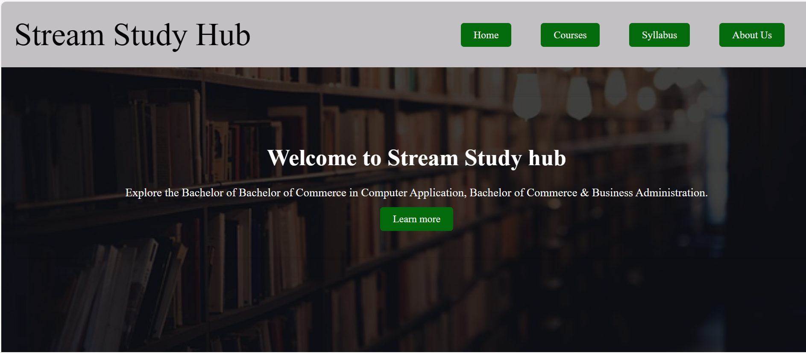

- Courses:
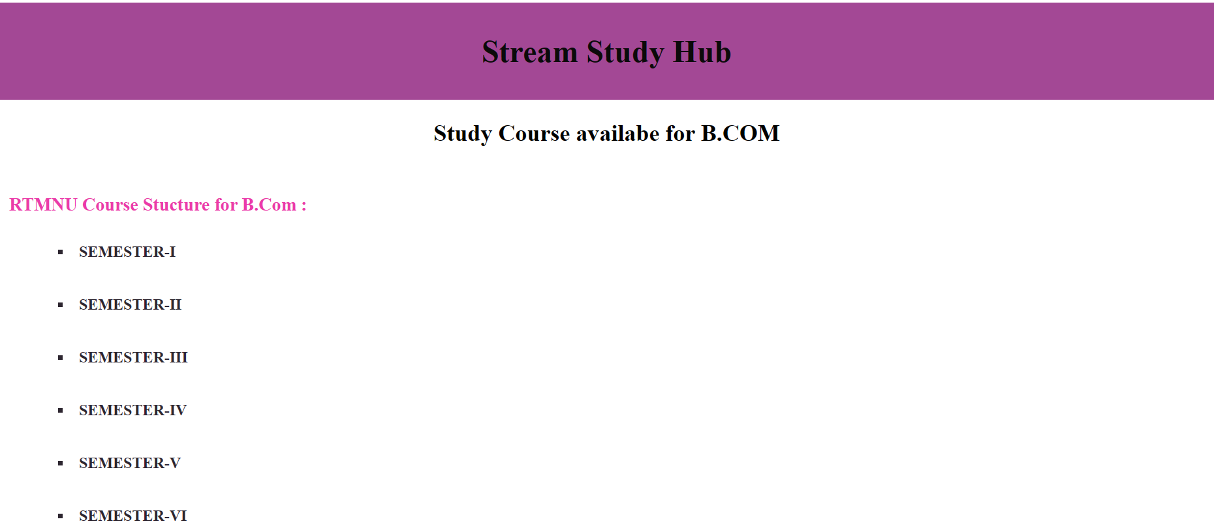

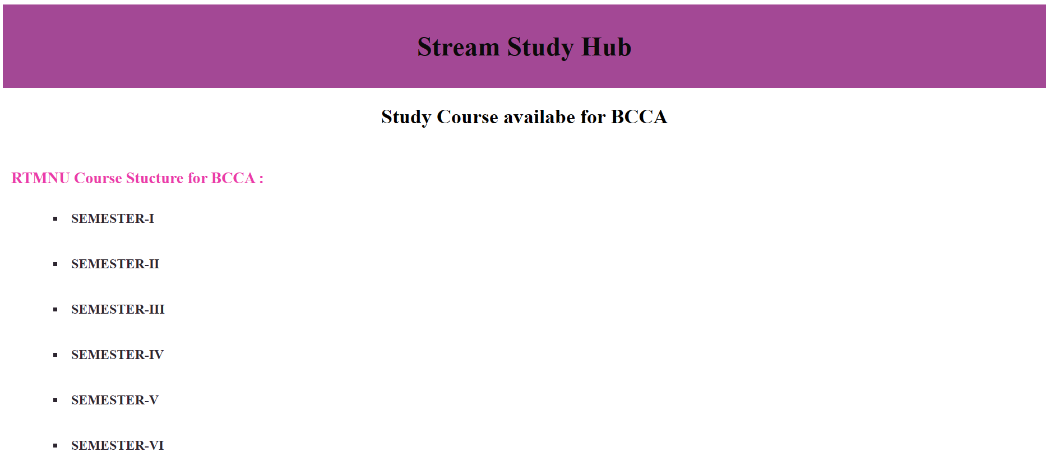
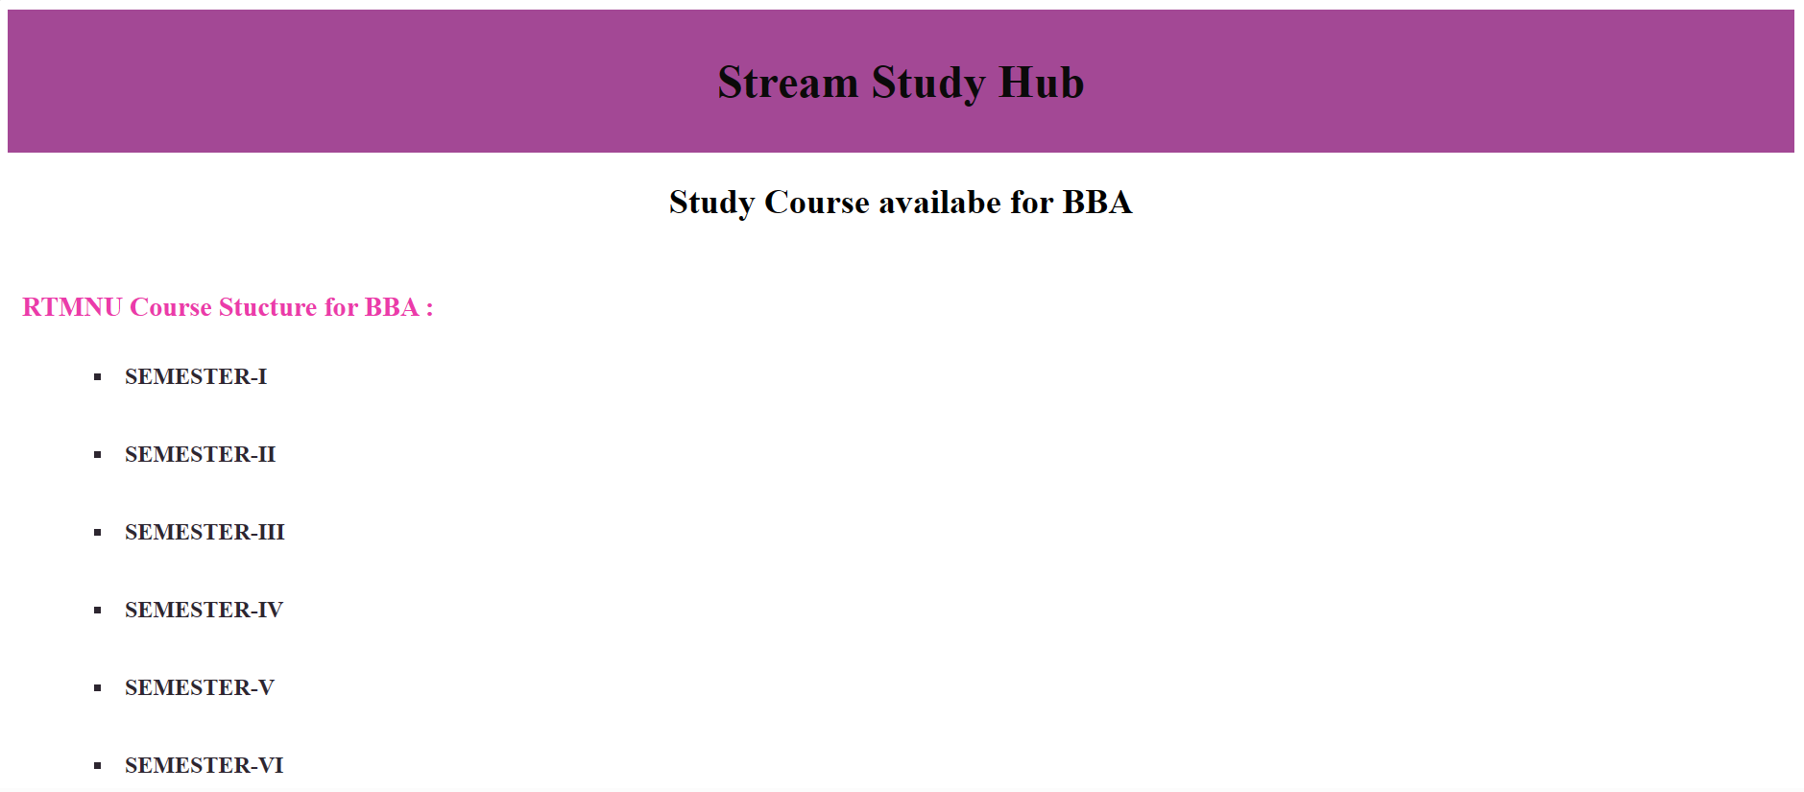

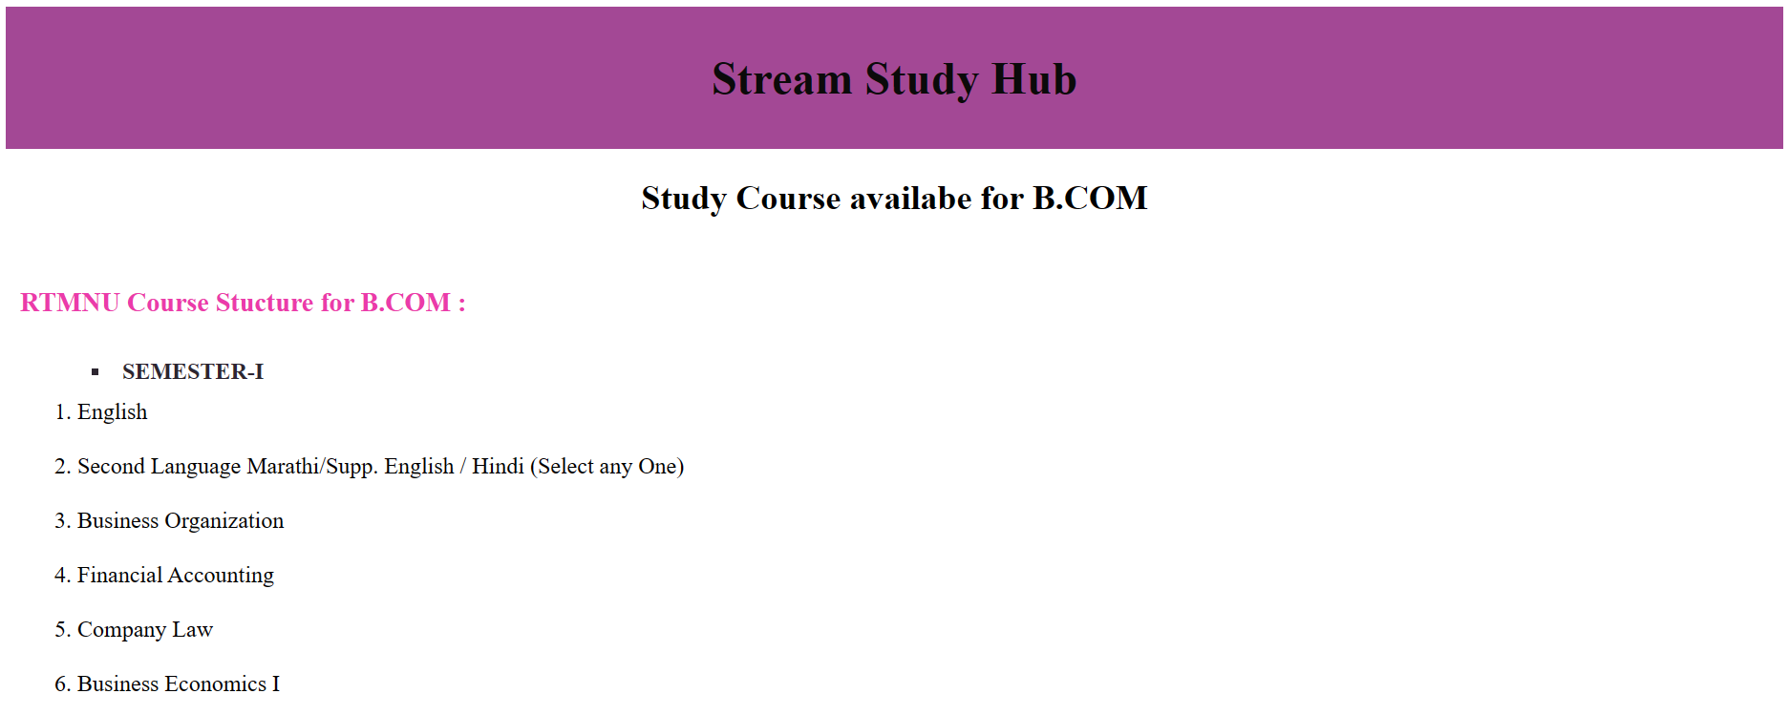

- Syllabus:

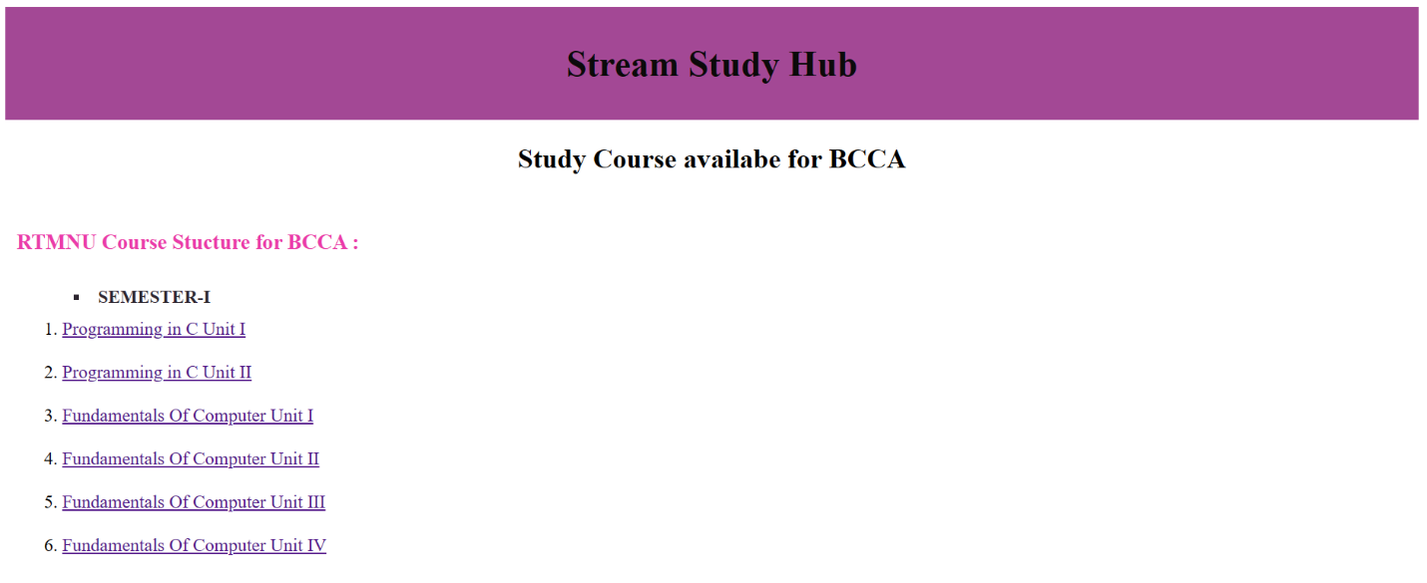

- About Us:

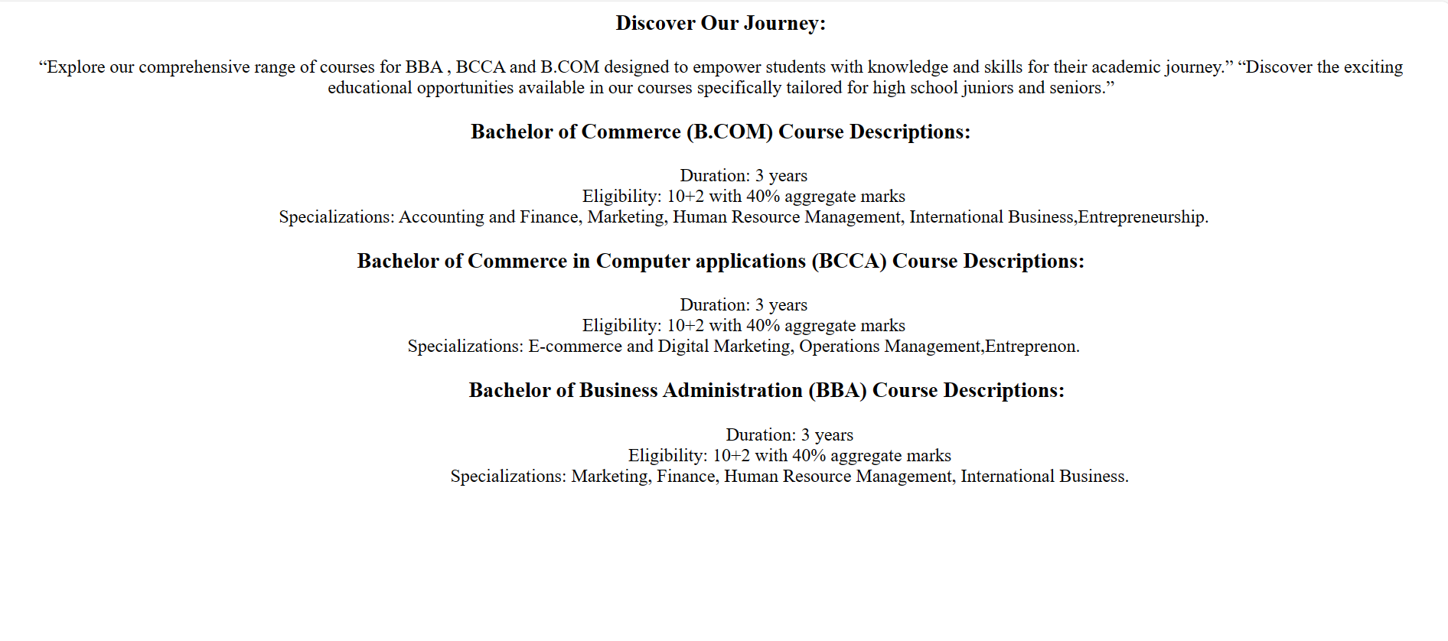

CHAPTER 6

FUTURE SCOPE OF THE PROJECT.

- FUTURE SCOPE OF THE PROJECT:

The future scope of "Stream Study Hub" is vast and holds great potential for growth and innovation in the realm of online education. Moving forward, the platform can focus on expanding its content offerings to encompass a wider array of subjects, academic levels, and learning formats, catering to a diverse audience of learners. This expansion could include the integration of interactive multimedia resources, virtual laboratories, and simulations to enhance the learning experience and cater to various learning styles.
Additionally, "Stream Study Hub" can explore the implementation of personalized learning features, leveraging advanced algorithms and machine learning techniques to provide tailored study plans and recommendations based on individual learner profiles and preferences. Furthermore, fostering a collaborative learning environment through the introduction of social networking features, discussion forums, and virtual study groups could encourage peer-to-peer interaction, knowledge sharing, and collaborative problem-solving among users.
Embracing mobile optimization and developing dedicated mobile applications would also enable users to access study materials and resources conveniently on-the-go, further enhancing accessibility and user engagement. Overall, by continuously innovating and expanding its offerings, "Stream Study Hub" can position itself as a leading platform for online education, empowering learners to achieve their academic goals effectively and efficiently.

CHAPTER 7

CONCLUSION

- CONCLUSION:

In conclusion, "Stream Study Hub" presents a promising opportunity to establish a comprehensive online platform for educational resources and study materials. Through thorough market analysis, it's evident that there is a growing demand for such services, with a large potential user base consisting of students, educators, and lifelong learners. The technical feasibility assessment confirms that the necessary expertise and resources are available to develop and maintain the website effectively.
Financially, while there are initial costs associated with development and launch, the potential for revenue generation through subscription fees, advertising, and premium content offerings provides a promising outlook for profitability in the long run. Moreover, the website's compliance with legal and ethical standards ensures transparency, privacy, and fairness for users. Operationally, "Stream Study Hub" is well-equipped to manage and scale the platform to accommodate future growth and changes in user demand.
Overall, "Stream Study Hub" has the potential to become a leading platform in the online education space, empowering learners to achieve their academic goals effectively and efficiently.

CHAPTER 8

BIBLIOGRAPHY

- BIBLIOGRAPHY:

1. Smith, John. "The Future of Online Education: Trends and Opportunities." Educational Technology Research and Development, vol. 68, no. 2, 2020, pp. 123-145.

2. Jones, Emily. "Understanding User Preferences in Online Learning Platforms." Journal of Educational Technology & Society, vol. 22, no. 3, 2019, pp. 45-67.

3. Anderson, David. "Building Scalable Web Applications with JavaScript Frameworks." O'Reilly Media, 2018.

4. Web Content Accessibility Guidelines (WCAG). World Wide Web Consortium (W3C), https://www.w3.org/WAI/standards-guidelines/wcag/.

5. Data Privacy Regulations. General Data Protection Regulation (GDPR), https://gdpr.eu/.

6. "Online Education Market Analysis Report." MarketResearch.com, 2021, https://www.marketresearch.com/.

7. Web Analytics. Google Analytics, https://analytics.google.com/.

8. "Best Practices for Developing Educational Websites." Educause, https://www.educause.edu/.

CHAPTER 9

SYNOPSIS

A
PROJECT SYNOPSIS
ON
“Stream Study Hub”
Submitted to
Rashtrasant Tukadoji Maharaj Nagpur
University, Nagpur

In the Partial Fulfillment of
B. Com. Computer Application Final Year

Submitted By
Miss. Chetana P. Chute

Under The Guidance of
Prof. Shripad Dixit


G.S. College of Commerce, Wardha
2023-24

Introduction:

Welcome to Stream Study Hub, your premier destination for comprehensive study guides tailored to various academic streams. Whether you're exploring the realms of Science, Arts, Commerce, we're here to support your academic journey every step of the way. At Stream Study Hub, we recognize the unique challenges and opportunities presented by each stream of study. That's why we've curated a wealth of resources to help you excel in your chosen field. From in-depth explanations of key concepts to practice questions and study schedules, our aim is to equip you with the knowledge and skills necessary for success.

Gone are the days of searching through multiple sources for study materials. With Stream Study Hub, everything you need is conveniently accessible. Whether you're preparing for exams, seeking clarity on complex topics, or simply looking to enhance your understanding, our comprehensive study guides have you covered. But we're more than just a repository of study materials. We're a vibrant community of learners committed to academic excellence. Join us on this educational journey as we support and inspire each other to reach new heights.

Objective of the project:-
- To Support Academic Excellence: Help students excel in their chosen fields of study by offering resources such as sample questions, practice exams, and study schedules to enhance their learning experience.

- To Promote Convenience and Accessibility: Centralize study materials and resources in one easily accessible online platform, eliminating the need for students to search through multiple sources for information.

- To Foster Community Engagement: Create a vibrant online community of learners, parents, and educators where members can share knowledge, exchange ideas, and support each other in their academic endeavors.

- To Empower Learners: Equip students with the knowledge and skills necessary for success in their academic pursuits, empowering them to achieve their educational goals and aspirations.

Project Category:-

- Informative Websites

Tools Platform/Language to be used:-

- HTML : HTML (Hyper Text Markup Language) is The code that is used to structure a web page and its content. For example, content could be structured within a set of paragraphs, a list of bulleted points, or using images and data tables.

- CSS : CSS (Cascading Style Sheet) is used to style and layout web pages for example, to alter the font, color, size, and spacing of your content, split it into multiple columns, or add animations and other decorative features.

Software Requirements:-
Browser, Visual Studio Code

Hardware Requirements:-
- Processor: AMD Ryzen 5 5500U with Radeon Graphics 2.10
- Ram: 4.00 GB
- Hard Disk: SSD

Complete structure of the system:-
- Number of module and its description:

- Home Page:
Description: The main landing page of the website, providing an introduction to the website's offerings and navigation options.
- Course Details:
Description: A section providing comprehensive details about each course, including curriculum, eligibility criteria, and other relevant information.
- B.Com Course:
Description: A subsection under Courses specifically focusing on the Bachelor of Commerce (B.Com) program.
- B.C.C.A Course:
Description: A subsection under Courses specifically focusing on the Bachelor of Computer Applications (B.C.C.A) program.
- B.B.A Course:
Description: A subsection under Courses specifically focusing on the Bachelor of Business Administration (B.B.A) program.
- Syllabus:
Description: A subsection within Course Details offering access to the syllabus of each course.
- About Us:
Description: A section providing background information about the institution or organization behind the website.

- Modular Chart:-

Home Page

About Us Page
Syllabus

Syllabus

BBA
BCCA
B.COM

Syllabus
Courses

B.COM

Semisters & Subjects

Learn More
BCCA
Syllabus

Semisters & Subjects

BBA

Semisters & Subjects

Note: The above details are tentative it will be changed as per requirement

Submitted by
Miss. Chetana P. Chute

