Introduction
The scope of the project is to allow a user to upload an image of an iris and compare it to a pre-existing database to ascertain or verify identity. The iris is often cited as being the most robust feature for biometric recognition due to its stability over time and its high degree of complexity, uniqueness and inter-subject differentiation. The National Laboratory of Pattern Recognition in Beijing has made the CASIA database available to us, which consists of iris images from 108 unique subjects. Our final application will predominantly be a development of research by John Daugman, whose iris recognition algorithms are now widely used in industry.
Specification
- Features
Essential
  - A GUI enabling basic user interaction.
  - The ability for a user to upload a bitmap of an Iris from an accessible source.
  - A utility for the user to identify and record the centre of the pupil, edge of iris and eyelid for their uploaded image.
  - Manipulation of the image such that the iris can be analysed and a unique bit-code extracted .
  - Indication of any positive identity match or the absence of such based on bit-code comparison with all records in the database, and the display of a corresponding ID where applicable.

Desirable

  - A utility that allows an administrator to upload and add new ID entries to the pre-existing database, from the GUI and on bulk.
  - Automation of the image manipulation such that the software can recognise the location of the pupil centre and boundaries of the iris itself.
  - An indication of probability of a false match when a positive Id occurs.

Luxury

  - An automated ability to eliminate the impact of blemishes such as eyelashes or glare on an uploaded image, whether it’s being added to the database or identity matched.

Undesirable

  - The application being OS dependent.

- User Experience

Figure 1 below shows an example of the type of GUI the user will interact with. Our final application will include further options as outlined in the specification.

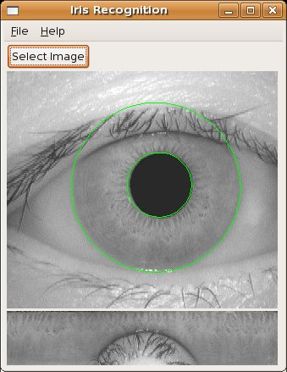
It is agreed that the GUI will be coded in Java and tested on the Linux OS. Use of a centralised DOC database may restrict the location of use.

Flow of Use:

Open -> GUI -> Upload -> Image positioning -> Identity testing -> Restart/Close

- Technology

Underlying the above will need to be these functional components:

- A central database on the IC DOC postgres server. We plan to access the server directly from our Java program using JDBC. The database needs to hold an Id, bit-codes for left and right eyes together with relevant mask for each.
- The Java GUI itself complete with correct fields, image manipulation capability and an administrative mode which allows new Ids to be entered into the database.
- A java module which will transform the Iris image into the required format for bit-code extraction.
- An algorithm in Java to extract the unique bit-code for each Iris image, once the image is in the correct format.
- An algorithm in Java which will enable the comparison of the bit-code of an entered Iris with one stored in the database and ascertain a match with a satisfactory level of confidence.

In addition we plan to use SVN software to maintain reliable and up to date code, and LateX text-editing software. Weekly project updates will also be held centrally.

Adopting the approach of agile methodologies, in particular the spiral model, we plan to have regular builds and develop the software with basic functionality first, progressing towards more complex tasks once these have been adequately implemented. We will review the fit with the original specification and requirements at each build, and identify any areas of divergence and make changes deemed necessary. We will also rotate tasks amongst group members as much as possible, allowing for different perspectives and ensuring mutual satisfaction for each component. Once the basic functionality of the program has been established we plan to complete extensions to the project detailed below, as well as refine the GUI and optimize algorithmic and supporting underlying code.

Architecture

Figure 2 below shows our initial breakdown of the software architecture. We have identified six main components of the program to be designed (which in turn aided us in allocating and dividing the various parts of the project for team members to work on). The main components are; the graphical user interface, the database, the sending of information to the database and the retrieval of information from it, together with the extraction and comparison algorithms.

With these six major components identified, we further broke down the processes that will be required in order to create a functional program. The core internal processes involve the coding of Daugman’s algorithms in order to prepare bitmap images for bit-code translation, creating the bit-code from a prepared bitmap image and then matching a given bit-code to the database.

Figure 2 – A chart to show our initial software architecture plan

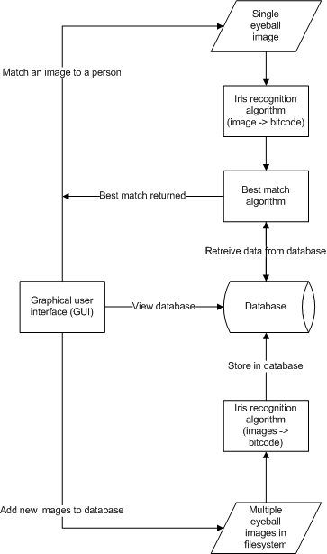
Comparison will involve the calculation of hamming distances for each bit-code pair.

In terms of performance, clearly C++ has the potential to provide a faster implementation. However, a key undesirable feature in the specification is platform dependence. To avoid this, to cater for each group members specific experience levels and to allow us to produce a satisfactory GUI using swing, a homogenous java implementation has been decided on.

- Documentation

Technical documentation will play a particularly important role with this program as it’s heavily mathematical in terms of its implementation. We will comment the code using Javadoc to enable ease of standardisation when writing up the documentation. We plan to use LateX for future reports and documentation as a whole because it provides an effective mathematical symbol set. In terms of a user guide, the need for this is limited due to the simplicity of the front end and ‘black box’ nature of the user interface.

Schedule

The project has been broken down into functionally distinct elements and split between group members according to their specific skills and goals. We will have builds every 2 weeks as a minimum, maintaining working code throughout the process at every stage. The initial focus will be on the basic specification of the task. We will use a centralised version checker to maintain up-to-date code and record changes over time.

Structured plan and initial schedule for each component:

Database

- Contact CSG to set up a group postgres account with dedicated password and user Id.
- Implement a basic Java interface that can be used to access a central postgres database remotely from inside a java program using the java.sql package.
- Create an appropriate database that can store the generated bit-code, possibly in BLOB format to represent each eye, together with relevant Ids for retrieval and a compatible interface for the main program.
- Fully integrate with GUI and all other relevant components.

GUI

- Basic functions complete.
- Testing with database implementation.
- Integrating with bit-code extraction/comparison.
- Extra functionality e.g. Automation, false match etc.
- Refinement.

Algorithms

- Ability to transform iris image ready for bit-code extraction.
- Creating a method or set of methods which extracts the bit-code from an iris image.
- A function to calculate the hamming distance of two bit-codes and decide on a match.

Extensions

- Automating the program so it can isolate and transform the iris without input from a user.
- Displaying a confidence level on the GUI to indicate the probability of a false match.
- Removing eye-lashed/blemishes from any uploaded image.

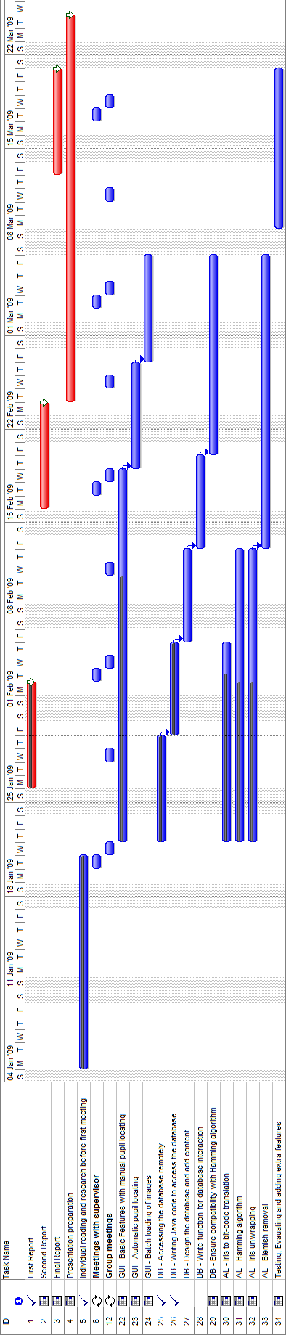
Fig.3
A Gantt chart describing our initial schedule for each component and the overall project. This plan will be used to benchmark our progress throughout development. A proportion of time has been allocated to overall testing and refinement towards the end of the project, which is entirely dependent on our progress at that stage.
Division of responsibilities

As previously stated specific tasks will be rotated as much as possible. The aim is also to ensure at all times that members responsible for different components are interacting with at least one other member to ensure compatibility throughout the development lifecycle. The initial division is as follows, and applies until the next report:

Edmund Noon (Team Leader): GUI interface, image manipulation, report writing.
Sebastian Smith (Team Secretary): Database Implementation, report writing, GUI support & refinement, note taking in meetings.
Arnar Jonsson: Implementing Daugman’s algorithms in Java Code.
Andrew Durnin: Database Implementation and Management, GUI support.
Mark Howe: Implementing Daugman’s algorithms in Java.
Team Member | Deliverable
Edmund Noon | GUI Interface with initial functionality as previously described
Arnar Jonsson | Java modules for bit-code extraction and comparison
Mark Howe | Java modules for bit-code extraction and comparison
Andrew Durnin | An appropriate functional database, maintenance of schedule and updated on timing of the project
Sebastian Smith | An appropriate functional database, co-ordination of report 1 with input from other team members and regular project updates

For a detailed account see John Daugman’s homepage: http://www.cl.cam.ac.uk/~jgd1000/
Daugman,J. (2004) ‘How Iris Recognition Works’, IEEE TRANSACTIONS ON CIRCUITS AND SYSTEMS FOR VIDEO TECHNOLOGY, vol.14(1).
Daugman, J. (1993) "High confidence visual recognition of persons by a test of statistical independence." IEEE Transactions on Pattern Analysis and Machine Intelligence, vol. 15(11), pp. 1148-1161.
Taken from Google Image search: ‘Java Iris Recognition GUI’

