**Experiment No.: 7**

**Title:** Demonstration using Simulation software OR

Experiment using Virtual labs

**Batch: *A-4* Roll No.: *16010422211*  Experiment No.:7 Aim:** Demonstration using Simulation software OR VLab

**Resources needed:** http://www2.ic.uff.br/~michael/kr1999/4-network/4_02-algor.htm

https://www.geeksforgeeks.org/distance-vector-routing-dvr-protocol/

**Theory**: DISTANCE VECTOR ROUTING

**Objective:**

*The objective is to understand and implement distance vector routing in computer networks.*

**Definition:**

*It’s a type of Dynamic Routing Protocol, the concept of a distance vector is the rationale for the name distance-vector routing. Distance Vector Routing is a distributed routing algorithm used to determine the best paths for data packets in computer networks. It relies on each nodes knowledge of its neighbour & their distances to make the routing decisions. In other words Distance vector routing is a routing algorithm used in computer networks to determine the best path for data to travel from the source to the destination.*

**Basic Concepts:**

*Distance: Distance in this context represents the cost or metric associated with a particular route. This cost can be based on factors such as the number of hops, link bandwidth, latency, or any other criteria depending on the specific routing protocol.*

*Vector: The "vector" part refers to the direction or next-hop router to reach a specific destination.*

**EX:**

*Consider 3-routers X, Y and Z as shown in figure. Each router have their routing table. Every routing table will contain distance to the destination nodes.*  
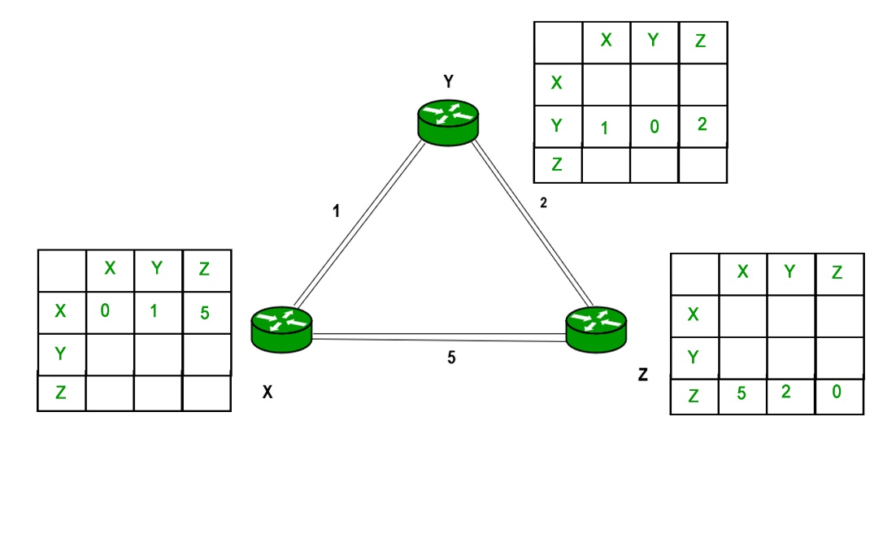

**Bellman-Ford Equation:**

*The heart of distance-vector routing is the famous Bellman-Ford equation. This equation*

*is used to find the least cost (shortest distance) between a source node, x, and a destina-*

*tion node, y, through some intermediary nodes (a, b, c, . . .) when the costs between the*

*source and the intermediary nodes and the least costs between the intermediary nodes and*

*the destination are given.*

**Advantages of Distance Vector Routing:**

*It offers several advantages including simplicity, scalability and robustness. Its simplicity makes it easy to implement and understand. The algorithm scales well and can handle dynamic changes. Additionally its robust against network failures and provides fault tolerance.*

**Disadvantages of Distance Vector routing –**

*It is slower to converge than link state & is at risk from the count-to-infinity problem.*

*It creates more traffic than link state since a hop count change must be propagated to all routers and processed on each router. Hop count updates take place on a periodic basis, even if there are no changes in the network topology, so bandwidth-wasting broadcasts still occur.*

*For larger networks, distance vector routing results in larger routing tables than link state since each router must know about all other routers. This can also lead to congestion on WAN links.*

**Code:**

import copy

import random

class DistanceVectorRouting:

    def __init__(self, nodes):

        self.nodes = nodes

        self.routing_table = {node: {} for node in nodes}

    def update_routing_table(self, node, distances):

        self.routing_table[node] = distances

    def get_random_distance(self, max_distance=10):

        return random.randint(1, max_distance)

    def generate_random_distances(self):

        initial_distances = {}

        for node in self.nodes:

            distances = {}

            for dest_node in self.nodes:

                if dest_node != node:

                    distances[dest_node] = self.get_random_distance()

            initial_distances[node] = distances

        return initial_distances

    def converge(self, max_iterations=10):

        for _ in range(max_iterations):

            prev_routing_table = copy.deepcopy(self.routing_table)

            for node in self.nodes:

                self.update_distance_vector(node)

            # Calculate the total cost

            total_cost = sum(sum(cost for cost in neighbor_costs.values()) for neighbor_costs in self.routing_table.values())

            if prev_routing_table == self.routing_table or total_cost >= 15:

                break

    def update_distance_vector(self, node):

        for neighbor in self.nodes:

            if neighbor != node:

                min_distance = float('inf')

                for target in self.nodes:

                    if target != node and target != neighbor:

                        distance = self.routing_table[target][neighbor] + self.routing_table[node][target]

                        if distance < min_distance:

                            min_distance = distance

                self.routing_table[node][neighbor] = min_distance

    def print_routing_table(self):

        for node in self.nodes:

            print(f"Routing table for Node {node}:")

            for dest, cost in self.routing_table[node].items():

                print(f"Destination: {dest}, Cost: {cost}")

            print()

if __name__ == "__main__":

    nodes = input("Enter node names separated by spaces: ").split()

    routing_algorithm = DistanceVectorRouting(nodes)

    initial_distances = routing_algorithm.generate_random_distances()

    for node, distances in initial_distances.items():

        routing_algorithm.update_routing_table(node, distances)

    routing_algorithm.converge()

    routing_algorithm.print_routing_table()

**Output:**

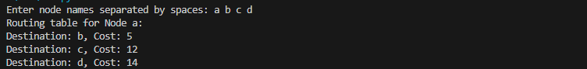

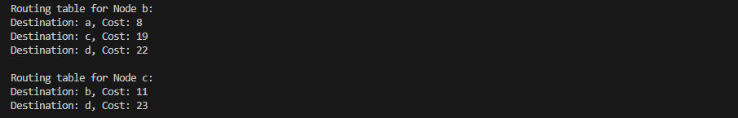

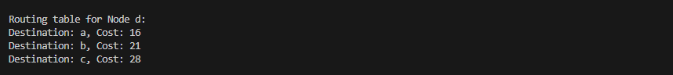

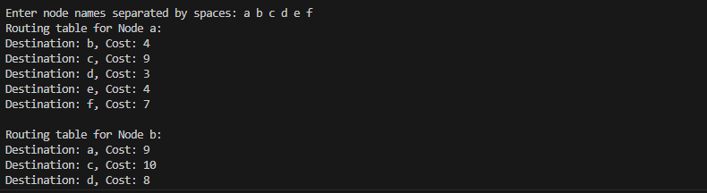

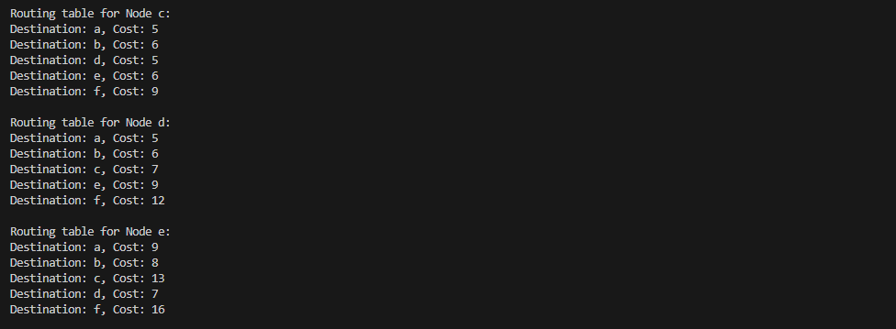

**Activity:** Demonstrate one experiment based on contents of the syllabus. Prepare the lab manual explaining steps for installation and aided with snapshots wherever applicable

**Questions:**

1. The experiment demonstrated corresponds to which layer? Ans. Network Layer, layer 3 of the OSI model.
2. List the protocols belonging to the layer. Ans. There are several protocols in the network layer:
3. Internet Protocol (IP): This is the most fundamental protocol of the Network Layer and is used for addressing and routing packets across the internet. IPv4 and IPv6 are the two main versions of the IP protocol.
4. Internet Group Management Protocol (IGMP): IGMP is used in IP networks to manage multicast group membership. It's crucial for multicasting services like streaming video.
5. Internet Control Message Protocol for IPv6 (ICMPv6): Similar to ICMP for IPv4, ICMPv6 serves the same error reporting and diagnostic purposes but is designed for use with IPv6.
6. Routing Information Protocol (RIP): RIP is a distance-vector routing protocol that helps routers share routing information within small to medium-sized networks.
7. Open Shortest Path First (OSPF): OSPF is a link-state routing protocol commonly used within large, complex networks. It provides a more scalable and efficient routing solution
8. List any two functions of that layer**.** Ans: its primary functions:

1. Routing: The Network Layer is responsible for routing data packets from the source to the destination. It determines the optimal path for data to traverse through a network based on the destination address (typically an IP address). This includes selecting the appropriate next-hop router or network segment to forward the packet toward its final destination. Routing algorithms and protocols are used to make these decisions.

2. Logical Addressing: The Network Layer provides logical addressing, such as IP addresses in the case of the Internet Protocol (IP). These addresses are assigned to devices on a network, allowing routers to identify the source and destination of data packets. Logical addressing provides a structured way to uniquely identify devices and locations in a network, which is crucial for proper routing and communication across networks.

**Outcomes**: CO 1 Understand the data communication systems, network topologies and network devices. CO 2 Enumerate the layers of the OSI model and TCP/IP model, their functions and

Protocols. CO 3 Build the skills of subnetting and routing mechanisms.

CO 4 Execute their knowledge of computer communication principles, including Error

detection and correction, multiplexing, flow control, and error control.

**Conclusion**: DVR Protocol is a valuable algorithm for efficient pathway navigation in computer networks. Understood its principle advantages and limitations from this experiment.

**Grade: AA / AB / BB / BC / CC / CD /DD**

**Signature of faculty in-charge with date References:**

**Books/ Journals/ Websites:**