**Experiment No.: 8**

**Title:** Network Design using Simulation software

**Batch: A-4 Roll No.: 16010422211 Experiment No.:8**

**Aim:** Network Design using Simulation software

**Resources needed:**

**Network Design :**

Typical home or small office network, focusing on the connection between Wi-Fi routers, routers, switches, and PCs:

Internet Service Provider (ISP): This is the company that provides you with access to the internet. The ISP connects your home or office to the broader internet infrastructure.

Router: The router is a crucial device that manages network traffic between your local network and the internet. It assigns local IP addresses to devices on your network, allowing them to communicate with each other and access the internet. It often includes a built-in firewall for security.

Wi-Fi Router: This is a specialized router that includes wireless access points. It allows devices like smartphones, laptops, and tablets to connect to the network without using physical cables. Wi-Fi routers often have multiple Ethernet ports to connect devices directly through cables as well.

Switch: A switch is a device that connects multiple devices within a local network. It operates at Layer 2 (Data Link Layer) of the OSI model and uses MAC addresses to forward data to the correct devices within the network. Switches are often used to connect multiple devices in a local area, such as PCs, printers, and other devices.

PCs and Devices: Personal computers, laptops, printers, and other devices are connected to the network, either through wired connections (Ethernet cables) or wirelessly through Wi-Fi.

A simplified flow can be given as:

The router manages the connection between the local network and the internet, assigning local IP addresses.

The Wi-Fi router provides both wired and wireless connectivity for devices.

The switch connects multiple devices within the local network through wired connections.

PCs and other devices connect to the network through either wired or wireless connections.

This setup allows devices within the local network to communicate with each other and access the internet through a single internet connection provided by the ISP.

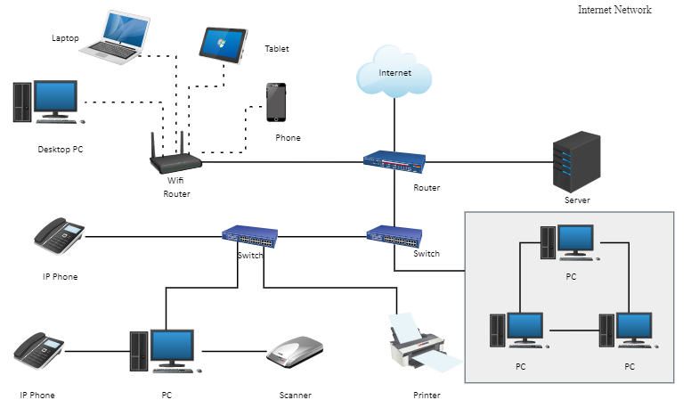

**Outcomes:CO3: Build the skills of subnetting and routing mechanisms.**

**Conclusion: Designed a home/ small office network and explained how the devices are connected necessary for data flow/ communication.**

**Grade: AA / AB / BB / BC / CC / CD /DD**

**Signature of faculty in-charge with date**