

**Experiment No. 5**

**Title:** Classification of IP addressing.

# Batch*: A-4* Roll No.: *16010422211* Experiment No.: *5*

**Aim:** To write a program to identify the class to which a given IP Address belong to.

# Resources Used: Java/C/Python

**Theory:**

A Computer at one place in the world needs to communicate with another computer somewhere else in the world. Usually computers communicate through the Internet. The packet transmitted by the sending computer may pass through several LANs and WANs before reaching the destination computer. For this level of communication, we need a global addressing scheme called as Logical addressing. Today we use the term IP Address to mean a logical address in the network layer of the TCP/IP protocol suite.

IP address is 32 bit long. The IP addresses are unique and universal. There are two prevalent notations: Binary notation and Dotted –Decimal notation. In binary notation ,the IP address is displayed as 32 bits..Each octet is often referred to as a byte. So it is referred to as 32 bit addressor 4-byte address.. To make it more compact and easier to read, Internet addresses are usually written in decimal form with a decimal point separating the byte

Number of IP Addresses per Device: Any device that has data sent to it at the network layer will have at least one IP address: one per network interface. This means that normal hosts such as [computers](http://www.tcpipguide.com/free/t_IPAddressingOverviewandFundamentals-2.htm) and network-capable printers usually get one IP address, while routers get more than one IP address. Some special hosts may have more than one IP address if they are multihomed - connected to more than one network. Lower-level network interconnection devices such as repeaters, bridges and switches don't require an IP address because they pass traffic based on layer two (data link layer) addresses. Network segments connected by bridges and switches form a single broadcast domain and any devices on them can send data to each other directly without routing. To the Internet Protocol, these devices are “invisible”, they are no more significant than the wires that connect devices together (with a couple of exceptions).

"CLASSFUL" IP Address Classification:

In Classful addressing, the address space is split into five classes: A, B, C, D, E. Each class occupies some part of the address space.as shown in Table 1. Looking at only the first few bits of any IP address

would tell the router where to “draw the line” between the network ID and host ID., and thus what to do with the datagram. The number of bits the router needs to look at may be as few as one or as many as four, depending on what it finds when it starts looking.

# Netid and Hostid

In classful addressing, an IP address in Class A, B, or C is divided into netid and host id. These parts are of varying lengths, depending on the class of the address. In class A, one byte defines the netid and three bytes define the host id. In class B, two bytes define the netid and two bytes define the host id. In class C, three bytes define the netid and one byte defines the host id.

Class A addresses were designed for large scale organizations with a large number of attached hosts or routers.

Class B addresses were designed for mid size organizations with tens of thousands of attached hosts or routers.

Class C addresses were designed for small organizations with a small number of attached hosts or routers.

Class D network addresses are used by multicasting. Multicasting is a method of reducing network traffic. Rather than send a separate datagram to each host if multiple host require the same information, a special multicast address can be used where one datagram is read by many hosts.

Class E Addresses were reserved for future use.

# Table 1

|  |  |  |
| --- | --- | --- |
| Network Class | IP Address Range | Net mask |
| A | 0.0.0.0 to 127.255.255.255 | 255.0.0.0 |
| B | 128.0.0.0 to 191.255.255.255 | 255.255.0.0 |
| C | 192.0.0.0 to 223.255.255.255 | 255.255.255.0 |
| D | 224.0.0.0 to 239.255.255.255 | - |
| E | 240.0.0.0 to 255.255.255.255 | - |

**Algorithm**

The algorithm used corresponds to the system used to divide the address space; it involves four very basic steps (see Figure 1 below)

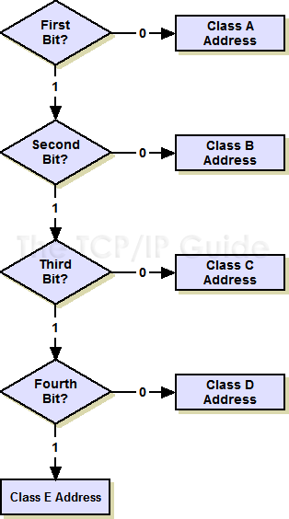

Figure 1: Class determination algorithm for “Classful” IP addresses The algorithm takes as input the first byte of the IP address in binary form

1. If the first bit is a “0”, it's a class A address and we're done. (Half the address space has a “0” for the first bit, so this is why class A takes up half the address space.) If it's a “1”, continue to step two.
2. If the second bit is a “0”, it's a class B address and we're done. (Half of the remaining non-class-A addresses, or one quarter of the total.) If it's a “1”, continue to step three.
3. If the third bit is a “0”, it's a class C address and we're done. (Half again of what's left, or one eighth of the total.) If it's a “1”, continue to step four.
4. If the fourth bit is a “0”, it's a class D address. (Half of the remainder, or one sixteenth of the address space.) If it's a “1”, it's a class E address. (The other half, one sixteenth.)

# Activity:

1. The program should accept the input IP address in dotted decimal form.
2. Convert this address into binary form and apply the classification algorithm.
3. Display the class of IP address as the output.

# Program:

def valid_ip(ip):

parts = ip.split('.')

if len(parts) != 4:

return False

for part in parts:

if not part.isdigit() or not (0 <= int(part) <= 255):

return False

return True

def classify_ip(ip_address):

octets = ip_address.split('.')

binary_octets = [format(int(octet), '08b') for octet in octets]

binary_ip = ''.join(binary_octets)

first_octet = int(octets[0])

if 1 <= first_octet <= 126:

ip_class = "A"

net_host_id = binary_ip[:8]

elif 128 <= first_octet <= 191:

ip_class = "B"

net_host_id = binary_ip[:16]

elif 192 <= first_octet <= 223:

ip_class = "C"

net_host_id = binary_ip[:24]

elif 224 <= first_octet <= 239:

ip_class = "D (Multicast)"

net_host_id = None

elif 240 <= first_octet <= 255:

ip_class = "E (Experimental)"

net_host_id = None

else:

ip_class = "Invalid"

net_host_id = None

return ip_class, net_host_id

def main():

ip = input("Enter an IP address in dotted decimal form (eg: 175.65.55.20): ")

if valid_ip(ip):

print(f"{ip} is a valid IP address.")

ip_class, net_host_id = classify_ip(ip)

if net_host_id:

net_host_id = net_host_id.zfill(32)

print(f"The IP address falls under class {ip_class}.")

print(f"Network ID: {net_host_id[:32]}")

print(f"Host ID: {net_host_id[:32]}")

else:

print(f"The IP address falls under class {ip_class}. It has no network/host ID.")

else:

print(f"{ip} is not a valid IP address.")

if __name__ == "__main__":

main()

**Output:**

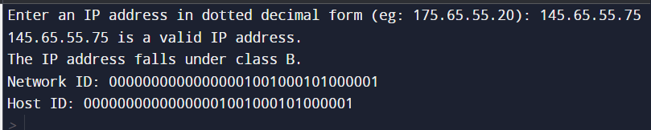

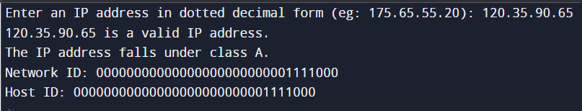

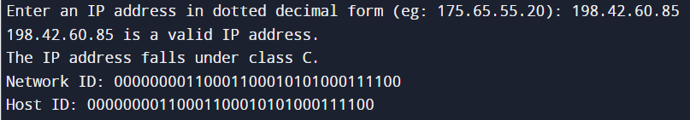

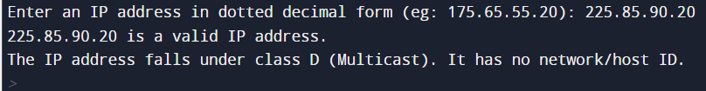

# Questions:

1. Which OSI layer corresponds to IP Layer? Ans. *The Layer that corresponds to IP is the Network layer of the OSI Model.*
2. Compare IPv4 and IPv6 header Ans. *A) IPv4 has 32-bit addresses, while IPv6 uses 128-bit addresses.*

*B) IPv4 header length varies with option, specified by “IHL” field.*

*C) IPv6 eliminates router fragmentation; fragmentation at source if needed.*

1. What is fragmentation? Ans*. It’s the process in networking where large data packets are broken into smaller fragments to fit within the maximum transmission unit (MTU) of the network link. Fragments are reassembled at the destination.*
2. What is Subnetting? Ans *In networking it’s a way to split a larger network into smaller parts. Each smaller part or “subnet” has its own address range. Which makes communication more efficient and secure*.

*Subnetting aids in resource allocation & organized data traffic control.*

1. What is Supernetting?

Ans. *Supernetting, is a networking practice that involves combining multiple contiguous subnets into larger block. This reduces the number of routes in routing tables, enhancing routing efficiency. It simplifies routing by summarizing network prefixes, but it can lead to less efficient address utilization.*

# Outcomes:

*CO2. Enumerate the layers of OSI model & TCP/IP model, their functions and protocols.*

**Conclusion:**

*Gained a comprehensive understanding on IP Addresses and using python implemented a code that is user defined, i.e takes the IP address from the user validates it and classifies it accordingly in different classes. In the second half of the expt, network ID and Host Id is shown in 32 bit long binary form converting the dotted decimal form.*

# Grade: AA / AB / BB / BC / CC / CD /DD

**Signature of faculty in-charge with date**

# References:

**Books/ Journals/ Websites:**

* Behrouz A Forouzan, Data Communication and Networking, Tata Mc Graw hill, India, 4th Edition
* S. Tanenbaum,” Computer Networks”, 4th edition, Prentice Hall