

**Batch:** A-4  **Roll No.:**  16010422211  **Experiment No.:** 2

**Aim:** To Design and Simulate binary to gray, gray to binary, BCD to Excess 3, Excess 3 to BCD code converters using Vlab.

**___________________________________________________________________**

**Resources needed:** internet connection,

Access to- https://he-coep.vlabs.ac.in/exp/various-code-converters/index.html

**Theory:**

**Explain following points in brief**

1. **Binary Codes**
2. **BCD Code**
3. **Excess 3 Code**
4. **Gray Code**
5. **Code converter**

**Explore the Theory and lab Manual in References section of the Vlab experiment**

**Procedure:**

1. Appear for Pretest and include the screenshot in write-up.
2. Design a Binary to Gray code Converter using pen & paper. Include scanned copy of design in write up.
3. Go through Procedure Tab.
4. Explore Simulator as per instructions in Procedure include screenshot of every circuit simulated in the writeup.
5. Appear for Posttest and include screenshot in write-up.
6. Create a document with screenshots mentioned above, Outcome and Conclusion.
7. Please note every document uploaded as Lab Writeup should be labelled as Exp_<No>_<RollNo.pdf

**___________________________________________________________________________**

**Observations and Results:**

1. Design of 4 bit Binary to Gray Code converter.
2. Observe and understand the simulated code converters.

***BINARY TO GRAY***

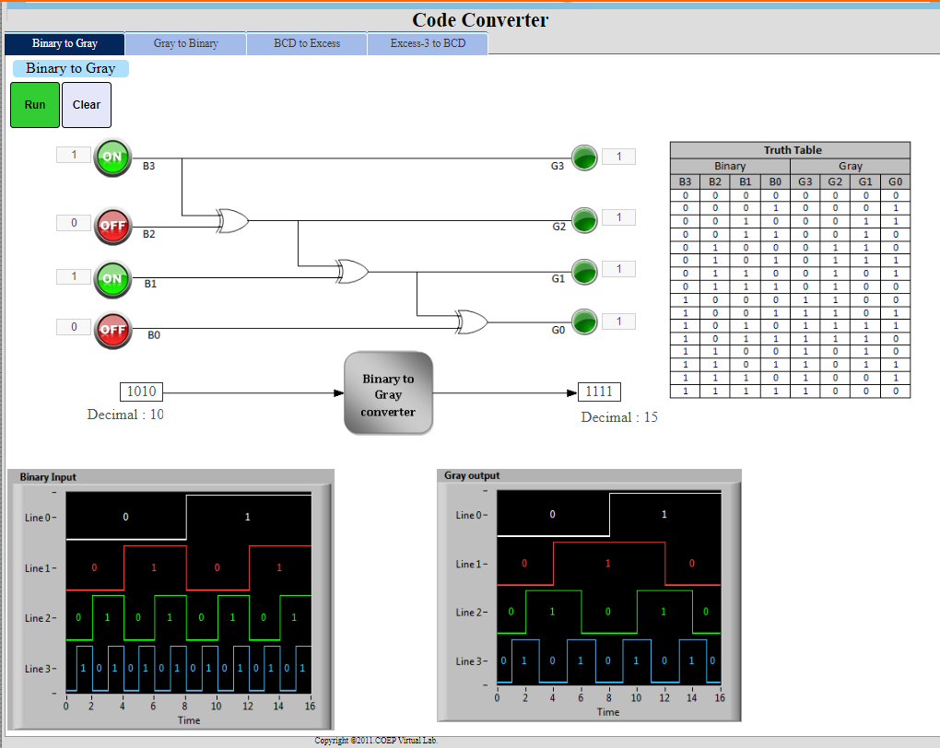

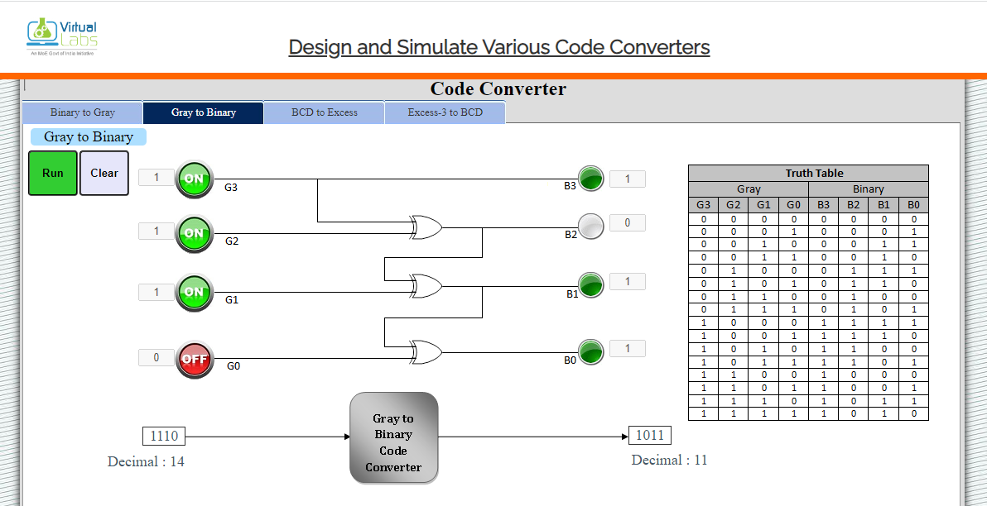

***GRAY TO BINARY***

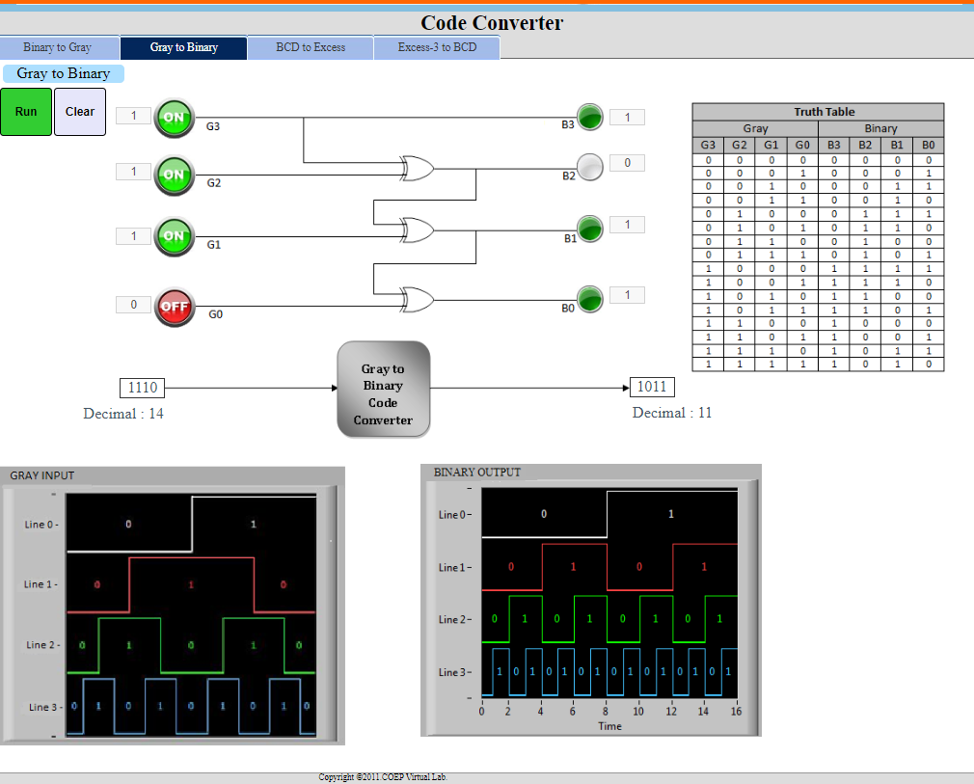

***BCD TO EXCESS 3***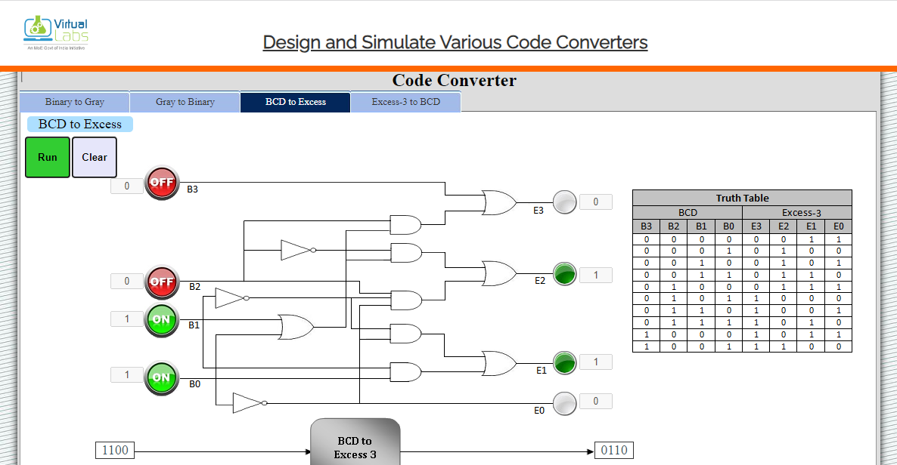

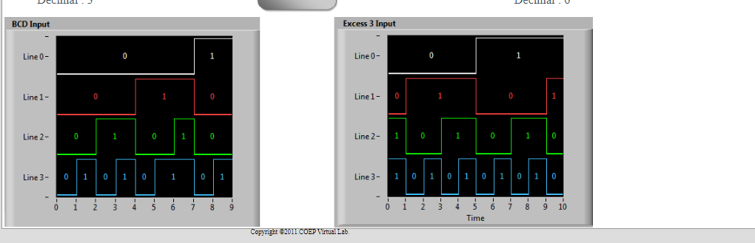

***EXCESS 3 TO BCD***

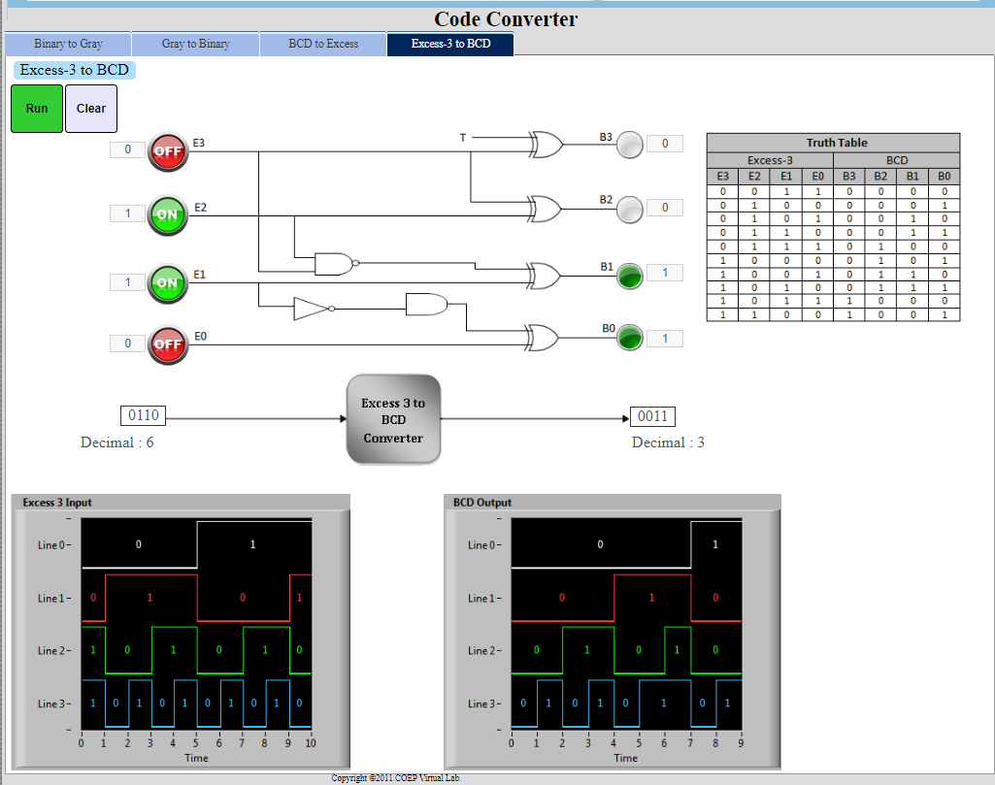

*PRETEST:*

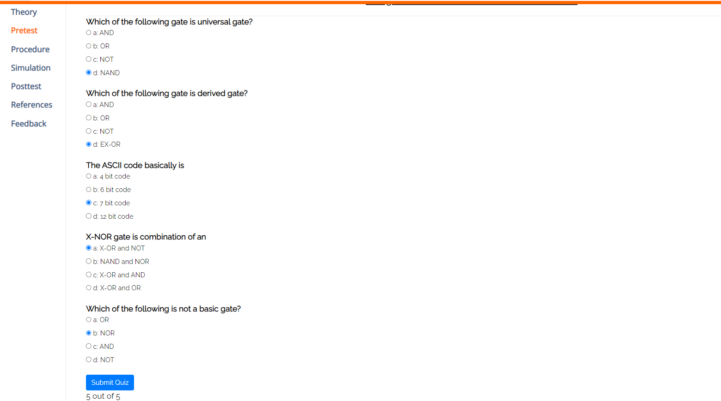

*POSTTEST:*

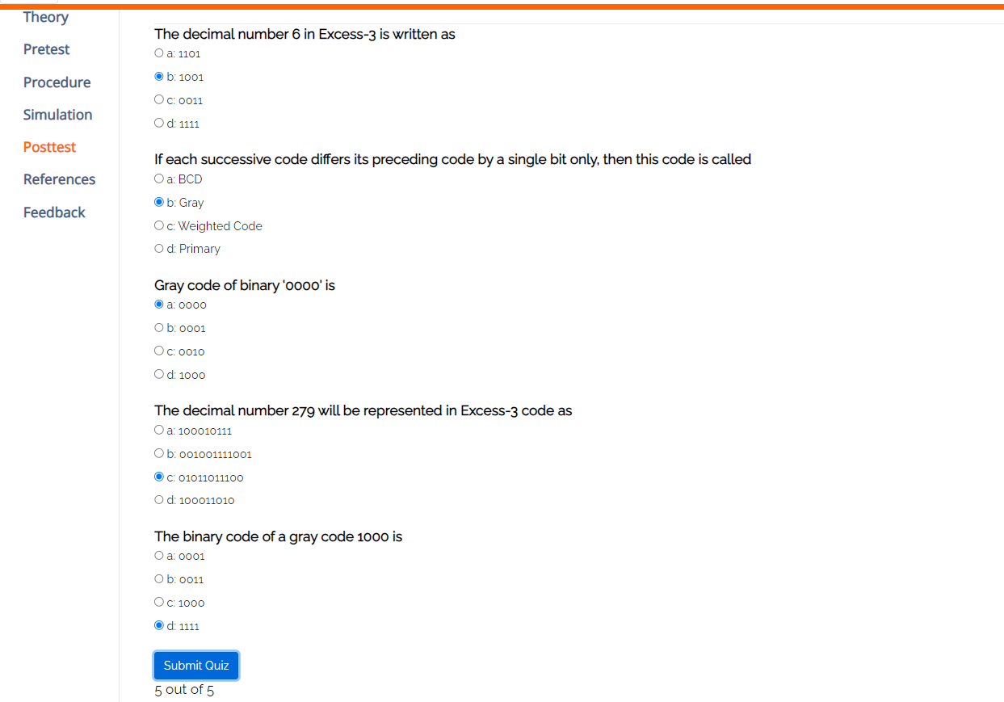

**Outcomes:** Solve problems on various number systems, Boolean algebra and graphical techniques

**___________________________________________________________________________**

**Conclusion:**

*Learnt how to Design and Simulate binary to gray, gray to binary, BCD to Excess*

*3, Excess 3 to BCD code converters using Vlab.*

**Grade: AA / AB / BB / BC / CC / CD /DD**

**Signature of faculty in-charge with date**

**___________________________________________________________________________**

**References:**

**Books/ Journals/ Websites:**

1. R. P. Jain, “Modern Digital Electronics”, Tata McGraw Hill.
2. <https://he-coep.vlabs.ac.in/exp/various-code-converters/index.html>
3. https://he-coep.vlabs.ac.in/exp/various-code-converters/images/Lab%20Manual%20Exp%20code%20converter.pdf