KJSCE/IT/SYBTECH/SEMIII/DiS/2023-24

**Experiment No. 5** 

**Title: Design combinational logic circuit using Logic Gates.**

(Constituent College of Somaiya Vidyavihar University)

KJSCE/IT/SYBTECH/SEMIII/DiS/2023-24

**Batch:*A-4* Roll No.*16010422211* Experiment No.: 5 Aim:** Design combinational logic circuit using Logic Gates.

**_______________________________________________________________ ___ _ Resources needed:** Simulation Platform

**Theory:**

**What is Combinational Logic Circuit?**

o At any instant of time, the output of the combinational circuits depends only on the present input terminals.

o The combinational circuit doesn't have any backup or previous memory. The present state of the circuit is not affected by the previous state of the input. o The n number of inputs and m number of outputs are possible in combinational logic circuits. 

**Explain in brief about Multiplexer.**

A multiplexer is a combinational circuit that obtains binary data from one of 2" input data lines and manages it to an individual output line. The selection of a specific input data line for the output is decided by a collection of selection inputs. A 2"-to-1 multiplexer has 2" input data lines and n input selection lines whose bit combinations decide which input data are chosen for the output.

**Procedure**:

a) Design combinational circuit for a Seat Belt warning system of Car - for Beeping the alarm under conditions when, any person in driver’s and/or Front passenger’s seat is seated, the seat belt is not fastened when the key is inserted. - Assume suitable data and mention the same.

b) Design the circuit using Multiplexer and simulate the designed circuit. c) Verify the circuit for the designed truth table using test bench.

d) Upload the Schematic Diagram generated on Simulation Software as well as Writeup containing Questions asked in writeup, CO and Conclusion.

e) Please note every document uploaded on google classroom should be labelled as Exp_<No>_<RollNo>_<schematic/writeup>.pdf

**___________________________________________________________________________ Observations and Results: Observe the output for different input combinations.**

(Constituent College of Somaiya Vidyavihar University)

KJSCE/IT/SYBTECH/SEMIII/DiS/2023-24

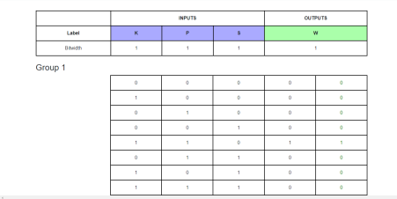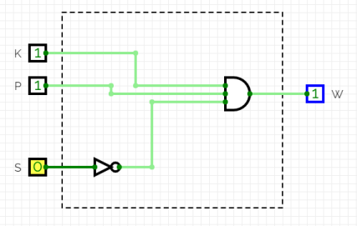

**Outcomes: CO2:Understand the basic building blocks, techniques used in digital logic design.**

**_________________________________________________________________________**  **Conclusion:***Designed a combinational circuit for a Seat Belt warning system of Car*.

(Constituent College of Somaiya Vidyavihar University)

**Grade: AA / AB / BB / BC / CC / CD /DD Signature of faculty in-charge with date**

KJSCE/IT/SYBTECH/SEMIII/DiS/2023-24

**___________________________________________________________________________ References:**

**Books/ Journals/ Websites:**

1. Mux simulation

https://docs.circuitverse.org/#/chapter4/5muxandplex?id=multiplexer

2. Test bench- https://docs.circuitverse.org/#/chapter7/3testcircuits



(Constituent College of Somaiya Vidyavihar University)