KJSCE/IT/SYBTECH/SEMIII/DiS/2023-24

(Constituent College of Somaiya Vidyavihar University)

KJSCE/IT/SYBTECH/SEMIII/DiS/2023-24

**Batch: *A-4* Roll No.: *16010422211* Experiment No.: *6* Aim:** To verify the characteristic table of the following flip-flops:- D, JK and T. **_______________________________________________________________ ___ _ Resources needed:** Simulation Platform (Online Circuitverse Simulator)

**Theory:**

**Theory:** "Flip-flop" is the common name given to two-state devices which offer basic memory for sequential logic operations. Flip-flops are heavily used for digital data storage and transfer and are commonly used in banks called "registers" for the storage of binary numerical data.

|  |
| --- |

Fig: Types of Flip-flops

**Set-Reset FlipFlop:**

The set/reset type flip-flop is triggered to a high state at Q by the "set" signal and holds that value until reset to low by a signal at the Reset input. This can be implemented as a NAND gate latch or a NOR gate latch and as a clocked version.

One disadvantage of the S/R flip-flop is that the input S=R=1 gives ambiguous results and must be avoided. The J-K flip-flop gets around that problem.

(Constituent College of Somaiya Vidyavihar University)

KJSCE/IT/SYBTECH/SEMIII/DiS/2023-24

**JK FlipFlop:**

JK-flip flop has two inputs, traditionally labeled J and K. IC 7476 is a dual JK master slave flip flop with preset and clear inputs. If J and K are different then the output Q takes the value of J at the next clock edge. If J and K are both low then no change occurs. If J and K are both high at the clock edge then the output will toggle from one state to the other. It can perform the functions of the set/reset flip-flop and has the advantage that there are no ambiguous states.

**D FlipFlop:**

D flip-flop tracks the input, making transitions with match those of the input D. The D stands for "data"; this flip-flop stores the value that is on the data line. It can be thought of as a basic memory cell. D flip-flop can be made from J-K flip-flop by connecting both inputs through a not gate as shown in fig.

**T FlipFlop:**

T or "toggle" flip-flop changes its output on each clock edge, giving an output which is half the frequency of the signal to the T input. It is useful for constructing binary counters, frequency dividers, and general binary addition devices. It can be made from a J-K flip-flop by tying both of its inputs high.

Table: Characteristic table and Excitation Table of flipflops

| **FlipFl**  **op**  **name** | **Characteristic Table** | | | **Characteris**  **tic Equation** | **Excitation Table** | | | |
| --- | --- | --- | --- | --- | --- | --- | --- | --- |
| **SR** | **S**  **0** | **R**  **0** | **Qnext**  **Qn** | **Qnext=**  **S+R’Q**  **Where SR=0** | **Q**  **0** | **Qnext**  **0** | **S**  **0** | **R**  **X** |
| **0** | **1** | **0** | **0** | **1** | **1** | **0** |
| **1** | **0** | **1** | **1** | **0** | **0** | **1** |

|  | **1** | **1** | **Invalid** |  | **1** | **1** | **X** | **0** |
| --- | --- | --- | --- | --- | --- | --- | --- | --- |
|  | | | | | | | | |
| **JK** | **J** | **K** | **Qnext** |  | **Q** | **Qnext** | **J** | **K** |
| **0** | **0** | **Qn** | **Qnext=**  **JQ’+K’Q** | **0** | **0** | **0** | **X** |
| **0** | **1** | **0** | **0** | **1** | **1** | **X** |
| **1** | **0** | **1** | **1** | **0** | **X** | **1** |
| **1** | **1** | **Qn’** | **1** | **1** | **X** | **0** |
|  | | | | | | | | |
| **D** | **D** | | **Qnext** |  | **Q** | **Qnext** | **D** | |
| **0** | | **0** | **Qnext=D** | **0** | **0** | **0** | |
| **1** | | **1** | **0** | **1** | **1** | |
|  | |  | **1** | **0** | **0** | |
|  | |  | **1** | **1** | **1** | |
|  | | | | | | | | |
| **T** | **T** | | **Qnext** |  | **Q** | **Qnext** | **T** | |
| **0** | | **Qn** | **Qnext=**  **TQ’+T’Q** | **0** | **0** | **0** | |
| **1** | | **Qn’** | **0** | **1** | **1** | |
|  | |  | **1** | **0** | **1** | |
|  | |  | **1** | **1** | **0** | |

(Constituent College of Somaiya Vidyavihar University)

KJSCE/IT/SYBTECH/SEMIII/DiS/2023-24

**Procedure**:

a) Login into your Circuitverse account

b) Open a new project and label it.

c) Draw the circuit diagram for the D Flip-flop. Label the inputs and outputs correctly. d) Toggle the CLK signal manually for D=0 and D=1 and check if the output changes as expected.

e) Now connect the CLK signal generator (under Sequential elements) f) Connect Flags (under MISC components) to CLK , D and Q so that the timing diagram window will be automatically activated.

g) Change values of D input and observe changes in the output.

h) Write the testbench and Verify it. Then export the testbench as an xls file. i) Take a snapshot showing all tests passing.

j) Repeat steps c to i for JK and T flip-flops.

k) Then complete the writeup and upload it

**___________________________________________________________________________**

**Observations and Results:** 

1. Complete the Characteristic

table for D, JK and T flip flop

given above. 2. Paste the circuit

diagram, testbench and output

snapshots below:

3. COPY-PASTE your files here:-

D-Flip Flop

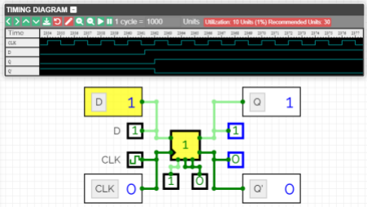(Constituent College of Somaiya Vidyavihar University)

KJSCE/IT/SYBTECH/SEMIII/DiS/2023-24

JK-Flip Flop



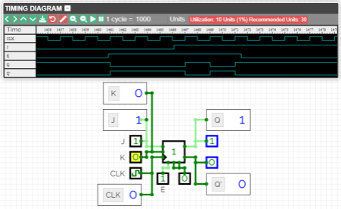T-Flip Flop

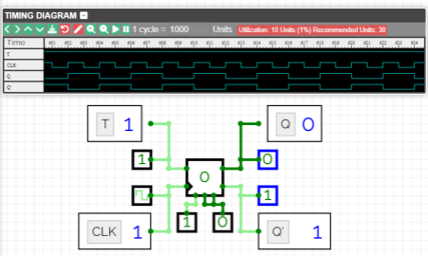**Outcomes: Design the combinational and sequential circuits using basic building blocks.**

**___________________________________________________________________________**

(Constituent College of Somaiya Vidyavihar University)

KJSCE/IT/SYBTECH/SEMIII/DiS/2023-24

**Conclusion:**

We could successfully verify the characteristic tables and excitation tables of D, JK and T Flip Flops.

**Grade: AA / AB / BB / BC / CC / CD /DD**

**Signature of faculty in-charge with date**

**___________________________________________________________________________ References:**

**Books/ Journals/ Websites:**

1. R. P. Jain, “Modern Digital Electronics”, Tata McGraw Hill.

2. http://hyperphysics.phy-astr.gsu.edu/hbase/electronic/flipflop.html



(Constituent College of Somaiya Vidyavihar University)