

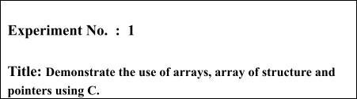

**Batch: A-4 Roll No.: 16010422211 Experiment No.: 1**

**Aim: Implement and demonstrate the use of arrays, array of structure and pointers using C.**



**Resources needed:** Turbo C/C++ editor and C compiler (Online/Offline)



**Theory**

1. **Arrays:** *Array in C is a fixed size collection of similar data items (entities) that are stored in memory locations.*
2. 

**Structure:** *The structure in C is a user-defined data type that can be used to group items of possibly different types into a single type.*

1. **Array of Structure:** *An array of structres in* [*C*](https://www.javatpoint.com/c-programming-language-tutorial) *can be defined as the collection of multiple structures variables where each variable contains information about different entities.*
2. **Pointers and Pointers to Structures**

*a variable which stores the address of another variable.*

1. **Functions and Function signature:**

*In c, we can divide a large program into the basic building blocks known as function.*



**Activity :** Implementing a C program to create a roll call list of a class **using array of**

**structure concept**. It has the details of students as roll number and name. Program should support following operations.

* 1. **Insert into last position.**
  2. **Delete from last position.**
  3. **Search specific student.**
  4. **Display complete list of student with details.**

**Results:** A C program depicting the correct behaviour of mentioned concept and capable of handling all possible exceptional conditions/inputs and the same is reflecting clearly in the output.

**Program and Output :**

*#include <stdio.h>*

*struct student{*

*int rollno;*

*char name[25];*

*}s[2];*

*void main(){*

*int c;*

*while(c!=5){*

*printf("Enter\n 1. for inserting data\n 2. for display\n 3.for search \n 4.for delete \n 5. To exit: ");*

*scanf("%d",&c);*

*switch (c){*

*case 1:*

*insertData();*

*break;*

*case 2:*

*deleteData();*

*break;*

*case 3:*

*searchData();*

*break;*

*case 4:*

*displayData();*

*break;*

*case 5:*

*break;*

*default:*

*printf("Enter from above choice");*

*break;*

*}*

*}*

*}*

*//Inserting a student in the last position*

*int a=0;*

*void insertData(){*

*if(s[2].name && s[2].rollno != NULL)*

*{printf("the array is full");}*

*else{*

*printf("RECORD of student\n");*

*printf("Enter the rollno.:");*

*scanf("%d",&s[a].rollno);*

*printf("Enter the name:");*

*scanf("%s",&s[a].name);*

*a++;*

*}*

*}*

*//Deleting a student from the last position*

*void deleteData(){*

*--a;*

*}*

*// Display*

*void displayData(){*

*if(s[0].name && s[0].rollno == NULL)*

*printf("array is empty");*

*else{*

*int m;*

*for(m=0;m<a;m++)*

*printf("\nRollno:%d, Name:%s\n",s[m].rollno,s[m].name);*

*}*

*}*

*//Search specific student*

*void searchData()*

*{ int n;*

*printf("enter the rollno. to search");*

*scanf("%d",&n);*

*int m=0;*

*while(m<=100)*

*{*

*if(s[m].rollno==n)*

*{*

*printf("\nName of the student is : %s",s[m].name);*

*printf("\nRoll no. of the student is : %d",s[m].rollno);*

*break;*

*}*

*if(m==100)*

*{*

*printf("\nNot found ");*

*break;*

*}*

*m++;*

*}*

*}*

*OUTPUT:*

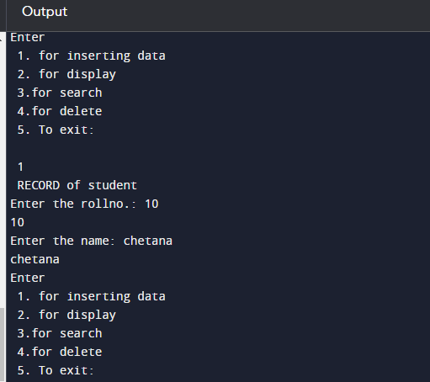

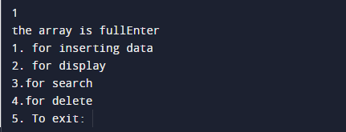



**Course Outcomes:**



**Conclusion***: Obtained a complete understanding of arrays, structure, arrays of structure and pointers. In this program, I implemented Array of structure concept & made use of several operations such as Insert, Delete, Search and Display. I tried to execute the code and got the output as attached above.*

**Grade: AA / AB / BB / BC / CC / CD /DD Signature of faculty in-charge with date**

**References:**

**Books/ Journals/ Websites:**

* Y. Langsam, M. Augenstin and A. Tannenbaum, “**Data Structures using C**”, Pearson Education Asia, 1st Edition, 2002
* **Data Structures A Psedocode Approach with C**, Richard F. Gilberg&Behrouz A. Forouzan, secondedition, CENGAGE Learning